Document Title | Existing BABAR (sPHENIX) Solenoid -  JLab Engineering Risk Assessment
Project | EIC Experimental Equipment
Purpose of document | To collate information pertaining to the long term engineering robustness and suitability of using the existing BABAR (sPHENIX) solenoid as the EIC detector solenoid
Version No. | 4.00
Date | 10.06.2020
Engineer | R. Fair
Reviewed by | R. Rajput-Ghoshal

Version | Date | Who | Changes from previous version
1.00 | 08.28.20 | R. Fair | Initial release
2.00 | 09.01.20 | R. Fair | Updated after review by R. Rajput-Ghoshal
3.00 | 09.01.20 | R. Fair | Updated after initial review by R. Ent, added conclusions and recommendations
4.00 | 10.06.20 | R. Fair | Section 3.4 updated with additional information on existing small leak within valve box. Executive Summary risk table (Distribution Valve Box and Coil Protection) text updated but no changes to risk levels.

Contents
Executive Summary 2
Introduction 5
Background Info 5
1. SLAC Risk Assessments (2004, 2006) 7
1.1 2004 Risk Assessment 7
1.2 2006 Risk Assessment 9
2. BNL Magnet Tests 10
2.1 Low Field Test 10
2.2 High Field Test 10
3. JLab Risk Assessment (2020) 15
3.1 Coil Design 15
3.2 Coil Protection 16
3.3 Magnet Mechanical Support System 18
3.4 Magnet Cryogenics System and Current Leads 19
4. Conclusions and Recommendations 21
References 23

Executive Summary
Purely from an engineering perspective, if the changes (improvements) listed below are carried out in order to mitigate the identified risks, then this magnet should be suitable for prolonged use as part of the detector system for the EIC project. However, it should be borne in mind that several of the mitigation efforts described below involve the disassembly of the magnet and this therefore imposes a certain level of risk. Furthermore, if the physics studies currently underway, indicate that additional changes are required to the magnet, (for example the inclusion of trim coils and/or changes to the iron circuit); then the system as a whole, will have to be re-evaluated - to ensure that the magnet remains within the original design limits under both normal and abnormal operating conditions.
Risk Rating | Before Risk Mitigation | After Risk Mitigation | Comments
HIGH | 1 | 0
MODERATE | 5 | 4 | Requires disassembly which can introduce additional risk
LOW | 2 | 4
Total | 8 | 8

Sub-System | Present Status | Failure Modes / Performance Limitations | Risk Rating Before Mitigation | Risk Mitigation | Risk Rating After Mitigation
Coil Design | Conservative electromagnetic design. | Micro-cracking of VPI resin is likely to have occurred after all these years of operation and thermal cycling, although this does not yet seem to have had a detrimental effect on the overall performance of the coil. | LOW | When magnet is not operating, keep coil at LN2 temperature.  Magnet has to be ramped to field no faster than 45 minutes to avoid eddy current heating and quenches – i.e. use 2.5 A/s or lower to 2000 A and then 1.5 A/s or lower to 4830 A. | LOW
Coil Protection | Standard design utilizing external dump resistor. VT11 open circuit, VT10 suspect – might affect quench detection and protection. Temperature sensors on splices reading high possibly due to poor mounting. | Additional critical voltage taps (for quench detection and protection) could be lost. Temperature sensors in key areas – coils, splices and current leads could either be lost or mis-read.  If the power supply, dump switch and dump resistor are original, they could fail. | HIGH | Purchase new magnet power supply, dump switch and dump resistor. BNL confirmed that they have refurbished the power supply (including the capacitors etc.) and the dump resistor (including the contactor and have added a snubber circuit) before the high-field test.  Add new redundant VTs and new temperature sensors or remount existing sensors – requires disassembly of magnet. | MODERATE (risk could be incurred as soldering new VTs to magnet conductor can be troublesome and might cause damage to the conductor and insulation)
Internal Mechanical Support System | Five strain gauges are not working and one shows unusually high readings and is ignored during tests. | If tie rods, disc springs have been overstressed, they could fail in the future although this is difficult to surmise as several gauges are not working and at least one is being ignored.  There could have been some overstressing of components during the transport from SLAC to BNL although there are no outward signs of this at present. | MODERATE | Fit new strain gauges – properly mounted and temperature compensated - requires disassembly of magnet. | MODERATE  (remains as moderate as the magnet requires disassembly which could lead to more rework)
Current Leads | The leads seem to be functioning well and have had no issues associated with them. There are plans to improve (increase) the gas flow cooling by operating the Helium circuit at a higher pressure. | Operating the helium circuit at a higher pressure (1.45 bar) will cause the magnet to operate at a higher temperature (approx. 4.65 K which means an enthalpy decrease of only 2.5% which should be OK as confirmed by their technical committee magnet expert [10].  There could have been some overstressing of components (e.g. the current leads themselves or splice joints) during the transport from SLAC to BNL although there are no outward signs of this at present. | LOW | Relocate current lead heaters and control temperature sensor to improve ice-management control. Increase helium gas flow. | LOW
Internal Cryogenic Cooling System | Potential hard touch between inner thermal shield and helium vessel (temp sensor on shield reading 4.2 K). Internal leak when cold: 10⁻⁶ to 10⁻⁷ torr-liters/sec level – presently being managed by pumping | Additional thermal shorts occur increasing the heat load on the system. Existing leak gets worse or additional leaks open up. There is some indication that both Ansaldo and SLAC struggled with making certain joints leak tight.  There could have been some overstressing of components (e.g. welds between cooling tubes and the coil support tube) during the transport from SLAC to BNL although there are no outward signs of this at present. | MODERATE | Fix leaks, survey all pipe work to ensure all joints are leak tight and no damage has been sustained by the years of operation and the transport from SLAC to BNL - requires disassembly of magnet. | MODERATE  (remains as moderate as the magnet requires disassembly which could lead to more rework and the leak may be difficult to locate)
Distribution Valve Box | If the internal leak (noted earlier) is in the valve box, then this could be fixed. This leak has been confirmed by BNL to be within the valve box. | Leak could get worse or other leaks could open up.  There could have been some overstressing of components during the transport from SLAC to BNL although there are no outward signs of this at present. | MODERATE | Fix leak – requires disassembly of valve box which should be easier than disassembly of the magnet. | LOW
Instrumentation | Strain gauges not working, temperature sensors on splices reading high, critical voltage taps lost or suspect. | Additional instrumentation could be lost or start mis-reading | MODERATE | Fix instrumentation - requires disassembly of magnet. | MODERATE  (remains as moderate as the magnet requires disassembly which could lead to more rework)
Control System | One recorded failure while at high current, PXIe data acquisition system may not be adequate | Additional failures during operation | MODERATE | Replace complete system | LOW

Introduction
The existing BABAR solenoid, previously at SLAC (BABAR experiment) and presently at BNL (sPHENIX experiment), is being considered for use as a detector solenoid for the EIC project. This document collates information from existing reports and presentations, and from discussions with personnel involved in assembling and operating the BABAR magnet, in an effort to provide a balanced view on the engineering robustness and reliability of this magnet for prolonged use as the EIC detector solenoid.
It should be noted that by the time the EIC project starts, this magnet will be about 30 years old and will be required to perform for a further 20 years during the expected lifetime of the EIC project.

Background Info
The magnet for the BABAR experiment at PEP-II at SLAC, CA was manufactured by Ansaldo, Italy based on design criteria developed over a period of 15 years between about 1980 and 1997 for aluminum-stabilized this solenoids. It was then transferred to BNL, NY for use in the sPHENIX experiment where it still resides today.
A brief history of the magnet is presented below:
 | Date | Operation | Comments
ANSALDO | Nov 1997 | Factory Acceptance Testing at Ansaldo, Italy
SLAC | Mar 1998 | Final commissioning at SLAC, California, USA | The coil current was incrementally increased to a 4605 A. The central field measured with an Hall probe was 1.503 T. The operating current for 1.50 T was then determined to be 4596 A and the design current (1.05 times the nominal current) was determined to be 4825 A. On charging the coil at 1.00 A/s the inductive voltage across the coil was 2.573V. The measured inductance is 2.573 H, which is in good agreement with computation (2.56 H). The final step in the commissioning process was to the solenoid charged to the design current of 4826 A. The measured field at the design current was 1.58 T. During these tests two fast dis-charge occurred due to false trigger of the Quench Detector System. This problem was fixed by modifying the front end electronic of the QDS [2].
 | May 1999 | Start of operations (refrigerator/solenoid system)
 |  | Decommissioned at SLAC, California, USA
 | Oct 2004 | Risk Review at SLAC | Magnet was in operation since 1999. There have been 63 unplanned interruptions to magnet operations since May 1999, almost 13 incidents/year or one a month. However,  None of these can be shown to be the result of a spontaneous quench in the coil. In nearly all cases, the interruptions can be traced to failures in utilities or supporting systems or to human error. There is some suggestion that several of the instrumentation internal to the magnet cryostat (for example strain gauges) may have failed – they have presently been by-passed seemingly without affecting the safety of the magnet. Average availability of magnet described as approx. 99 %. [5].
 | May 2006 | Risk Review at SLAC | No spontaneous quenches of the magnet since operation started in May 1999. Potential sensor failures within the magnet cryostat were identified as risk items. Sensor failure or noise spikes may result in erroneous hardwire trips and a subsequent fast discharge of solenoid. Only the most reliable sensors, such as voltage taps, are used for quench detection and fast discharges. Filters, implemented by software timers, have been added on all software interlocks to eliminate the possibility of noise spikes triggering a shutdown. In addition, redundant sensors are installed in all inaccessible locations. Although  the control systems can monitor multiple sensors, only one sensor is used to control the system. [4]
 | Apr 2008 | BABAR run ends | Magnet put into SLAC storage until 2015.
BNL | Feb 2015 | Arrived at BNL, New York, USA
 | Apr 2015 | Inspection/Acceptance Test (Hipot, leak check, etc.) | The magnet passed R, L, Q tests, 400 V impulse test and a 520 V Hipot test. The two helium circuits were vacuum leak checked and pressure tested to 81 PSIG (6.6 bar). The cryostat was vacuum leak checked.
 | Sep 2015 | First leak found | Electric insulator of a 10mm helium line within the valve box – fixed
 | Oct 2015 | Second smaller leak found | Cooling line – fixed by soft soldering. Located at the upper elbow joint of the cooling line located between the copper power busses - just below the Valve box in the connection tube between the Valve box and the main Cryostat. Ansaldo and SLAC seem to have been struggling with these pipes in the past.
 | Oct 2015 | Third even smaller leak found (10⁻⁶ to 10⁻⁷ torr-liters/sec level) | Not fixed – considered OK - further (6 inches) down the Valve box-Cryostat connection/tube compared to the previous one. Managed by pumping with Turbo pump during operation.
 | Feb 2016 | Pressure test/leak check for the entire LN2/He pipeline | Passed - test of the new piping that the Cryo group added after the leak checks/fixing in Oct. 2015
 | Feb 2016 | Cool down started
 | Mar 2016 | Hipot and other electrical tests | Passed
 | Mar 2016 | 100 A test | Passed
 | Dec 14 2017 | Steel flux return circuit installed
 | Dec 15 2017 | Start cool down | VT11 (near one end of magnet coil) found to be open circuit; VT10 (closer to magnet coil end) was used instead
 | Dec 21 2017 | Short circuit test | Carried out by fitting a copper bar between magnet current leads A and B – done to test the 535 MCM cables connecting the PSU to the magnet. Peak temp on cables = 133 ºF at 4700 A after 2 hours temperature stabilization.
 | Jan 22 2018 | 10 A test | To see if magnet current leads (superconducting bus bars) were superconducting as the newly mounted temperature sensors were reading higher than expected.
 | Jan 24 2018 | 75 A tests | Same reason as above.
 | Jan 29 2018 | 500 A test
 | Feb 1 2018 | 1000 A test
 | Feb 5 2018 | 2000 A test
 | Feb 9 2018 | Almost 4040 A, fast discharge | VT10 seemed to become open circuit for a brief period of time and then recovered. Caused the magnet to fast discharge. VT9 and VT20A were subsequently used for quench detection/protection.
 | Feb 13 2018 | 4830 A | Stayed at 4830 A for 40 minutes – limited by LHe availability. Ensured that the gas-cooled magnet current lead voltage stabilized before initiating a slow discharge. As per BABAR operation, at about 966 A, a fast discharge was initiated to reduce the run down time. Note: during the ramp to 4830 A, the control system crashed, causing a fast discharge from 2500 A.
 | Feb 16 2018 | Started ramp at 2.5 A/s with 1000 A steps. Magnet quenched at 3000 A. | Quench deemed to be ‘real’ by BNL engineers (due to difference between voltages across the inner and outer layers).
 | Feb 16 2018 | Started ramp again at 2.5 A/s. Tried to ramp to 4830 A, magnet quenched at 4410 A. | Approx. 2 hours for cryogenic recovery.
 | Feb 16 2018 | Ramped at 2.5 A/s to 1000 A, 2000 A and then at 1.5 A/s to 3000 A, 4000 A and then in 200 A steps up to 4830 A. | Stayed at 4830 A for 36 minutes. Then a slow discharge was initiated. No ill-effects have been observed with the magnet following these quenches and fast discharge events.
 | Jun 30 2020 | Risk assessment carried out for sPHENIX project [9] | Only risks identified for the magnet involve delays of the support platform construction and the inability to read temperature sensors from the service building 400 feet away.
There are no further plans to energize the magnet till about 2022 or 2023

SLAC Risk Assessments (2004, 2006)
The magnet and its refrigeration system were commissioned in Mar 1998, and started operation in May 1999. Two formal risk assessments were carried out at SLAC in 2004 and 2006 following 5 to 7 years of operation.

1.1 2004 Risk Assessment

During the operating life of the BaBar experiment to date (May 1999 – 2004), there have been a total of 63 unplanned interruptions to magnet operations. None of these can be shown to be the result of a spontaneous quench in the coil. In nearly all cases, the interruptions can be traced to failures in utilities or supporting systems or to human error. However, there are three categories of interest as follows:

- Unknown

For the events labeled as ‘Unknown’ in Figure 1 below, either the event was not well documented or the cause of the event was not known at the time. If a hardwire quench detection interlock is tripped, it can be difficult to obtain information about what initiated the problem. However, if the cause were known, it would most certainly fit into one of the other categories. A fair number of the unknown events are thought to have been caused by electrical noise on the quench detector circuit.

- Miscellaneous Instrument Fault

Sensors reading out incorrect information cause this problem. This can be either due to faulty sensors and data acquisition hardware or due to transient noise spikes that result in incorrect readings.

- Strain Gauge

Strain gages are mounted on the magnet support structure to monitor unusual stresses or deformations. This is a software interlock that will cause the magnet to ramp down if tripped. So far, all trips have been due to strain gage failures and not actual structural problems. Just as for BaBar, strain gauges will not be included in the quench detection system.

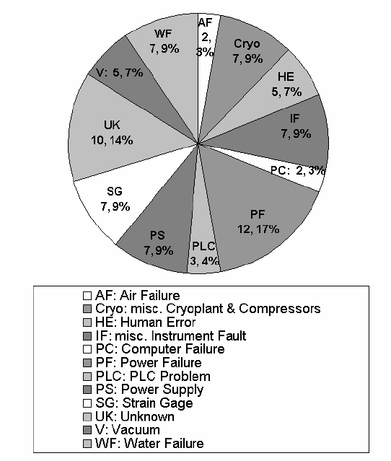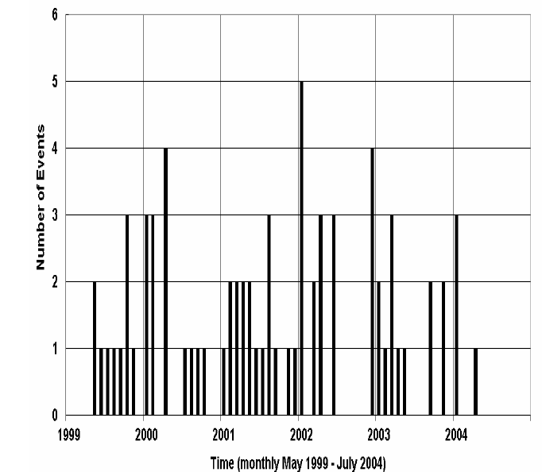
- (b)
Figure 1 – (a) Historical distribution of the failure modes for the BABAR superconducting magnet. The absolute number and relative percent of each failure mode is shown in the chart [5]; (b) Number of magnet interruption events per month between May 1999 and July 2004 of the BABAR experiment [5]
After mitigations were implemented – namely installing cooling and vacuum backup systems, changing the control programming and removing unneeded interlocks – the total number of interruptions after 2004 has been significantly reduced.

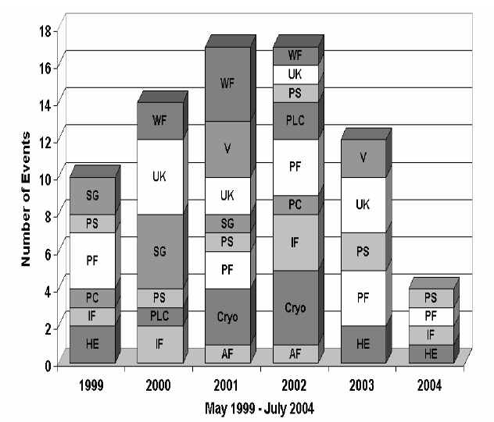
Figure 2 – Number and cause of magnet interruptions as a function of year for the BABAR experiment – significantly reduced after mitigations were implemented [5]

Since the exact length of down time per magnet interruption has not been consistently recorded, it is hard to calculate an exact availability for the BaBar solenoid. However, some estimates can be made. The BaBar experiment ran for 9.5 months in 2000, 2001, and 2003 and for 8.5 months in 2002. Using the total number of magnet interruptions shown above for each of those years and assuming that each interruption costs 8 hours of operations time (this is conservative, actual interruptions typically last 2 to 4 hours) the magnet availability in 2000, 2001, and 2003 is between 98% and 99%. In 2002 the availability was 97.8 %. In the case of the 7 months of operation to date in 2004, the magnet availability is greater than 99%.

1.2 2006 Risk Assessment
The risk assessment carried out in 2006 [4] concluded that the following posed the highest risks of failure (not in any order of importance):

- Electrical power failure
- Compressor failure
- Liquefier/refrigerator failure
- Cooling water failure
- Compressed air failure
- Sensor/instrument failure
  - Sensor failure or noise spikes may result in erroneous hardwire trips and a subsequent fast discharge of solenoid. Only the most reliable sensors, such as voltage taps, are used for quench detection and fast discharges. Filters, implemented by software timers, have been added on all software interlocks to eliminate the possibility of noise spikes triggering a shutdown. In addition, redundant sensors are installed in all inaccessible locations. Although the control systems can monitor multiple sensors, only one sensor is used to control the system.
- Control system failure
- Solenoid vacuum system failure
- Human error
- Helium purifier failure

BNL Magnet Tests

Low Field Test
The low field test was carried out at 100 A [6] in March 2016 without any iron flux return circuit. It allowed the following to be accomplished:
- Provided an early verification of the mechanical stability of the solenoid and cryostat during cool down to 4.5 K
- Demonstrated electrical integrity at low current and voltage
- Provided a means to test and tune the quench detection and data acquisition systems
- Checked out all instrumentation (voltage taps, temperature sensors, strain gauges, linear position gauges)
The run plan included an electrical checkout at room temperature, cool down to 4.5 K and another electrical checkout at 4.5 K, followed by ramp testing to 100 A.
The low field test of the sPHENIX Solenoid was completed successfully and accomplished the following important tasks and results.
1. The magnet was cooled down to 4.5 K and warmed back to room temperature without problems and the experience in the cool down and warmup will be useful for the future high field test cool down.
2. The magnet was shown to be electrically stable with no anomalies during ramping and shutdowns.
3. The energy extraction system switching process was verified.
4. The magnet maintained mechanical stability throughout cool down and warmup.
5. Important parameters for quench detection and operation were determined.
6. Magnetic field was verified up to the level of 100 A.
7. Strain gauges were read but more work needs to be done to understand the results before the high field test. (Note: Five strain gauges were not working and one showed an unusually high reading was ignored).

High Field Test
The high field test [7] was carried out after installation of a return flux steel box enclosing the superconducting magnet. Four new temperature sensors were added to the flexible portion of the magnet’s current leads (superconducting bus bars) and at the bottom of the fixed portion of the current leads (superconducting bus bars). However, during testing it was determined that the boards the sensors were mounted to, were not in good thermal contact with the superconducting bus bars and therefore read higher than they should have. Before the cool down started, VT11 was found to be open-circuit. VT11 is one of the VTs connected to one end of the magnet – it was ignored and VT10 was used instead; VT10 is closer to the magnet coil winding.
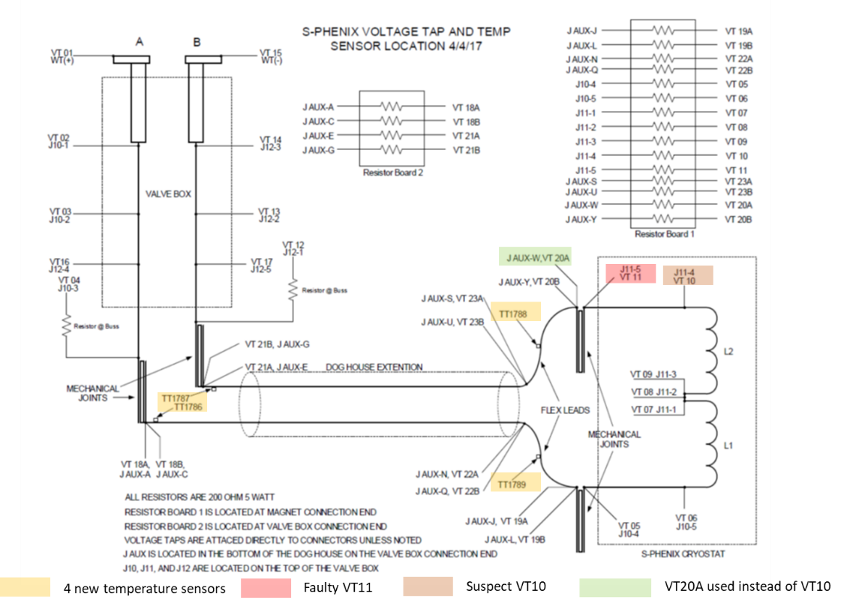
Figure 3 – Locations of existing voltage taps and 4 new temperature sensors added for the full field test [7]

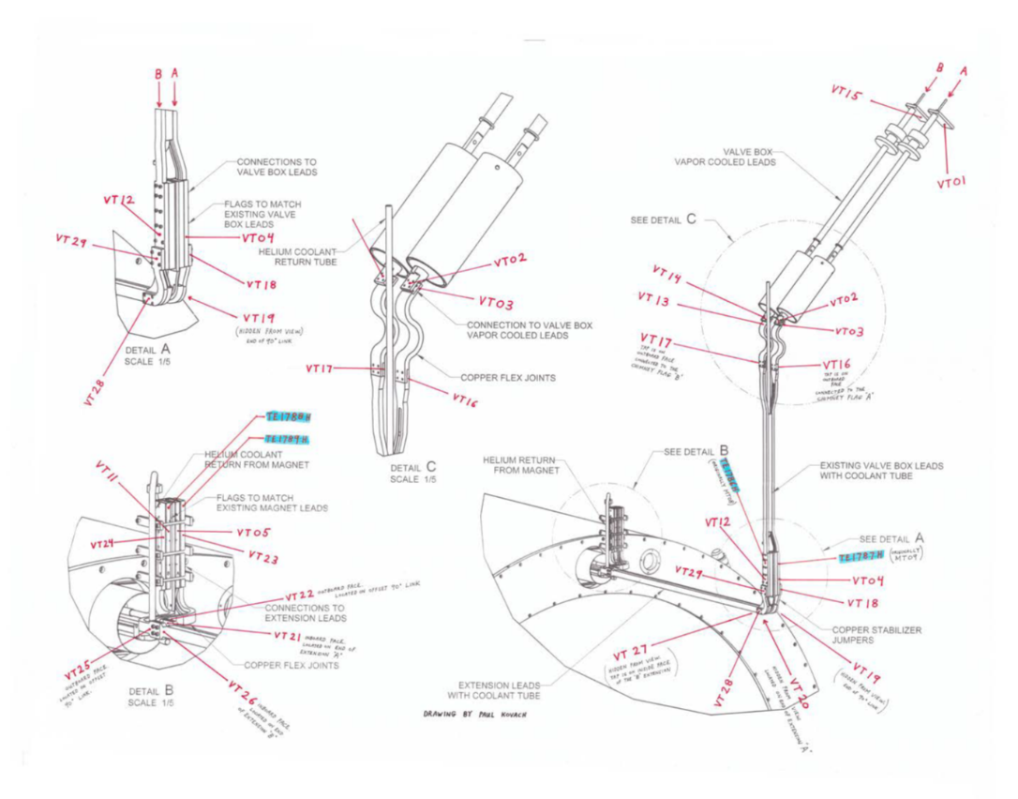
Figure 4 – Physical locations of existing voltage taps [8]

The magnet was ramped in stages: 10 A, 75 A, 500 A, 1000 A, 2000 A and nearly made it to 4040 A but then underwent a fast discharge due to VT10 becoming open circuit for a brief period of time. VT10 recovered shortly thereafter. VT9 and VT20A were subsequently used for quench detection/protection.
The coil was then ramped again to 4830 A. During the ramp to 4830 A, the control system crashed, causing a fast discharge from 2500 A. On re-cooling and re-running to 4830 A, the magnet stayed at 4830 A for 40 minutes - limited by LHe availability. The team ensured that the gas-cooled magnet current lead voltage stabilized before initiating a slow discharge. As per BABAR operation, at about 966 A, a fast discharge was initiated to reduce the run down time.
On a subsequent ramp up to full field, while ramping at 2.5 A/s with 1000 A steps, the magnet quenched at 3000 A. The BNL engineers concluded that this was in fact a ‘real quench’ – triggered by a difference between voltages across the inner and outer layers of the magnet.
After cryogenic recovery, on attempting to ramp again at 2.5 A/s, the magnet again quenched at 4410 A. It then took about 2 hours to recover the cryogenics. Communication was made with a SLAC engineer who confirmed that the BNL engineers were perhaps ramping at too high a ramp rate. This observation is most likely correct as the construction of this magnet (coil wound inside an aluminum support cylinder) would likely suffer from eddy-current heating within the support cylinder, which in turn could cause the coil layer immediately adjacent to the cylinder to heat up and quench. This conclusion seems to have been confirmed when the team re-ramped the magnet using lower ramp rates: at 2.5 A/s to 1000 A, 2000 A and then at 1.5 A/s to 3000 A, 4000 A and then in 200 A steps up to 4830 A, thus achieving full field successfully. The magnet stayed at 4830 A for 36 minutes (again due to the availability of LHe) and was then slow discharged to zero Amps.
The magnet appears not to have suffered from any ill-effects from the quenches and fast discharge events.
Magnet coil temperatures ranged from 4.58 K to 7.82 K. The inner thermal shield temperatures ranged from 4.2 K (thermal contact with helium vessel?) to 32.13 K. The outer thermal shield temperatures ranged from 29.86 K to 41.01 K. The lower portions of the magnet current leads were at 6.97 K and 7.32 K.
Magnetic field measurements at the center of the solenoid (with the steel in place) indicated a value of about 7% lower than calculated. The difference was possibly due to a combination of issues – 40+ years old steel, actual number of turns in the magnet coil being 1 to 2 % lower than what was used in the model and the existence of larger than expected gaps in the steel.
A surveyor measured any sideways - i.e. x-axis or horizontal expansion; (note: z-axis is along the proton beam axis while y-axis is vertical), and he observed only 0.002 inch of sideways movement (which was within his error/uncertainty) between 0 and 4000 A – so not an issue.
Examination of the strain measurement from one of the installed strain gauges indicated a clear correlation with the current in the magnet. The BNL engineers also verified that the change of strain was proportional to the square of the change of current as force is proportional to the square of current.
Hardware issues noted by the BNL engineers following the high field test are listed below. Special attention should be paid to item 5 below relating to a leak either within the valve box or within the solenoid itself (1.2x10^-5 Torr-L/sec measured while cold at end of high power test).
- Current lead flow controllers need to be able to operate at a lower pressure drop
  - MKS units were losing feedback at low pressures at 912 facility
  - Using MKS units in parallel would lower the pressure drop and increased flow capacity
  - Consider using Alley Cat flow meters
  - Review existing piping and see if there are any other flow/pressure restrictions
- Current leads heaters: locate to flange where the frost is and new mounting piece to transfer the heat. Review location of the temperature sensor that controls the heater.
- The coax line had a large pressure drop across it
  - Coax was not part of IP8 installation plan but high dP relevant for any future uses of this line.
  - Issue may be with the transition at the solid piping section or with repair made to bayonet tips at valve box end
- Increase flow through shield
  - Initial single MKS flow meter was not able to supply more than 0.65 g/s
  - Two units in parallel were able to double the flow with less pressure drop
    - 1.2 g/s at 1.3 atm
  - The configuration for IP8 install will be different: the shield flow returns cold in series with the cryo transfer bundle shield. We will have an Sierra thermal mass flow insertion meter after the heater going to the WR.
- Internal Leak inside of Valve box or solenoid
  - 1.2x10^-5 Torr-L/sec measured while cold at end of high power test
  - Ray Ceruti’s test from before low power test isolated leak to be somewhere in the piping of the vertical valve box chimney
  - Vacuum system was able to maintain good insulating vacuum during testing with Turbo molecular pumps.
- Improve temperature sensor mounting for splice joints
  - Stack up layers on temperature sensors may be high and G-10 plate may be influencing temperatures
  - Provide a physical mount for the sensors
- Consider adding vent for new splice joint loop
  - Splice loop can trap gas and increase pressure drop
  - Vent line would need to go from top of joint and route up to top of phase separator
- Review level probes in valve box phase separator
  - Probes read somewhat erratically
  - Consider adding a shroud around them to limit splashing or cold vapor influence
- Consider replacing the vacuum system
  - Most components were from the original test and have may hours on them
  - Roughing pumps failed twice during low and high-power testing, replacements were installed till the pumps could be repaired
- Warm up procedure should recommend temperature drift over forced warm up
  - Recommendation from January 2018 cryogenic review
- The cables length for IP8 will be longer than 100ft.
  - Get Lakehsore 224 unit for the Cernox sensors to handle high capacitance wires.
  - Review wiring length for the CLTS sensors / Strain gage sensors

JLab Risk Assessment (2020)

3.1 Coil Design
This solenoid operates with a current of 5 kA and 20 MJ of stored energy. The solenoid is cooled by forced flow liquid helium transferred from a 4000 l storage dewar which in turn is kept at a constant level by a large Linde helium liquefier/refrigerator. The magnet is protected by a set of hardware and software interlocks that will either ramp the current in the magnet down or open a breaker which quickly discharges the current into a dump resistor [1]. The double layer coil is internally wound on a 35 mm thick 5083 aluminum support mandrel. 11 parallel cooling pipes (20 mm ID, 20 mm OD) welded to the outside diameter of the support mandrel form part of the thermo-syphon system. Electrical insulation consists of dry wrap fiberglass cloth and epoxy vacuum impregnation. The conductor is composed of a superconducting Rutherford type cable embedded in a pure aluminum matrix through a co-extrusion process, which ensures good bonding between the aluminum and the superconductor. In order to have a field homogeneity of +/- 3% in the large volume specified by the BaBar experiment, the current density in the winding is graded: lower in the central region and higher at the ends. The gradation is obtained by using conductor of two different thickness: 8.4 mm for the central region and 5 mm for the ends. Both 20 mm wide conductors are composed of a 16 strand Rutherford cable stabilized by pure aluminum [2].
Table 1 – BABAR magnet parameters [2]
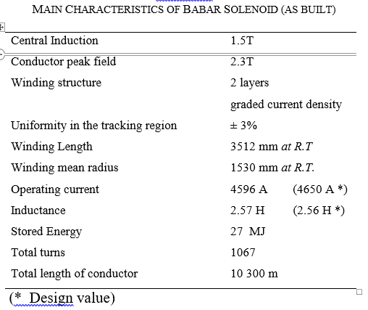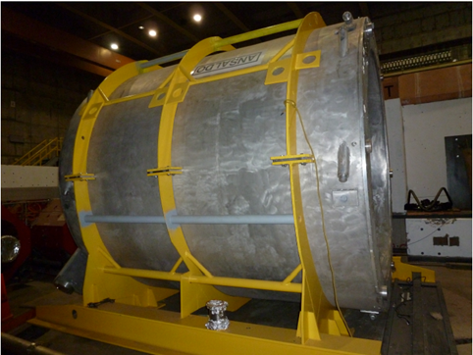
Conductors supplied by: Europa Metalli (Fornaci di Barga –Italy)
Co-extrusion process by: ALCATEL SWISS CABLE under assistance of ETH Zurich
Conductor critical current measured in the MA.RI.SA facility using the transformer method

Table 2 - Electrical and thermal margins of the BABAR coil as constructed [3]
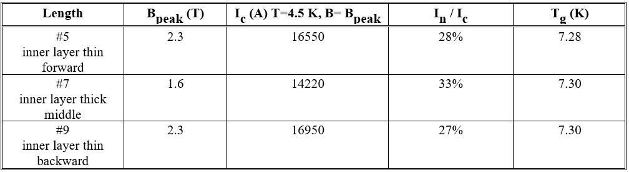
The BABAR short sample critical current measurements results a show higher safety margin than originally designed into the coil. The enthalpy margin is as high as a very large coil like ALEPH. This will also lead to more safe operation of the coil, minimizing the risks of premature quenching due to disturbances or wrong operation i.e. lack of coolant, too fast charge and dis-charge [3].
- The coil design is conservative.
- The magnet has had several thermal cycles during the BaBar era and there is some evidence that the coil was not maintained at Nitrogen temperature. The magnet has also undergone several high current fast discharges and quenches. This could dictate the condition of the coil insulation as well as the thermal contact between the cooling pipes and the outside of the coil mandrel. It is quite likely that the VPI has suffered from micro-cracking – again this is dependent on the number of quenches and thermal cycles, and therefore the mechanical integrity of the coil could be compromised – however, to date, there is no evidence of this – i.e. no degrading quench behaviour which is a good sign.
- It is clear that eddy-current heating will occur if the magnet is ramped too quickly and that the magnet will quench as has happened a couple of times already during testing at BNL. Ramp rates determined as safe by BNL are: 0 to 2000 A at 2.5 A/s and then 1.5 A/s to 4830 A.
- There is also a question of whether the current leads have been over-stressed during the transport from SLAC to BNL – either the leads themselves or splices to the leads. However, there is no outward evidence of any deterioration of the leads at present.
- If possible, BNL intend to keep the magnet at LN2 temperature while waiting to start the experiment

3.2 Coil Protection
The coil is protected with the usual method of an external resistor in parallel with the coil, which extracts approximately 75 % of the stored magnetic energy. If a quench is detected (50 mV unbalance signal between the two voltages in two layers), a breaker opens, closing the current in coil and dump resistor. The peak voltage at the coil ends can be as high as 320V. Considering that the center tap of the dump resistor was shorted to ground, the maximum voltage to ground is 170 V. The fast dis-charge from the nominal current causes a quench due the heating of the supporting cylinder (Quench Back). The coil temperature increases to 37 K uniformly. In these conditions about 5 hours are needed to cool-down the coil again, fill the reservoir and be ready for re-starting [2,4].
Quench detection was configured (at least for the BNL low field test), by using the “central” tap between the layers and the end taps, and subtracting the inner layer voltage from the outer layer voltage; this is called the half coil voltage difference, or delta. During superconducting operation, the difference signal, if properly balanced, will average to zero with only a noise level, which can be determined. When the voltage difference increases above a set threshold voltage level above the noise and is present for a set validation time (to eliminate false trips due to spikes), the detector trips and a stop signal is sent out to shut down the power supply, switch in the eternal energy extraction (dump) resistor. In the unlikely event that a quench occurs simultaneously in the two halves, a different type of signal is used that is the difference between the inductive voltage during the ramp and calculated value of inductance times the ramp rate. For this type of detection, the bucked coil voltage as just described, the voltage threshold for tripping must be carefully determined in order to avoid false trips due to dynamic inductance changes during power ramps and/or adjusting in the calculation for those changes after measuring them. This type of quench detector is called current derivative or Idot. [6].

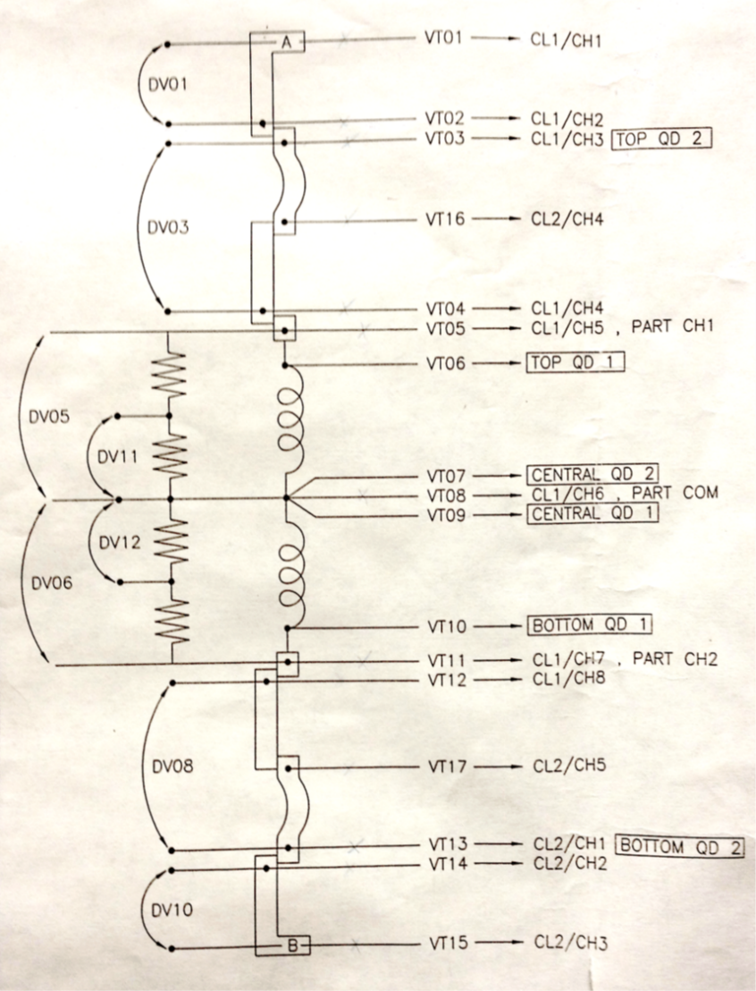
Figure 3 – The magnet itself is equipped with 17 voltage taps which, in pairs, measure the voltages of the inner and outer layers, the total magnet voltage, and sections of the leads. At some locations there are multiple taps for redundancy. [6]
- The coil protection system is considered to be standard and works well and reliably as long as the breaker and resistor is serviced regularly. As the resistor and breaker are located externally to the coil itself, these items can be replaced easily if necessary.
  - Recommendation: Purchase new magnet power supply, breaker and resistor
- The coil temperature rise is safe. The hot spot temperature could be twice as high as the average coil temperature rise but would still be considered safe by the usual design criteria of 150 K maximum temperature.
  - Recommendation: None
- At least one critical voltage tap has been lost and another ne considered suspect. They have therefore been eliminated from the quench detection and protection system. There is a high likelihood that additional voltage taps could be lost or could malfunction in the future.
  - Recommendations: Fit additional voltage taps and check all the others. This requires disassembly of the magnet, and unfortunately this could introduce another risk to the magnet, that of causing damage to the conductor or insulation during the soldering and fitting of new voltage taps. So this remedial action should be carefully planned before execution.

3.3 Magnet Mechanical Support System
There are 6 axial and 16 radial Inconel 718 tie rods supporting the cold mass.
The coil is placed inside a non-symmetric flux return yoke. This gives rise to axial offset forces. In order to have an offset force in one direction only (no inversion during the ramp up), the coil was positioned with 30 mm axial displacement in the forward direction. The total force is forward directed and has a maximum of 8 ton at 3800 A. The three tie rods at the opposite side (forward) are not strained. The force behavior vs. current is in agreement with an axial displacement of 33 mm in the forward direction of coil with respect to iron (as resulted from ANSYS computation). When positioning the coil, the aim was to set the displacement to 30 mm in order to have a maximum force at 2500 A and few tons at full current.
The offset force is not equally shared by the three tie rods. The average strain in the three tie rods is 500 µm corresponding to 0.3 mm displacement. The displacement measured with mechanical probes gave 1 mm axial displacement. This could be due to the spring washers on tie rods, causing a displacement not resulting as stress on tie rods.
The net axial force is the difference of two large compressive forces of approximately 380 MT on the forward and backward ends of the coil. It is very sensitive to the axial location of the coil within the barrel; the gradient is approximately 1.5 MT/mm of axial displacement [2].
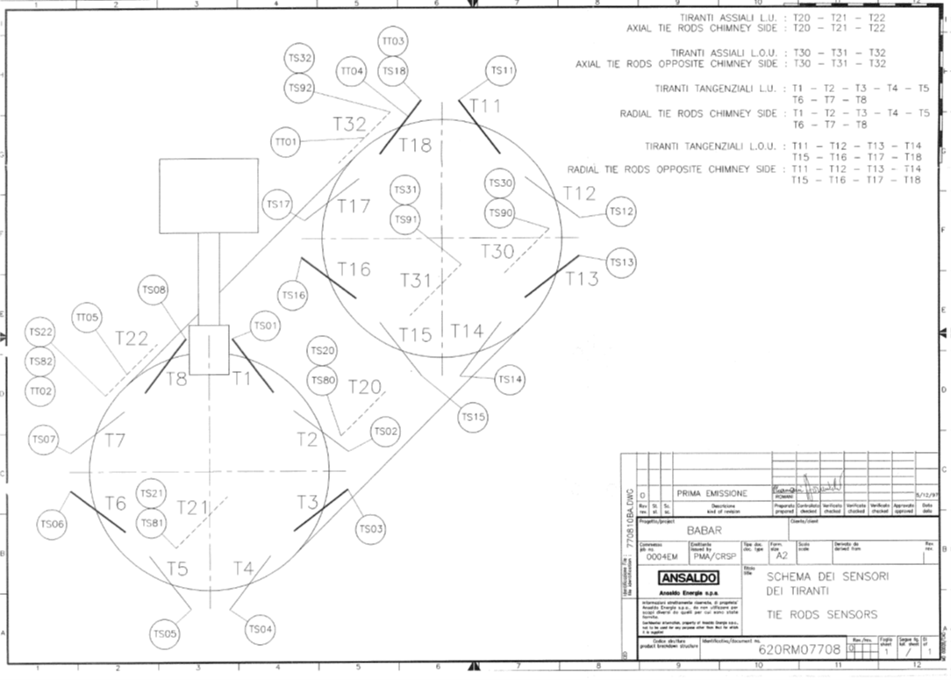
Figure 4 – There are 26 active strain gauges and 3 passive gauges for temperature compensation mounted at various locations within the magnet. [6]

- It is unlikely that the tie rods have been stressed beyond their elastic limit. However, the condition of the tie rods and spring washers remains as an unknown and therefore could pose some risk of damage for future operation.
- Several strain gauges (5) have been lost and at least one indicates a high reading and is subsequently ignored during magnet operation.
  - Recommendation: Fit new strain gauges. This will require disassembly of the magnet.
- There is also a question of whether any of these mechanical components have been over-stressed during the transport from SLAC to BNL. However, there is no outward evidence of any deterioration of the internal mechanical support system at present.

3.4 Magnet Cryogenics System and Current Leads
There is a potential hard touch between the inner thermal shield and helium vessel (observed by the temperature sensor on the inner shield reading 4.2 K).
Regarding the leaks, BNL repaired two leaks and located one more small leak (10⁻⁶ to 10⁻⁷ torr-liters/sec level ) too difficult to repair without major rework – which is presently being managed by pumping during operation of the magnet. All leaks were located in the valve box, an appendage that contains the electrical power leads and helium supply and return lines. It would be prudent to build a new valve box. This could be accomplished and installed without disassembling the magnet, and BNL have the engineering drawings from Ansaldo to do so. Since the original valve box is operational the new / spare valve box could be built and commissioned without impact to the project.
There is some evidence (observed by BNL engineers who worked on other leaks on the magnet cryogenic system) that both Ansaldo and SLAC have struggled to repair leaks on cooling pipework in the past.
There was a suggestion from an earlier review that the current lead flow may not have sufficient flow due to the return pressure. The proposed solution was as follows [10]:
Operate the solenoid bath at higher pressure, which means higher bath temperature.
Technical committee magnet expert has reviewed the new proposed operating conditions and concluded that the magnet should be able to operate at the higher bath temperature of 4.65K at 1.45bar. The Current Sharing Temperature Tcs, i.e. the temperature at which a defined electric field is detected in the cable due to the superconducting-to-normal state transition. This temperature depends on the magnetic field and on the ratio between operating current and critical current. At 4600 A the peak field in the winding is at 2.3T. When considering the Ic(B) curve of the conductor, one find Tcs=7.28 K. The temperature margin between the Tcs and the operating temperature T0 = 2.78K. The real parameter is the enthalpy margin defined as the energy for unit volume (J/m^3) which can be dissipated in the winding without causing a transition. For this conductor the margin is 3635 J/m^3 if T0=4.5 K. If the coolant temperature increases, the enthalpy margin decreases. At a T0= 4.65 K, the enthalpy margin only decreases by 2.5 %.
BNL will be able to operate, with the return valve and control logic, the solenoid return separator at a higher boiling point pressure, e.g. 1.45 bar which will provide 250 mbar DP budget for the current lead flow circuit and warm return piping. BNL will swap to “Low Pressure Drop” Allicat: Sierra Whisper series Mass flow Controllers from the current MKS brand mass flow controller.
The 400 Liter supply reservoir will be operated at 1.65 bar. 4.85K
- The existing internal leak (although small at present) and the potential for additional leaks is a concern.
- There is also a question of whether any of the internal cryogenic have been over-stressed during the transport from SLAC to BNL – e.g. welds between the cooling tubes and the coil support tube. However, there is no outward evidence of any deterioration of the internal cryogenic cooling system at present.

Conclusions and Recommendations
It should be noted that by the time the EIC project starts, this magnet will be over 30 years old and will be required to perform for a further 20 years during the expected lifetime of the EIC project.
Purely from an engineering perspective, if the changes (improvements) listed above in the Executive Summary are carried out in order to mitigate the identified risks, then this magnet should be suitable for prolonged use as part of the detector system for the EIC project.
However, it should be borne in mind that several of the mitigation efforts described involve the disassembly of the magnet and this therefore imposes a certain level of risk.
Furthermore, if the physics studies currently underway, indicate that additional changes are required to the magnet, (for example the inclusion of trim coils and/or changes to the iron circuit); then the system as a whole, will have to be re-evaluated - to ensure that the magnet remains within the original design limits under both normal and abnormal operating conditions.
Recommendations:
To provide a sufficiently high level of confidence in the reliability of this magnet (from an engineering point of view) for EIC operations lasting 20 years or longer, the magnet should be refurbished as suggested below.
- The magnet should be disassembled sufficiently:
  - To allow the existing multi-layer insulation (MLI) to be removed and replaced with new MLI.
  - To allow inspection of the superconductor coil block – resin and insulation system.
  - To allow inspection and if necessary, repair of insulation and support of any internal bus bars.
  - To allow all cooling pipe work and welds to the coil support tube to be inspected and all leaks repaired.
  - To allow inspection of the thermal shield and cooling pipework and welds.
  - To allow inspection of all vacuum seals and welds.
  - To allow inspection of all accessible conductor splices in particular the ones between the coil and the current leads.
  - To allow inspection and if necessary, replacement of insulating components – e.g. G10 collars, plates, etc.
  - To allow inspection and if necessary, replacement of the magnet current leads.
  - To allow broken voltage taps to be repaired and additional redundant taps installed.
  - To allow temperature sensors which are presently possibly malfunctioning to be either repaired or replaced.
  - To allow additional or redundant temperature sensors to be installed
  - To allow malfunctioning strain gauges to be either repaired or replaced.
  - To allow additional or redundant strain gauges to be installed.
  - To allow a full inspection and if necessary, replacement of the tie rods and disc springs for the internal mechanical support system.
- If the valve box is to be re-used, it should also be disassembled to inspect cooling pipework and to repair any leaks.

References
- ‘Availability and Failure Modes of the BaBar Superconducting Solenoid’, M. Knodel, A. Candia, W. Craddock, E. Thompson, M. Racine, J. G. Weisend II, SLAC-PUB-10769, October 2004
- ‘Design and Testing of the 1.5 T Superconducting Solenoid for the BaBar Detector at PEP-II in SLAC’, O’Connor, T.G. et al, September 14th 1998
- ‘The Superconducting Solenoid for The BABAR Experiment at PEP-II in SLAC’, Fabbricatore, P., et al.
- ‘Failure scenarios and mitigations for the BABAR superconducting solenoid’, Thompson, E., et al, AIP Conference Proceedings 823, 71 (2006), 09 May 2006
- ‘Availability and failure modes of the BABAR superconducting solenoid’, Knodel, M. et al, SLAC-PUB-10769, Applied Superconductivity Conference, October 2004
- ‘Low field test of sPHENIX solenoid magnet’, Muratore, J. F. et al, March 2016
- ‘High field test of sPHENIX superconducting magnet’, Kin Yip
- ‘sPHENIX High Field Test’, Schultheiss, C., Yip, K., 01/25/2018
- ‘sPHENIX Risk Register, June 30 2020’
- ‘Experimental Safety Review Committee – SC- Magnet Cryogenics’, Orfin, P., Apr 09 2020

----------------------------------------------------------End of Document----------------------------------------------

