Input for various IR-8-Simulations

This document describes the format for the input files provided to allow for simulations of the acceptance for different physics observables, synchrotron radiation, beam gas background and design of the vacuum system. Please keep in mind this design is pre-CDR level.

What is not yet done:
- a full integration of the 2nd IR into the EIC accelerator
- machine checks for operations
- any background simulations, i.e. beam gas and SR
- no design of the SR masks and simulations how effective the collimator system is with 2 IR
but as electron beam is largely the same as IP-6, there should be no huge differences
- beam pipe design – this will need work as the larger crossing angle will make the transition into B0 more complicated
- a design of the IR magnets – first checks that magnet parameters are reasonable (peak fields okay for conductor) have been done, but have not yet done designs such that we can guarantee cross-talks can be sufficiently limited.
What you should do:
- Optimize detector locations (Roman Pots, Off-Momentum Detectors, ZDC, …) a first placement is available on the 2nd tab in Beam.optics.electron.18GeV.xlsx

Current IR Layout of IP-8:

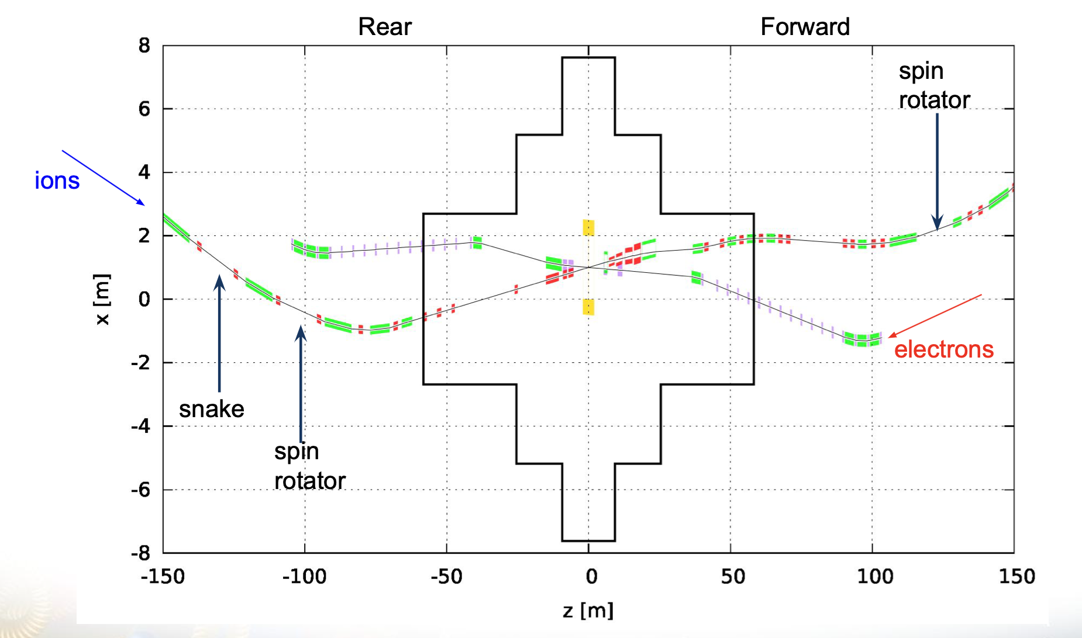

General agreements / understanding for the files:
- The entire crossing angle is 35 mrad
- The electron beam had 8 mrad and the hadron beam 27 mrad
- The magnet positions for the hadron beam elements and inner aperture are in
IP8_magnet_placement_hadron_electron_FF_detectors.xlsx (tab 1 and 3)
They are aligned that the entire crossing angle is in the hadron beam.
- The magnet positions for the electron beam elements and inner aperture are in
IP8_magnet_placement_hadron_electron_FF_detectors.xlsx (tab 2)
- The electron information is in Beam.optics.electron.18GeV.xlsx, the relevant section starting from QDS01 to QUS01is highlighted in green. The file has the same structure as the hadron beam one.

The relevant files are provided from MADX, which have the full layout of the hadron and electron machine integrated.

The file Beam.optics.forward.hadrons.275GeV.txt holds the optics and its format is
BETX,BETY = beta functions in horizontal and vertical plane
ALFX, ALFY = slope of the beta functions
DX = dispersion function in the horizontal plane
DPX = slope of the dispersion function
The parameters for the 2nd focus are
Dispersion in x = 0.38m
β_{x}=0.62177m
β_{y} =4.304m
Alfa_{x}=0.029
Alfa_{y} = 0.0011
The 2nd focus is indicated in the file with a marker called MPOT1

All IR parameters are available in Beam.optics.forward.hadrons.275GeV.txt at the marker "FFDS$START" for the IR beam parameters. To calculate the beam size in x and y one needs the emittance as this is a global bema parameter, not IR dependent they are listed in the CDR (https://www.bnl.gov/ec/files/EIC_CDR_Final.pdf) in table 3.3 to 3.5

Some important facts and relations to use:
- The fundamental limit on x_{L} acceptance is x_{L}< 1-10σ_{δ} with σ_{δ} being the beam energy momentum spread
- RMS beam size at IP: σ*_{x,y} = √εβ*_{x,y} with ε being the geometric emittance
- RMS beam size somewhere in the ring: σ_{x,y} = √εβ_{x,y} with ε being the geometric emittance
- RMS angular beam divergence σ*_{x,y} = √ε/β*_{x,y}
- The beam size at the 2nd focus needs to be calculated accounting for the Dispersion D
$σ_{x,y}=\sqrt{{β(z)}_{x,y}ϵ_{x,y}+{\left(D_{x}\frac{δp}{p}\right)}^{2}}$ and $x_{L}<1-10\sqrt{\frac{{β(z)}_{x,y}ϵ_{x,y}+D_{x,y}^{2}σ_{δ}^{2}}{D^{2}}}$

How to scale the magnetic fields for different energies:
Note: The B0 has the same field at all energies
- L: length of the element
- ANGLE = bending angle of a dipole
- K1 = quadrupole strength (K1*L=integrated quadrupole strength)

The fields of the magnets can be calculated following the prescriptions
Dipole field in T: B_{rho}*ANGLE/L
Quadrupole gradient in T/m: B_{rho}*K1

The B_{rho} is beam energy dependent:
 | 5 GeV | 10 GeV | 18 GeV
Electron B_{rho} (T-m) | 16.6782 | 33.3564 | 60.0415
 | 41 GeV | 100 GeV | 275 GeV
Hadron B_{rho} (T-m) | 136.7255 | 333.5494 | 917.2959

Location of files:
Indigo: https://indico.bnl.gov/event/10974/contributions/
The presentations discussing the design in more detail are at https://indico.bnl.gov/event/12068/

