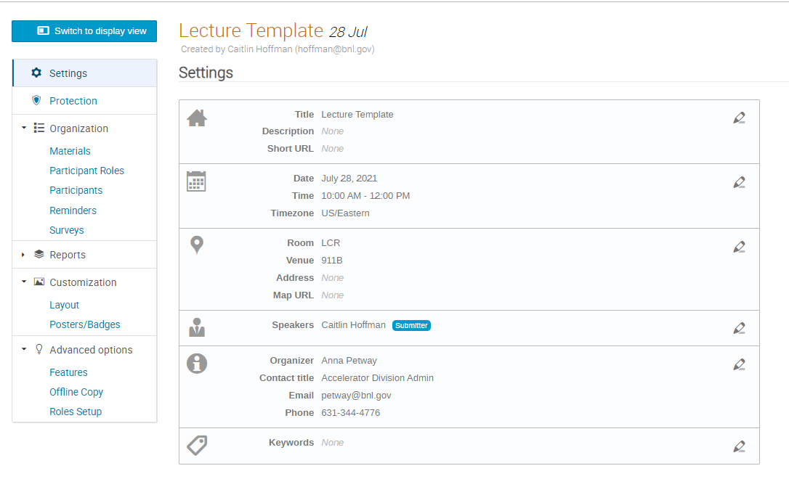
You can add more than one Speaker or organizer.
Submitter means the person can upload presentations
What is written (above) determines what is shown on main site (below):

