Depending on if your Meeting is one day or 5 days, you can easily manage your agenda with these simple tools.
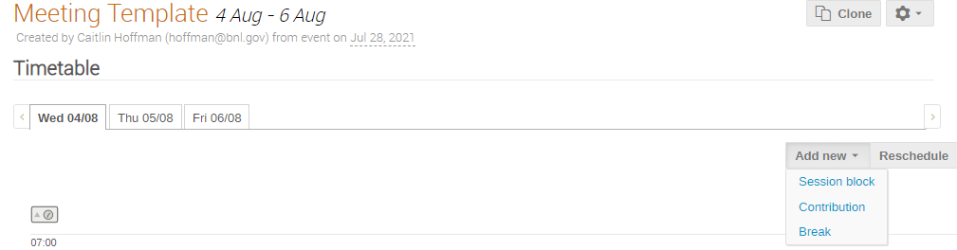

Contributions:
Adding a Talk:
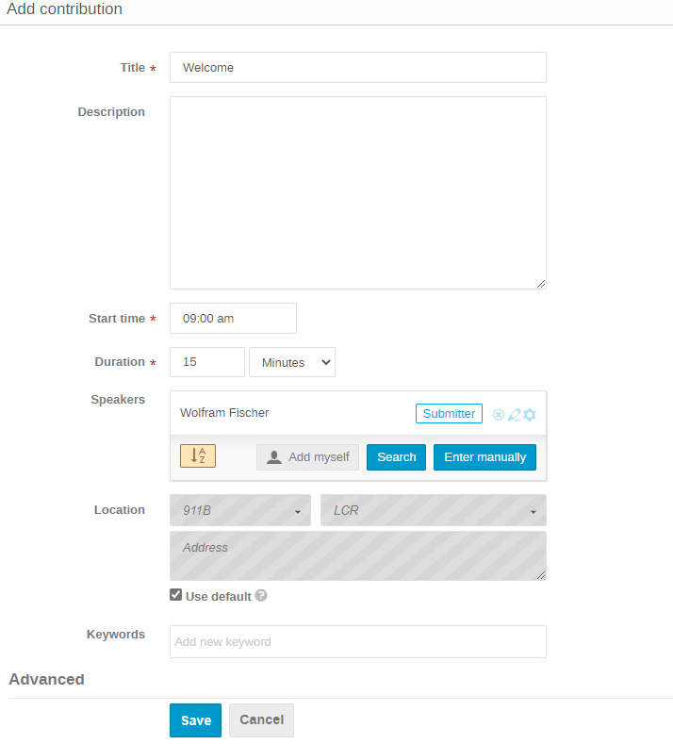

Session Blocks:
If you want to create a session with multiple talks.

Create a Session:
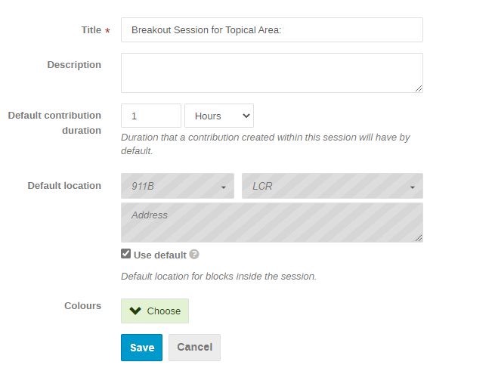
You can change the duration by minutes or hours.
The session will inherit the location of the meeting from its settings, but you can always change the location and give each session different color.

Create a Block of time: (Should be the same duration as the session)
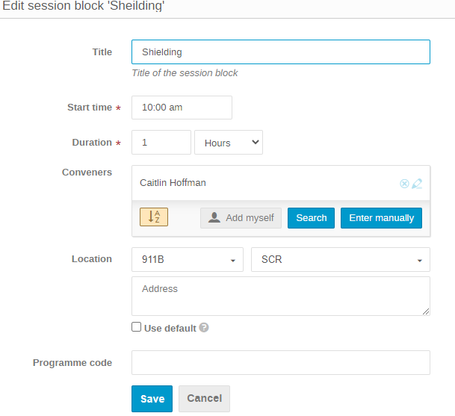
Go to the Block to add Contributions:
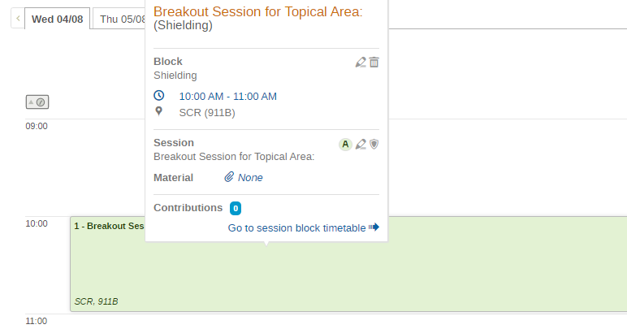

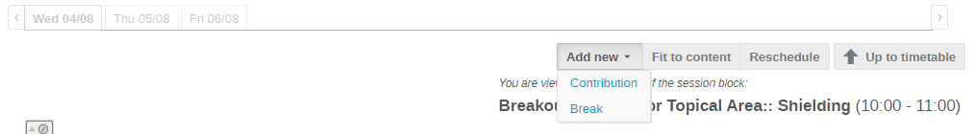

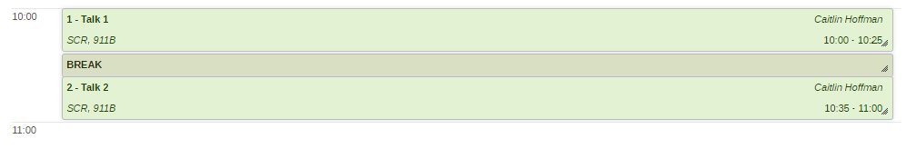

And you can see the final product:
