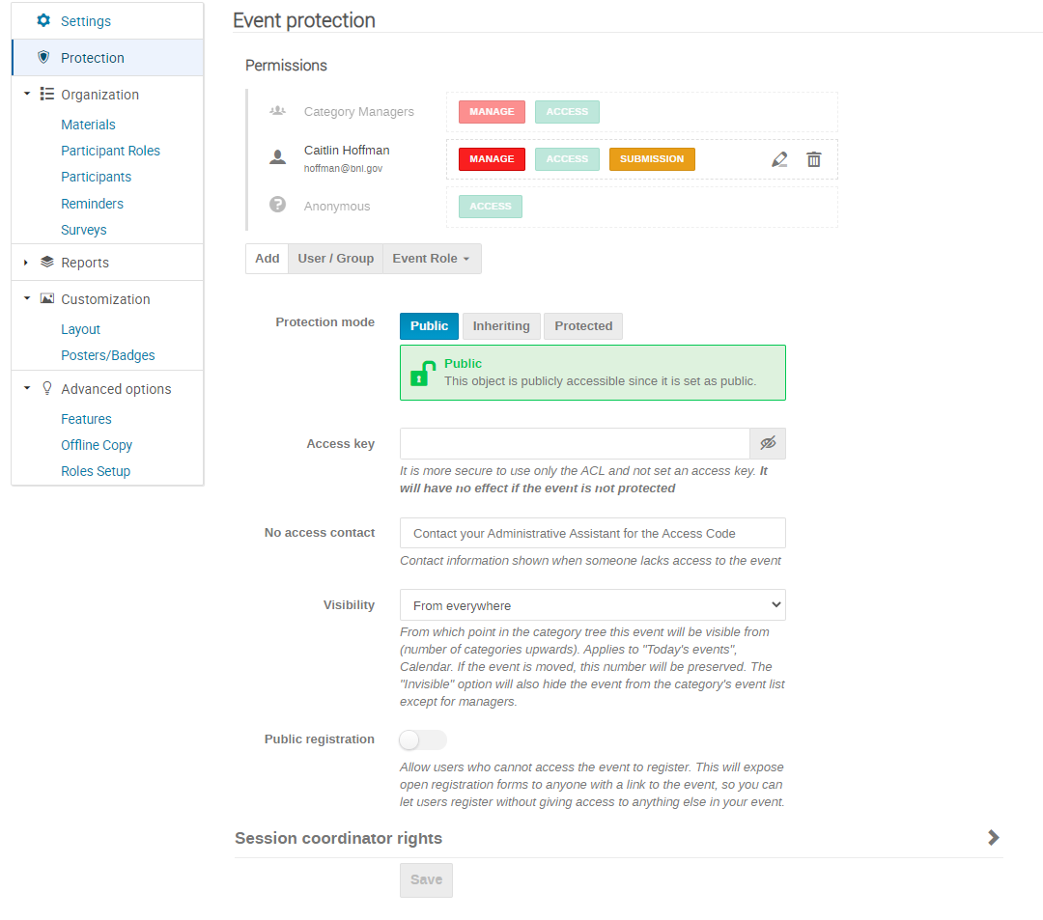
When your Event is PROTECTED, you must add each Users and give them Access
Access Keys = Password
Managers can edit the settings. They can add users and give them one or all 3 of these permissions.
Access gives only access to view the page and it’s contents
Submission allows a participant to upload material

What is written (above) determines what is shown on main site (below):

