C-A D Engineering Design Support Documentation Cover Page

Document number: 010604188 CAL-04
Title: LeadPot relief and burst limit | Author: R. Than
Subject: Sphenix solenoid cryostat
C-A Department Group:  Cryogenic Systems Group | Checked by:  Approval:
Documentation Type | Equipment Type
[ ] Written Technical Paper | [ ] Magnets and Power Supplies
[ ] Design Calculations | [ ] Vacuum Systems
[ ] Design Review Presentation | [ ] RF Systems
[ x ] Design Certification | [ x ] Cryogenic Systems
[ ] Specification | [ ] Experimental Equipment
[ ] Procurement Documentation | [ ] Beam Instrumentation
[ ] Safety/ALARA Review Presentation | [ ] Water Systems
 | [ ] Buildings, Structures, and Shielding
Other | Other
Equipment Location: | Associated information for cataloging
[ ] Tandem Van DeGraff | [ ] CA-D Design Room Job No.
[ ] Linac
[ ] Booster | [ ] CA-D Design Room Drawing No
[ ] AGS
[ ] RHIC | [ ] CA-D Specification No
[ x ] 912 Experimental Area
[ ] 919 Experimental Area | [ ] CA-D Experiment No.
[ ] RHIC Experimental Area
 | [] Other
[ ] Buildings Structures, and Shielding
Other
BROOKHAVEN NATIONAL LABORATORY
COLLIDER-ACCELERATOR DEPARTMENT
CRYOGENIC SYSTEMS GROUP

Doc. No.: 010604188 CAL-04
Issued Date: Aug 2015__
Rev. No. A________

LeadPot relief and burst limit

8/6/15 | A |  | R.  Than
Date | Rev. | Change Notes | By | By | Checked | Approved | Reviewed | Reviewed | Reviewed | Reviewed
REVISION HISTORY

SUMMARY

The required relief pressure was determined as a function of energy input rate, i.e. power input to helium volume of the current lead pot. The assumption is the heat input is very fast and the pressure in the pot rises to the required relief pressure assuming no inventory is vented prior to reaching required relief pressure. The relief temperature is determined by assuming a starting density of helium inside the pot.
Heat is added, at constant density until the required pressure is reached to handle the given load. The temperature reached is dictated by the density and pressure reached to handle the heat input load.

In reality the heat addition is not instant, so the density will be lower than assumed.

The Figure 1 and Figure 2 shows the required relief pressure for any given power input, for single relief opening of 0.4 inch diameter (0.5” tube) and 0.630 inch diameter (0.750” x0.065” tube), with flow coefficient of 0.62, at 3 different densities. A density of 69 kg/m3 corresponds to a 50% liquid content in the pot.

Since this is for a catastrophic failure of the bus, the burst pressure of the lead pot is used to size the relief capacity required, rather than the MAWP.

A structural analysis needs to be done to determine the burst pressure at the weld joints to the end caps of the lead pot. The cylinder pipe segment has a burst pressure rating of 3600 psi.

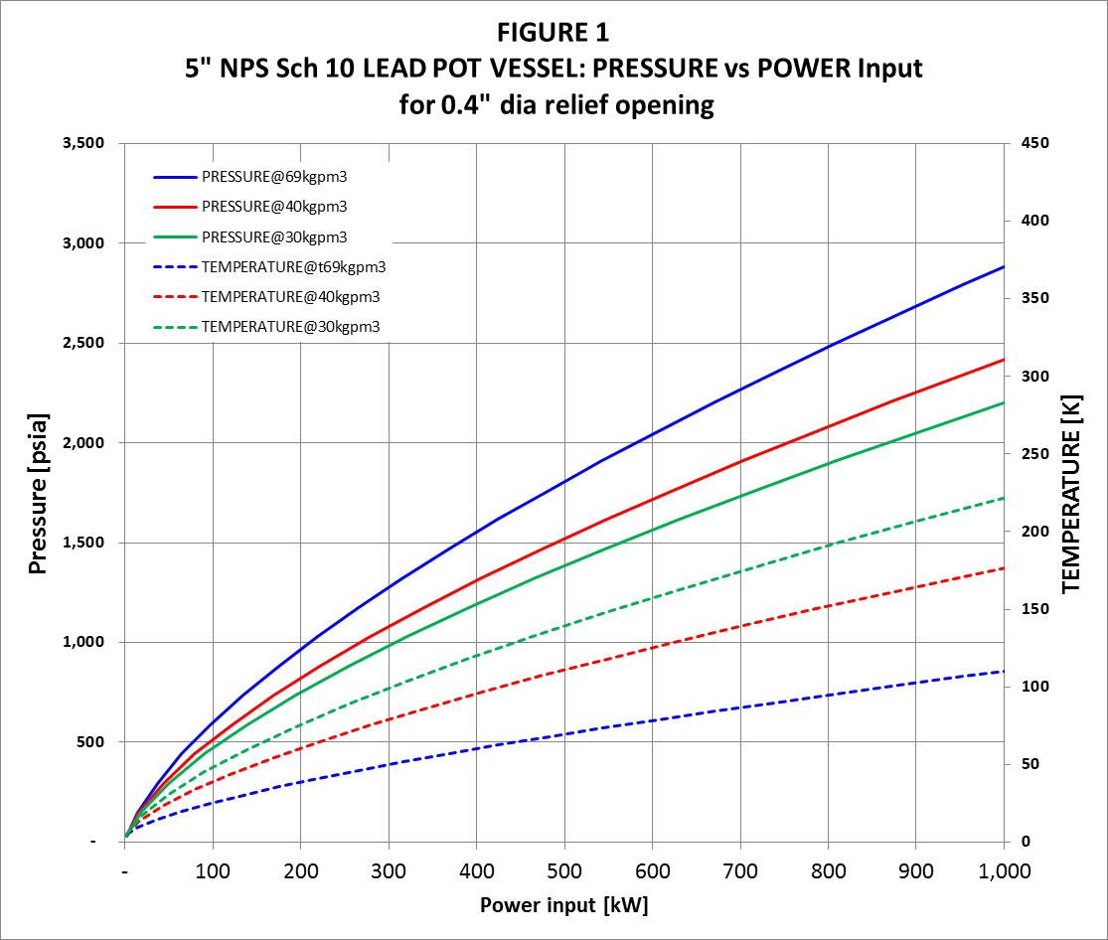

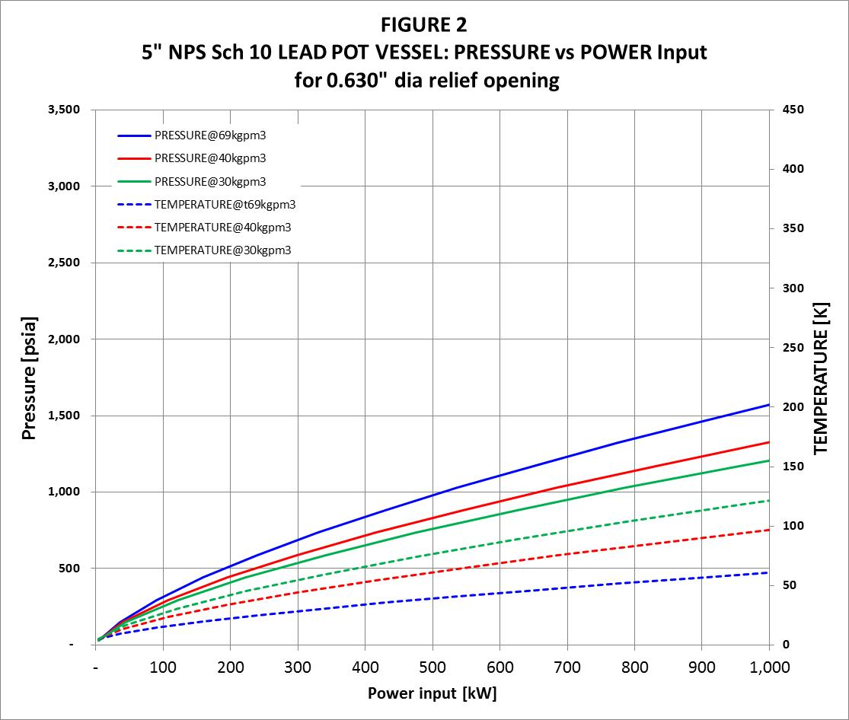

Calculation, Sample hand calculation for plots

