TR1: The proposed silicon tracker is based on the 65nm MAPS technology currently under
development at ALICE. What are the impacts on the silicon tracker design and its physics
performance if ALICE has to fall back on 180 nm technology?

The fallback option for the ALICE ITS-3 sensor should the 65nm stitched Tower process prove to be unsuitable is a 180 nm Tower process sensor with similar but probably not identical specifications. Moving to the 180 nm process would probably involve moderately increasing the pixel pitch and a moderate increase in the power dissipation. The current design goals for the ITS-3 in 65 nm technology includes a pixel size of 10 um^2 and a power dissipation of 20 mW/cm^2. We have been conservative in the simulations and the single point resolution used only includes the geometric component of the pixel pitch. By fitting the hit clusters we can improve the single point resolution by typically 50%. We believe it likely that single point resolution based on the increased 180 nm based pixel would fall within this margin. Nevertheless, the momentum and pointing resolution as a function of geometric pixel size may be found in the yellow report http://www.eicug.org/web/sites/default/files/Yellow_Report_v1.1.pdf. On page 438.
For the increased power dissipation, this will affect the detector in two main areas. The first is increased cooling needs. The second is the need for more services in the form of increased power delivery conductor to keep the voltage drops manageable. Both of these areas increase the material present in the tracking and other detector acceptance. The momentum resolution in the │eta│> 1 region is more strongly dependent on the mass present (I believe that there were some studies done as part of the tracking effort in the ATHENA detector development. This is an area where Ernst and Laura may be able to point to plots that demonstrate this.)
(The question specifically requests an impact on the physics performance. I am not in a position with my understanding of the actual physics simulations (my understanding was that we are not yet at the level to produce quantitative physics performance implications, but perhaps I have missed something) to address that aspect. Others may wish to add their thoughts)

"TR2: Based on knowledge and operational experience from currently installed/operating silicon-based systems, estimate the number (or fraction) of dead channels to be expected in your proposed tracker (as function of time, if possible). Estimate the impact of this typical number of dead pixels/sectors on physics results. What fraction of the MAPS units will be active (versus passive balconies)?"

There are two existing examples of similar tracking detectors based on MAPS used at colliders. The PXL detector for the STAR experiment and the ALICE ITS upgrade. In the case of the PXL detector at STAR, latch-up based damage to the AMS 0.65 um process sensors was observed that led to a loss of ~5% of the silicon area per year. The latch-up based damage was recognized only when the full detector was installed and was a result of very low cross section damage mechanism that was not accessible during individual sensor testing. The details of the damage and the mitigation strategies may be found in the NIM paper https://arxiv.org/pdf/1710.02176.pdf . We believe that the particulars of this damage will not be representative of what can be expected for the Tower 65nm based sensors under development as this type of issue has been addressed in the design phase of ALPIDE (ALICE ITS upgrade sensor) and such mitigations will be propagated to the new 65 nm Design.
For the ALICE ITS upgrade based on the ALPIDE Tower 180nm based sensors, extensive beam running with the full detector has not yet taken place. This is expected over the next year and the rate of beam induced damage, if any, has not yet been measured. We expect to learn much in the coming year and should any issues arise we would expect to address them in the ITS-3 sensor design process. Our expectation based on extensive testing of ALPIDE is that the sensors should maintain their full existing live fraction over the anticipated 10 years of running at the CERN LHC.
The installed ITS upgrade detector has a very high fraction of live pixels. Based on the construction on the middle layers (representative of the full detector) one can see the live pixel fraction and noise rates of the installed detector staves below.
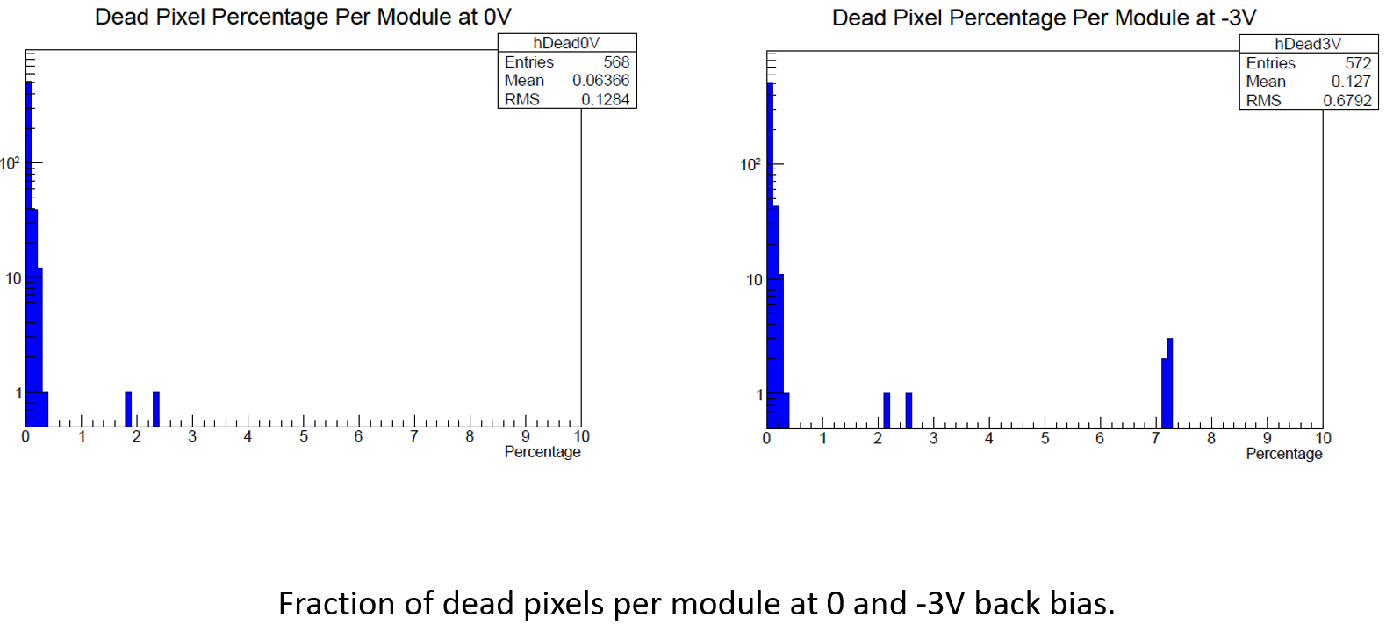
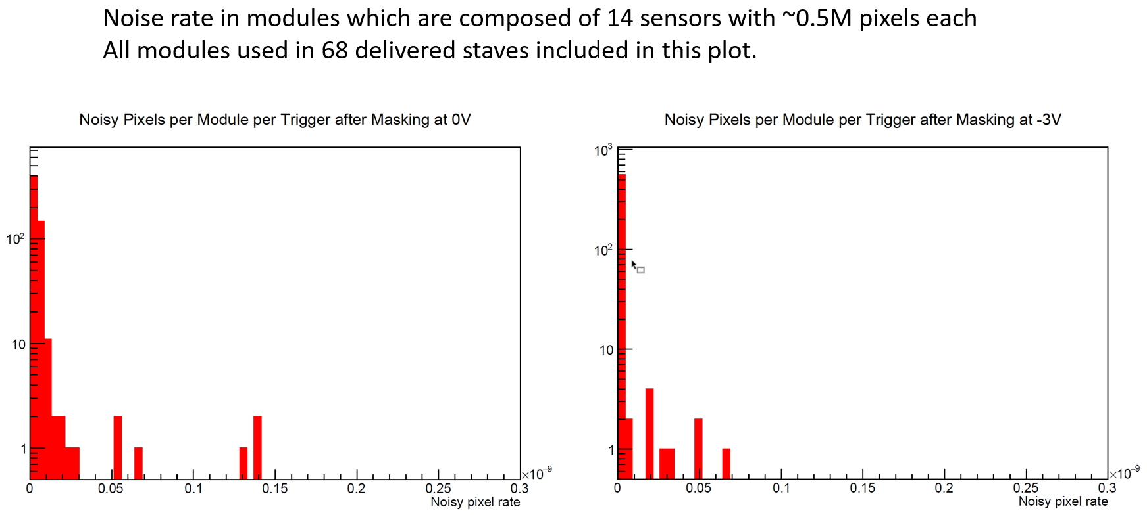
(The effect of this on the physics should be negligible but others may wish to add more that addresses this)

