Project Execution Plan

for the

Linac Intensity Upgrade Phase 2
(LIUP2)

at the

Brookhaven National Laboratory
Upton, NY

Office of Isotope R&D and Production (SC – 24.3)
Office of Science
U.S. Department of Energy

Date Approved:

Month/Year

Submitted by:

_____________________________________________________ Date: _____________________
Deepak Raparia, LIUP2 Contract Project Manager
Brookhaven National Laboratory (BNL)

_____________________________________________________ Date: _____________________
Cathy S. Cutler, Project Director
Medical Isotope Research & Production Program (MIRP)
Brookhaven National Laboratory (BNL)

_____________________________________________________ Date: _____________________
Michiko Minty, Accelerator Division Head, Collider-Accelerator Department
Brookhaven National Laboratory (BNL)

_____________________________________________________ Date: _____________________
Wolfram Fischer, Chair, Collider-Accelerator Department
Brookhaven National Laboratory (BNL)

_____________________________________________________ Date: _____________________
Haiyan Gao, Associate Laboratory Director, Nuclear Particle Physics
Brookhaven National Laboratory (BNL)

_____________________________________________________ Date: _____________________
Doon Gibbs, Laboratory Director
Brookhaven National Laboratory (BNL)

_____________________________________________________ Date: _____________________
Joseph Eng, Federal Project Director
Brookhaven Area Site Office (BHSO), DOE

_____________________________________________________ Date: _____________________
Robert Gordon, Manager
Brookhaven Area Site Office (BHSO), DOE

_____________________________________________________ Date: _____________________
Arne Freyberger, Isotope Accelerator Facilities Program Manager
Office of Isotope R&D and Production, Office of Science,
Department of Energy (DOE)

_____________________________________________________ Date: _____________________
Ethan Balkin, Radioisotope Production R&D Program Manager
Office of Isotope R&D and Production, Office of Science,
Department of Energy (DOE)

Concurrence:

_____________________________________________________ Date: _____________________
Jehanne Gillo, Director
Office of Isotope R&D and Production, Office of Science, DOE

_____________________________________________________ Date: _____________________
J. Stephen Binkley, Deputy Director (for projects with TPC of $400 or larger)
Office of Science, DOE

Approval:

_____________________________________________________ Date: _____________________
NAME Acquisition Executive (see Approval Matrix)
Office of Isotope R&D and Production
Office of Science, DOE

Project Execution Plan for the
LIUP2 Project at the
Brookhaven National Laboratory

Change Log

Revision No. | Pages Affected | Effective Date
 | Initial Draft | July 2019
V1.0 | General Formation and Figure/Table Captions Updated | April 8, 2021
V2.0 | Table 2.1, Cost updated | April 9, 2021
V3.0 | Figure 5.1, Replaced with updated Org Chart | April 19, 2021
V4.0 | Cost, Tables & Figures updated | July 14, 2021
V5.0 | Cost, Table & Figures updated | Sep, 8 2022

Project Execution Plan for the
Linac Intesity Upgrade Phase 2 (LIUP2) Project at the
Brookhaven National Laboratory

Table of Contents

1. Introduction 8
1.1. Project Background 8
1.2. Justification of Mission Need 8
2. Project Baseline 8
2.1. Scope Baseline 8
2.1.1. Technical Scope 8
2.1.2. Technical Performance Parameters 14
2.2 Cost Baseline by Work Breakdown Structure (WBS) 15
2.3 Schedule Baseline and Critical Path 15
2.3.1 Milestones 16
2.4 Funding Profile 17
2.4.1 Planned DOE Funding 17
3. Acquisition Approach 18
4. Change Control 18
5. MANAGEMENT Structure 19
6. Project Management/Oversight 21
6.1. Risk Management 21
6.2. Project Reporting and Communication 22
6.3. Earned Value Management System (EVMS) 22
6.4. Project Reviews 22
6.5. Engineering and Technology Readiness 22
6.6. Environment, Safety and Health 22
6.6.1. Integrated Safety Management 22
6.6.2. Environmental and Regulatory Compliance 23
6.6.3. Review of ESSH Issues Associated with Project Design 23
6.6.4. ESSHQ Plans for Construction 26
6.6.5. ESSHQ Plans for Commissioning, Operations and Decommissioning 26
6.7. Project Quality Assurance Program 27
6.7.1. QA Program 27
6.7.2. Personnel Training and Qualifications 27
6.7.3. Documents and Records 27
6.7.4. Work Process 28
6.7.5. Design 28
6.7.6. Procurement 28
6.7.7. Inspection and Acceptance Testing 29
6.7.8. ESSHQ Plans for Fabrication 29
6.7.9. DOE ESSHQ Oversight 29
6.8. Value Engineering 30
6.9. Transition to Operations 30
6.10. Project Closeout 30
APPENDIX A WBS DICTIONARY 31
Appendix B Risk List 33
Appendix C Report of the prototype quadrupole power supply 34

Project Execution Plan for the
Linac Intensity Upgrade Phase 2 (LIUP2) Project at the
Brookhaven National Laboratory

Acronym List

AIP Accelerator Improvement Project
AY At-Year
BHSO Brookhaven Site Office
BNL Brookhaven National Laboratory
BSA Brookhaven Science Associates
C-AD Collider Accelerator Department (at BNL)
CPM Contractor Project Manager
DOE Department of Energy
DCPM Deputy Contractor Project Manager
ES&H Environmental, Safety and Health
ESRC Experimental Safety Review Committee
ESSHQ Environmental, Safety, Security, Health, and Quality
EVMS Earned Value Management System
FTE Full Time equivalent
FY Fiscal Year
HAD Hazard Assessment Document
HTS High Temperature Superconductor
ISM Integrated Safety Management
KPP Key Performance Parameter
LIUP2 Linac Intensity Upgrade Phase 2
NEPA National Environmental Policy Act
NP Nuclear Physics
OPM Operational Procedures Manual
PARS Project Assessment and Reporting System
PEP Project Execution Plan
PoP Proof of Principle
QA Quality Assurance
R&D Research & Development
RHIC Relativistic Heavy Ion Collider
SAD Safety Assessment Document
SBMS Standards Based Management System
SC Office of Science
SOW Statement of Work
SRF Superconducting Radio Frequency
TEC Total Estimated Cost
TPC Total Project Cost
UPP Ultimate Performance Parameters
WBS Work Breakdown Structure

Introduction
The Project Execution Plan (PEP) describes the coordination of efforts of the project team, including the processes and procedures used by the Linac Intensity Upgrade Phase 2 (LIUP2) Contract Project Manager (CPM) to ensure that the project is completed on time and within budget. The PEP defines the project scope and the organizational framework, identifies roles and responsibilities of contributors, and presents the work breakdown structure (WBS), cost and schedule. The PEP was prepared using guidelines from DOE Order 413.3B, Program and Project Management for the Acquisition of Capital Assets.

Project Background
Brookhaven National Laboratory (BNL), located in Upton, NY, is owned by the U.S. Department of Energy (DOE), and is operated by Brookhaven Science Associates (BSA), under the U.S. Department of Energy Contract No. DE-SC0012704. The Brookhaven 200 MeV Linear Accelerator (Linac), is an essential facility within the Nuclear & Particle Physics Directorate (NPP), at BNL, and is managed by the Collider-Accelerator Department (C-AD). The Linac provides accelerated polarized protons to the Relativistic Heavy Ion Collider (RHIC) and high intensity protons to the Brookhaven Linac Isotope Producer (BLIP).

Justification of Mission Need
The BNL Linac operation started in 1971. The Linac can currently provide proton or H- beams to BLIP of up to 200 MeV energy and 165 µA average current. Improved BLIP production can be realized by increasing the Linac beam current to 250 µA. Recent accelerator improvement projects at BLIP (installation of a beam Raster system), and Linac (Phase 1 of the Linac intensity upgrade) have increased yields of ⁸²Sr. Phase 1 of the Linac intensity upgrade has concluded that the Linac intensity can be increased further for BLIP isotope production. In addition, upgrading Linac systems will provide for continued reliable operation.

Project Baseline
This section describes the project in terms of the scope, cost, schedule, and funding profile.

Scope Baseline
The Linac upgrade will increase the beam power provided to BLIP and increase the reliability and capability of Linac.

Technical Scope
The goal of Phase 2 of the Linac Intensity Upgrade is to provide 250 µA average beam current to BLIP. An Accelerator Improvement Project plan (AIP) was approved for Phase 1 of a Linac intensity upgrade in 2014. The Phase 1 goals were to increase the average beam current from 125 to 140 µA and to evaluate the Linac subsystems for possible 250 µA operation after Phase 2. It was concluded that the Linac can deliver 250 μA with upgrades of some of the subsystems. The 250 µA average beam current will be accomplished by increasing the beam pulse width, increasing bunch current and possibly increasing the beam repetition rate.
55mA

beam current
900 𝞵s
time
450 𝞵s
0
Figure 2.1: Increasing the average current to 250 μA by doubling the beam pulse length.

The following systems are planned for the upgrades:

2.1.1.1 RF System
To accommodate the proposed longer RF pulse width (1100 µs), the RF system requires modifications. The Linac has a spare test RF station that is used for testing and development. The spare RF station is similar to each of the nine operational RF stations, except for a dummy RF load in place of a Linac RF Tank. All the test RF system components were upgraded in 2016 as part of the Linac Intensity Phase 1 scope. The RF test station was then successfully operated at a pulse width of 1100 µs. The following upgrades are required for the longer pulse based on the RF test system development:
- Increase of the 250 kW driver capacitor banks for RF systems 3-9 from 25 to 40 µF.
- Increase of the 7835-power amplifier anode power supply capacitor banks for RF systems 3-9 from 50 to 84 µF.
- For all systems, replacement of the 4CW 25,000 Anode and Cathode power supplies and the A7 Low Level Electronics in the RF Modulator.

During a shutdown period the DTL cavity was tested at increased RF pulse width. After running at the longer pulsed width, the tank was opened for inspection (Figure 2.2). Several BeCu spring rings had failed at the drift tube and stem collar junctions (12 of 72), one example is shown in Figure 2.3. A CST simulation confirmed the higher RF current at this location (Figures 2.4 and 2.5). Thermal testing of the BeCu spring joints was conducted in the lab to investigate this issue. A method was developed using tighter spring contact that gave better thermal performance. This method required heating the collars and forcibly pressing them on the drift tube stems. A split-collar design has also been successfully tested in tank 7 with up to 1100 µs for several weeks.

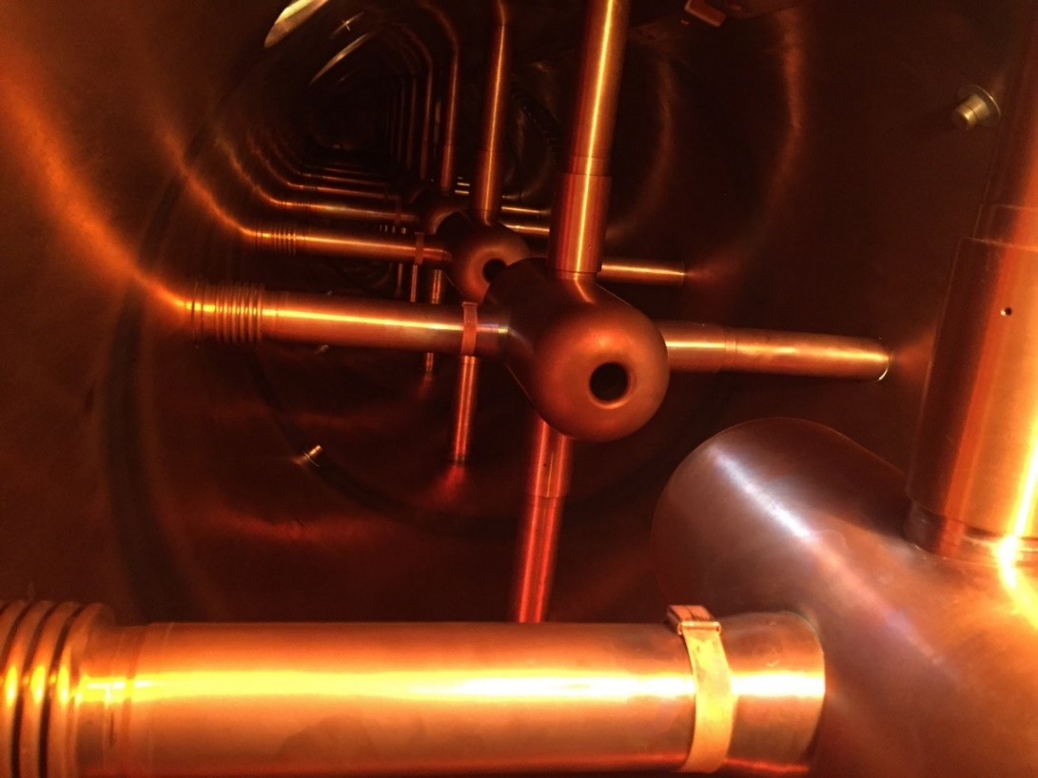
Figure 2.2: BNL DTL tank with stems.

Figure 2.3: Damaged silver-plated beryllium copper RF spring ring in the collar.

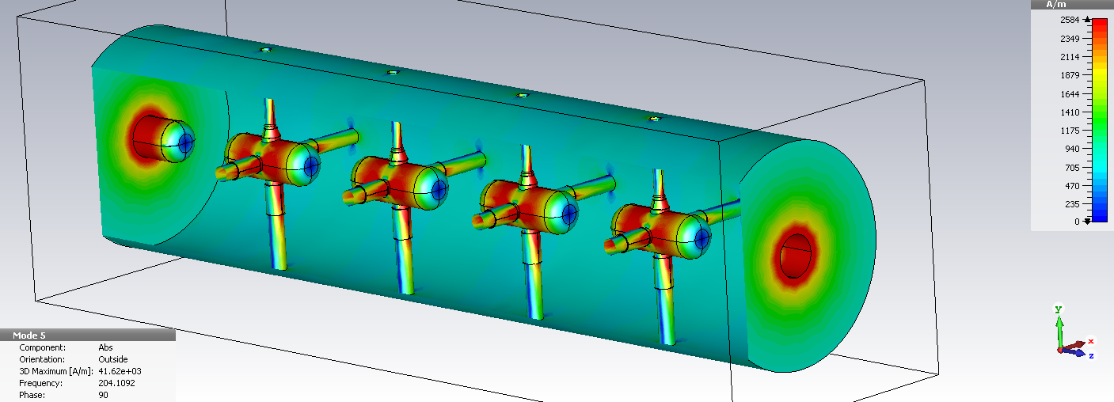
Figure 2.4: CST simulation of four drift tube cavity. The RF current at spring ring are ~ 4000 A/m, about 50 W per collar.

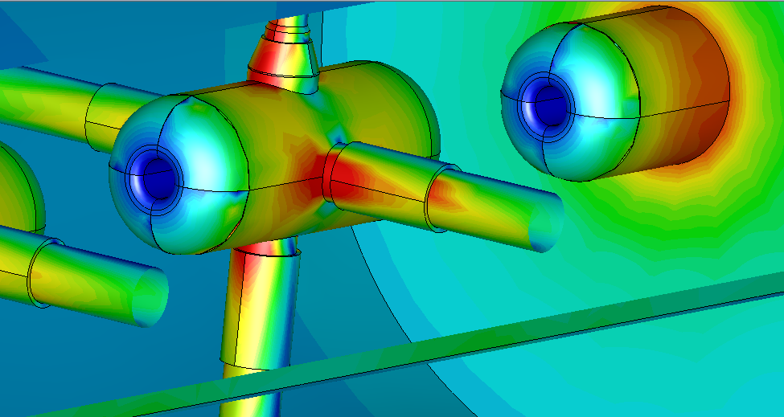
Figure 2.5: Showing current densities are not symmetric around the stem and collars.

2.1.1.2 Quadrupole Power Supply System

The Linac quadrupole power supplies are about 50 years old and contain obsolete components. They are a resonant charge type power supply. The supplies do not have a current feedback loop, and as a result, the output current is not as stable as more modern power supplies. Phase 2 requires the power supplies to have a flat top width of 900 to 1100 µs that is not possible with the present design. The topology of the proposed new Linac quadrupole power supplies could be either switch mode type or linear during the flat top and switch mode during ramping up and down. This will keep the power dissipation in the quadrupole conductors to a minimum. Another reason for choosing a flexible topology, switch mode design, or a combination of switch mode and linear during the flat top, is that the size of the power supplies is smaller compared to other topologies.
There are 165 quadrupole power supplies that need to be replaced. In 2017 a project was approved to build two prototype power supplies and test them with Linac quadrupoles in operation. The project was successfully completed in March 2019, a final report of the project is in appendix C. Figure 2.6 shows the two prototype power supplies installed in Mod 2 racks.

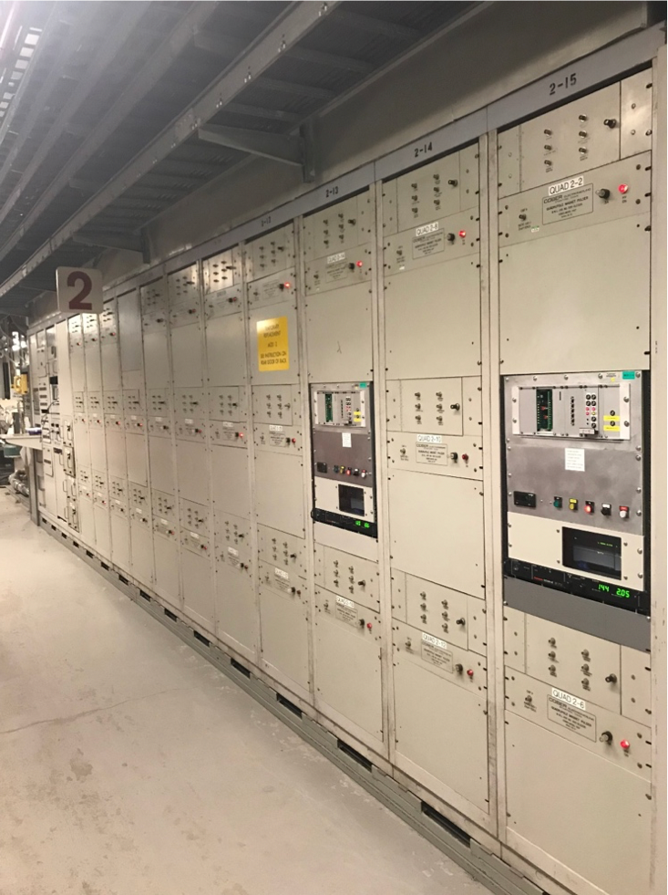
Figure 2.6: Prototype power supplies installed in Mod2 Racks.

The two prototypes met all the specifications during the initial testing and final commissioning. Figure 2.7 shows current repeatability data: after 5 hours of running the power supply the current error was 31.2 mA with a flat top of 225 A. These prototype supplies are powering two quadrupoles in the tanks 2 since March 2019.

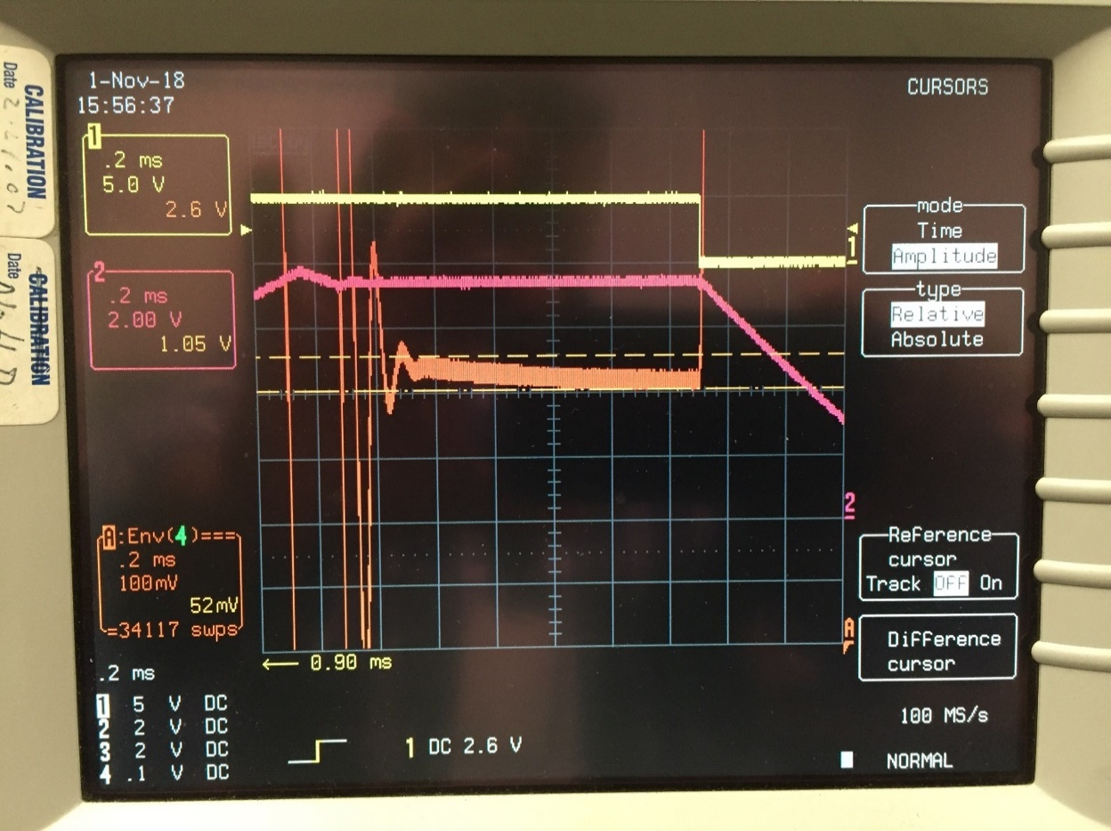
Figure 2.7: Current repeatability data. Channel 1 is the magnet current enable pulse. Channel 2 is the magnet current during the flat top. Flat top current 225 A. Channel A is the current error during the flat top. After 5 hours of running the power supply the Current error=31.2 mA.

2.1.1.3 Beam Instrumentation System

The present beam instrumentation is 50 years old. Some instruments are not fully functioning or operating only with low repeatability. A higher beam current will require an upgrade to the beam monitoring system. The following instrumentation will be added or upgraded:
- Beam position monitor (BPM) after DTL tank 9 and between the first (BM1) and second (BM2) bending magnets in the BLIP transport line
- BPM electronics for the connection to existing BPMs after the DTL cavities 2 through 8 and the BPMs listed above
- Single wire Secondary Emission Monitors (SEM) electronics (20 units)
- Beam profile monitor (harp) between BM1 and BM2
- New current transformers (11 units) for DTL tanks 2-9, and between BM1 and BM2
- (f) New slit and collector emittance monitors (X, Y) in front of DTL tank 1.

2.1.1.4 Control System

The Linac Controls System will have all obsolete Datacon Systems components replaced with newer technology in order to control the new quadrupole power supplies, perform data acquisition, and control other Linac devices. There are two technologies that are being considered. The first is the Front-End Computer Remote I/O System (FRIO System), which is comprised of VME 4143 modules for analog reference outputs and VME PAS9737 modules for data acquisition. The V233 Quadruple Function Generator (QFG) modules with the Power Supply Interface (PSI) modules (QFG System) is another option which will be considered depending on the timing needs of devices that are being upgraded throughout the Linac. Both systems are VME based.

The VME 4143and VME PAS9737 modules can accommodate up to 32 and 64 device channels, respectively. The 4143 analog output module has a 12-bit resolution and a maximum voltage range of ±10 V. The PAS9737 data acquisition module has a 16-bit resolution with a sampling rate of 100 kHz.

Technical Performance Parameters

System
Beam
 | Average beam current | 250 µA
 | Beam pulse width | 700-900 µs
 | Repetition rate | 6.67-10 Hz
RF
 | RF pulse width | 1100 µs
Quadrupole Power Supply
 | Max current | 300 A
 | Flat top width | 1200 µs
 | Current stability | 0.1%
Control System
 | Readback sampling frequency | 10 kHz
 | Analog to Digital Converter resolution | 16 bits
 | Voltage reference resolution | 12 bits
 | Voltage reference range | ±10 V

LIUP2 Key Performance Parameters (KPPs):
- All the hardware installed.
- Demonstration of 950 µs RF pulse width.
- Demonstration of 200 µA average beam current.
LIUP2 Ultimate Performance Parameters (UPPs)
- Demonstration of 1100 µs RF pulse width.
- Demonstration of 250 µA average beam current.

2.2 Cost Baseline by Work Breakdown Structure (WBS)
The Linac Intensity Upgrade Phase 2 has been organized into a WBS for purposes of planning, managing, and reporting project activity status. A WBS Dictionary is provided in Appendix A of this document.

The total project cost including contingency is $21.8 M, Table 2.1 shows the cost summary.
Table 2.1: Cost Summary in AY $K
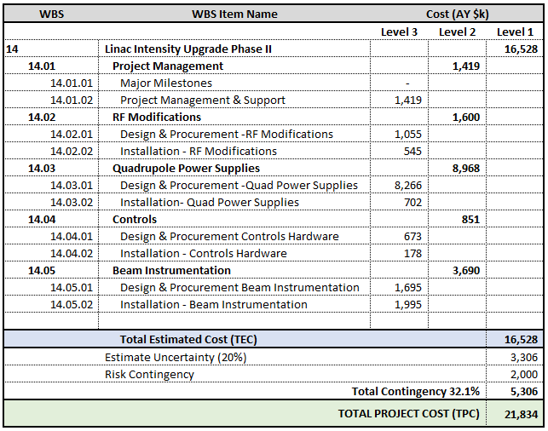

Schedule Baseline and Critical Path

The schedule has the following constraints putting them on the Critical Path:
RHIC and BLIP shutdowns – Installation in the tunnel is only possible when the Linac is not running.
Installation complete – Subsystem testing can only occur after all installation is complete.
Commissioning – Testing with beam can only begin after all subsystem tests and integrated installation is complete.

The Summary L3 WBS Schedule is shown below (Figure 2.8), followed by the Critical Path. The early Finish date is planned for March 31, 2028, approximately 4.5 years total project duration. There is an additional 18 months of schedule contingency added to the plan to accommodate potential supply chain constraints and vendor procurement uncertainty, resulting in a Late Finish date of September 30,2029, to the extent needed.

The Critical Path is constrained by the annual shutdown periods, and the Quadrupole Power Supply Procurement & Fabrications, predominantly. (Figure 2.9). The project plan is based upon the assumption that annual Shutdown Periods will commence on or about July 1, for ~6 months per CY.
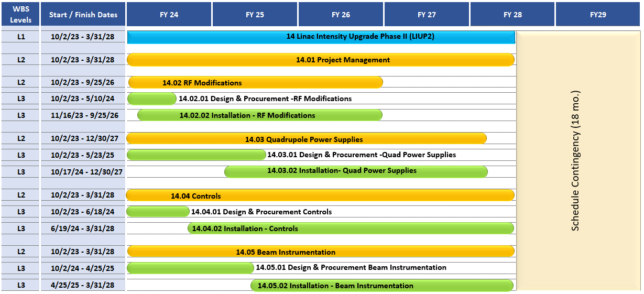

Figure 2.8: Summary Schedule

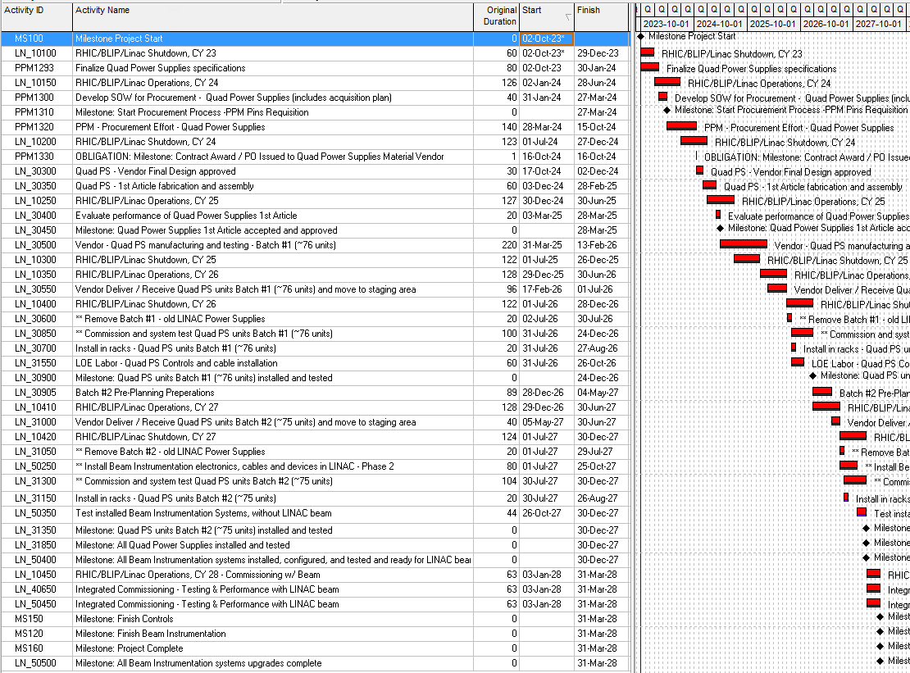

Figure 2.9: Critical Path

Milestones
Milestones will be used as schedule events to mark the due date for major accomplishments of specified efforts or objectives. A milestone may mark the start, an interim step, or the end of one or more activities as needed to provide insight into the project’s progress. The following table details the major milestones for the LIUP2 project.
Table 2.2: Reportable Milestones
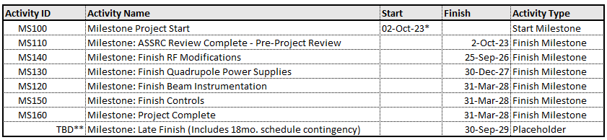

2.4 Funding Profile

2.4.1 Planned DOE Funding
The LIUP2 project will be entirely funded by DOE-IP and the planned DOE funding profile by Fiscal Year (FY) is shown in Table 2.3.

Table 2.3: LIUP2 Funding Profile in AY $M
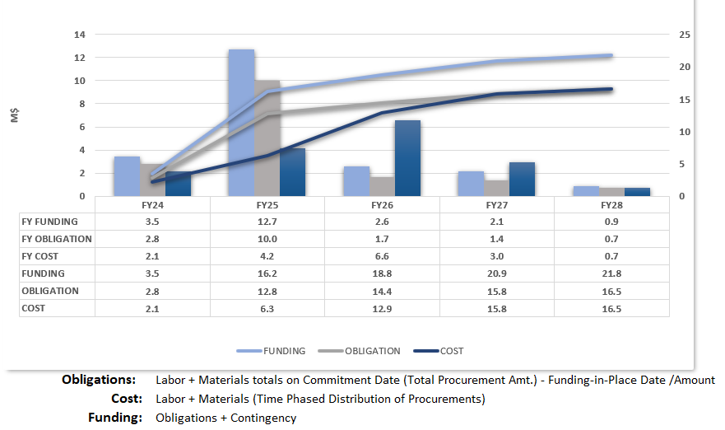

Acquisition Approach

BNL, as the prime contractor, is responsible for the design, procurement, fabrication, assembly, and integration of the LIUP2 components. When appropriate, subcontracted equipment and material will be competitively procured through fixed-price contracts. Sole-source procurements of one-of-a-kind equipment will be supported by appropriate justification.

Change Control

Changes to the technical, cost and schedule baselines will be controlled using the thresholds described in Table 4-1.

All changes that include or exceed Level 2 approval thresholds should first be submitted to the Contractor Project Manager using a Baseline Change Proposal (BCP). For changes exceeding Level 2, the Contractor Project Manager will endorse the request (i.e., recommend approval) to higher authority or reject the request. If endorsed, the Contractor Project Manager will then transmit the BCP to the Contractor Manager with recommendations. If the request exceeds Level 1, the Contractor Manager will submit the BCP to the Federal Program Manager in DOE Headquarters for approval.
Level | Cost | Schedule | Technical Scope
DOE-SC-26 Program  (Level 0) | A cumulative allocation of ≥ $500k contingency in WBS Level 2 | 3-month or more delay of a Level 1 milestone date | Change of any WBS element that could adversely affect performance specifications
C-AD Manager  (Level 1) | A cumulative increase of ≥ $250K in WBS Level 2 elements | > 1-month delay of a Level 1 milestone date or > 3-month delay of a Level 2 milestone date | Any deviation from technical deliverables that does not affect expected performance specifications
LIUP2  Contractor Project Manager  (Level 2) | Any increase ≥  $50k in the WBS Level 2 | > 1-month delay of a Level 2 milestone date | Technical design changes that do not impact technical deliverables

If the change is approved, the copy of the approved BCP, together with any qualifications or further analysis or documentation generated in considering the request is returned to the requestor, and copies are sent to LIUP2 Project Controls for implementation and filing. If approval is denied, a copy of the BCP, together with the reasons for denial, is returned to the requestor, and a copy is filed by Project Controls. The official at the next higher control level may review any granted change to ensure proper application of the procedure and consistency of the change with the goals and boundary conditions of the project.
Table 4.1: Summary of Baseline Change Control Thresholds

MANAGEMENT Structure
This section provides the management organization for the LIUP2 project as needed for development, fabrication, installation, and testing of LIUP2. Figure 5.1 outlines the LIUP2 management structure.

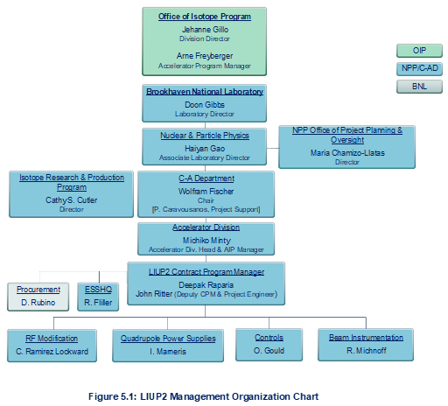

Within the DOE Office of Science (SC), the Office of Isotope R&D and Production has overall responsibility for the LIUP2 project. The Point of Contact in the Office of Isotope R&D and Production is Jehanne Gillo, the Director of the Office of Isotope R&D and Production

Director for Facilities and Project Management Division

- Provides technical guidance to the Federal Program Manager
- Initiates formal periodic reviews of the project

Facilities Program Manager in the Office of Nuclear Physics

- Functions as DOE single point of contact for all Project matters
- Serves as the representative in communicating the interests of the SC program
- Assists with budget formulation
- Reviews documents and recommend approval
- Reviews project progress reports and deliverables
- Supports formal periodic reviews and tracks issues to resolution

Brookhaven National Laboratory

- Ultimately responsible and accountable to DOE for executing the Project within scope, cost and schedule in a safe and responsible manner
- Provides access to laboratory/contractor resources, systems, and capabilities required to execute the Project

LIUP2 Contractor Project Manager (CPM)

- Reports to the Accelerator Division Head of the BNL Collider-Accelerator Department and has the responsibility and authority for delivering the project scope on schedule and within budget
- Manages the execution of the project to ensure that the project is completed within approved cost, schedule and technical scope
- Ensures that project activities are conducted in a safe and environmentally sound manner
- Ensures ES&H responsibilities and requirements are integrated into the project.
- Oversees design, fabrication, installation, and construction. Represents the project in interactions with the DOE. Participates in management meetings with DOE and communicates project status and issues
- Requests and coordinates internal and external peer reviews of project.
- Responsible for risk evaluation and management in accordance with the risk management plan

LIUP2 Deputy Contractor Project Manager (DCPM)

- Assists the CPM in all matters relating to the LIUP2 Project, including the planning, procurement, disposition and accounting of resources, progress reports on project activities, ESSHQ issues, and Risk Management. In the absence of the CPM, the DCPM assumes the project management responsibilities
- Ensures that effective project management systems, cost controls and milestone schedules are developed, documented and implemented to assess project performance
- Responsible for overall engineering coordination of the design and fabrication phases of the project and works directly with the Level 2 Managers to achieve this
- Responsible for reviewing data produced by the LIUP2 team to confirm it will support the LIUP2 key performance parameters and is consistent with its requirements
- Maintains an overview of all scope requirements, including parameters, energy, power, footprints, quantities and planned locations of equipment
- Responsible for calling meetings as required whenever data from one area appears to be in conflict with expected outcomes and/or project scope and direction

LIUP2 Subsystem Managers

- Responsible for the design, fabrication, assembly, and testing of their subsystem in accordance with the performance requirements
- Provide a monthly status on both technical progress and schedule

LIUP2 Project Management

- The C-AD Project Management personnel assist the project staff in developing the required documentation, reports, project plan, and enable control of the cost and schedule

LIUP2 ESSHQ

- The ESSHQ lead is responsible for ESSHQ coordination between the LIUP2 project and the ESSHQ organization at BNL and other participating institutions

.

Project Management/Oversight

Risk Management
Risk management is based on a graded approach in which levels of risk are assessed for project activities and elements and assessments of technical, cost and schedule risks are conducted throughout the project lifecycle. The Risk List is provided as Appendix B.

The LIUP2 risk management approach consists of a five-step process:

- Identifying potential project risk – any member of LIUP2 may suggest a potential risk. The subproject (WBS level 2) managers are responsible for addressing the potential risk with the DCPM or CPM concurrence.

- Analyzing project risk - the probability of the risk occurring together with the potential impact to the project’s technical performance, cost and/or schedule baseline. Probability is assessed qualitatively (Low, Moderate, and High).

- Planning risk abatement strategies.

- Executing risk abatement strategies - abatement strategies differ according to the potential risk and its timing. A table of abatement strategies is included in the Risk Management plan.

- Monitoring and tracking the results and revising risk abatement strategies - risk assignments are associated to specific WBS entries down to Level 3. The WBS number will also serve as the Risk Index. This serves to emphasize the role of the Level 2 WBS manager in risk management. Risk information, including the probability and impact assessments and brief summaries of mitigation strategies, are stored in the LIUP2 document repository.
In addition to the task-based risks at the sub-system level there are broader risks to the project to be considered:

- Delays in funding, e.g., due to an extended continuing resolution:
The LIUP2 project plan assumes funding for each new FY arrives at the beginning of 2QFY in that year. Any additional delays may result in schedule disruptions due to, e.g., procurement delays or reassignments of planned-for engineering/technician effort.
- RHIC and BLIP run schedule:
The RHIC and BLIP schedule for shutdown periods constrains periods where in-tunnel installation can take place.

Project Reporting and Communication

The CPM participates in monthly calls with the program office. It is anticipated that IP will have progress reviews as required.

The standard BNL accounting system is the basis for collecting cost data, and the Control Account structure for LIUP2 will separate costs accordingly at pre-defined WBS levels.

Technical performance is monitored throughout the project to ensure conformance to approved functional requirements. Design reviews and performance testing of the completed systems are used to ensure that the equipment meets the functional requirements.

Earned Value Management System (EVMS)
Brookhaven National Laboratory has a certified EVMS that complies with the ANSI/EIA-748 Standard. The LIUP2 TPC is below the threshold for requiring EVMS Reporting. The health of the project will be assessed using a Tailored EVMS approach including, milestone status, weekly/monthly teleconferences, and face-to-face meetings as necessary.

Project Reviews
Independent Reviews of the AIP’s status and management may be conducted as needed.

Engineering and Technology Readiness
The project will assess engineering and technology readiness through design reviews, IPRs, and other independent technical reviews as required.

Environment, Safety and Health

Integrated Safety Management
The Integrated Safety Management (ISM) policy for this project requires full commitment to safety by the project management team. Principles of ISM are incorporated into project planning and execution, following the guidelines described in the BNL Standards Based Management System (SBMS). All phases of the project will be carried out in compliance with ES&H policies and procedures, and the LIUP2 CPM will work collaboratively to help ensure work is being performed in an appropriately safe manner.

Environmental and Regulatory Compliance
It was expected that there would be no significant environmental, regulatory or political sensitivities that impact the project, and appropriate National Environmental Policy Act (NEPA), State, and local requirements have been addressed and completed. In September 2013 the NEPA Compliance Officer at BHSO determined that LIUP2would be categorically excluded from further NEPA review.

Review of ESSH Issues Associated with Project Design
At the design stage, C-AD personnel plan, develop, define and control the design of the C-A facilities and its components in a manner that assures consistent achievement of safety, environmental protection and mission objectives. To assist in determining the necessary ESH reviews for a project, each Project Manager/Project Physicist/Project Engineer must complete a C-AD Design Review Questionnaire. The questionnaire identifies required documents, approvals, calculations, drawings, materials certifications, variances and procedures need to complete the project. The questionnaire also identifies any required safety reviews by standing C-AD or BNL ESH review committees.

For example, the Collider-Accelerator Department’s Radiation Safety Committee will review facility-shielding configuration designs (if applicable) to assure that the shielding has been designed to:

- Prevent contamination of the ground water
- Limit annual site-boundary dose equivalent to less than 5 mrem
- Limit annual on-site dose equivalent to inadvertently exposed people in non-Collider-Accelerator Department facilities to less than 25 mrem
- Limit dose equivalent to any area where access is not controlled to less than 20 mrem during a fault event
- Limit the dose equivalent rate to radiation-workers in continuously occupied locations to ALARA but in no case greater than 0.5 mrem in one hour or 20 mrem in one week
- Limit the annual dose equivalent to radiation workers where occupancy is not continuous to ALARA, but in no case to exceed 1000 mrem

In addition to review and approval by the Radiation Safety Committee, the Radiation Safety Committee Chair or the ESSHQ Associate Chair must approve final shielding drawings. Shielding drawings are verified by comparing the drawings to the actual configuration. Radiation surveys and fault studies are conducted after the shielding has been constructed to verify the adequacy of the shielding configuration. The fault study methodology that is used to verify the adequacy of shielding is described and controlled by Collider-Accelerator Department procedures.

The DOE ESSHQ requirements applicable to Projects at C-AD’s accelerator facilities are listed in Table 6-1. All non-standard industrial hazards, including radiological hazards, associated with accelerator facilities are addressed comprehensively in DOE Order 420.2C, Safety of Accelerator Facilities. Appropriate and adequate protection of workers, the public, and the environment from ionizing radiation are also covered under 10CFR835, Occupational Radiation Protection, which applies to all DOE facilities regardless of the source and type of ionizing radiation. Protection against routine industrial hazards is covered in 10CFR851, Worker Safety and Health Program. The C-A Department implements the DOE requirements indicated in Table 6-1 using procedures and training. At the BNL level, the Standards Based Management System (SBMS) is used to keep DOE requirements current and to flow requirements down to the Department level. At the C-A Department level, SBMS requirements are flowed down into routine operations procedures. All ESSHQ requirements and hazard controls are documented in detail in the C-A Operational Procedures (OPM).

In order to meet the requirements in DOE Order 420.2C, Safety of Accelerator Facilities, C-AD incorporates a description and safety assessment of new equipment into the current Safety Assessment Document (SAD) for C-AD. At the appropriate time, the C-A Department obtains an approved Accelerator Safety Envelope for new equipment from DOE and performs an Accelerator Readiness Review in accord with Order 420.2C prior to commissioning and operations.
Table 6.1: Significant DOE ESSHQ Requirements for BNL Accelerators
Topic | DOE Requirements Document
Authorization Basis Documents | DOE O 420.2C, Safety of Accelerator Facilities  DOE O 420.1C, Facility Safety (Natural Phenomenon and Fire Protection Sections)
Conduct of Operations | DOE O 422.1, Conduct of Operations Requirements for DOE Facilities
Quality Assurance | DOE O 414.1D, Quality Assurance
Maintenance Management | DOE O 430.1B, Ch. 2, Real Property Asset Management
Training and Qualification Programs | DOE O 420.2C, Safety of Accelerator Facilities
Radiation Protection | 10CFR835, Occupational Radiation Protection
Transportation and Packaging | DOE O 460.2A, Departmental Materials Transportation and Packaging Management
Worker Protection | DOE O 450.2, Integrated Safety Management  10CFR851, Worker Safety and Health Program
Environmental Protection | DOE O 451.1B Chg 3, National Environmental Policy Act Compliance Program - Change 1
ESH Reporting | DOE O 231.1B, Environment, Safety, and Health Reporting
Accident Investigation | DOE O 225.1B, Accident Investigations
Radioactive Waste Management | DOE O 435.1 Chg 1, Radioactive Waste Management

The C-A Department also conforms to the requirements of ISO 14001, Environmental Management System, and OHSAS 18001, Occupational Safety and Health Management System, and achieves third-party registration for these internationally recognized management systems. Thus, in addition to DOE requirements, documentation of environmental protection and occupational safety and health programs for new facilities and projects are prepared and audited by independent parties. This documentation includes:
- Environmental Process Evaluations for all processes with significant environmental aspects
- Facility Risk Assessments for all facilities and areas
- Job Risk Assessments for all jobs

DOE O 420.1A, Facility Safety, has two sections that are applicable to accelerator facilities: Natural Phenomenon and Fire Protection Sections. DOE STD-1020-2002, Natural Phenomena Hazards Design and Evaluation Criteria for Department of Energy Facilities, describes the Performance Criteria (PC) to be used for evaluating building design for earthquake, wind and flood phenomena. DOE-STD-1020-2002 employs the graded approach in assigning PC categories to DOE buildings. The graded approach enables cost-benefit studies to be used to address categorization. BNL is currently using PC1 for all existing C-AD facilities for life safety issues; however, all projects are reviewed and categorized according to their own unique details.

Significant environmental aspects of new equipment could include:

- Excavation
- Chemical Storage/Use
- Liquid Effluent
- Airborne Effluents
- Hazardous Waste
- Radioactive Waste
- Radiation Exposures
- New or Modified Federal/State Permits

If cooling water is used, the existing New York State Pollutant Discharge Elimination System (SPDES) permit would be revised, as necessary, based on the disposition of cooling tower discharge. Discharge of contaminants to the ground or to the sanitary system would be neither planned nor expected. The closed loop cooling system would be connected to the cooling tower via a heat exchanger. Cooling-tower water would be treated either with ozone or with biocides and rust inhibitors and would meet all SPDES effluent limits.

If airborne emissions result from facilities or projects, then the National Emission Standards for Hazardous Air Pollutants (NESHAPS) is implemented. Examples of sources that are identified and assessed include point sources such as stacks, diffuse sources such as activated air from accelerator enclosures, and bench-top work conducted in ventilation hoods.

ESSHQ Plans for Construction
All requests for goods or services are processed through a formal and well-documented system of review to incorporate any special ESSHQ requirements of the contractor or vendor. BNL reviews the proposed contract scope of work using the Work Planning and Control for Experiments and Operations Subject Area (Work Planning & Control). Building modification and utility drawings for new equipment are sent to the BNL’s Safety and Health Services Division for review by the appropriate Environment, Safety and Health (ES&H) disciplines.
C-AD defines the scope of work for each project with sufficient detail to provide reviewers and support personnel with a clear understanding of what is needed, expected, and required. This includes the type of work to be performed, location of work, defined contract limits, allowed access routes, and any sensitive or vulnerable laboratory operations or infrastructure that may be impacted by this work. C-AD ensures that facility hazards are characterized and controls implemented specific to the expected construction location and activities.
BNL and C-AD ensure that minimum ESSHQ competency requirements for contractors are detailed and provided to the Procurement & Property Management Division (PPM). PPM includes those requirements in the bid and contract documents to qualify contractors for award. Competency requirements are consistent with the project, facility and job to be performed.

ESSHQ Plans for Commissioning, Operations and Decommissioning
C-AD identifies hazards and associated on-site and off-site impacts to workers, the public and the environment from the C-AD accelerator facilities and projects for both normal operations and credible accidents. Sufficient detail is provided in a C-AD Safety Assessment Document (SAD) to ensure that C-AD has performed a comprehensive hazard and risk analysis. The amount of descriptive material and analysis in the SAD relates to both the complexity of the facility and the nature and magnitude of the hazards. In addition, the SAD provides an understanding of radiation risks to the workers, the public and the environment.

The C-AD SAD follows the generally accepted principles identified in DOE Order 420.2C. Prior to commissioning, or operations, an independent Accelerator Readiness Review is performed for accelerators. C-AD uses procedures and training for commissioning and operations according to requirements in DOE O 422.1, Conduct of Operations Requirements for DOE Facilities. For projects that are not accelerators, a BNL Operational Readiness Evaluation is performed. All equipment and systems created/upgraded by a Small Project are the subject of a separate and distinct Hazard Analysis at the onset of the project. For projects that have non-standard industrial hazards, a safety analysis is performed and credited controls or engineered safety systems are defined and configuration controlled.

Post-operations activities would include a transition period, deactivation, decommissioning and remedial surveillance and maintenance activities. These activities will require development of a written plan that meets whatever requirements are in place at the time of post-operations. For large projects, the expectation for a post-operations plan would be that it follows the principles of DOE O 430.1B, Ch. 2, Life Cycle Safety Asset Management.

Project Quality Assurance Program

QA Program
The project, through the Collider-Accelerator (C-A) Department, shall adopt in its entirety the BNL Quality Assurance (QA) Program. This QA Program describes how the various BNL management system processes and functions provide a management approach, which conforms to the basic requirements defined in DOE Order 414.1D, Quality Assurance.

The quality program embodies the concept of the “graded approach” i.e., the selection and application of appropriate technical and administrative controls to work activities, equipment and items commensurate with the associated environment, safety and health risks and programmatic impact. The graded approach does not allow internal or external requirements to be ignored or waived, but does allow the degree of controls, verification, and documentation to be varied in meeting requirements based on environment, safety and health risks and programmatic issues.

The BNL QA Program would be implemented within the projects using C-A QA implementing procedures. These procedures supplement the BNL Standards Based Management System documents for those QA processes that are unique to the C-A Department. C-A QA procedures are developed by C-A QA and maintained in the C-A Operations Procedures Manual (Chapter 13: ESSHQ Division).

The C-A QA philosophy of adopting the BNL Quality Program and developing departmental procedures for the implementation of quality processes within C-A ensures that complying with requirements will be an integral part of the design, procurement, fabrication, construction and operational phases of the projects.

A Quality Representative has been assigned to serve as a focal point to assist C-A management in implementing QA program requirements. The Quality Representative has the authority, unlimited access, both organizational and facility, as personnel safety and training allows, and the organizational freedom to: assist line managers in identifying potential and actual problems that could degrade the quality of a process/item or work performance, recommend corrective actions, and verify implementation of approved solutions. All C-A personnel have access to the Quality Representative for consultation and guidance in matters related to quality.

Personnel Training and Qualifications
The BNL Training and Qualification Management System (Training and Qualifications) within the Standards Based Management System supports C-A management's efforts to ensure that personnel working on the projects are trained and qualified to carry out their assigned responsibilities. The BNL Training and Qualification Management System (Training and Qualifications) is implemented within the C-A Department with the C-A Training and Qualifications Plan of Agreement (Training Plan).

Documents and Records
The BNL Records Management System (Records Management) and controlled document Subject Areas within SBMS, supplemented by C-A procedures, provide the requirements and guidance for the development, review, approval, control and maintenance of documents and records.

C-A documents encompass technical information or instructions that address important work tasks, and describe complex or hazardous operations. They include plans, and procedures, instructions, drawings, specifications, standards and reports.

Work Process
Work is performed employing processes deployed through the BNL SBMS. SBMS Subject Areas are used to implement BNL-wide practices for work performed. Subject Areas are developed in a manner that provides sufficient operating instructions for most activities. However, C-A management has determined that it is appropriate to develop internal procedures to supplement the SBMS Subject Areas. These C-A procedures are bounded by the requirements established by the BNL Subject Areas.
Group leaders and technical supervisors are responsible for ensuring that employees under their supervision have appropriate job knowledge, skills, equipment and resources necessary to accomplish their tasks. Where applicable, contractors and vendors are held to the same practices.

Design
Design planning shall establish the milestones at which design criteria, standards, specifications, drawings and other design documents will be prepared, reviewed, approved and released. The design criteria shall define the performance objectives, operating conditions, and requirements for safety, reliability, maintainability and availability, as well as the requirements for materials, fabrication, construction, and testing. Appropriate codes, standards and practices for materials, fabrication, construction, testing, and processes shall be defined in the design documentation. Where feasible, nationally recognized codes, standards and practices shall be used. When those are either overly restrictive, or fall short of defining the requirements, they shall be modified, supplemented, or replaced by BNL specifications.

Specifications, drawings and other design documents present verifiable engineering delineations in pictorial and/or descriptive language representations of parts, components or assemblies for the project. These documents shall be prepared, reviewed, approved and released in accordance with C-A procedures. Changes to these documents shall be processed in accordance with the C-A configuration management program.

Procurement
Personnel responsible for the design or performance of items or services to be purchased shall ensure that the procurement requirements of the purchase request are clear and complete. Using the graded approach, potential suppliers of critical, complex, or costly items or services shall be evaluated in accordance with predetermined criteria to ascertain that they have the capability to provide items or services which conform to the technical and quality requirements of the procurement. The evaluation shall include a review of the supplier's history with BNL or other DOE facilities, or a pre-award survey of the supplier's facility. C-A personnel shall ensure that the goods or services provided by the suppliers are acceptable for intended use.

Inspection and Acceptance Testing
The BNL Quality Management System within the SBMS, supplemented by C-A procedures, provides processes for the inspection and acceptance testing of an item, service or process against established criteria and provides a means of determining acceptability. Based on the graded approach, the need and/or degree of inspection and acceptance testing shall be determined during the activity/item design stage. Inspection/test planning has as an objective the prompt detection of non-conformances that could adversely affect performance, safety, reliability, schedule or cost.

ESSHQ Plans for Fabrication
The LIUP2 project will use the BNL SBMS to identify and control hazards for all equipment and work at BNL for LIUP2. C-AD has review processes that comply with the BNL SBMS. The project will prepare designs and work procedures and have them reviewed by the appropriate laboratory or department review committees. The equipment and work practices will be reviewed by the C-AD Experimental Safety Review Committee (ESRC). The reviews of the ESRC are covered in C-AD Operations Procedures Manual (OPM) Chapter 9 Section 2. The installation will be covered under the rules and safeguards in place for work in the RHIC tunnel.

The risk analysis in the Hazard Analysis Document (HAD) addresses the hazards of LIUP2. It also addresses hazards, controls and risks for experimental halls, experiments and their associated targets and detectors. The Safety Assessment Document (SAD) follows the generally accepted principles identified in DOE Order 420.2C.

DOE ESSHQ Oversight
The CPM has the overall responsibility for the ESSHQ implementation to ensure that the project is constructed safely. He will maintain cognizance of all project activities, including the final ESSHQ plan and subsequent updates. The CPM is assisted in these responsibilities by the DOE Facility Representative from BHSO. The Operations Management Division at BHSO will coordinate ESSHQ oversight with the DOE Facility Representative. The DOE Facility Representative will coordinate with other subject matter experts (e.g., health physics) in the Operations Management Division as needed. BHSO personnel will monitor the LIUP2 fabrication activities on a regular basis to ensure that planned BNL oversight is being performed and that applicable BNL plans are being followed.

At BNL, BNL management is responsible for ensuring the safety (including meeting all requirements) of the project. BHSO oversight is planned to monitor BNL’s activities and to assess BNL’s systems for ensuring safety and environmental compliance. This will include review of the various plans and procedures developed by BNL, and field operation awareness activities to ensure that BNL oversight is functioning properly. Applicable ESSHQ disciplines, such as construction safety, industrial hygiene, and waste management, will be identified for the project. Oversight activities under each applicable discipline will be performed as needed to monitor BNL performance.

Value Engineering
As part of the Peer Review process, the design and fabrication is being reviewed and evaluated with Value Engineering principles in mind. Project personnel continue to evaluate alternative design approaches and the flexibility of the design for present and future research as appropriate. The VE approach will determine the impacts on cost (both project and life cycle) of any suggested changes to the design.

Transition to Operations
Before Project completion a transition to operations plan will be developed. Guidance for the operation planning will be provided by the DOE Office of Nuclear Physics.

Project Closeout
Project closeout will begin when all equipment has been installed and subsystem measurements to verify the KPPs have begun. A Draft Closeout report will be developed prior to Project completion and is expected to address demonstration of KPPs, Lessons Learned, the closure status of purchase orders, the expected total cost of the Project and when the Project is expected to close the control accounts and complete the financial closeout.

APPENDIX A WBS DICTIONARY

This dictionary gives a succinct definition of some of the most important tasks included in the WBS.

14.01 Project Management

Project Milestones and Level of effort tasks associated with the daily management, oversight, and assessment of the project. The effort includes the labor of the Contractor Project Manager, Project Controls, ESSHQ, financial oversight, documentation, and reporting.

14.02 RF Modification

This WBS element covers all the needed upgrades to operate at a longer RF pulse width. The capacitance in the driver and power amplifier capacitor banks must be increased. The anode and cathode power supplies need to be replaced and new low-level electronics added in the RF modulator. This WBS will cover engineering, design, procurement, and component installation required for the upgrade.

14.03 Quadrupole Power Supplies

The Linac quadrupole power supplies power all the drift tube quadrupoles. The existing power supplies will be replaced by new units capable of longer width flattop. This WBS covers all engineering, design, procurement, and installation tasks necessary to replace all the power supplies.

14.04 Controls

The Control WBS will cover all a complete upgrade of the existing control system. The controls to be replaced include the quadrupole power supplies, data acquisition and beam diagnostics. The Controls WBS encompasses the engineering, design, procurement and installation of the new control system.

14.05 Beam Instrumentation

The Beam Instrumentation WBS will cover all needed upgrades of the existing beam instrumentation system. The Beam Instrumentation WBS encompasses the engineering, design, procurement and installation of the upgraded beam instrumentation system. The instrumentation to be added, replaced or upgraded include the following:

(a) beam position monitor (BPM) chamber after DTL tank 9 and between first (BM1) and second (BM2) bending magnet in the BLIP transport line, (b) BPM electronics for the connection to existing BPMs after the DTL cavities 2 through 8 and BPM listed above, (c) Single wire Secondary Emission Monitors (SEM) electronics (20 unites), (d) Beam profile Monitor (harp)between BM1 and BM2, ( e) new current transfers (11 unites) for DTL cavities 2-9, and between BM1 and BM2, (f) new slit and collector emittance monitors (X,Y).

Beam Position Monitors
Dual plane BPM button style pick-ups will be distributed at select locations throughout the BLIP beam transport. The signal from each button is delivered to the signal processing electronics using heliax cables.

Beam Position Monitor Electronics

Beam Position electronics for the existing BPMs after the DTL cavities 2 through 8 and BPM listed above

Single wire Secondary Emission Monitors (SEM) electronics

Replaced 50-year-old electronics for the single wire secondary emission (SEM) monitors

Beam Profile Monitors (Harp)
Transverse beam profiles are measured by plunging a multiwire in the beam. Image processing software can provide beam size sigma, centroid, Gaussian fits and Chi-squared fitting accuracy.

Beam Current Monitors
A commercially available assembly that consists of a ferrite toroid wound with many turns of signal wire is positioned around a ceramic break in the beam transport, all enclosed in a protective shroud. This is used as a non-destructive technique to measure the beam current or bunch charge depending on the style of detector installed. A separate set of wire turns on the DCCT toroid is used for injecting a calibration signal. Matching commercial signal processing electronics are included for each detector to provide data to operations.

Slit and Collector Emittance Monitors (X, Y)

Slit and collector Emittance monitor in front of drift tube tank 1

Appendix B Risk List

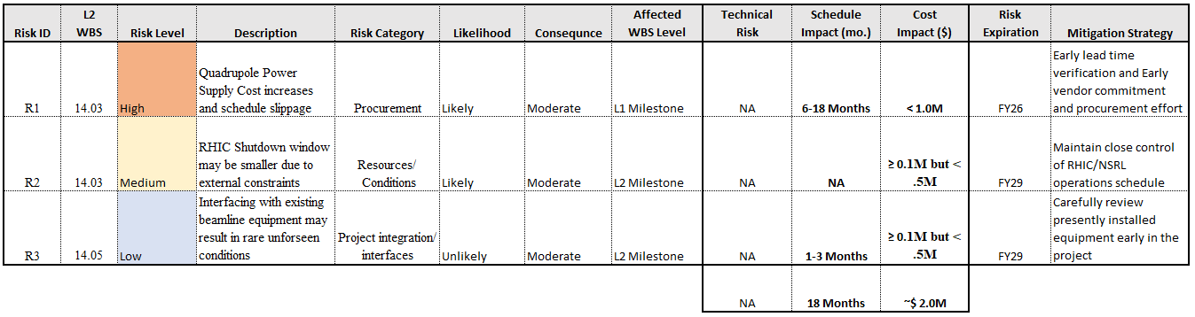

The total worst-case estimate of all Risks is $2,000k. + 18 Months

Cost & Schedule Impact Mitigation:

- Although there are risk-based schedule impacts, due to the staged work during shutdowns, we do not anticipate the forecasted project completion date to be affected by any of the above risks.

- There remains uncertainty about market supply chain issues that could result in cost and schedule impacts to the project.
Mitigating Strategies:
- The Contract Project Manager shall work closely with all CAM’s, and the BNL Procurement team, to identify early procurement dates to mitigate potential procurement delays. These schedule impact risks are difficult to quantify as they are driven by the unpredictable nature of market supply chain issues and other geopolitical factors within the market that may affect timely delivery of critical equipment/materials.
- We have added 18 months of project schedule contingency to our project plan to offset these potential schedule impacts and have assigned project contingency in the amount of $5.3M to mitigate these and other cost related potential risks and uncertainties.

Appendix C Report of the prototype quadrupole power supply

