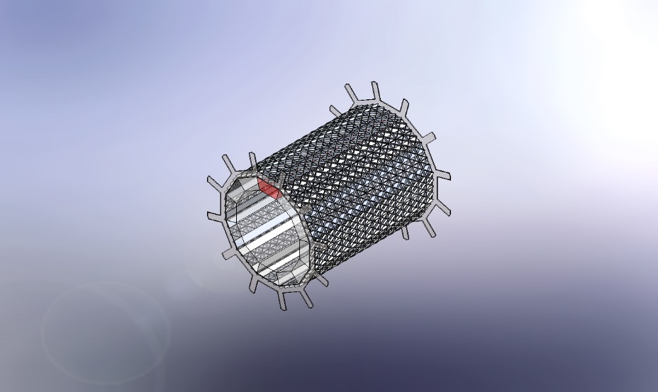 | Simulation of Em_Cal_Mesh_15_Comparison&Analysis  Date: Monday, April 25, 2022  Designer: Avishay_Mizrahi  Study name: Liniar_Static_01  Analysis type: Static  Table of Contents  Description 1  Assumptions 2  Study Properties 2  Units 3  Material Properties 4  Loads and Fixtures 6  Contact Information 7  Mesh information 8  Resultant Forces 9  Study Results 10  Conclusion 19

Description
This mesh was symmetrically distributed, and support was added to the top center using the radial component.
The maximum displacement is at the top center in the direction of gravity. The uniform thickness of the beams is 6.5 mm.

Assumptions
There is no friction in the model.
The whole mesh is made up of one part (for the purpose of analysis).
The ring in all models is uniform and made of the same material tested in the simulation.
Fixtures in the model have no movement in any direction.

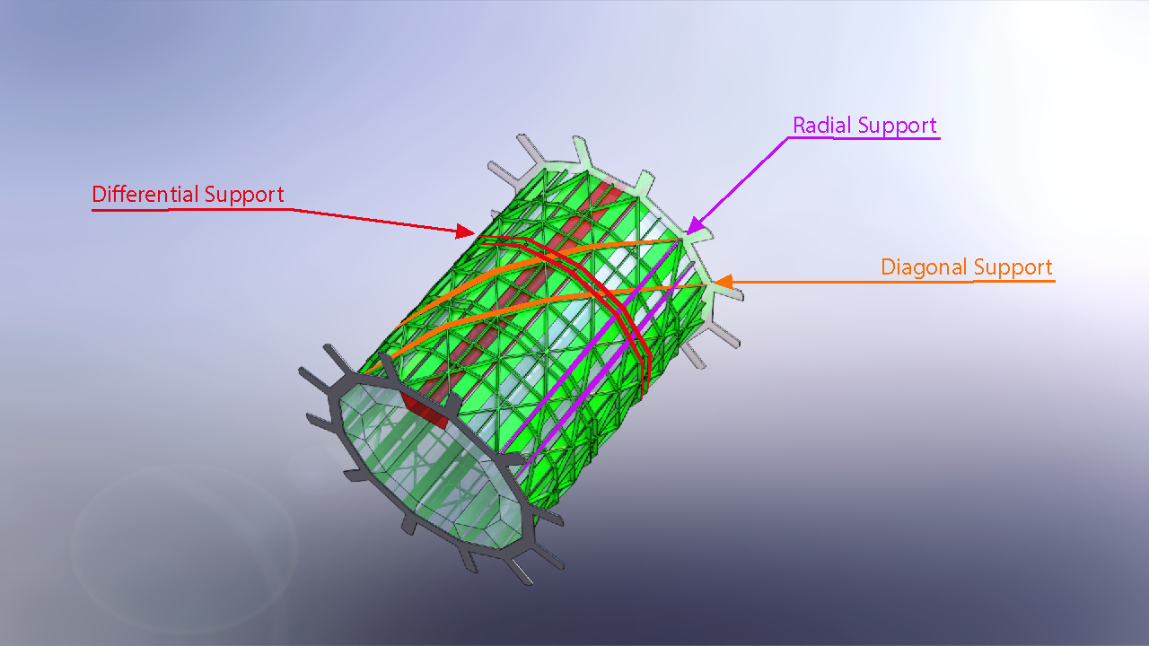

Study Properties
Study name | Liniar_Static_01
Analysis type | Static
Mesh type | Solid Mesh
Thermal Effect: | On
Thermal option | Include temperature loads
Zero strain temperature | 298 Kelvin
Include fluid pressure effects from SOLIDWORKS Flow Simulation | Off
Solver type | Automatic
Inplane Effect: | Off
Soft Spring: | Off
Inertial Relief: | Off
Incompatible bonding options | Automatic
Large displacement | On
Compute free body forces | On
Friction | Off
Use Adaptive Method: | Off
Result folder | SOLIDWORKS document (C:\MIT\MIT Electron-Ion Collider Project\Mesh comparison and analysis\Em_Cal_Mesh_15_Comparison&Analysis)

Units
Unit system: | SI (MKS)
Length/Displacement | mm
Temperature | Kelvin
Angular velocity | Rad/sec
Pressure/Stress | N/m^2

Material Properties
Model Reference | Properties | Components
 | Name: Radial_Segment  Model type: Linear Elastic Isotropic  Default failure criterion: Unknown  Yield strength: 6.89476e+06 N/m^2  Tensile strength: 3.4e+07 N/m^2  Elastic modulus: 1.72369e+08 N/m^2  Poisson's ratio: 0.3  Mass density: 4,199.01 kg/m^3 | SolidBody 1(Boss-Extrude1)(Barrel_Electromagnetic_Calorimeter_radial_segment-1),  SolidBody 1(Boss-Extrude1)(Barrel_Electromagnetic_Calorimeter_radial_segment-10),  SolidBody 1(Boss-Extrude1)(Barrel_Electromagnetic_Calorimeter_radial_segment-11),  SolidBody 1(Boss-Extrude1)(Barrel_Electromagnetic_Calorimeter_radial_segment-12),  SolidBody 1(Boss-Extrude1)(Barrel_Electromagnetic_Calorimeter_radial_segment-2),  SolidBody 1(Boss-Extrude1)(Barrel_Electromagnetic_Calorimeter_radial_segment-3),  SolidBody 1(Boss-Extrude1)(Barrel_Electromagnetic_Calorimeter_radial_segment-4),  SolidBody 1(Boss-Extrude1)(Barrel_Electromagnetic_Calorimeter_radial_segment-5),  SolidBody 1(Boss-Extrude1)(Barrel_Electromagnetic_Calorimeter_radial_segment-6),  SolidBody 1(Boss-Extrude1)(Barrel_Electromagnetic_Calorimeter_radial_segment-7),  SolidBody 1(Boss-Extrude1)(Barrel_Electromagnetic_Calorimeter_radial_segment-8),  SolidBody 1(Boss-Extrude1)(Barrel_Electromagnetic_Calorimeter_radial_segment-9)
Curve Data:N/A
 | Name: 6061-T6 (SS)  Model type: Linear Elastic Isotropic  Default failure criterion: Max von Mises Stress  Yield strength: 2.75e+08 N/m^2  Tensile strength: 3.1e+08 N/m^2  Elastic modulus: 6.9e+10 N/m^2  Poisson's ratio: 0.33  Mass density: 2,700 kg/m^3  Shear modulus: 2.6e+10 N/m^2  Thermal expansion coefficient: 2.4e-05 /Kelvin | SolidBody 1(Cut-Extrude2)(Em_CAL_Barrel_Support_Rack_15_Matrix-1),  SolidBody 1(Cut-Extrude2)(Em_CAL_Barrel_Support_Rack_15_Matrix-10),  SolidBody 1(Cut-Extrude2)(Em_CAL_Barrel_Support_Rack_15_Matrix-11),  SolidBody 1(Cut-Extrude2)(Em_CAL_Barrel_Support_Rack_15_Matrix-12),  SolidBody 1(Cut-Extrude2)(Em_CAL_Barrel_Support_Rack_15_Matrix-2),  SolidBody 1(Cut-Extrude2)(Em_CAL_Barrel_Support_Rack_15_Matrix-3),  SolidBody 1(Cut-Extrude2)(Em_CAL_Barrel_Support_Rack_15_Matrix-4),  SolidBody 1(Cut-Extrude2)(Em_CAL_Barrel_Support_Rack_15_Matrix-5),  SolidBody 1(Cut-Extrude2)(Em_CAL_Barrel_Support_Rack_15_Matrix-6),  SolidBody 1(Cut-Extrude2)(Em_CAL_Barrel_Support_Rack_15_Matrix-7),  SolidBody 1(Cut-Extrude2)(Em_CAL_Barrel_Support_Rack_15_Matrix-8),  SolidBody 1(Cut-Extrude2)(Em_CAL_Barrel_Support_Rack_15_Matrix-9),  SolidBody 1(Cut-Extrude1)(Em_CAL_Barrel_Support_Thicker_Ring-1),  SolidBody 1(Cut-Extrude1)(Em_CAL_Barrel_Support_Thicker_Ring-3)
Curve Data:N/A

Loads and Fixtures
Fixture name | Fixture Image | Fixture Details
Fixed-1 |  | Entities: 48 face(s)  Type: Fixed Geometry
Resultant Forces
Components | X | Y | Z | Resultant
Reaction force(N) | -103.322 | 81,268.3 | 0.0685501 | 81,268.3
Reaction Moment(N.m) | 0 | 0 | 0 | 0

Roller/Slider-1 |  | Entities: 5 face(s)  Type: Roller/Slider
Resultant Forces
Components | X | Y | Z | Resultant
Reaction force(N) | -4,879.78 | 219,056 | 0 | 219,110
Reaction Moment(N.m) | 0 | 0 | 0 | 0

Load name | Load Image | Load Details
Gravity-1 |  | Reference: Top Plane  Values: 0 0 -9.81  Units: m/s^2

Contact Information

Contact | Contact Image | Contact Properties
Global Interaction |  | Type: Bonded  Components: 1 component(s)  Options: Independent mesh

Mesh information
Mesh type | Solid Mesh
Mesher Used: | Blended curvature-based mesh
Jacobian points for High quality mesh | 16 Points
Maximum element size | 0.167113 m
Minimum element size | 0.061676 m
Mesh Quality | High
Remesh failed parts independently | Off

Mesh information - Details
Total Nodes | 436560
Total Elements | 220572
Maximum Aspect Ratio | 1,708
% of elements with Aspect Ratio < 3 | 15.4
Percentage of elements with Aspect Ratio > 10 | 46.8
Percentage of distorted elements | 0
Time to complete mesh(hh;mm;ss): | 00:00:48
Computer name:

Mesh Control Information:
Mesh Control Name | Mesh Control Image | Mesh Control Details
Control-1987 |  | Entities: 12 Solid Body (s)  Units: m  Size: 0.0685289  Ratio: 0.0685289
Control-1988 |  | Entities: 12 component(s)  Units: m  Size: 0.0835566  Ratio: 0.0835566

Resultant Forces

Reaction forces
Selection set | Units | Sum X | Sum Y | Sum Z | Resultant
Entire Model | N | -4,983.1 | 300,324 | -8,303.06 | 300,480

Reaction Moments
Selection set | Units | Sum X | Sum Y | Sum Z | Resultant
Entire Model | N.m | 0 | 0 | 0 | 0

Free body forces
Selection set | Units | Sum X | Sum Y | Sum Z | Resultant
Entire Model | N | 0 | 0 | 0 | 0

Free body moments
Selection set | Units | Sum X | Sum Y | Sum Z | Resultant
Entire Model | N.m | 0 | 0 | 0 | 0

Study Results

Name | Type | Min | Max
Stress1 | VON: von Mises Stress | 3.8e-04N/mm^2 (MPa)  Node: 39648 | 7.4e+01N/mm^2 (MPa)  Node: 307775
Em_Cal_Mesh_15_Comparison&Analysis-Liniar_Static_01-Stress-Stress1

Name | Type | Min | Max
Displacement1 | URES: Resultant Displacement | 0mm  Node: 432343 | 1mm  Node: 17045
Em_Cal_Mesh_15_Comparison&Analysis-Liniar_Static_01-Displacement-Displacement1

Name | Type | Min | Max
Displacement2 | URES: Resultant Displacement | 0mm  Node: 432343 | 1.01mm  Node: 17045
Em_Cal_Mesh_15_Comparison&Analysis-Liniar_Static_01-Displacement-Displacement2

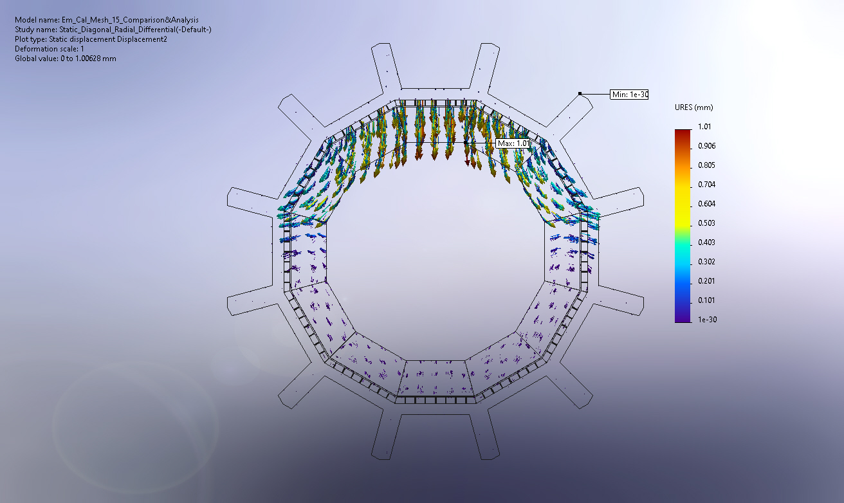
Image-1

Image Comments:
In this image you can see the direction of displacement to estimate the position of support in the next model.

Conclusion
The motivation for this was to save the volume of material that would interfere with the operation of the detector. I took the No. 7 mesh that passed the aluminum test and compressed it while reducing the thickness of the beams evenly. The calculated volume is 0.57 cubic meters. Improving the following model can be done in the form of reducing gaps between the beams and reducing their uniform thickness.

