PRINCIPAL INVESTIGATOR | J. HatcherLamarre |  | PHONE | 631 344 8257
DEPARTMENT/DIVISION | AD |  | DATE | 6/24/22
OTHER INVESTIGATORS | D.Kim, D.Medvedev, V.Sanders
TITLE OF PROPOSAL  TYPE A | Examining Novel Isotope Production Pathways for a Medium to High Energy Cyclotron
PROPOSAL TERM (month/year) | From | 10-01-22 | Through |  | 9-30-25

SUMMARY OF PROPOSAL
Description of Project: The Medical Isotope Research and Production (MIRP) program at BNL is often tasked with developing production pathways for radionuclides to meet industrial, medical, environmental, national security and research community’s needs, and which are not readily available from commercial sources. The purpose of this proposal is to demonstrate the feasibility of implementing new production routes using a ≤30 MeV cyclotron to supply these needs. The DOE Isotope Program is considering investing in the purchase of a multiparticle, ≤30 MeV cyclotron at one of the national laboratories within the next 3 years. By fully developing production pathways for critical radionuclides using our current capabilities and expertise, the MIRP group can position BNL as a prime location for the new cyclotron. Currently, isotopes are being produced at BNL by irradiating targets at the BLIP using a proton beam with a range of 66 to 200 MeV. This range of energy enables us to produce much needed isotopes such as actinium-225 and strontium-82 in high yield and purity but does not allow for the efficient production of some isotopes where the energy window is critical in reducing impurities. Our current cyclotron is limited in both energy and current so to expand isotope production capabilities at BNL, we propose to examine potential production pathways for radionuclides which can be produced using a ≤30 MeV cyclotron with higher beam current (up to 1 milliamp) and multi-particle capabilities. The list of radionuclides which can be produced using a beam ≤30MeV is extensive; two isotopes of particular importance are cobalt-57 and lead-203. Production of these isotopes using a 30 MeV cyclotron, allows for the use of alternative target materials which may be easier to separate and purify. We propose to develop novel targets using methods such as electroplating and sputtering, these techniques will produce high purity targets and avoid metal impurities. This is particularly important for lead-203, in the past lead-203 was produced with large amounts of iron and other metal impurities which needed to be removed prior to use. We intend to test these targets using the BLIP and the 19 MeV MIRP cyclotron, evaluate separation methods, and determine the quality control requirements of these isotopes. In addition to increasing the domestic supply, the data obtained from this work will position us well to compete for the siting of the ≤30 MeV cyclotron and can be further used for future funding opportunities.
Expected Results: This project seeks to fully develop production parameters for the two isotopes mentioned previously. This will be accomplished by:
- Modeling target yields and irradiation parameters
- Designing and fabricating targets which will withstand the higher beam currents.
- Establish robust and efficient separations methodologies for the novel isotopes.

Proposal

Introduction:
Brookhaven National Laboratory stands at the forefront of isotope production for industrial, environmental, national security and medical applications. The medical isotope research and production group at BNL, is often charged with the responsibility to discover novel pathways of production for isotopes of interest. The DOE isotope program seeks to invest $30-$50 million into the purchase of a high energy cyclotron in approximately three years. This proposal seeks to support Brookhaven National Laboratory as a prime location for the cyclotron investment. By developing production pathways of isotopes of current and future interest or need, the MIRP group can demonstrate its ability to optimize output of a new cyclotron facility.
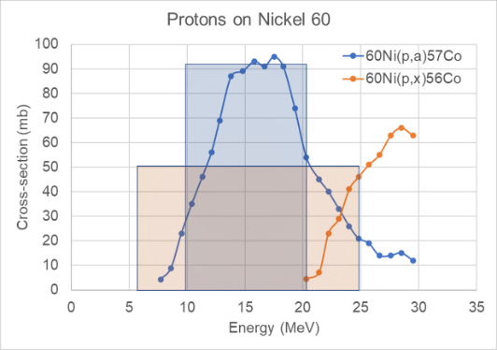
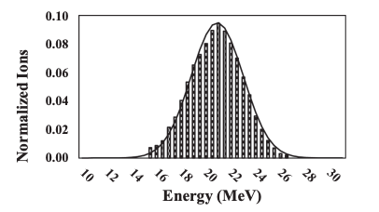
The proposed cyclotron will have a maximum proton energy of 30 or 70 MeV. While this energy range can be achieved at BLIP by attenuating the beam, the energy of the resulting protons is no longer uniform. Figure 1 shows the proton energy distribution of an attempted beam attenuation using an aluminum degrader. The beam energy was intended to be reduced from 100 MeV to 24 MeV, the actual energy distribution shows the energy is actually 21 MeV and can vary by as much as 7 MeV. [1] This variation can affect the purity and yield of the desired isotopes. This energy spread can produce impurities and therefore degrade radiolytic purity as well as overall yield such that they are not useful. To make isotopes which meet industry standards, a certain level of purity must be provided and maintained. Cyclotrons allow for very precise control over the energies that are incident on the target. For some elements, this increases the purity by reducing the likelihood of the formation of byproducts.

Figure 1 (LEFT) Gaussian fit of the proton energy distribution after degradation to 24 MeV from 100 MeV with aluminum degraders. This energy spread can contribute to the formation of impurities. (Right) show the effect of energy range on the formation of impurities

In addition to a higher quality product, a new high energy cyclotron will expand our isotope production capabilities by opening avenues for isotope production which have not been extensively explored at BNL. The new cyclotron will have multi particle capabilities meaning that the cyclotron will produce proton, deuteron and alpha particle beams. While the number of isotopes which can be produced using a cyclotron at 30 to 70 MeV, is vast, we propose to investigate two isotopes in which there are currently no US producers and there is a demonstrated need, cobalt-57 and lead-203. Cobalt 57 decays via electron capture and is commonly used in both industrial and medical practices as a calibration source. The domestic and foreign supplies of cobalt-57 have halted due to company restructuring and geopolitical issues. Using a cyclotron, cobalt-57 can be produced in high yield from a natural nickel target. Lead-203 is an isotope of interest as an imaging agent as well as part of a theragnostic pair with Lead-212. The supply of lead-203 has also halted. Lead-203 can be produced in high yield from a natural or enriched thallium target.

Impact and scope:
To prove our capability to handle the new cyclotron, we will develop production pathways which will be ideal for a 30-70 MeV cyclotron. Using the BLIP we can produce the desired isotopes by irradiating thin targets with natural abundance target materials. As previously mentioned, the purity of those isotopes is not likely to meet industry standards. However, these lower quality isotopes can be used to probe every aspect of the production pathway. Including but not limited to cross-section studies, target handling, separations and radioanalytical purity. In routine production for distribution, enriched isotope target materials will be used to produce a pure product.
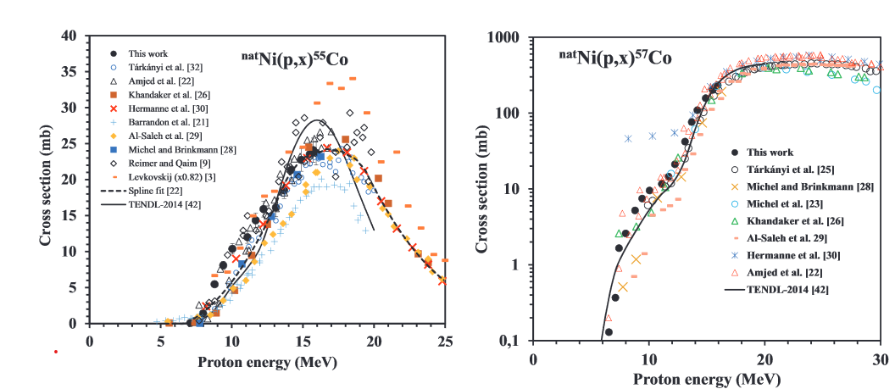
The production of Co-57 will be realized via ^{nat} Ni(p,x)Co-57 nuclear reaction. Figure 2 underscores the importance of energy control for protons incident on the Ni target. The image on the left shows the steady increase and stabilization of the nuclear cross-section of the ^{nat}Ni(p,x)Co-57 reaction with increasing incident energy. The image on the right shows the rise and fall of the cross-sections of an impurity of the reaction, cobalt-55. To minimize the formation of Co-55 (which makes the material unusable) the energy has to be set to 25 MeV.[2]
Figure 2 Nuclear Cross-Section data for the irradiation of natural nickel and the formation of Co-57 and Co-55

Production of Pb-203 will be accomplished through ^{nat}Tl(p,x)Pb-203 nuclear reaction. Similarly, precise control of proton energy is equally critical. Figure 3 shows the production of lead-isotopes from the irradiation of natural thallium. In this case, the coproduction of Pb-202m, which leads to the daughter product Pb-202, peaks around 5 MeV higher than the production of Pb-203. A beam fluctuation of 7 MeV will result in an impure product which cannot be separated via chemical means. [3]
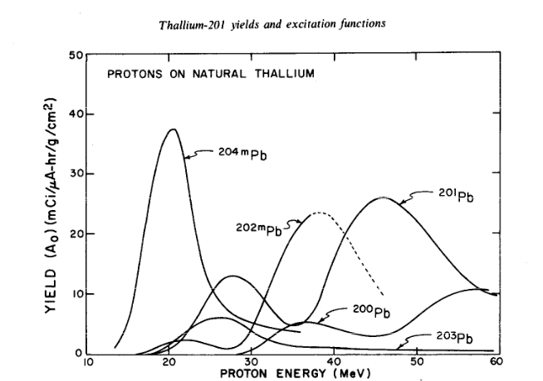
Figure 3 Yields of various lead isotopes from the proton irradiation of natural thallium

Experimental Plan:
Target design:
Experimental plan is focused on the development and testing of targets for production of Co-57 and Pb-203. To achieve high radionuclidic purity the energy degradation within the target material must be minimized. This approach would require a thin layer of target material. To maintain high yield the target will have to be irradiated at very high currents (>300 uA) while cooled adequately. Development of the design will be carried out with the assistance of the modeling group at BNL who are experts in designing targets to withstand extreme irradiation conditions. This would require development of a chemically inert target material holder and cooling schemes involving robust convection and conduction modes of heat transfer. We propose electroplating and sputtering techniques to achieve that. Once the target is fabricated, it will be tested at BLIP or cyclotron for survivability at high heat load and modifications made in the cooling modes to achieve the optimum design. The conditions (incident energy and current) at BLIP and cyclotron will be adjusted to mimic heat load anticipated in the 30 MeV cyclotron. This experimental approach will be used for both nickel and thallium targets. An array of targets with varied thickness of target material coating will be irradiated and the integrity of the coating will be examined after irradiation. The current will be systematically increased to identify the thickness optimal for production and target survival.
Separations and purity:
Separation studies for both isotopes will be examined. The identification of the ideal separation system including resin and solvent conditions will be investigated. The ideal separation conditions are those that produce the highest yield of the desired radioisotope while minimizing the presence of impurities and target material. The recycling of costly enriched targets will be investigated as well. We propose to extensively explore separation routes for the production of cobalt-57 and lead-203. The separation of lead from thallium will be evaluated using a cation exchange column. Figure 4 shows the log of the distribution coefficients vs acid concentration for the separation of metals. The distribution coefficient directly correlates to how well the metal will be retained on the resin at the given acid concentration. The Kd charts of Pb(II) and Tl(III) on a cation exchange resin.[4] The separation seems favorable using low concentrations of hydrochloric acid. The use of a Tl(III) salt or the oxidation of Tl metal and their effect on separations will be examined. The separation of cobalt and nickel will also be investigated using ion exchange resins, in this case, the separation of the elements using an anion
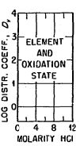
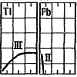
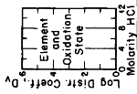
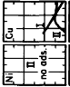
exchange resin is seemingly straight forward.[5] We will investigate how the separation behaves on a large scale.
Figure 4. Distribution coefficient vs acid concentration of Tl, Pb, Co and Ni on a cation exchange resin (Tl and Pb) and on an anion exchange resin (Ni and Cu)

The radionuclidic purity will also be determined. We propose to fully develop radio analytical methods (ICP, HPGE) to determine the purity of both cobalt and lead. For lead specifically as it
is a medical isotope which will be labeled with ligands, the yield of labeling reactions as it pertains to radionuclidic purity will also be evaluated.

Milestones and timeline | Start | End
Cobalt-57
- Identify Target specs for cyclotron  - Target Design  - Target material thickness Cooling approach  - Heat load simulations | Y1Q1 | Y1Q3
- Target fabrication  - Electrodeposition  - Sputtering | Y1Q3 | Y2Q1
- Test targets using BLIP and/or Cyclotron | Y2Q1 | Y2Q3
- Develop separations  cold and hot processes | Y1Q1 | Y3Q4
- Develop radioanaytical methods to determine purity | Y3Q2 | Y3Q4
Lead-203
- Identify Target specs for cyclotron  - Target Design  - Target material thickness Cooling approach  - Heat load simulations | Y1Q1 | Y1Q3
- Target fabrication  - Electrodeposition  - Sputtering | Y2Q3 | Y3Q1
- Test targets using BLIP and/or Cyclotron | Y3Q1 | Y3Q3
- Develop separations  - cold and hot processes | Y1Q1 | Y3Q4
- Develop radioanalytical methods to determine purity | Y3Q2 | Y3Q4

Team and Budget
PI Jasmine Hatcher-Lamarre is an inorganic radiochemist with years of experience in the coordination chemistry of metals, separations, and extractions. Dohyun Kim is a physicist with extensive experience with cyclotrons and development of target holders and cooling systems for isotope production. Dmitri Medvedev is a nuclear engineer with considerable experience in isotope production and target development. Vanessa Sanders is a radiochemist with years of experience with radioanalytical methods, separations, and metal to ligand complexation. The incoming scientist is a chemist with a strong background in electrochemistry. The requested budget is 500K/year for three years to fully develop pathways to produce Lead-203 and Cobalt-57. In the first year, the majority of the budget requested will go to the salaries of the PI, Co-PIs, and incoming staff scientist and materials. The first year’s budget will be dedicated to developing the targets for irradiation and cold separation studies of Cobalt-57. The second year’s budget will be dedicated to irradiating test foils using the BLIP or MIRP cyclotron and testing the separations methods developed for Cobalt-57 and to begin target development and separation studies of targets to produce Lead-203. Year three’s budget will be focused on irradiating foils using and testing separations for Lead-203 production. A postdoc will be hired in year two to work on this project, if we are unable to find a postdoc, the PI as well as the incoming staff scientist will complete the work.
References
1. Mastren, T., et al., Natural nickel as a proton beam energy monitor for energies ranging from 15 to 30 MeV. Nuclear Instruments and Methods in Physics Research Section B: Beam Interactions with Materials and Atoms, 2019. 443: p. 1-4.
2. Uddin, M.S., et al., Experimental determination of proton induced reaction cross sections on natNi near threshold energy. Radiochimica Acta, 2016. 104(5): p. 305-314.
3. Lagunas-Solar, M., et al., Thallium-201 yields and excitation functions for the lead radioactivities produced by irradiation of natural thallium with 15–60 MeV protons. The International Journal of Applied Radiation and Isotopes, 1978. 29(3): p. 159-165.
4. Nelson, F., T. Murase, and K.A. Kraus, Ion exchange procedures: I. Cation exchange in concentration HCl and HClO4 solutions. Journal of Chromatography A, 1964. 13: p. 503-535.
5. Nelson, F., R.M. Rush, and K.A. Kraus, Anion-exchange studies. XXVII. Adsorbability of a number of elements in HCl-HF solutions1, 2. Journal of the American Chemical Society, 1960. 82(2): p. 339-348.

VITA
Dr. Jasmine Hatcher-Lamarre

Education and Work Experience:

- B.A. in Chemistry Queens College, CUNY 2009
- Ph.D in Inorganic Chemistry Graduate Center, CUNY 2018
- Postdoctoral Fellow Brookhaven National Laboratory 2018-2021
- Assistant Physicist Brookhaven National Laboratory 2021-Present

Publications and invited talks: nine peer-reviewed publications and forty scientific presentations

Selected publications and presentations relevant to current proposal

- “Alpha Emitting Nuclides for Targeted Therapy”: J. Hatcher-Lamarre et al; Nuclear Medicine and Biology, (2021), 92, 228-240.
- Thorium Target Debulking Studies using Wells-Dawson Polyoxometalates (Invited)”; J. Hatcher-Lamarre et al; National Society of Black Physicist annual conference Providence, RI November 14-17 (2019)

- “Polycations XXII. Ru(bpy)2L2 and Ru(phen)2L2 systems with cationic 4,4'-bipyridine ligands: syntheses, characteristics, and interactions with DNA”: J. Hatcher et al; American Chemical Science Journal (2015) 9(1) 1-7

VITA

Dr. Dmitri G. Medvedev

Education

Ph.D. Nuclear Engineering, 2004
Texas A&M University, College Station, TX
M.S. Chemical Engineering, 1999
D.I. Mendeleyev University of Chemical Technology of Russia, Moscow, Russia

Employment History (reverse chronological order)

Medical Scientist Jan 2006-present
Medical Isotope Research and Production Program
Collider-Accelerator Department
Brookhaven National Laboratory, Upton, New York, USA
Visiting Fellow Oct 2004-Dec 2005
Molecular Imaging Laboratory, Clinical Center,
National Institute of Health, Bethesda, Maryland, USA
Graduate Research Assistant Jun 2000-Sept 2004
Department of Chemistry,
Texas A&M University, College Station, Texas, USA

Publications most closely related to the proposed project
J. R. Griswold, D. G. Medvedev, J. W. Engle, R. Copping, J. M. Fitzsimmons, V. Radchenko, J. C. Cooley, M. E. Fassbender, D. L. Denton, K. E. Murphy, A. C. Owens, E. R. Birnbaum, K. D. John, F. M. Nortier, D. W. Stracener, L. H. Heilbronn, L. F. Mausner and S. Mirzadeh. Large scale accelerator production of ²²⁵Ac: Effective cross sections for 78-192 MeV protons incident on Th-232 targets. Applied Radiation and Isotopes 118, 366-374 (2016).
DeGraffenreid, AJ; Medvedev, DG; Phelps, TE; Gott, MD; Smith, SV; Jurisson, SS; Cutler, CS. Cross-section measurements and production of Se-72 with medium to high energy protons using arsenic containing targets. Radiochimica Acta 107, 4, 279-287, (2019)
Morgan B. Fox, Andrew S. Voyles, Jonathan T. Morrell, Lee A. Bernstein, Amanda M. Lewis, Arjan J. Koning, Jon C. Batchelder, Eva R. Birnbaum, Cathy S. Cutler, Dmitri G. Medvedev, Francois M. Nortier, Ellen M. O’Brien, and Christiaan Vermeulen
Investigating high-energy proton-induced reactions on spherical nuclei: Implications for the preequilibrium exciton model. Phys. Rev. C, accepted

VITA
Dr. Dohyun Kim

Education and Work Experience:
PhD, Physics Myongji University, Korea 2010
MS, Physics Myongji University, Korea 2002
BS, Physics Myongji University, Korea 2000

Physicist Brookhaven National Laboratory 2021 – Present
Associate Physicist Brookhaven National Laboratory 2019 – 2021
Assistant Physicist Brookhaven National Laboratory 2017 - 2019

Selected publications and presentations relevant to current proposal
- RaDIATE collaboration, Tensile behavior of dual-phase titanium alloys under high-intensity proton beam exposure: radiation-induced omega phase transformation in Ti-6Al-4V, in Journal of Nuclear Materials, 152413, Jul. 25, 2020
- Dohyun Kim, Mohamed Benmerrouche and Cathy S. Cutler, “FLUKA simulation of Ac-225 production with a medical cyclotron” in Journal of Medical Imaging and Radiation Sciences, Vol 50, 2019
- Kelly JM, Amor Coarasa A, Nikolopoulou A, Wüstemann T, Barelli P, Kim D, Williams C Jr, Zheng X, Bi C, Hu B, Warren JD, Hage DS, DiMagno SG, Babich JW, “Dual-Target Binding Ligands with Modulated Pharmacokinetics for Endoradiotherapy of Prostate Cancer”, in Journal of Nuclear Medicine, Apr. 27, 2017
- Dohyun Kim, David L. Alexoff, Mike Schueller, Ben Babst, Richard Ferrieri, David J. Schlyer and Joanna S. Fowler, “The Design and Performance of a Portable Handheld ¹¹CO₂ Delivery System” in Applied Radiation and Isotopes, Dec. 31, 2014

VITA
Dr. Vanessa A. Sanders
_________________________________________________________________________________

Education History
Ph.D. in Radiochemistry | University of Nevada Las Vegas, Las Vegas, Nevada | 2017
B.A. in Chemistry | Florida Memorial University, Miami Gardens, Florida | 2009

Employment History
Assistant Scientist | Brookhaven National Laboratory | April 2019- Present
Research Associate Postdoctoral Researcher | Brookhaven National Laboratory | May 2017-March 2019
esearch Assistant | University of Nevada Las Vegas | 2013-2017

Selected publications and presentations relevant to current proposal

Sanders, V., Pratt, E., Bhupathiraju, N. V. S. D., Carter, L., Ferdous, J., Marquez-Nostra, B., Schyler, D., Lewis, J., Francesconi, L., Cutler, C. (2021). ²²⁷Th Labeled 3,4,3-(LI-1,2-HOPO): Optimized Synthesis, Biological Distribution and Dosimetry. Journal of Nuclear Medicine, 62(supplement 1), 1482-1482.
Phipps, M. D.; Sanders, V. A.; Deri, M. A., Current State of Targeted Radiometal-Based Constructs for the Detection and Treatment of Disease in the Brain. Bioconjug.Chem. 2021.
Akam, E.; Azevedo, C.; Chaney, A. M.; Dhanvantari, S.; Edwards, K. J.; Henry, K. E.; Ibhagui, O. Y.; Ijoma, J. N.; Ikotun, O. F.; Mack, K. N.; Nagle, V. L.; Pereira, P. M. R.; Purcell, M. L.; Sanders, V. A.; Shokeen, M.; Wang, X., Visions by Women in Molecular Imaging Network: Antiracism and Allyship in Action. Molecular Imaging and Biology 2021, 23 (3), 301-309.
Hatcher-Lamarre, J. L.; Sanders, V. A.; Rahman, M.; Cutler, C. S.; Francesconi, L. C., Alpha emitting nuclides for targeted therapy. Nuclear Medicine and Biology 2021, 92, 228-240.
Sanders, V. A.; Cutler, C. S., Radioarsenic: A promising theragnostic candidate for nuclear medicine. Nuclear Medicine and Biology 2021, 92, 184-201.

1. ALIGNMENT WITH THE LABORATORY MISSION AND VISION
Type A proposals need to be clearly aligned with BNL’s priority programs and initiatives. For FY23, the highest priorities for Type A proposals (not in priority order) are: Accelerator Science and Technology; Atmospheric and Climate Science; Clean Energy; Discovery Science Driven by Human-AI-Facility Integration; High Energy Physics: Understanding the Origin of Space and Time; Isotope Production and R&D Capabilities; Quantum Information Science and Technology; and Research and Development towards the Second Detector at the Electron-Ion Collider.

The Laboratory Initiatives are in the areas of 1. Nuclear Physics; 2. Clean Energy and Climate; 3. Quantum Information Science and Technology; 4. Artificial Intelligence and Data Science; 5. High Energy Physics; 6. Isotope Production; and 7. Accelerator Science and Technology.

Please identify which area(s) the proposal supports. This proposal supports area 6: Isotope Production
2. POTENTIAL FUTURE FUNDING
The work from this proposal will be used to aid in BNL’s bid for the $30-$50M investment from the DOE IP. This work may also be used as part of an early career research grant.

3. BUDGET JUSTIFICATION
Budget item | Amount | Justification
J.Hatcher-Lamarre | $57K | Separations, extraction and supervise the postdoc
D. Medvedev | $84K | Film irradiation, target development
D. Kim | $85K | Target holder design and simulations
V. Sanders | $57K | Separation, radioanalytical methods
New Scientist-1 | $152K | Separations, Target development
Postdoc (1.5 FTE) | $151K | Separations, target development, radioanalytical studies
MIRP Operators | $16K | Target transport, BLIP support
Engineer | $30K | Target holder design and construction
Designer | $24K | Target and target holder design
Materials | $240K | Resins, chemicals, enriched targets, pumps for separation studies, etc.
- NAME OF SUGGESTED BNL REVIEWERS
Anibal Boscoboinik (CO)
Matthew Bird (CO)
Dmitry Polansky (CO)
Alexi Bolotnikov (IO)

5. EQUIPMENT (Reference: DOE Order 413.2C Chg. 1 (Min Chg) for guidance on equipment restrictions)
Will LDRD funding be used to purchase equipment?  If “Yes,” provide cost and description of equipment  Year 1 - $ 100K  Year 2 - 70K  Year 3 - 70K  Description: We intend to purchase materials for target development such as a sputtering machine and power supplies for electrochemistry.  6. HUMAN SUBJECTS (Reference: DOE Order 443.1C)  Are human subjects involved from BNL or a collaborating institution?  Human Subjects is defined as “A living individual from whom an investigator obtains either (1) data about that individual through intervention or interaction with the individual, or (2) identifiable, private information about that individual”.  If yes, attach copy of the current Institutional Review Board Approval and Informed Consent Form from BNL and/or collaborating institution. | Y/N | Y/N__Y______  N
7. VERTEBRATE ANIMALS  Are live, vertebrate animals involved? | Y/N | N
If yes, attach copy of approval from BNL’s Institutional Animal Care and Use Committee.

8. NEPA REVIEW  Are the activities proposed similar to those now carried out in the  Department/Division which have been previously reviewed for potential environmental impacts and compliance with federal, state, local rules and regulations, and BNL’s Environment, Safety, and Health Standards? (Therefore, if funded, proposed activities would require no additional environmental evaluation.) |  | Y/N |  | Y
If no, has a NEPA review been completed in accordance with  the National Environmental Policy Act (NEPA) and Cultural Resources Evaluations Subject Area and the results documented? |  | Y/N |  | _______
(Note: If a NEPA review has not been completed, submit a copy of the work proposal to the BNL NEPA Coordinator for review. No work may commence until the review is completed and documented.)
9. ES&H CONSIDERATIONS  Does the proposal provide sufficient funding for appropriate decommissioning of the research space when the experiment is complete? |  | Y/N |  | N
Is there an available waste disposal path for project wastes throughout the course of the experiment? |  | Y/N |  | Y
Is funding available to properly dispose of project wastes throughout the course of the experiment? |  | Y/N |  | Y
Are biohazards involved in the proposed work? If yes, attach a current copy of approval from the Institutional Biosafety Committee. |  | Y/N |  | N
Can the proposed work be carried out within the existing safety envelope of the facility (Facility Use Agreement, Nuclear Facility Authorization Agreement, Accelerator Safety Envelope, etc.) in which it will be performed? |  | Y/N |  | Y
If no, attach a statement indicating what has to be done and how modifications will be funded to prepare the facility to accept the work.
10. TYPE OF WORK | Select Basic, Applied or Development |  | Development

APPROVALS
Business Operations Manager | 
Department Chair/Division Manager  To the Department Chair/Division Manager: Please indicate if this project is a sensitive technology under the S&T Risk Matrix. (Note: Red projects require an Access Management Plan.)  - Green  - Yellow  - Red - checked  Not Applicable |   Wolfram Fischer, 23 June 2022  STRM RED, access management plan in place
Associate Laboratory Director  for Nuclear and Particle Physics | _________________________________________
 | Haiyan Gao

