BNL Arrival Tips:
*Elke’s cell phone in case issues at customs or main gate: 1-757-256-5224
GUV (Guest, User, Visitor Center / Bldg 400): hours for getting badge: 7:00 a.m. to 5:00 p.m., Monday through Friday excluding holidays.
Housing check-in:
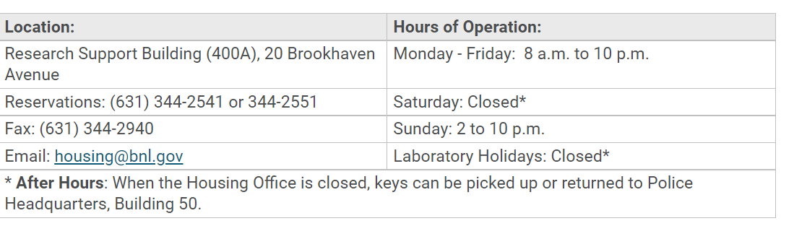
Food:
The Lunchbox offering breakfast and lunch in Cafeteria inside Bldg 488: Mon, Tues, Wed @8am-1pm.
Additional food truck (changes daily) outside Bldg 488 serves lunch Mon-Fri @11-1pm.
Micro-marts in the lobbies of Building 400 and 740 are open 24-hours with ready-to-eat food and beverage options.

