PRINCIPAL INVESTIGATOR | Dejan Trbojevic |  | PHONE | 6316555098
DEPARTMENT/DIVISION | Wolfram Fisher |  | DATE | Jan 30, 2023
OTHER INVESTIGATORS | S. Brooks, G. Mahler, R. Michnoff, S. Trabocchi, M. Sivertz
TITLE OF PROPOSAL  TYPE B | A Section of Fast Cycling Permanent Magnet FFA Synchrotron
PROPOSAL TERM | From | Oct/2024 | Through |  | Sept/2026

SUMMARY OF PROPOSAL

- Description of Project: A recent collaboration and visit to the Radiation Oncology of the Stony Brook University Hospital Cancer Center resulted in a proposal by Chairman professor Ruy Samuel submitted to the Dean. The Stony Brook proposal to build the proton radiation facility in collaboration with BNL includes: 1. The permanent magnet fast cycling synchrotron; 2. Transport beam lines a) Injection beam line from the cyclotron to the synchrotron with the b) extraction beam lines for connection of the synchrotron to the experimental beam line and to the 3. Permanent proton gantry. The funding to be established is estimated to be ~$40M. The injector for the synchrotron is the existing 16.5 MeV proton isotope production GE cyclotron with a separate extraction beam line.
For this LDRD we propose to build a part of the synchrotron arc made of few permanent magnets and show a proof of principle for novel compact and cost-effective fast cycling synchrotron.
- Potential Applications: Development of the Long Island proton cancer and FLASH radiation therapy facility at the Stony Brook Cancer Center in the Department of Radiation Oncology with possible participation of GE HealthCare.

- Fast Cycling synchrotron with the fixed permanent magnets and fixed betatron tunes for the FLASH cancer radiation therapy
This is a proposal based on the existing patent on permanent magnet Fixed Field Alternating Gradient accelerator. The previous patent required high RF power of the order of 10 MW as the acceleration had to be in a very short time to avoid crossing multiple resonances as the horizontal and vertical betatron tunes varied in a range 0.05-0.38. This proposal reduces the RF power from the previous 10 MW to 400 kW as the betatron tunes are fixed.
The proposal follows the successful commissioning of the Cornell Brookhaven Electron Test Accelerator (CBETA) accelerator one of 10 BNL best scientific achievements in 2020 [1-8]. The electrons were transported though the single beam line from the superconducting accelerator starting with energy of 36 MeV and finishing with 150 MeV, passing 4 times through the linac in acceleration mode and 4 times in decelerating mode making full energy recovery.
This is a proposal of an extraordinary synchrotron as acceleration time does not depend on limited speed of magnet response. The acceleration cycle is limited only by the RF. In the present design the accelerator cycle frequency is 1.3 kHz. The proposal uses permanent combined function magnets lay out in a racetrack and occupying a very small area of 10 x 6 m. The synchrotron permanent magnets are significantly smaller than warm iron synchrotron magnets. This specific energy range is very important for the proton cancer therapy and recent FLASH cancer radiation therapy [9]. The FLASH therapy occurs when the large radiation dose is delivered in controlled way during a very short time ~100 ms shows significant damage reduction to the normal tissue with destruction of the cancerous tumor.

Expected results:
We would like to build a section of the racetrack arc made of six cells and do the testing it in the BNL NASA facility by propagating and measuring protons in an energy range between 10 and 250 MeV. We expect that a part of the FFA arc, made of six FFA cells, will show clearly that all protons within this very large energy range are transported in predicted orbits.

PROPOSAL: Section of Fast Cycling FFA Synchrotron
The fast-cycling FFA synchrotron proposal is based on the author’s existing patent [10] and previous invited talk at the International Accelerator Physics Conference IPAC in San Sebastian 2011 [11].
The proton therapy accelerator from 10 MeV to 250 MeV is designed using the racetrack lattice made of Non-Scaling Fixed Field Alternating Gradient (NS-FFAG) arcs and two parallel straight sections. The injector for this accelerator is the 16.5 MeV GE cyclotron already used in Radiation Oncology Department for isotope production.
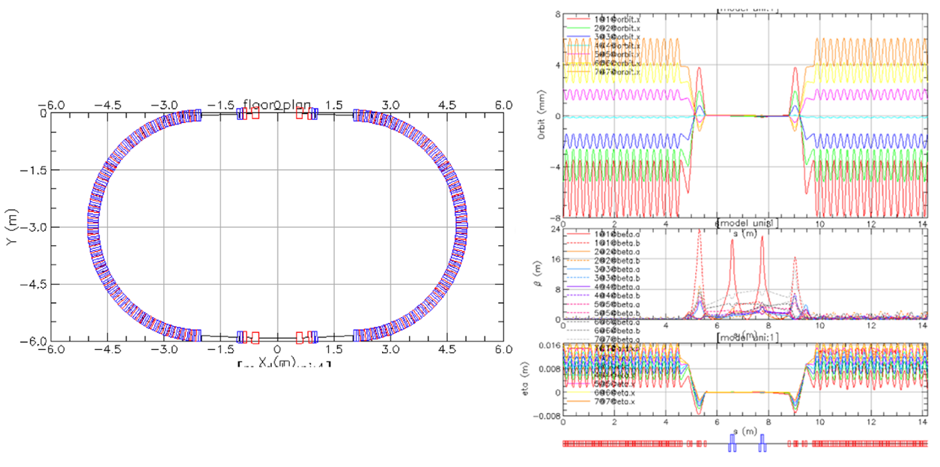
Figure 1: Layout of the FFA synchrotron (left) with orbits, betatron functions and dispersion (right).
The racetrack accelerator magnets in the arcs are combined function magnets with additional sextupole, octupole and decapole multipoles. The dipole bending field at the central lowest energy where the beam orbit is purely circular while the Neodymium Iron Boron magnetic residual induction is Br =1.3 T.
The radial orbit offsets ‘Δx_{MAX}’ in the NS-FFAG arcs xmax < 38 mm (for the kinetic energy range between 10 MeV< Ek<250 MeV or momentum offset range between -68.2% < Δp/p_{CENT} < 68.2%). The straight sections have proton orbits of all energies merged in a single orbit with zero radial offsets as it was successfully shown in the CBETA project. The straight sections in the racetrack are on two opposite sides. One is used one for acceleration, where the three RF cavities are placed, while the second one is used for the single turn proton injection and extraction with injection/extraction kickers and septa. The permanent magnets accelerator should reduce overall and operating cost. It fits into a very small area of 6 x 10 m space. The racetrack of the FFA synchrotron is shown in Fig. 1. with the betatron functions, orbits, and dispersion functions (on the right side).
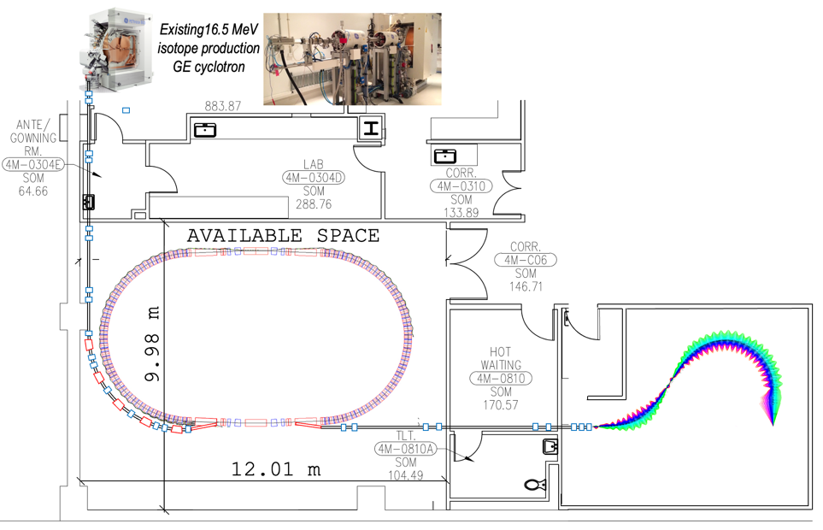
Figure 2: Available space at Stony Brook university Hospital. The beam lines, fast cycling synchrotron, and gantry are shown.

The goal of the proposal is to build one part of the FFA arc of the synchrotron consisting of 6 cells and test it at the NASA facility with the proton beam in the energy range between 10 and 250 MeV.
A tune vs. energy dependence for the fast-cycling synchrotron are shown in Fog. 9. A design is still in progress. The tune variation in Non-Scaling FFA gradient design is within a range from initial 0.38 down to 0.04. This new dependence removes crossing multiple resonances and increase of the beam emittance or beam loss. It allows a dramatic reduction of the RF power from 10 MW down to 300-400 kW as the number of turns in the synchrotron can be raised from the precious 900 up to 3600. The permanent magnet design for this solution of the lattice design is shown in Fig. 3. It is important to note a small magnet size of both focusing and defocusing non-linear magnets. This size is to be compared with the large iron synchrotron magnets. The combined function magnets with the dipole and quadrupole magnetic field have additional multipoles: sextupole, octupole and decapole allowing the tune dependence to be fixed. A cost and electrical power savings are additional significant advantages.
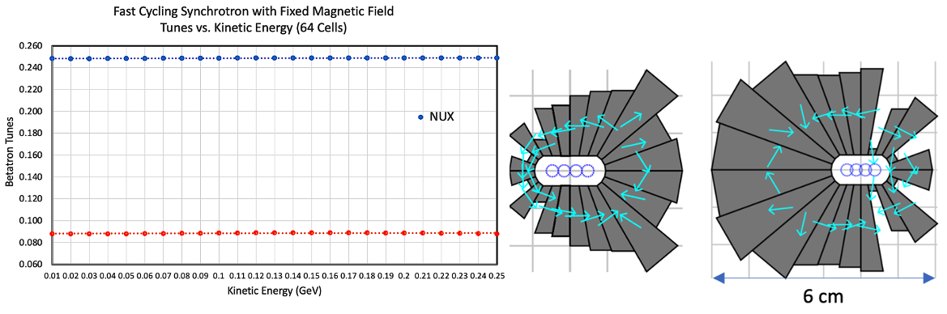
Figure 3: Tune dependence on energy in the Fast-Cycling synchrotron. Magnet design for the Fast-Cycling Synchrotron (left), the focusing combined unction magnet and the defocusing function magnet (right).

This LDRD will allow us to build an arc section of the fast-cycling FFA synchrotron. After the magnets of the arc block are successfully tested and corrected by multiple magnetic measurements the arc block will be tested with a 10-250 MeV proton beams. We expect a full confirmation with the beam measurements showing us that a proof of principle of the Fast-Cycling-Proton-Synchrotron with permanent magnets could be built.
In proton acceleration within the non-relativistic energy range the main problem is the limitation on the speed of magnetic field response to the change of energy. This limitation is now eliminated by using the permanent magnets for the same energy range. This is an extraordinary solution. It is possible to get synchrotron cycling with 1.3 kHz with respect to present maximum possible rates of 15-60 Hz. One of possible application is in FLASH cancer radiation therapy.

This proof of principle would enable new areas of research at BNL using the same principle but building the magnets with multi-layer superconducting wires and making:
- Small, energy efficient, and fast cycling proton drivers for NPP and HEP
- Fast cycling synchrotron for muon collider or accelerator driven system (ADS) for transmutation of nuclear waste

VITA PRINCIPAL INVESTIGATOR
Dejan Trbojevic | Senior Physicist
Collider-Accelerator Department | Brookhaven National Laboratory
Education and Training:
Ph.D., Physics, Georgetown University, Washington, D.C., 1984
M.Sc., Physics, Electro-Technical University, Belgrade, Serbia, 1980
B.A., Technical Physics, Electro-Technical University, Belgrade, Serbia, 1974
Research and Professional Experience:
- – Present Senior Physicist (tenured 2003), Brookhaven National Laboratory
Principal Investigator from the BNL side of the CBETA project (2016-2020).
1992 – 2003 Accelerator Physicist, Brookhaven National Laboratory
1986 – 1992 Physicist, Accelerator Division, Fermi National Laboratory, Batavia, IL
1984 – 1986 Post-Doctoral, Accelerator Division, Fermi National Laboratory, Batavia, IL
Research and Professional Accomplishments:
- Principal Investigator of Brookhaven Cornell Test Accelerator 2015 - present
- Principal Investigator of the LDRD FFA-LG for eRHIC 2012 – 2014
- Principal Investigator of the iRCMS CRADA 2009 – present
- Deputy of the Accelerator R&D group of the R&D Division 2008 – present
- Deputy of the Accelerator Physics group in the Accelerator Division 2006 – 2008
- Group Leader in the Accelerator Physics in the Accelerator Division 2004 – 2006
- Head Commissioner of the RHIC 1999 – 2000
- Key member of team designing and constructing RHIC 1992 – 1999
Patents:
- 2015, “Scanning Systems for Particle Cancer Therapy”, US 20140163301 A1, www.google.com/patents/US20140163301
- 2009, “Gantry for medical particle therapy facility”, D. Trbojevic, US Patent number: 7582886
- 2012, “Gantry for medical particle therapy facility,” D. Trbojevic, US Patent 8,173,981
- 2012, “Non-Scaling Fixed Field Alternating Gradient Permanent Magnet Cancer Therapy Accelerator,” D. Trbojevic, Patent Submitted: Attorney Docket No.: S126140
- 2012, “Innovative Scanning System for Ion Cancer therapy,” D. Trbojevic
- 2012, “Linear Fixed-Field Multipacks for recirculating Linear Accelerators”, A. Bogacz, V. Morozov, and D. Trbojevic, 2166U (JSA)
Synergistic Activities:
Brookhaven Science and Technology Award (2014)
Brookhaven Town Board Award: Certificate of excellence for the design of the gantry for the carbon cancer therapy (2012)
American Physical Society (APS) Fellow, (2008 – present)
Reviewer, Physical Review Special Topics for Accelerators and Beams, on IEEE Transactions on Nuclear Science, and the Small Business Innovation Research (SBIR) for the DOE (2000 – present
VITA PRINCIPAL CO-INVESTIGATOR
Dr. Stephen J. Brooks
Upton, NY 11973-5000 631-344-8844 sbrooks@bnl.gov
Education
D. Phil. Particle Physics, 2010 (University of Oxford)
M. Math. Mathematics, 2003 (University of Oxford)
B.Sc. Mostly Applied Mathematics, 2001 (The Open University)
Employment History
Physicist (C-AD, BNL) 10/1/2017 – present
Design of permanent magnets for accelerator applications, including fixed-field lattice for CEBAF 20GeV energy upgrade and wiggler for coherent electron cooling. Lab-directed R&D in field limits of permanent magnets including a magnetic measurement system. Design studies of novel oval-aperture Halbach magnets that provide higher gradients for hadron therapy gantries. Magnetic calculations and tuning for the production run of permanent magnets for the CBETA accelerator during 2018.
Associate Physicist (C-AD, BNL) 10/2015 – 09/2017
Magnet cell design and field-map tracking simulation for the CBETA multi-pass energy recovery linac built at Cornell. Construction of a series of 12 novel Halbach-derived magnets using 3D printed molds and a new shimming technique to achieve accelerator-level field quality at low cost.
Assistant Physicist (C-AD, BNL) 10/2013 – 09/2015
Design and simulation of BNL’s proposed eRHIC particle accelerator and related prototype accelerators and magnets. First ever beam dynamics studies for a new sort of “3D” cyclotron.
Accelerator Physicist (Rutherford Appleton Laboratory) 09/2003 – 10/2013
Research topics included: beam dynamics and magnetic field simulations in FFAG (fixed-field) particle accelerators; heat deposition and yield of particle beam targets. Previously worked on the Neutrino Factory "muon front end" design, including setting up a public distributed computing project to run the simulations and optimize the design automatically.
Associate Lecturer in Physics (The Open University) 2007 - 2009
Tutored the course "S357: Space Time and Cosmology" for two years at distance learning university, with ~20 students. Syllabus included classical mechanics, special and general relativity and cosmology.
Vacation Studentships (Rutherford Appleton Laboratory) Summer 2000 – Easter 2003
Developed graphics for interactive particle beam transport simulations.
Research and Professional Accomplishments
From 2009-2014, performed the first computer simulations of fixed-field accelerators with vertical orbit excursion, including an invited talk at the IPAC’14 conference. Another invited talk was at the IPAC’18 conference. During the summer of 2017, built and demonstrated the highest ever energy range in a “non-scaling” fixed-field accelerator (a factor of 3.8), using beam from ATF-1 and magnets from CBETA R&D. Reviewer of 6 papers for Physical Review Accelerators and Beams, one in Physical Review Applied and one in Instruments.
Other Skills
Physics: research topics above, plus experience with the MARS target simulation code and Poisson/Superfish magnet design code.
Computing: C/C++, scientific and numerical computing, Windows and Linux platforms, OpenGL computer graphics, PHP, website design, distributed computing, software GUI, interactive animation.

1. ALIGNMENT WITH THE LABORATORY MISSION AND VISION
This proposal is connected to the mission of the Collider Accelerator Department for the DOE present and future in Relativistic Heavy Ion Collider to develop and maintain the existing and future accelerator Brookhaven National Laboratory facilities. It includes only essential part – couple of arc cells of the future synchrotron accelerator to be build and tested within the existing CAD proton beam lines. It is a proof of principle for future proton drivers, and it is applicable for the cancer proton therapy. It presents the best possible solution for the new FLASH cancer radiation therapy.

- POTENTIAL FUTURE FUNDING
We are expecting the Stony Brook University hospital and GE HealthCare to be the essential providers of the funding estimated to be of the order of $40M.

4. BUDGET JUSTIFICATION
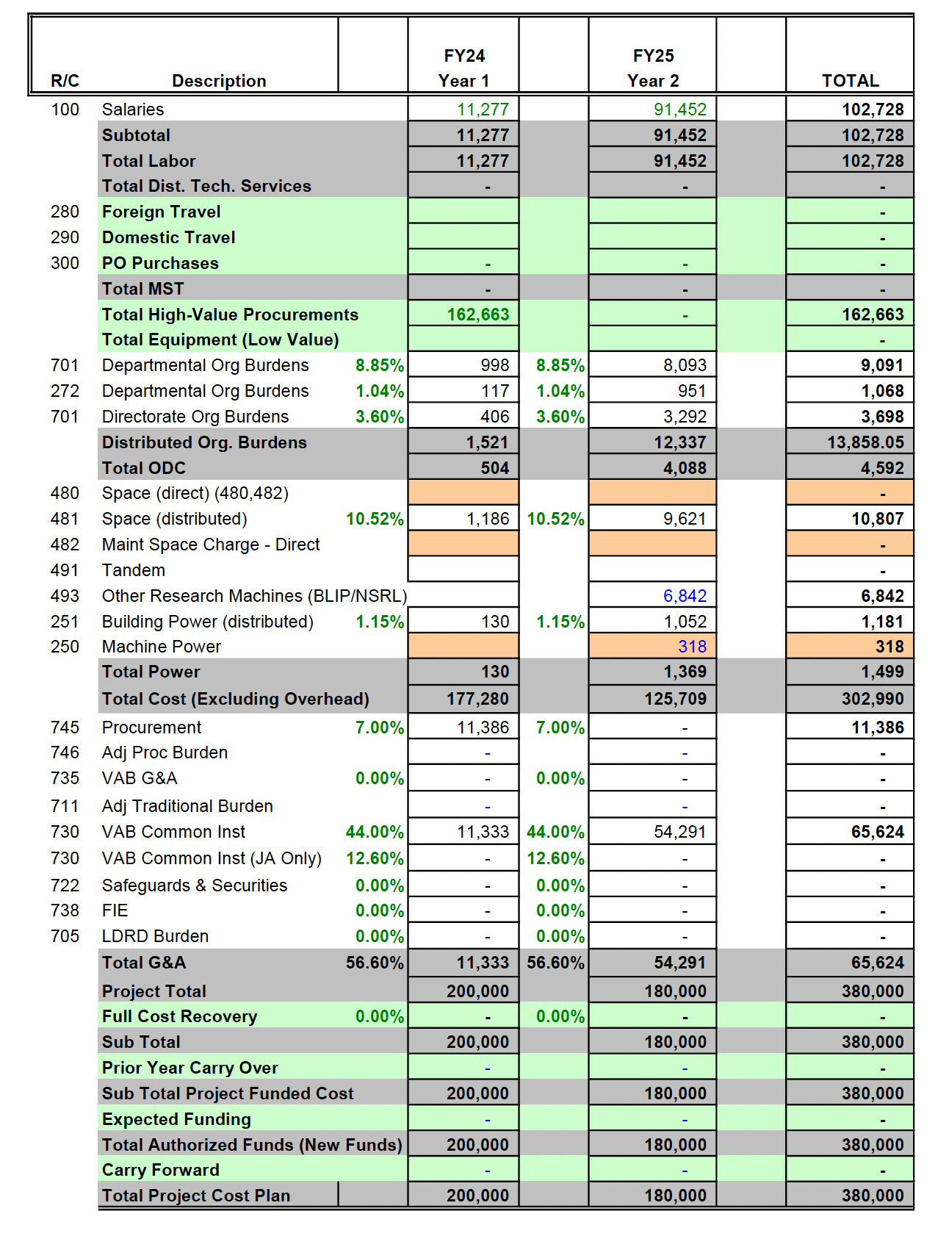

5. NAME OF SUGGESTED BNL REVIEWERS
Francois Meot is familiar with the FLASH therapy.
2. POTENTIAL FUTURE FUNDING
There are continuing regular contacts and exchange of information between the CAD and the Radiological Oncology Department of the Stony Brook University Hospital with respect to the development of the Proton Cancer Therapy facility.

3. POTENTIAL EARLY CAREER AWARD INVESTIGATORS (if applicable)
The earlier carred award might be possible with a young scientist contributing to the important spin off the nuclear physics

4. BUDGET JUSTIFICATION
Include a description of all costs requested in your budget. You do not need to describe the Lab burdens.

5. NAME OF SUGGESTED BNL REVIEWERS

Provide the name of two BNL subject matter experts who may be contacted as potential reviewers of your proposal. Their reviews will be in addition to those conducted by the Associate Lab Directors and their Deputies and the Directors of the Computational Science Initiative and Advanced Technology Research Office, Members of the Brookhaven Council, and Scientists not associated with the research.

6. EQUIPMENT (Reference: DOE Order 413.2C Chg. 1 (Min Chg) for guidance on equipment restrictions)
Will LDRD funding be used to purchase equipment?  If “Yes,” provide cost and description of equipment  Year 1 - $  Year 2 - $  Year 3 - $  Description:  7. HUMAN SUBJECTS (Reference: DOE Order 443.1C)  Are human subjects involved from BNL or a collaborating institution?  Human Subjects is defined as “A living individual from whom an investigator obtains either (1) data about that individual through intervention or interaction with the individual, or (2) identifiable, private information about that individual”.  If yes, attach copy of the current Institutional Review Board Approval and Informed Consent Form from BNL and/or collaborating institution. | Y/N | Y/N NO
8. VERTEBRATE ANIMALS  Are live, vertebrate animals involved? | Y/N | NO
If yes, attach copy of approval from BNL’s Institutional Animal Care and Use Committee. | Y/N

9. NEPA REVIEW  Are the activities proposed similar to those now carried out in the  Department/Division which have been previously reviewed for potential environmental impacts and compliance with federal, state, local rules and regulations, and BNL’s Environment, Safety, and Health Standards? (Therefore, if funded, proposed activities would require no additional environmental evaluation.) |  | Y/N |  | YES
If no, has a NEPA review been completed in accordance with  the National Environmental Policy Act (NEPA) and Cultural Resources Evaluations Subject Area and the results documented? |  | Y/N |  | YES
(Note: If a NEPA review has not been completed, submit a copy of the work proposal to the BNL NEPA Coordinator for review. No work may commence until the review is completed and documented.)

10. ES&H CONSIDERATIONS  Does the proposal provide sufficient funding for appropriate decommissioning of the research space when the experiment is complete? |  | Y/N |  | YES
Is there an available waste disposal path for project wastes throughout the course of the experiment? |  | Y/N |  | YES
Is funding available to properly dispose of project wastes throughout the course of the experiment? |  | Y/N |  | YES
Are biohazards involved in the proposed work? If yes, attach a current copy of approval from the Institutional Biosafety Committee. |  | Y/N |  | NO
Can the proposed work be carried out within the existing safety envelope of the facility (Facility Use Agreement, Nuclear Facility Authorization Agreement, Accelerator Safety Envelope, etc.) in which it will be performed? |  | Y/N |  | YES
If no, attach a statement indicating what has to be done and how modifications will be funded to prepare the facility to accept the work.
11. TYPE OF WORK | Select Basic, Applied or Development |  | Applied

APPROVALS
Business Operations Manager | 
Department Chair/Division Manager | Cris Manalo
 | Wolfram Fischer
To the Department Chair/Division Manager: Please indicate if this project is a sensitive technology under the S&T Risk Matrix. (Note: Red projects require an Access Management Plan.)  Green  Yellow  Red  Not Applicable  Cognizant Associate Lab Director/Computational Science Initiative Director/Advanced Technology Research Office Director | ___________________________________
Print Name

References:

[1] Adam Bartnik et. all, “CBETA: First Multipass Superconducting Linear Accelerator with Energy Recovery”, PHYSICAL REVIEW LETTERS 125, 044803 (2020). https://journals.aps.org/prl/pdf/10.1103/PhysRevLett.125.044803
[2] Colwyn Gulliford et. all., “Measurement of the per cavity energy recovery efficiency in the single turn Cornell-Brookhaven ERL Test Accelerator configuration”, PHYSICAL REVIEW ACCELERATORS AND BEAMS 24, 010101 (2021). https://journals.aps.org/prab/pdf/10.1103/PhysRevAccelBeams.24.010101
[3] Stephen Brooks et all.,” Permanent magnets for the return loop of the Cornell-Brookhaven energy recovery linac test accelerator”, PHYSICAL REVIEW ACCELERATORS AND BEAMS23,112401 (2020). https://journals.aps.org/prab/pdf/10.1103/PhysRevAccelBeams.23.112401
[4] S. Brooks, J. Cintorino, A. Jain, and G. Mahler, Production of low cost, high field quality Halbach magnets, in 8th International Particle Accelerator Conference (JACoW, Geneva, 2017), p. THPIK007. https://accelconf.web.cern.ch/ipac2017/papers/thpik007.pdf
[5] S. Brooks, G. Mahler, R. Michnoff, and J. Tuozzolo, CBETA permanent magnet production run, in 10th International Particle Accelerator Conference (JACoW, Geneva, 2019), p. THPTS088. https://accelconf.web.cern.ch/ipac2019/papers/thpts088.pdf
[6] J. S. Berg, S. Brooks, F. Méot, D. Trbojevic, N. Tsoupas, J. Crittenden, Y. Li, and C. Mayes, “CBETA FFAG beam optics design,” 59th ICFA Advanced Beam Dynamics Workshop on Energy Recovery Linacs (JACoW Publishing, Geneva, Switzerland, 2018), p. TUIDCC004. https://accelconf.web.cern.ch/erl2017/papers/proceed1.pdf
[7] C. Gulliford, N. Banerjee, A. Bartnik, J.S. Berg, J. Crittenden, J. Dobbins, R. Hulsart, J. Jones, D. J. Kelliher, B. Kuske, W. Lou, M. McAteer, R. Michnoff, S. Peggs, P. Quigley, D. Sagan, K. Smolenski, V. Vesherevich, D. Widger, G. H. Hoffstaetter, and D. Trbojevic, “Beam commissioning results from the CBETA fractional arc test”, https://arxiv.org/pdf/1902.03370.pdf
[8] D. Trbojevic and G. Hoffstaetter, “Transformative 'Green' Accelerator Achieves World's First 8-pass Full Energy Recovery”, News Report, January 21st, 2020.
https://www.bnl.gov/newsroom/news.php?a=116982
[9] Konrad P. Nesteruk and Serena Psoroulas, “FLASH Irradiation with Proton Beams: Beam Characteristics and Their Implications for Beam Diagnostics”, applied sciences, 2021, 11, 2170, https://doi.org/10.3390/app11052170
[12] D. Trbojevic, “Non-Scaling Fixed Field Alternating Gradient Permanent Magnet Cancer Therapy Accelerator,” United States Patent Application Publication, Pub. No.: US 2014/0252994 A1, Pub. Date: Sep. 11, 2014.
https://patentimages.storage.googleapis.com/dd/50/50/48d3c22914795b/US20140252994A1.pdf
[10] D. Trbojevic and V. Morozov,” NON-SCALING FIXED FIELD ALTERNATING GRADIENT PERMANENT MAGNET CANCER THERAPY ACCELERATOR”, invited Talk at IPAC2011, San Sebastián, Spain. WEOBA03, pp. 1923-1925. https://accelconf.web.cern.ch/IPAC2011/papers/weoba03.pdf
[11] P. W. Schmor, “REVIEW OF CYCLOTRONS USED IN THE PRODUCTION OF RADIOISOTOPES FOR BIOMEDICAL APPLICATIONS”, Proceedings of CYCLOTRONS 2010, Lanzhou, China, pp. 419-424.
https://accelconf.web.cern.ch/cyclotrons2010/papers/frm2cio01.pdf
[12] D. Trbojevic, “Non-Scaling Fixed Field Alternating Gradient Permanent Magnet Cancer Therapy Accelerator,” United States Patent Application Publication, Pub. No.: US 2014/0252994 A1, Pub. Date: Sep. 11, 2014.
https://patentimages.storage.googleapis.com/dd/50/50/48d3c22914795b/US20140252994A1.pdf
[13] D. Boussard, “RF FOR PPbar(PART II)”, CERN/SPS/84-2 ARF, Lecture given at the CERN Accelerator School Course on Antiprotons for Colliding Beam Facilities, SERN, 11-21 October 1983.
https://cds.cern.ch/record/149856/files/cer-000061084.pdf

