 |  | Date | tap to enter date
TITLE OF PROPOSAL - LDRD TYPE B | Type title of proposal
PRINCIPAL INVESTIGATOR (PI) | Type name of Principal Investigator
DEPARTMENT/DIVISION | Type Department and Division
OTHER INVESTIGATORS | Type name(s) of other investigators
PROPOSAL TERM (month/year) | FROM: tap to enter date
 | THROUGH: tap to enter date
EARLY CAREER ELIGIBLE: YES ☐ NO ☐

SUMMARY OF PROPOSAL

Description of Project:

Click here to enter text

Expected Results:

Click here to enter text

*Note: The above items should not exceed one page

INSTRUCTIONS

Under Description of Project, provide a summary of the scientific/technological concept of the proposed project including the motivation for the research and the approach that will be used to conduct the investigation. Briefly explain in a paragraph or less the competitive advantage of your approach. Also indicate how the project meets the general characteristics of the LDRD Program and how it is tied to the DOE Mission.

Under Expected Results, clearly state the expected results and how they will impact our understanding of the science/technology.

These items should not exceed one page. The content should be understandable by a non-expert.
This will greatly improve your chances of success. Please define all acronyms initially.

Follow the Summary of Proposal with a proposal not to exceed three pages that includes a concise state-of-the-art review, well supported by references, which do not count toward the three-page limit. Please include high-level deliverables and milestones (including your plans to communicate the results) for the duration of the project in the proposal and success metrics. The milestones are of great importance for setting realistic expectations for the project and for keeping the research on track. (Note that a mid-year review is required, and milestones will be reviewed then.)

Complete the Questionnaire, paying close attention to Items 1 “Alignment with the Mission and Vision” and 2 “Potential Future Funding.” Since the primary purposes of Type B LDRD funding are to develop science/technology areas for new directions and position the researcher for funding about a year after the project concludes, both of these will be important considerations during the selection process. Estimates of the financial return on investment are expected in the Potential Future Funding section (Item 2). Proposals will be returned if these sections aren’t completed. Since the objective of the Type B call is also to encourage future Early Career Award applicants, please fill out item 3, if applicable.

In addition, please fill out Items 4 and 5, which are a “Budget Justification” and the “Name of Suggested BNL Reviewers.” Attach a budget in the suggested template, indicating the intent to use collaborators, postdoctoral research associates, and/or students, and obtain the required approvals.

Also, in the Approvals section is a determination (highlighted in yellow) delegated to the Principal Investigator’s Chair/Division Manager if the project is a sensitive technology under the S&T Risk Matrix. No other attachments are needed. Go to the LDRD website for further information.

The Instructions should be removed before submitting

PROPOSAL

ONE-PAGE VITA FOR EACH
PRINCIPAL INVESTIGATOR AND CO-PRINCIPAL INVESTIGATOR

1. ALIGNMENT WITH THE LABORATORY MISSION AND VISION
Type B proposals need to be clearly aligned with BNL’s mission and vision. Please refer to the Annual Lab Plan and Lab Plan presentation (https://intranet.bnl.gov/planning/office/) to identify how the proposed research aligns with the Laboratory’s mission and vision.

2. POTENTIAL FUNDING
Identify below the Agencies and the specific program/office, which may be interested in supplying future funding. Give some indication of time frame. This information is required.

3. POTENTIAL EARLY CAREER AWARD INVESTIGATORS (if applicable)
Indicate the year in which you will potentially submit an Early Career Award application. Early Career Investigators need to have at least three years of eligibility left for the Early Career Award Program to be considered in this category. Please include in your proposal a description of how this LDRD will help your ECA effort.

4. BUDGET JUSTIFICATION
Include a description of all costs requested in your budget. You do not need to describe the Lab burdens.

5. NAME(S) OF SUGGESTED BNL REVIEWERS
Provide the name of (4) four BNL subject matter experts (SMEs). Two of the SMEs may be contacted as potential reviewers of your proposal. Their reviews will be in addition to those conducted by two members of the Research Staff, not associated with the research.

Name 1: ______________________________
Name 2: ______________________________
Name 3: ______________________________
Name 4: ______________________________

6. EQUIPMENT (reference: DOE Order 413.2C Chg. 1 (Min Chg) for guidance on equipment restrictions)
Will LDRD funding be used to purchase equipment?
☐ Yes or No ☐

If yes, provide cost and description of equipment
Year 1 - $________________
Year 2 - $________________
Year 3 - $________________
Description: _______________________________________________________

7. HUMAN SUBJECTS (Reference DOE Order 443.1C)
Are human subjects involved from BNL or a collaborating institution?
☐ Yes or No ☐

Human subjects are defined as “A living individual from whom an investigator obtains either (1) data about that individual through intervention or interaction with the individual, or (2) identifiable, private information about that individual”.

If yes, attach a copy of the current Institutional Review Board Approval and Informed Consent Form from BNL and/or collaborating institution.

8. VERTEBRATE ANIMALS
Are live vertebrate animals involved?
☐ Yes or No ☐

If yes, attach a copy of approval from BNL’s Institutional Animal Care and Use Committee.

9. NEPA REVIEW
Are the activities proposed similar to those now carried out in the Department/Division that have been previously reviewed for potential environmental impacts and compliance with federal, state, local rules, and regulations, and BNL’s Environment, Safety, and Health Standards? (Therefore, if funded, proposed activities would require no additional environmental evaluation.)

☐ Yes or No ☐

If no, has a NEPA review been completed in accordance with the National Environmental Policy Act (NEPA) and Cultural Resources Evaluations Subject Area and the results documented?
☐ Yes or No ☐

(Note: If a NEPA review has not been completed, submit a copy of the work proposal to the BNL NEPA Coordinator for review. No work may commence until the review is completed and documented.

10. ESH CONSIDERATIONS

Does the proposal provide sufficient funding for appropriate decommissioning of the research space when the experiment is complete?
☐ Yes or No ☐

Is there an available waste disposal path for project waste throughout the course of the experiment?
☐ Yes or No ☐

Is funding available to properly dispose of project waste throughout the course of the experiment?
☐ Yes or No ☐

Are biohazards involved in the proposed work?
☐ Yes or No ☐
If yes, attach a current copy of approval from the Institutional Biosafety Committee.

Can the proposed work be carried out within the existing safety envelope of the facility (Facility Use Agreement, Nuclear Facility Authorization Agreement, Accelerator Safety Envelope, etc.) in which it will be performed?
☐ Yes or No ☐

If no, attach a statement indicating what has to be done and how modifications will be funded to prepare the facility to accept the work.

11. TYPE OF WORK

Select:
☐ Basic
☐Applied
☐ Development

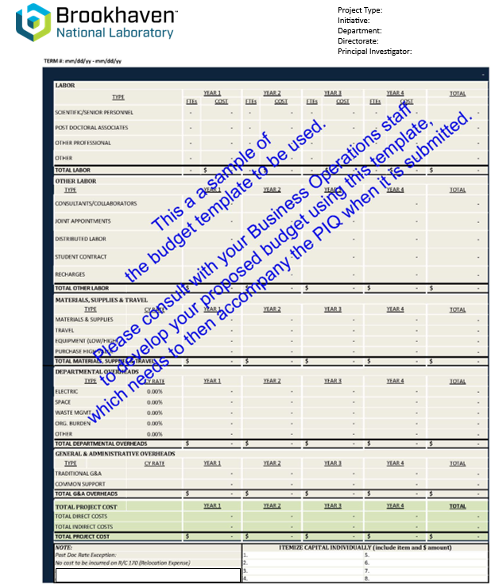

APPROVALS

Business Operations Manager Signature

Department Chair/Division Manager Signature

To the Department Chair/Division Manager:
Please indicate if this project is a sensitive technology under the S&T Risk Matrix. (Note: Red projects require an Access Management Plan.)

☐Green
☐Yellow
☐Red
☐Not Applicable

Associate Laboratory Director for
Nuclear and Particle Physics Haiyan Gao

