Commissioning,
Maintenance and Operation of the ePIC Experiment at the EIC

prepared by:
Abhay Deshpande, Rolf Ent, John Lajoie and Rosario Nania
April 30, 2024

Commissioning, Maintenance & Operation of the ePIC
Experiment at the EIC

Overview

Purpose of this document

The EIC Resources Review Board (EIC-RRB) provides coordination among the different funding partners both during the ePIC detector development and construction phase of the project and during the operations of the experiments that follow. This will include common computing needs of the ePIC detector. The RRB provides oversight of resources utilized for detector construction and planning. The RRB functions as the body that reaches agreement on scope entailed in common projects, as appropriate, which shall be funded by Funding Agencies of the RRB. The RRB is responsible for annually agreeing on and endorsing detector financial commitments from the members. The RRB will monitor progress toward overall detector funding and construction.

The EIC-RRB has the dual authority to evaluate funds to the ePIC collaboration and to monitor the use of those funds. Separate international agreements are pursued that will define costs and funding commitments for constructing the ePIC detector.

Maintenance and Operation (M&O) costs of the experiment are incurred not only when the detector is running but also during construction and commissioning. Institutes and
agencies committed to supplying ‘deliverables’ as defined in separate agreements have implicit responsibility for M&O costs associated with construction and commissioning of those items. In addition, M&O for general infrastructures and items shared among the different detector systems should be considered as common costs and should be divided among the funding agencies. The purpose of this document is to define responsibilities for M&O costs and a foreseen timetable, and to outline the responsibilities of the US as host country for the EIC.

Contents of this document
The information in this document is presented for initial consideration by the EIC-RRB. Further M&O agreement should then emerge from the joint deliberations of the Funding Agencies (FAs), the ePIC Collaboration and the EIC Partnership Host Labs Management.

The document contains a draft list of items that incur M&O costs to operate the ePIC experiment. Ultimately this list will define what is included and is not included in the M&O agreement(s). It will cover material costs, any personnel costs related to detector operation that are either ’billed’ (e.g., outsourced manpower) or external (e.g., the use of personnel for tasks directly and exclusively to do with ePIC detector M&O), and computing-related costs. In a future iteration we plan to include preliminary estimates of the total cost of operating the ePIC experiment.

Possible algorithms for sharing M&O costs are outlined with some consequences of
adopting different schemes.

Timetable
This document is prepared to guide first discussions at the RRB in May 2024. It is hoped that those discussions, followed up by the written exchange of comments, will allow a further iteration of the document for the RRB in late 2024, and provide the seeds that can be used in further agreements between the EIC host labs and the agencies.

Period of validity
This document is aimed at preparing agreement to cover the M&O costs during ePIC detector construction, commissioning, and operations. It is assumed to start from 2028 onwards to allow time for the funding agencies to prepare. Costs for the period 2025-2027 can be handled ‘informally’ as has been the case hitherto. An assumption has been made for how costs and funds will evolve in time from construction to running. It is anticipated that the actual M&O costs will be updated annually for approval by the EIC-RRB.

Governance Model

The EIC is a US-based collider. DOE and the host labs promote the EIC as a facility that is fully international in character with the EIC-RRB to provide oversight of resources utilized for detector construction, operations, and planning. To set the stage towards costs, we give here a short description of the key governance principles:
- US DOE finances EIC accelerator operations, determines number of operations weeks and schedule.
- US DOE supports the host labs’ administrative and technical staff and the infrastructure costs for the experiments.
- DOE and non-DOE participate in and finance the governance of the experimental program including construction and upgrades, maintenance and operations (M&O), and distributed software and computing.
- BNL and TJNAF, as the co-hosts for the EIC Experimental Program, convene nominally twice a year the EIC-RRB as international oversight body.

Costs

The EIC-RRB must concur that all M&O costs are correctly itemized and that there is a
reasonable framework for an equitable cost distribution among the participating
countries, agencies, and institutes. It will be the ongoing task of the EIC-RRB to oversee the provision and spending of M&O monies and to take action if problems arise with cash flow, contributions, crises or the evolution of responsibilities. It seems likely that in some cases the EIC-RRB will have to endorse in-kind rather than cash contributions to M&O costs.

Appendix A is a draft list of items incurring M&O costs with tentative categorization that the EIC-RRB should scrutinize for completeness and correctness. Appendix B contains preliminary projected estimates of percentages of the total M&O costs for the years 2028 to 2037. This timeline is based on a timeline of actuals of the M&O of the CERN-LHC experiments. The projected timeline assumes EIC construction and early detector arrival to start after 2025, EIC pre-operations to start in the early 2030s, and completion of the EIC Project and start of EIC science operations in 2035. The translation into preliminary estimates of M&O costs will happen in the next months.

Cost categories
There are three categories of M&O costs according to the items involved. These categories define responsibilities for covering the costs. A fourth category D recognizes that the EIC is a US-based collider which comes with some natural host responsibilities.
- Category A concerns equipment built and maintained using Common Funds e.g. magnets, or services and operations common to the whole experiment e.g. software licenses.
- Category B concerns maintenance of equipment built by a sub-set of the collaboration, mainly sub-detectors.
- Category C concerns collaboration support using Common Funds, e.g., support for travel and as-needed time for key Collaboration functions, local co-support of travel for visiting scientists, and general support for a global strategy to allow for underprivileged scientists to participate in EIC science.
- Category D concerns items for which the DOE and US host laboratories would naturally assume responsibility for, e.g. costs to run the accelerator which sets the weeks of operations and schedule, infrastructure for the experimental areas and experiments and infrastructure operations costs, survey and alignment, and the overall Environmental, Health, and Safety aspects for detector operations.

The Funding Agencies (FAs) and Collaborating Institutes (CIs) will be apportioned a share of Category A costs, and of Category B costs for any specific projects in which they participate. The FAs and CIs will also be apportioned a share of Category C costs. DOE and the host laboratories will pay the Category D costs. Concerning Category A, B and C costs, the host laboratories will be treated as the other CIs.

Cost sharing
The goal is to reach an equitable sharing of M&O costs and to find effective methods of
managing and monitoring the funds. Several algorithms have been commonly used to cover M&O costs of experiments in high energy physics, namely sharing by number of scientists (authors), sharing by scientists in the collaboration with a PhD-equivalent level degree, and sharing by costbook (capital investment). Cost-sharing algorithms may be different for category A, B and C items.

Category A items
Sharing by scientists rather than by costbook is popular as it is linked directly to the exploitation of a detector and is perceived to be a fair measure of benefit. To fold in the educational and more transient character of students, ’scientists’ are taken to be fully-qualified PhDs, or the equivalent, appearing as named authors on publications of the collaboration. This implies that a reference publication is defined annually.

Category B items
For Category B items a sharing with a different cost-sharing algorithm may be more appropriate. FAs and CIs can retain responsibility for their own category B costs and sharing can vary with sub-system. Because many ePIC sub-systems have multiple participants, the institutes participating to a given detector sub-system will propose a sharing of the M&O costs as agreed among themselves, and the EIC-RRB will make sure this proposal can be accepted. The ePIC collaboration will have to manage and monitor costs and funds, as the RRBs will do for category A items. It will be incumbent on the spokesperson to guarantee the integrity of all sub-systems to the Collaboration, the RRB and the host laboratories, and to demonstrate that there is sufficient provision for M&O, e.g. via a document presented annually to the RRB. In addition, a recovery plan must be agreed in case of a disaster in any one sub-system, and the threshold at which intervention will occur must be defined.

Category C items
Category C items can be handled in the same way as category A items, as a sharing with scientists with a PhD-equivalent level. The cost-sharing mechanism may be chosen to differ from that used for category A items to take into account the special role of the DOE host laboratories to host the ePIC collaboration and visiting scientists, and to encourage participation in ePIC detector operations of underprivileged scientists.

Fair Sharing
There are several groups of participants in the ePIC experiment and contributions may differ. Some examples are listed below.

- Participants that have contributed to building the EIC machine and those that have not so contributed.
- Participants that have contributed to the ePIC detector and/or possible upgrades by in-kind sub-system contributions or by intellectual contributions.
- Participants that have provided labor or have provided direct equipment scope.
- Participants that provide contributions to the ePIC distributed computing.
- Participants that belong to RRB member FAs or participants that belong to RRB non-member or observer status.

It is important that all participants are treated in a transparent way and that due recognition is given for their contributions. Specific situations will be evaluated by the EIC-RRB.

Rebates
A possible way of recognizing contributions to the machine and/or to the distributed computing is via ’rebates’, whereby DOE pays part of the category A bill of contributors. The total rebate would be fixed.

Flexibilities
It is understood that the financial situation in each member and non-member (observer) country that participates in the EIC-RRB may be different. There should be some means for the EIC-RRB to apply flexibility in contributions to the M&O Common Funds. For example, the contributions of various agencies to common-funded detector construction, to planned future detector upgrades, or to the EIC distributed computing and software may be different. The EIC-RRB can fold this into their determinations of equitable sharing of M&O costs at their bi-annual meetings.

APPENDIX A: Table outlining the items incurring M&O costs during the construction, pre-operations, and operations of the EIC experiments, with PROPOSED categorization.

Detector related costs  Gas consumption  M&O of gas systems  M&O of cooling systems (incl. consumption)  M&O of moving/hydraulic systems  Shutdown maintenance and operation  Magnet power supply maintenance  UPS maintenance for common systems  Sub-detector electronics maintenance  Beam pipe  Counting & control rooms  Test and Diagnostic Equipment | A  A  A  A  A  A  A  B  A  A  A | Test beams and calibration facilities  General operation  Upgrades  Common electronics and DAQ  Test and Diagnostic Equipment  Counting & control rooms | A  A/B  A  A/B  A
Computing  Recording media  Computing services*  Detector controls  Computer/LAN maintenance/replacement  System management  Software license fees  Common desktop infrastructure  Data management | A  A  A  A  A  A/B  A  A | Special Services*  Laboratory instruments  Test and Diag. Equipment  Assembly and active storage areas  Workshops  Cooling, ventilation, and pumps  Heavy transport  Cranes  Transportation  Passive storage space  Engineering  Detector safety systems | A/B  A/B  A/B  A/B  A/B  A  A  A  A/B  A  A
 |  | Communications  Cellular phones  Videoconferencing | A/B  A/B
Collaboration Secretariats  Photocopying machines, fax, printers  Printing and publication costs  Secretarial assistance  Support for Visiting Scientists  Support for Collab. Positions  (Technical and Resource Coordinators, etc.) | A  A  A  C  C | Outreach  Outreach events and activities | C

* These items are intended to cover specific exceptional needs that go beyond what would ordinarily be expected to be covered by the host laboratories.

APPENDIX B: Estimates of combined M&O costs (To be further worked out after the May 2024 RRB)

A timeline to achieve full M&O costs in terms of percentages of total M&O costs for Category A items. This timeline is based on a timeline of actuals of the M&O of the CERN-LHC experiments. The projected timeline assumes EIC construction and early detector arrival to start after 2025, EIC pre-operations to start in the early 2030s, completion of the EIC Project and start of EIC science operations in 2035.

A timeline to achieve full M&O costs in terms of percentages of total M&O costs for Category B items. The category B costs are assumed to be flat after installation. The projected timeline assumes detector installation to be completed by 2030 and EIC pre-operations to start in the early 2030s.

A timeline to achieve full M&O costs in terms of percentages of total M&O costs for Category C items. This timeline is presently assumed to be similar as that for Category A items as the support of people naturally coincides with the various early construction, installation, pre-operations and science operations activities. The projected timeline assumes EIC construction and early detector arrival to start after 2025, EIC pre-operations to start in the early 2030s, completion of the EIC Project and start of EIC science operations in 2035.

APPENDIX C: EIC Resources Review Board Charter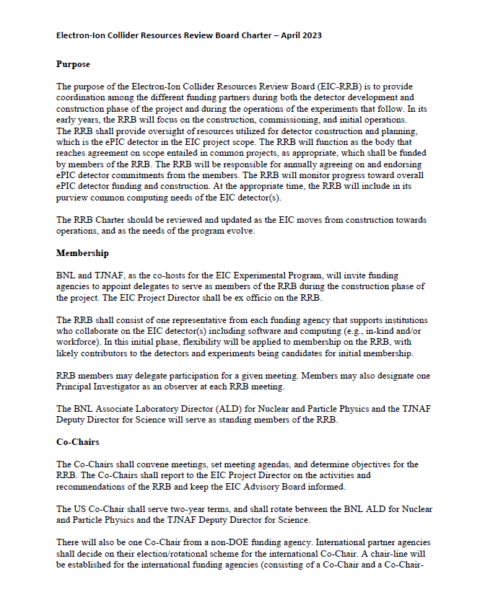
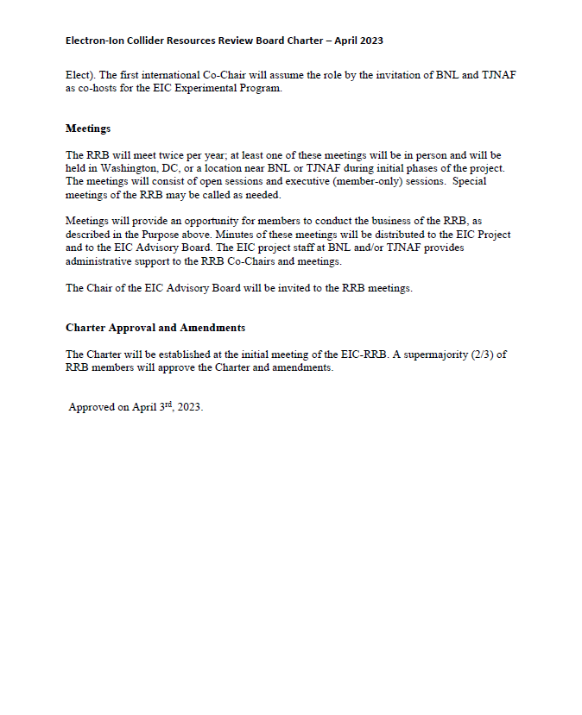

The present draft relates to the ePIC experiment but can also serve as model for a potential future second EIC detector.

