Second draft reply to be sent on February 21, 2023 (ZY):
Dear Thomas,
Please find below the updated report defining the specification for forward- and barrel-ToF AC-LGADs as well as Roman Pots. Answers to the five questions in your letter dated on December 13, 2022, are highlighted.
Q1. What is the occupancy of the system and how does this impact the pixelization of the systems?
Q2. What material budget is tolerable based on the performance of the detectors sitting behind ToF systems?
Q3. To what momentum can one separate 𝜋, K, p and e at the 3-sigma level for real DIS events?
Q4. How are the services impacted by the final pixelization of both systems?
Q5. What requirements does the TOF system have on other systems, i.e. tracking, DAQ, electronics?
The ePIC AC-LGAD ToF PID system includes Barrel and Forward ToF detectors. The current design of the BToF uses strip sensors with 500-micron pitch and 1-cm length, while the FToF uses pixel sensors with 500-micron pitch. Pixel sensors with 500-micron pitch are also used in the far-forward detector system, including the B0 tracking and Roman Pot detectors. For these detectors, 25-30 ps timing resolution, and 30-micron spatial resolution in the direction with 500-micron pitch are assumed for each hit. The material budget for the BToF (FToF) is 1% (8%) X₀, while that for the B0 tracker is 5% X₀. The table below summarizes these design parameters.

 | Area (m²) | Channel size (mm²) | # of channels | Timing resolution | Spatial resolution  (μm) | Material budget
Barrel TOF | 11 | 0.5*10 | 2.4M | 30 ps | 30 in r∙φ | 0.01 X0
Forward TOF | 2.2 | 0.5*0.5 | 8.8M | 25 ps | 30 in x and y | 0.08 X0
B0 tracker | 0.07 | 0.5*0.5 | 0.28M | 30 ps | 30 in x and y | 0.05 X0
Roman Pots | 0.14 | 0.5*0.5 | 0.56M | 30 ps | 140 in x and y | no strict req.
(Q3) A 25-ps timing resolution from ToF hits, combined with a 20-ps resolution in the start time, provides 3-sigma level separation between electron and pion, pion and kaon, kaon and proton at momentum p<0.5, 1.8 and 3.1 GeV/c by the BToF, and 0.8, 2.7 and 4.6 GeV/c by the FToF, respectively [1]. Shown as an example in the left panel of Fig. 1 is the BToF PID performance in DIS events, obtained from ePIC DD4Hep+Jana2 simulation framework. The timing resolutions, path-length and momentum uncertainties from track reconstruction are considered. The BToF PID performance with 35-ps resolution from ToF hits and 20-ps resolution in the start time is also shown for comparison.
The spatial resolution of AC-LGAD sensors strongly depends on the pitch size and is constrained by signal sharing. The doping of the resistive n+ layer has been optimized for 500-micron pitch sensors for signal sharing, which provides a spatial resolution around 30 microns from test beam [8]. With such a spatial resolution, the BToF can improve the momentum resolution when hits from the outermost MAPS layer are missing (see the right panel of Fig. 1) [2]. The FToF at Z=1.9m with 30-micron spatial resolution in both x and y directions is expected to improve track reconstruction in the forward direction.
An ideal AC-LGAD detector has optimized timing and spatial resolutions, while minimizing the power consumption and material budget. These requirements compete and may not be reached at the same time. For example, the overall timing resolution of LGAD detectors can be described by the following formulas:
$σ_{t}^{2}=σ_{ionization}^{2}+σ_{jitter}^{2}+σ_{TDC}^{2}+σ_{clock}^{2}$,
where $σ_{ionization}$ is from random variation of particle energy deposition in the LGAD sensor determining the signal amplitude and shape, $σ_{jitter}$ is associated with frontend electronics, $σ_{ionization}$ from finite TDC bin width, and $σ_{clock}$ from clock distribution. The jitter term is inversely proportional to signal amplitude, and proportional to signal rise time and to sensor input capacitance. With a sensor design with more charge sharing optimized for better spatial resolution, the jitter term becomes larger due to smaller signal amplitude, which could degrade the overall timing resolution when the jitter term is the dominant contribution. From the FY22 R&D studies, which focused on sensor development, we have found that AC-LGAD sensors are promising to provide the needed timing and spatial resolutions of the abovementioned baseline design. The goal of the R&D in FY23 and beyond is to determine detector designs combining the sensor, frontend ASIC, backend electronics and mechanical supporting structure that balances among the timing resolution, spatial resolution, material budget (and cost), and optimized for EIC physics.
An important factor that affects the detector design is the pitch of the electrodes, which is constrained by the signal sharing in the AC-LGAD sensor. With the current doping of the resistive n+ layer, we have found that 500-micron pitch is optimal. We plan to study whether or not larger pitch sizes (e.g., 800 microns or larger) will still allow sufficient signal sharing with different values of the n+ doping. The pixel pitch and length of strip sensors also limit the time resolution due to the dependence of the jitter term on the sensor input capacitance. A larger electrode pitch and/or strip length corresponds to larger capacitance and thus a larger jitter term contribution to the overall timing resolution. It has been found from test beam [8] that the strip AC-LGAD sensor from the 1st BNL production for EIC with 500-micron pitch and 1-cm strip length provide a reasonably good timing resolution between 32-36 ps, while sensors with 500-micron pitch and 2.5-cm strip length have a worse timing resolution of around 51 ps. In FY23, we plan to look into sensor design optimization to improve the timing resolution by 1) reducing the sensor thickness and thus the $σ_{ionization}$ contribution, 2) increasing the AC-LGAD sensor gain and thus the signal amplitude to reduce the $σ_{jitter}$ term. Through these changes, we will seek to improve the timing resolution for sensors with larger pixel pitch and/or longer strip length, which can reduce the number of channels and thus cabling and power consumption. (Q4) For example, for the FToF baseline design with 500-micron pitch pixel sensors, 424 HV+LV cables and 212 optical fibers will be needed, while the total power consumption can be as large as 13.6 kW. With a coarse pixel pitch of 800 microns, the number of cables can be reduced to 248 HV+LV cables and 124 fibers, with the total power consumption reduced to 6 kW assuming the same power consumption of 1 mW/channel for the frontend ASIC [4]. The power consumption might be further reduced to 3 kW with 1.3 mm pixel pitch, which can help reduce the 8% X₀ material budget for the FToF if needed. The table below summarizes the impact of pixelization on the FToF service. We note that for the BToF, increasing the pitch size would have a similar impact on power consumption but will not reduce the number of cables or fibers, which is fixed by the BToF modular design.

Pixel size (mm²) | # of pixels | # of HV cables | # of LV cables | # of fibers | Total power consumption (kW)
0.5*0.5 | 8.8M | 424 | 424 | 212 | 14
0.8*0.8 | 3.4M | 248 | 248 | 124 | 6
1.3*1.3 | 1.3M | 144 | 144 | 72 | 3
The material budget for the BToF (FToF) is 1% (8%) X₀. A breakdown of the contributions to the material budgets can be found in [10], with the dominant contribution from the cooling and mechanical supporting structure. (Q2) We don’t anticipate a significant change in the material budget for the BToF, which is optimized to be around 1% X₀ and the impact on the performance of the DIRC and barrel EMC calorimeter is acceptable.
- The barrel DIRC detector is designed to provide PID at relatively large momentum, e.g. 3-sigma pi/K separation up to 6.5 GeV/c. To achieve such performance, the track angular resolution at the surface of the DIRC has been assumed to be 0.5 mrad in DIRC simulation. Multiple scattering through 1% X₀ material leads to $≥$0.5 mrad smearing for particles with momentum below 3.2 GeV/c [5]. If the BToF material budget increase to 2% (4%) X₀, the smearing would be $≥$0.5 mrad for particles with momentum below 4.6 (6.8) GeV/c [5], which could deteriorate the DIRC PID performance. We note that a simulation study for the track angular resolution for DIRC was only very recently completed [11], and more detailed studies are needed involving not only tracking but also DIRC.
- The BTOF is placed at the radius around 65 cm, about 15 cm away from the front surface of the barrel EM calorimeter. The impact of the BToF material on the performance of the barrel EM calorimeter is negligible according to [6].
(Q2) We foresee a possible need to reduce the material budget for the FToF, corresponding to 8% X₀ material in front of the dRICH and forward EM calorimeter.
- The dRICH is designed to provide PID at relatively large momentum, e.g. more than 3-sigma pi/K (e/pi) separation between 3-60 (1-15) GeV/c. To achieve such performance, the track angular resolution at the entrance of the dRICH is assumed to be 1 mrad. Multiple scattering through 8% X₀ material leads to $≥$1 mrad smearing for particles with momentum below 5 GeV/c [5]. If the FToF material budget reduces to 4% X₀, the smearing would be less than 1 mrad for momentum above 3.4 GeV/c [5], which would be consistent with the assumed angular resolution for the dRICH momentum coverage. We note that a simulation study for the track angular resolution for dRICH was only very recently completed [11], and more detailed studies are needed involving not only tracking but also dRICH.
- The FToF is placed at z=190 cm, about 140 cm in front of the forward EM calorimeter. A detailed simulation with ePIC software is still to be done, but according to [6], the impact of the FToF material on the forward EM calorimeter may not be negligible.
For the Roman Pots system, the current design assumes the needed pixelization (500-micron pitch pixels) for both cable and power, and material budget is not a major issue since the protons being measured are at approximately the beam energy. For the AC-LGAD timing layer in the B0 tracking system, it uses the same pixel sensors as the Roman Pots. Note that the core tracking layers in B0 require ~10-micron resolution, or better, which is achieved by the three MAPS layers. The AC-LGAD layer provides redundant tracking information, but more-importantly the timing information needed for background rejection. A maximum of 5% X₀ is tolerable for the material budget before noticeable impact on the tracking resolution is observed.
(Q1) With the fast rise time (300-500 ps) and short signal integration time (<10 ns) in the AC-LGAD sensor [8], the occupancies in the TOF and Far-Forward AC-LGAD detectors is expected to be very small. For the BToF (FToF), the average number of hits per event from neutral-current DIS events in 18 GeV electron+275 GeV proton collisions is found to be around 3.7 (2.4), while the maximum number of hits per event is around 140 (40) from 65k DIS events [3] (see Fig. 3 and 4), which are still negligible compared to the total number of channels, i.e., 2.4M (8.8M) in the BToF (FToF). We note that the signal hit rate dominates over the background hit rate in the ToF detectors. Assuming the rate of DIS events is 500 kHz, the total signal hit rate is around 2 MHz (1 MHz) in the BToF (FToF), while the background hit rate is around 1 MHz (0.1 MHz) from electron beam-gas interactions, 0.1 MHz (0.01 MHz) from proton beam-gas interactions, and 10 kHz (1 kHz) from synchrotron radiation [9].
For the Roman Pot detector, the occupancy is driven by the actual physics rate and backgrounds. The latter are mostly driven by beam gas when the detector is placed at 10-sigma from the hadron beam. The total rates are around 505 kHz, assuming the best-case scenario for vacuum quality in the Roman Pots region but could be as high as 550 kHz if the vacuum is less pure. Given what is known about the vacuum profile and DIS event rate, the expected occupancy in Roman Pots will be much smaller than 1%.
The TOF PID relies on the calculation of $β$, namely the path length divided by the time-of-flight. The relative uncertainty of the time-of-flight, which is given by the difference between the time of arrival of particles at the TOF detector and the start time, ranges between 0.5-1% for the BToF, and around 1.5% for the FToF. (Q5) The path length, which has to be obtained from track reconstruction, should have an uncertainty much smaller than the time-of-flight uncertainty so that it does not degrade the TOF PID performance. An early study based on Fun4All indicates that the path length uncertainty is better than 0.1%, which is negligible compared to the contribution from timing resolution [7].
(Q5) For BToF that uses strip sensors, the dependence of measured Time-of-Arrival on the hit position along the strip direction (z) needs to be corrected. From the first test beam in 2022, an additional 5 ps contribution to the timing resolution was found from 0.5 mm uncertainty in z. The contribution would increase linearly to 10 ps with 2.5 mm uncertainty in z. The impact on the BToF PID performance from this contribution has been studied with the latest ePIC DD4HEP+Jana2 simulation framework and is found to be small but non-negligible, as shown in Fig. 2. We will try to understand and reduce this contribution in future sensor R&D.
(Q5) TOF requires a precise clock distribution to the frontend readout ASIC. To have negligible contribution from the clock signals, a 5 ps clock jitter is necessary which puts a requirement to the DAQ System and its clock distribution scheme. Such low jitter clock schemes were already developed by the CERN High Precision Timing Project and were presented multiple times at DAQ WG meetings. The DAQ WG already started a Timing Subgroup which is tasked with replicating and then evaluating the CERN scheme within ePIC. Note that this jitter requirement is not particular to AC-LGAD or TOF but is shared with any other detector/technology which provides very precise timing information e.g., LAPPD.
(Q5) Data rate requirements of the TOF detector from the DAQ system have been known to the DAQ WG for some time. These requirements are: 500 Readout Boards (RDO) with 1 fiber each for a total of 500 fibers. Those fibers are connected to 12 DAQ DAM boards (e.g. “FELIX”). The data rate on the fiber is 6 Gb/s in the worst case.
References
[1] Presentation by O. Hartbrich at ePIC collaboration meeting on January 11, 2023.
https://indico.bnl.gov/event/17621/
[2] Presentation by S. Maple at ePIC tracking working group meeting on December 15, 2022.
https://indico.bnl.gov/event/17752/
[3] Presentation by S. Yano at eRD112 meeting on January 18, 2023.
https://indico.bnl.gov/event/18076/
Presentation by Z. Ye at ePIC TOF WG meeting on February 20, 2023.
https://indico.bnl.gov/event/18474/
[4] Presentation by W. Li at ePIC TOF integration meeting on September 30, 2022.
https://indico.bnl.gov/event/17336/
[5] Passage of Particles Through Matter, Particle Data Group.
https://pdg.lbl.gov/2022/reviews/rpp2022-rev-passage-particles-matter.pdf
[6] Presentation by A. Bazilevsky at ATHENA tracking group meeting on Aug 31, 2021.
https://indico.bnl.gov/event/12597/
[7] Presentation by W. Fan at ATHENA PID group meeting on October 11, 2021.
https://indico.bnl.gov/event/13523/
[8] C. Madrid et al., First survey of centimeter-scale AC-LGAD strip sensors with a 120 GeV proton beam, arXiv:2211.09698.
[9] Presentation by R. Cruz-Torres at ePIC collaboration meeting on January 10, 2023
https://indico.bnl.gov/event/17621/
and at ePIC Background Task Force meeting on January 20, 2023.
https://indico.bnl.gov/event/18052/
[10] Presentation by N. Schmidt at ePIC TOF WG meeting on August 8, 2022.
https://indico.bnl.gov/event/16607/
[11] Presentation by N. Schmidt at ePIC TOF WG meeting on February 13, 2023.
https://indico.bnl.gov/event/18422/

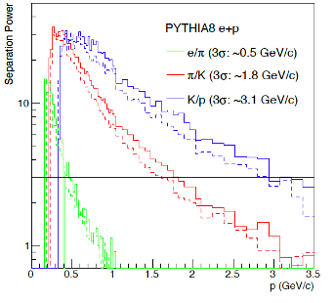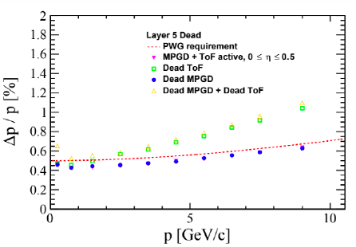
Figure 1. Left: Barrel TOF PID performance in Pythia DIS events. The solid (dashed) lines show the separation power for e/𝜋, 𝜋/K, K/p with 20 ps start time and 25 (35) ps TOF hit resolution. Right: momentum resolution when hits from the outermost MAPS layer are missing.
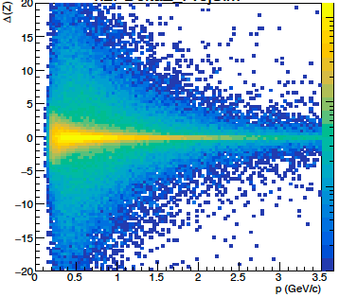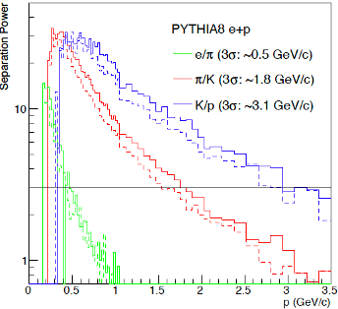
Figure 2. Left: difference between reconstructed and true BToF hit position along the z direction. Right: Barrel TOF PID performance in Pythia DIS events. The solid (dashed) lines show the separation power for e/𝜋, 𝜋/K, K/p with (w/o) the additional contribution from the z position of the BToF hits.
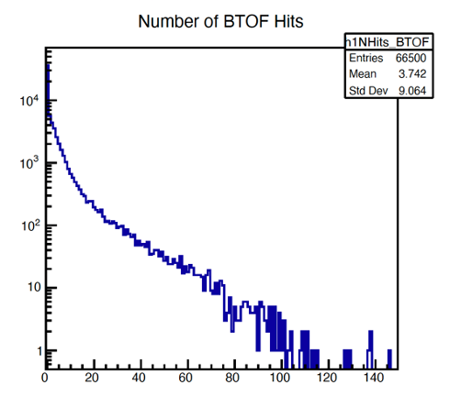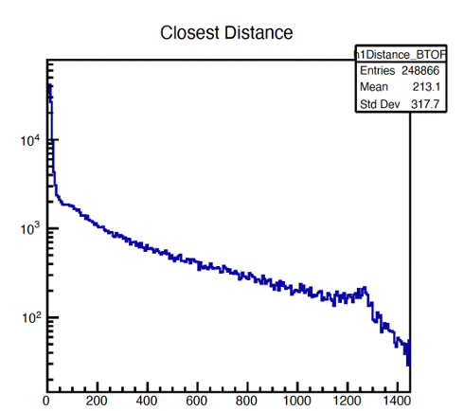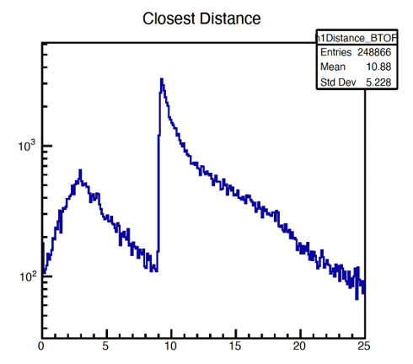
Figure 3. BToF occupancy from 66.5k neutral current DIS events in 18 GeV electron+275 GeV proton collisions. Left: number of BToF hits per event. Middle: closest distance in units of mm to another BToF hit for each BToF hit. Right: same as middle with a zoomed-in view. The timing difference between the two BToF hits is required to be larger than 10 ps. The 10 ps cut is introduced to remove pair of hits that cannot be resolved by the ToF due to limited timing resolution anyway.
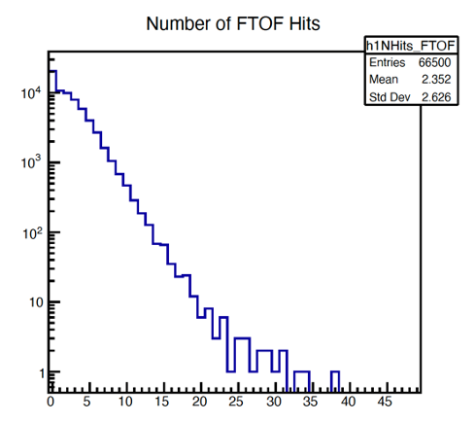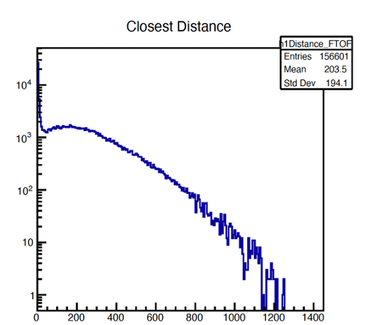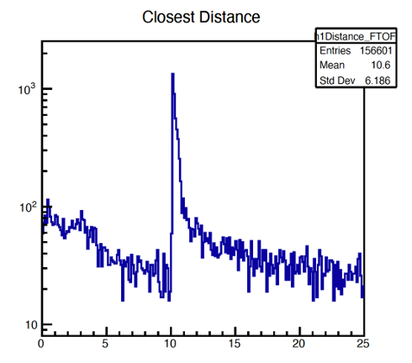
Figure 4. Same as Figure 3 but for the FToF.

Please include your name when you write the answers/comments.
Follow-up questions from Thomas (Jan 24, 2023)
On Q1:
We probably need a tic more than "will be very small". The background will play a role, likely a dominant one. What is the integration time and signal shaping time for the ToF which impacts this as well. Please provide numbers and plots. Plots on occupancy and distance between hits.
On Q2:
You really do not answer this. "it is 1% for the barrel which has negligible impact" and "is under study". We need to know what an acceptable material budget is. Without knowing this it is difficult to define R&D. We need something quantitative here. Also, please outline the material budget composition. How do we get to 1%? How do we get to 8%?
On Q4:
You simply list the cabling/services info but do not address how the services are impacted by the pixelization in detail. You give one example for 800x800 instead of 500x500. May be a table which lists HV, LV, and fibers for a set of sizes (incl. strips).
[Wei]
Here are a few more questions:
(a) Is it not that the timing resolution due to charge sharing gets worse? So are tracking goals and tof goals in contradiction? If so there must be an optimal balance. (See also below)
[ZY] Yes
(b) The argument about charge sharing for a ToF is odd. Isn't this only relevant for tracking to get a better position resolution? What is the pixel size needed for ToF, not for tracking (independent of the background). Say we ignore tracking, what is the optimum for ToF? Then one can consider tracking but then one needs to understand the interplay between ToF and pixel size, or? Please provide numbers for the ToF application and then give numbers for TOF+tracking.
[Jenni/Simone] larger pads have larger input capacitance …
Best ToF is related mainly on the sensor thickness, 50um have a Landau limit on the time resolution of ~30-35 ps and 20um can go <20ps. Jitter component of the time resolution is usually <10ps for high gain. With a 20um device it’s complicated to have large DC-pads since the input capacitance to the amplifier would be very large. To give an example the ATLAS timing chip is designed to have ~4pF of input capacitance, the sensor pad is 1.3x1.3 mm and 50um. To reproduce the same chip for a 20um device the input capacitance would be 10pF+, which increases the noise (and the signal is intrinsically lower for a 20um device), limiting the time resolution from the Jitter component. To adapt the chip it would be needed to increase the power consumption to work with higher capacitances. Current EIC chips are optimized for ~1pF (not sure about this statement for EICROC, we have to check), for 20um that would mean pads of 150x150um or less. With AC-LGADs the advantage is that you can have a 500x500um pitch device but the actual pads are 100x100um (so lower capacitance) are rely on charge sharing to have better resolution, same with strips (using narrow strips).
The Jitter componet of the time resolution in a strip sensor where the signal is shared by two strips ~equally is worse by a factor of sqrt(2) (this is because the signal is shared, so Pmax/2 but the timestamps are combined so it’s 2/sqrt(2)). If the signal is mainly on one strip the Jitter is roughly the same But the final limit is still set by the Landau component, so if the sensor is operated with lar.ge gain to minimize the Jitter component (usually 10ps) the total time resolution would be roughly the same with and without charge sharing. In case of pads (charge shared by 4 pads) the Jitter is worse by a factor 2 (4/sqrt(4)).
(c) what are the numbers for 500 micron x 2.5 cm strips? The draft says it's not great but lacks numbers.
[Zhenyu]
(d) It is our understanding that the B0 has one layer AC-LGAD for timing, for tracking a 500 micron pixel is not good enough that’s why one uses MAPS detectors there. Correct? What's the role of the pixel size then?
[Alex] Indeed, the core tracking layers require ~10um resolution, or better, but this is most-important for 3 of the 4 tracking layers (along with sufficient longitudinal separation), such that a sagitta can be measured. The AC-LGAD layer provides redundant tracking information, with a reduced spatial resolution, but more-importantly it provides timing information needed for background rejection. A fully AC-LGAD system would of course not have the required spatial resolution.
(e) The track/path length uncertainty enters in the time/mass resolution. Right now, nobody knows the path length uncertainty as we do not have truth seeding and this impacts how well you track gets reconstructed. What is your requirement?
[Zhenyu] timing resolution sqrt(25*25+20*20) ps / 2 ns = 0.01. Path length uncertainty is 0.001. Making some plots showing PID performance
Overall a table summarizing these things would be nice, pixel size limitation, timing and position resolution etc. Tables often save many words ;-) Also a table on what you think the specifications (as acceptable for an integrated EIC detector) are and what you work towards in the R&D.

First draft reply sent on January 23, 2023 (ZY):
Dear Thomas,
Please find below the report defining the specification for forward- and barrel-ToF AC-LGADs as well as Roman Pots. Answers to the five questions in your letter dated on December 13, 2022, are highlighted.
Q1. What is the occupancy of the system and how does this impact the pixelization of the systems?
Q2. What material budget is tolerable based on the performance of the detectors sitting behind ToF systems?
Q3. To what momentum can one separate 𝜋, K, p and e at the 3-sigma level for real DIS events?
Q4. How are the services impacted by the final pixelization of both systems?
Q5. What requirements does the TOF system have on other systems, i.e. tracking, DAQ, electronics?
The ePIC AC-LGAD TOF PID system includes Barrel and Forward TOF detectors. The BToF uses strip sensors with 500-micron pitch and 1-cm length, while the FToF uses pixel sensors with 500-micron pitch. Pixel sensors with 500-micron pitch are also used in the far-forward detector system, including the B0 tracking and Roman Pot detectors. For these detectors, 25-ps timing and 30-micron spatial resolutions in the direction with 500-micron pitch are assumed for each hit. The material budget for the BToF (FToF) is 1% (8%) X₀.
The 25-ps timing resolution from ToF hits, combined with a 20-ps resolution in the start time, provides 3-sigma level separation between electron and pion, pion and kaon, kaon and proton at momentum p<0.5, 1.8 and 3.1 GeV/c by the BToF, and 0.8, 2.7 and 4.6 GeV/c by the FToF, respectively [1]. Shown as an example in the left panel of Fig. 1 is the BToF PID performance in DIS events, obtained from ePIC DD4Hep+Jana2 simulation framework. The timing resolutions, path-length and momentum uncertainties from track reconstruction are considered. The PID performance with 20-ps resolution in the start time and 35-ps resolution from BToF hits is also shown for comparison.
The spatial resolution of AC-LGAD sensors strongly depends on the pitch size and is constrained by signal sharing. The doping of the resistive n+ layer has been optimized for 500-micron pitch sensors for signal sharing, which provides a spatial resolution around 30 microns from test beam. With such a spatial resolution, the BToF improves the momentum resolution when hits from the outermost MAPS layer are missing (see the right panel of Fig. 1) [2]. The FToF at Z=1.9m with 30-micron spatial resolution in both x and y directions is expected to improve track reconstruction in the forward direction.
The occupancies in the TOF and Far-Forward AC-LGAD detectors will be very small. For the BToF (FToF), the average number of hits per event is found to be around 5, while the maximum number of hits per event is around 80 (60) from 10k DIS events in 18 GeV electron+275 GeV proton collisions [3], which are negligible compared to the total number of channels, i.e., 2.4M (8.9M) in the BToF (FToF). For the Roman Pot detector, the occupancy is driven by the actual physics rate + backgrounds. The latter are mostly driven by beam gas when the detector is placed at 10-sigma from the hadron beam. The total rates are around 505 kHz, assuming the best-case scenario for vacuum quality in the Roman Pots region but could be as high as 550 kHz if the vacuum is less pure. Given what is known about the vacuum profile and DIS event rate, the expected occupancy in Roman Pots will be much smaller than 1%.
The pitch size of the sensors is constrained by the signal sharing in AC-LGADs. With the current doping of the resistive n+ layer, we have found that 500-micron pitch is optimal. We plan to study whether or not larger pitch values (e.g. 800 microns or larger) will still allow sufficient signal sharing with different values of the n+ doping. The length for strip sensors is limited by time resolution. It has been found from test beam that the sensor performance with 500-micron pitch and 1 cm strip length is sufficiently good while sensors with 500-micron pitch and 2.5-cm strip length have considerably worse resolution. We plan to continue optimizing the sensor design with coarse pitch and larger strip length, which can reduce the number of channels and thus cabling and power consumption. For example, for the FToF baseline design with 500-micron pitch pixel sensors, 424 HV+LV cables and 212 optical fibers will be needed, while the total power consumption can be as large as 13.6 kW. With a coarse pixel pitch of 800 microns, the number of cables can be reduced to 248 HV+LV cables and 124 fibers, with the total power consumption can be reduced to 6.1 kW [4]. The lower number of cables and power consumption (and thus cooling) can help reduce the material budget, which is 1% (8%) X₀ in the current BToF (FToF) design.
We don’t foresee making a significant reduction in the material budget for the BToF, which is already optimized to be around 1% X₀ and has negligible impacts on the performance of detectors behind it. The impact on the barrel DIRC mainly comes from the multiple scattering effect. The smearing of the particle incident angle after particles passing through 1% X₀ material is below 1 mrad for p>1.6 GeV/c [5]. The impact of the BToF material on the performance of barrel EM calorimeter is negligible [6]. The impact by the FToF material on the performance of dRICH and forward EM calorimeter is under study.
For the Roman Pots system, the current design assumes the needed pixelization (500-micron pitch pixels) for both, and material budget is not a major issue since the protons being measured are at approximately the beam energy. For the AC-LGAD timing layer in the B0 tracking system, a maximum of 5% X₀ is tolerable for the material budget before noticeable impact on the tracking resolution is observed.
TOF detectors rely on tracking to estimate the path length of particles between the primary vertex and TOF hits. Study based on Fun4All indicates that the path length uncertainty is better than 0.1%, which is negligible compared to the contribution from timing resolution (>1%). For BToF that uses strip sensors, the dependence of measured Time-of-Arrival on the hit position along the strip direction (z) needs to be corrected. From the first test beam in 2022, an additional 5 ps contribution to the timing resolution was found from 0.5 mm uncertainty in z. The contribution would increase linearly to 10 ps with 2.5 mm uncertainty in z. The impact on the BToF PID performance from this contribution has been studied with the latest ePIC DD4HEP+Jana2 simulation framework and is found to be small but non-negligible, as shown in Fig. 2. We will try to understand and reduce this contribution in future sensor R&D.
TOF requires a precise clock distribution to the frontend readout ASIC. To have negligible jitter contribution from the clock signals a 5 ps clock jitter is necessary which puts a requirement to the DAQ System and its clock distribution scheme. Such low jitter clock schemes were already developed by the CERN High Precision Timing Project and were presented multiple times at DAQ WG meetings. The DAQ WG already started a Timing Subgroup which is tasked with replicating and then evaluating the CERN scheme within ePIC. Note that this jitter requirement is not particular to AC-LGAD or TOF but is shared with any other detector/technology which provides very precise timing information e.g. LAPPD.
Data rate requirements of the TOF detector from the DAQ system have been known to the DAQ WG for some time. These requirements are: 500 Readout Boards (RDO) with 1 fiber each for a total of 500 fibers. Those fibers are connected to 12 DAQ DAM boards (e.g. “FELIX”). The data rate on the fiber is 6 Gb/s in the worst case.

References
[1] Presentation by Oskar Hartbrich at ePIC collaboration meeting on January 11, 2023.
https://indico.bnl.gov/event/17621/
[2] Presentation by Stephen Maple at ePIC tracking working group meeting on December 15, 2022.
https://indico.bnl.gov/event/17752/
[3] Presentation by Satoshi Yano at eRD112 meeting on January 18, 2023.
https://indico.bnl.gov/event/18076/
[4] Presentation by Wei Li at ePIC TOF integration meeting on September 30, 2022.
https://indico.bnl.gov/event/17336/
[5] Passage of Particles Through Matter, Particle Data Group.
https://pdg.lbl.gov/2022/reviews/rpp2022-rev-passage-particles-matter.pdf
[6] Presentation by Alexander Bazilevsky at ATHENA tracking group meeting on Aug 31, 2021.
https://indico.bnl.gov/event/12597/
[7] Presentation by Wenqing Fan at ATHENA PID group meeting on October 11, 2021.
https://indico.bnl.gov/event/13523/
Figure 1. Left: Barrel TOF PID performance in Pythia DIS events. The solid (dashed) lines show the separation power for e/𝜋, 𝜋/K, K/p with 20 ps start time and 25 (35) ps TOF hit resolution. Right: momentum resolution when hits from the outermost MAPS layer are missing.

Figure 2. Left: difference between reconstructed and true BToF hit position along the z direction. Right: Barrel TOF PID performance in Pythia DIS events. The solid (dashed) lines show the separation power for e/𝜋, 𝜋/K, K/p with (w/o) the additional contribution from the z position of the BToF hits.

Initial Questions from Thomas on December 13, 2022:
Q1. What is the occupancy of the system and how does this impact the pixelization of the systems?
Far-Forward (Alex Jentsch) For the Roman Pots, the occupancy is driven by the actual physics rate + backgrounds, which are mostly driven by beam gas, if the detector is at 10sigma from the hadron beam. These total rates are around 505kHz, assuming the best-case scenario for vacuum quality in the Roman Pots region, but could be as high as 550kHz if the vacuum is less-pure. Given what is known about the vacuum profile, and DIS event rate, the expected occupancy is << 1 %, on average.
Alessandro Tricoli (TOF). The pixelation in the phi direction is constrained by the signal sharing in AC-LGADs. With the current doping of the resistive n+ layer, we have found that 500 microns pitch is optimal. There is an ongoing investigation whether larger pitch values (e.g. 600-700 microns) allow sufficient signal sharing with different values of the n+ doping. The pitch in the z direction is limited by the corrections for the speed of the signal and the time resolution. It has been found that the sensor performance with about 1 cm is sufficiently good, while larger pitches, up to about 2 cm, are under investigation. Given those constraints on the geometry of a pixel/strip, the goal is to reach an occupancy O(1%) per electrode and per event. A small occupancy is not only driven by the performance of a space point reconstruction for tracking, but also by the signal sharing between adjacent electrodes in AC-LGADs, as the 4D reconstruction depends on the assumption that the signal amplitude is dominated by a single particle hit. It will be good to insert here some information about the physical occupancy per unit area from simulations. Occupancy is 80/Barrel TOF channels, 60/forward TOF.
Q2. What material budget is tolerable based on the performance of the detectors sitting behind ToF systems?
This is a question for the other detectors. We have 1% X0 for Barrel and 8%X0 for forward. Simulation shows no impact by Barrel TOF, while the impact by forward TOF on dRICH is under study.
Q3. To what momentum can one separate 𝜋, K, p and e at the 3-sigma level for real DIS events?
Assuming 20 ps resolution in the start time and 25 ps resolution from TOF, 3-sigma level separation between e/𝜋, 𝜋/K, K/p can be achieved at p<0.5, 1.8 and 3.1 GeV/c by the barrel TOF, and 0.8, 2.7 and 4.6 GeV/c by the forward TOF, respectively. The performance of barrel TOF PID for DIS events can be found in Fig. 1, which is obtained from the latest ePIC DD4Hep+Jana2 simulation framework. The path-length and momentum reconstruction uncertainties from track reconstruction are taken into account. For comparison, PID performance with 20 ps resolution in the start time and 35 ps resolution from TOF is also shown.
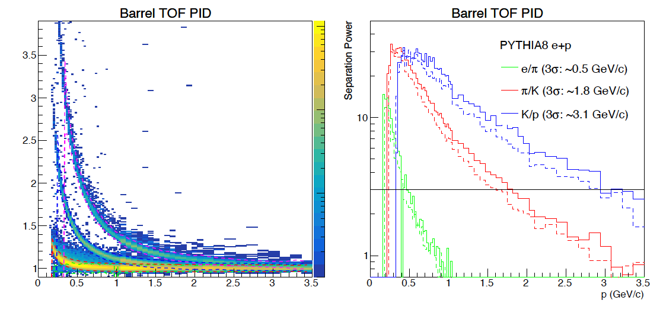
Figure 1. Barrel TOF PID performance in Pythia DIS events. The solid (dashed) lines on the right show the separation power for e/𝜋, 𝜋/K, K/p with 25 (35) ps TOF hit resolution.
Q4. How are the services impacted by the final pixelization of both systems?
Far-Forward (Alex Jentsch) Fine pixelization means more cabling + cooling is needed for the Roman Pots system. The current design already assumes the needed pixelization (500um) for both items, and material budget is not a major issue for the Roman Pots since the protons being measured are at approximately the beam energy.
For the B0 tracking system timing layer (one layer of AC-LGADs), a maximum of 5%X_0 is tolerable for the material budget before noticeable impact on the tracking resolution is observed.
TOF (Wei Li) Finer pixelization for TOF would correspond to more HV/LV cables and data fibers but with current possible designs, numbers of cables and fibers are generally in a range that service and routing will not strongly depend on the pixelization. For barrel TOF, the baseline design has 288 HV+LV cables and 288 data fibers to DAQ. For forward endcap TOF, about 400 HV+LV cables and 200 data fibers are estimated for the baseline design.
Future designs will only reduce these numbers. For example, the table below show numbers of sensors, cables and fibers for the baseline design of 0.5x0.5 mm² pixel option v.s. 0.8x0.8 mm² pixel option. Such low cable/fiber density will not present an issue for service.
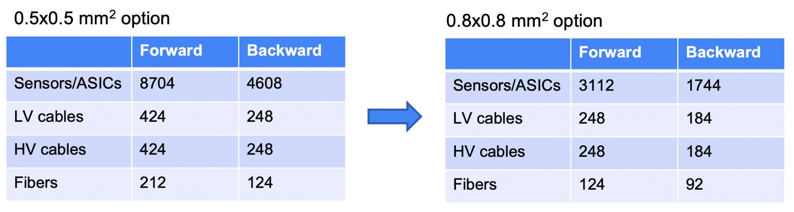
Finer pixelization will lead to higher cooling demand, which can impact the cooling strategy in terms of type and amount of materials. This is still under investigation and part of R&D goal of eRD112. The current baseline design represents an upper limit in terms of material budget for cooling structure (i.e., 5%X_0 for forward TOF). Similarly, by slightly reducing the granularity or going for larger pixel size, power consumption will be reduced substantially. By going from 0.5x0.5 mm² to 0.8x0.8 mm² pixel option, power consumption is reduced by a factor of more than 2, as shown in tables below.
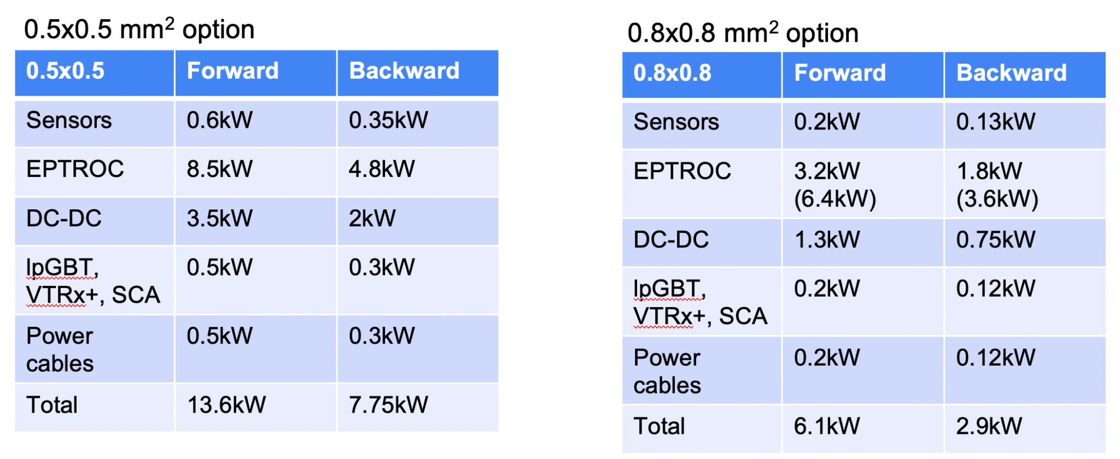

Q5. What requirements does the TOF system have on other systems, i.e. tracking, DAQ, electronics?
TOF relies on tracking to estimate the path length of particles between the primary vertex and TOF hits. Study based on Fun4All indicates that the path length uncertainty is better than 0.1%, which is negligible compared to the contribution from timing resolution (>1%).
For Barrel TOF that uses strip sensors, the dependence of measured Time-of-Arrival on the hit position along the strip direction (z) needs to be corrected. From the first test beam campaign in 2022, an additional 5 ps contribution to the timing resolution was found from 0.5 mm uncertainty in z. The contribution would increase linearly to 10 ps with 2.5 mm uncertainty in z. The resolution in z provided by tracking has been studied with the latest ePIC DD4HEP+Jana2 simulation framework. The results are shown in Fig. 2. The impact on TOF PID performance is found to be minimal.

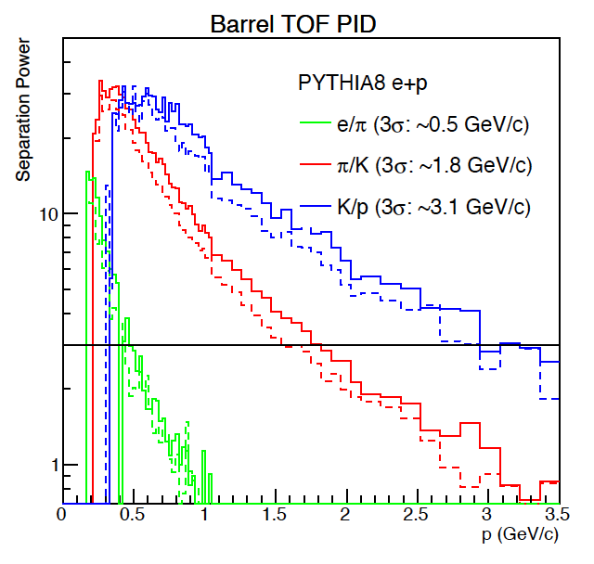
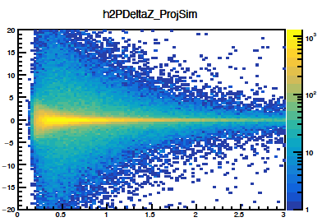
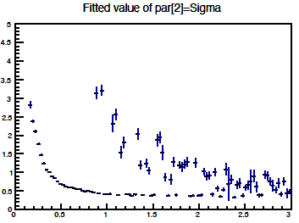

Figure 2.
Tonko: TOF requires a precise clock distribution to the frontend readout ASIC. To have negligible jitter contribution from the clock signals a 5 ps clock jitter is necessary which puts a requirement to the DAQ System and its clock distribution scheme. Such low jitter clock schemes were already developed by the CERN High Precision Timing Project and were presented multiple times at DAQ WG meetings. The DAQ WG already started a Timing Subgroup which is tasked with replicating & then evaluating the CERN scheme within ePIC.
Note that this jitter requirement is not particular to AC-LGAD or TOF but is shared with any other detector/technology which provides very precise timing information e.g. LAPPD.
Tonko: Data rate requirements of the TOF detector from the DAQ system have been known to the DAQ WG for some time. These requirements are: 500 Readout Boards (RDO) with 1 fiber each for a total of 500 fibers. Those fibers are connected to 12 DAQ DAM boards (e.g. “FELIX”). The data rate on the fiber is 6 Gb/s in the worst case.

