DSC dRICH Questions – 09/27/2024
- Services
  - Cables
    - Low Voltage - How many cables coming from dRICH?
    - High Voltage - How many cables coming from dRICH?
    - Sensor Bais - How many cables coming from dRICH?
    - Readout / Data - How many cables coming from dRICH?
    - Cooling estimate - More questions below, quick estimate on needs?
    - Gas lines (C2F6, dry air/nitrogen or something else)?
    - FEBs / electronics – Do we still fit in the envelope?
    - Cable Reference
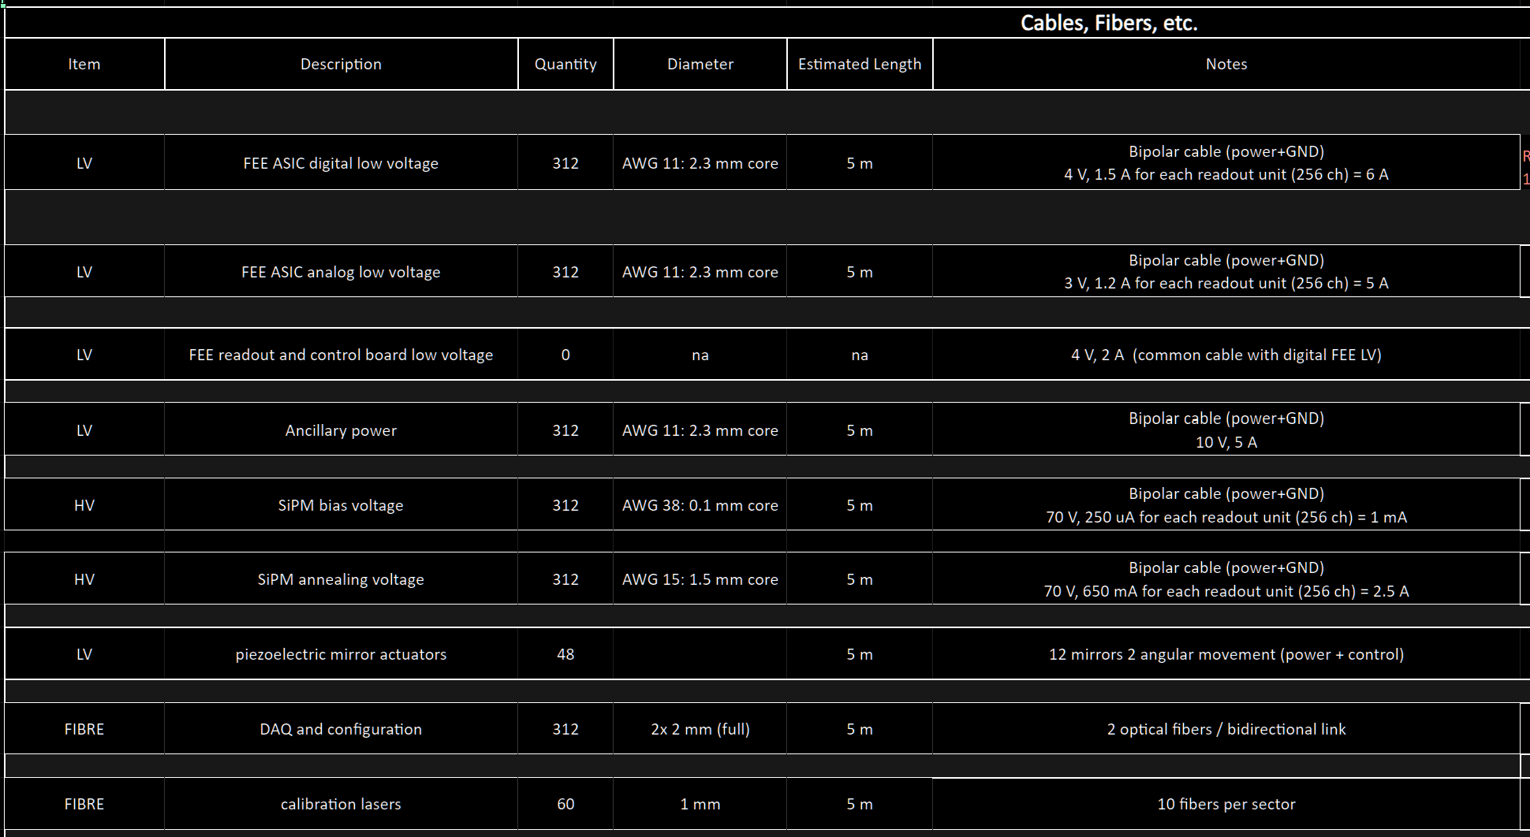
  - Cooling
    - Heat Dissipation – Total heat dissipated by the detector.
      - Sensors
      - FEBs
      - RDOs
    - Heat Stability – Changes in heat dissipation over time.
      - Activity
      - Radiation damage
      - Temperature
    - Pressure Drop – Drop in pressure across the detector
    - Temperature – Desired operating temperature.
    - Tolerance – Allowable deviation from the desired temperature.
    - Gradient – Allowable difference in temperature across the detector.
    - Stability – Allowable deviation from the desired temperature over time.
    - Segmentation – The number of detector components there are that require cooling, we can determine the number of parallel or series lines, manifolding, etc.
    - Leak mitigation – Air, negative pressure water, non-conductive fluid, etc.
    - Cooling Reference
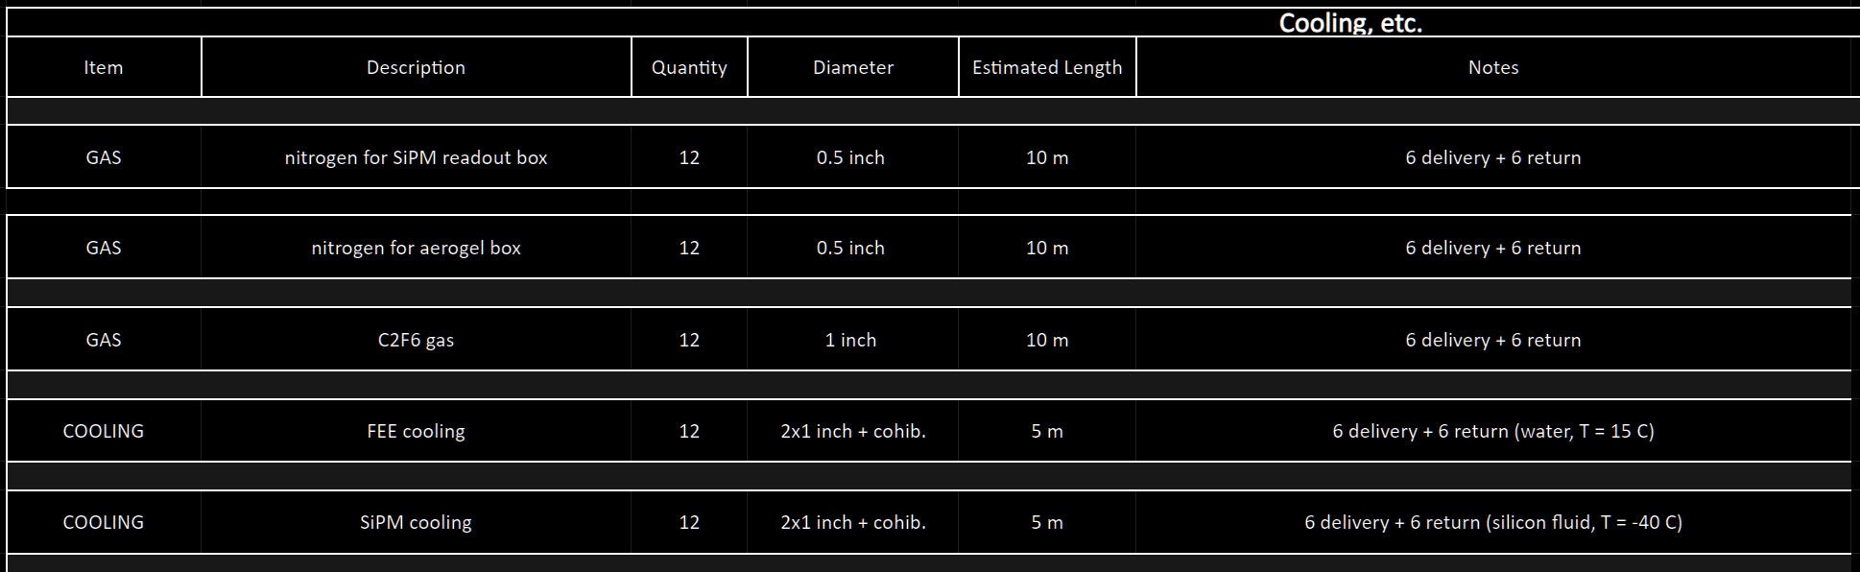
- Support
  - Mounting locations
  - Adjustment
    - Beampipe clearance (more space needed during bakeout)
  - Detector weight
  - Serviceability
  - Split in half?
  - Beam pipe clearance?
- Detector
  - Envelope
    - Barrel - 220mm Inner radius, 1800mm Outer radius, 1980mm, 3250mm pos Z (Hadron side), 1270mm total length
    - Reference
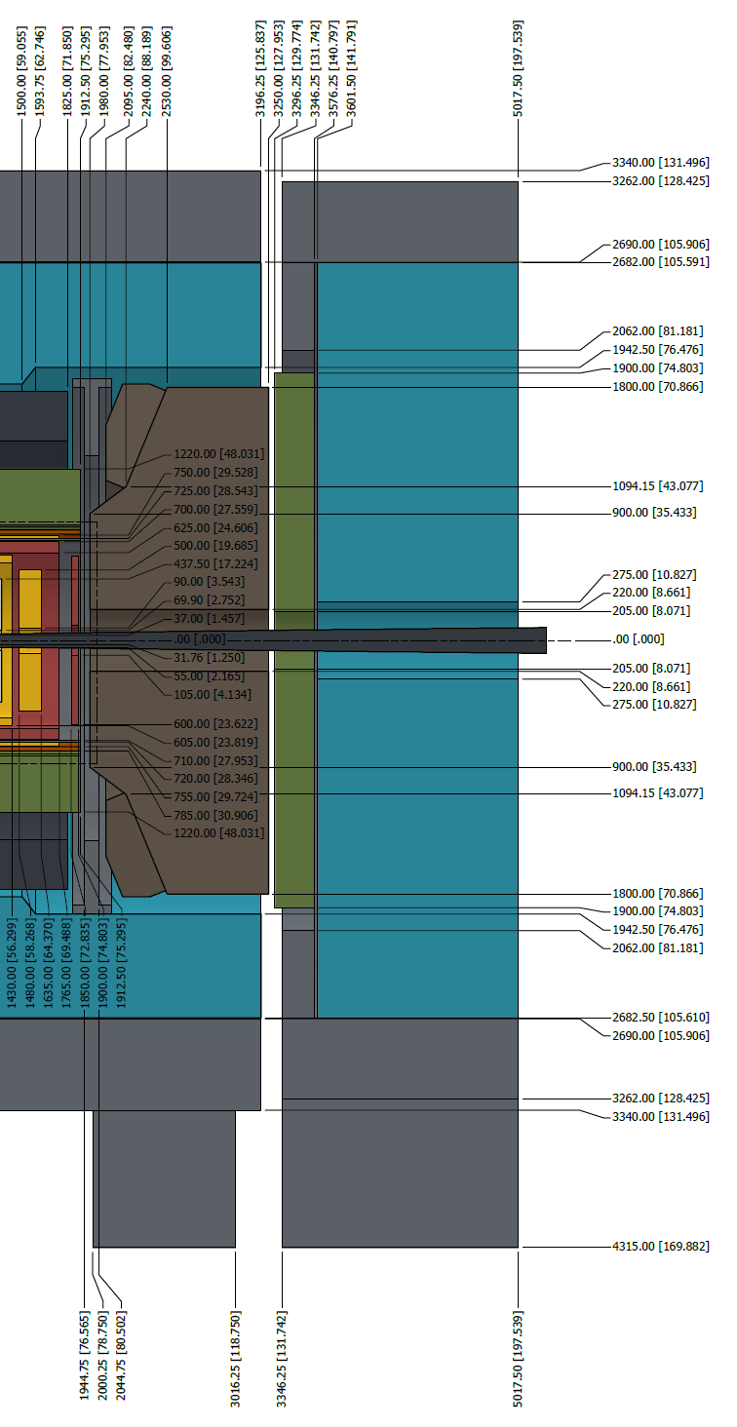
    - Reference

