DSC MPGD Questions – 09/27/2024
- Services
  - Cables
    - Low Voltage - How many cables coming from MPGDs?
    - High Voltage - How many cables coming from MPGDs?
    - Sensor Bais - How many cables coming from MPGDs?
    - Readout / Data - How many cables coming from MPGDs?
    - Cooling estimate - More questions below, quick estimate on needs?
    - Gas lines (operating gas, dry air/nitrogen or something else)?
    - FEBs / electronics – Do we still fit in the envelope?
    - Cable Reference
    - Outer Barrel
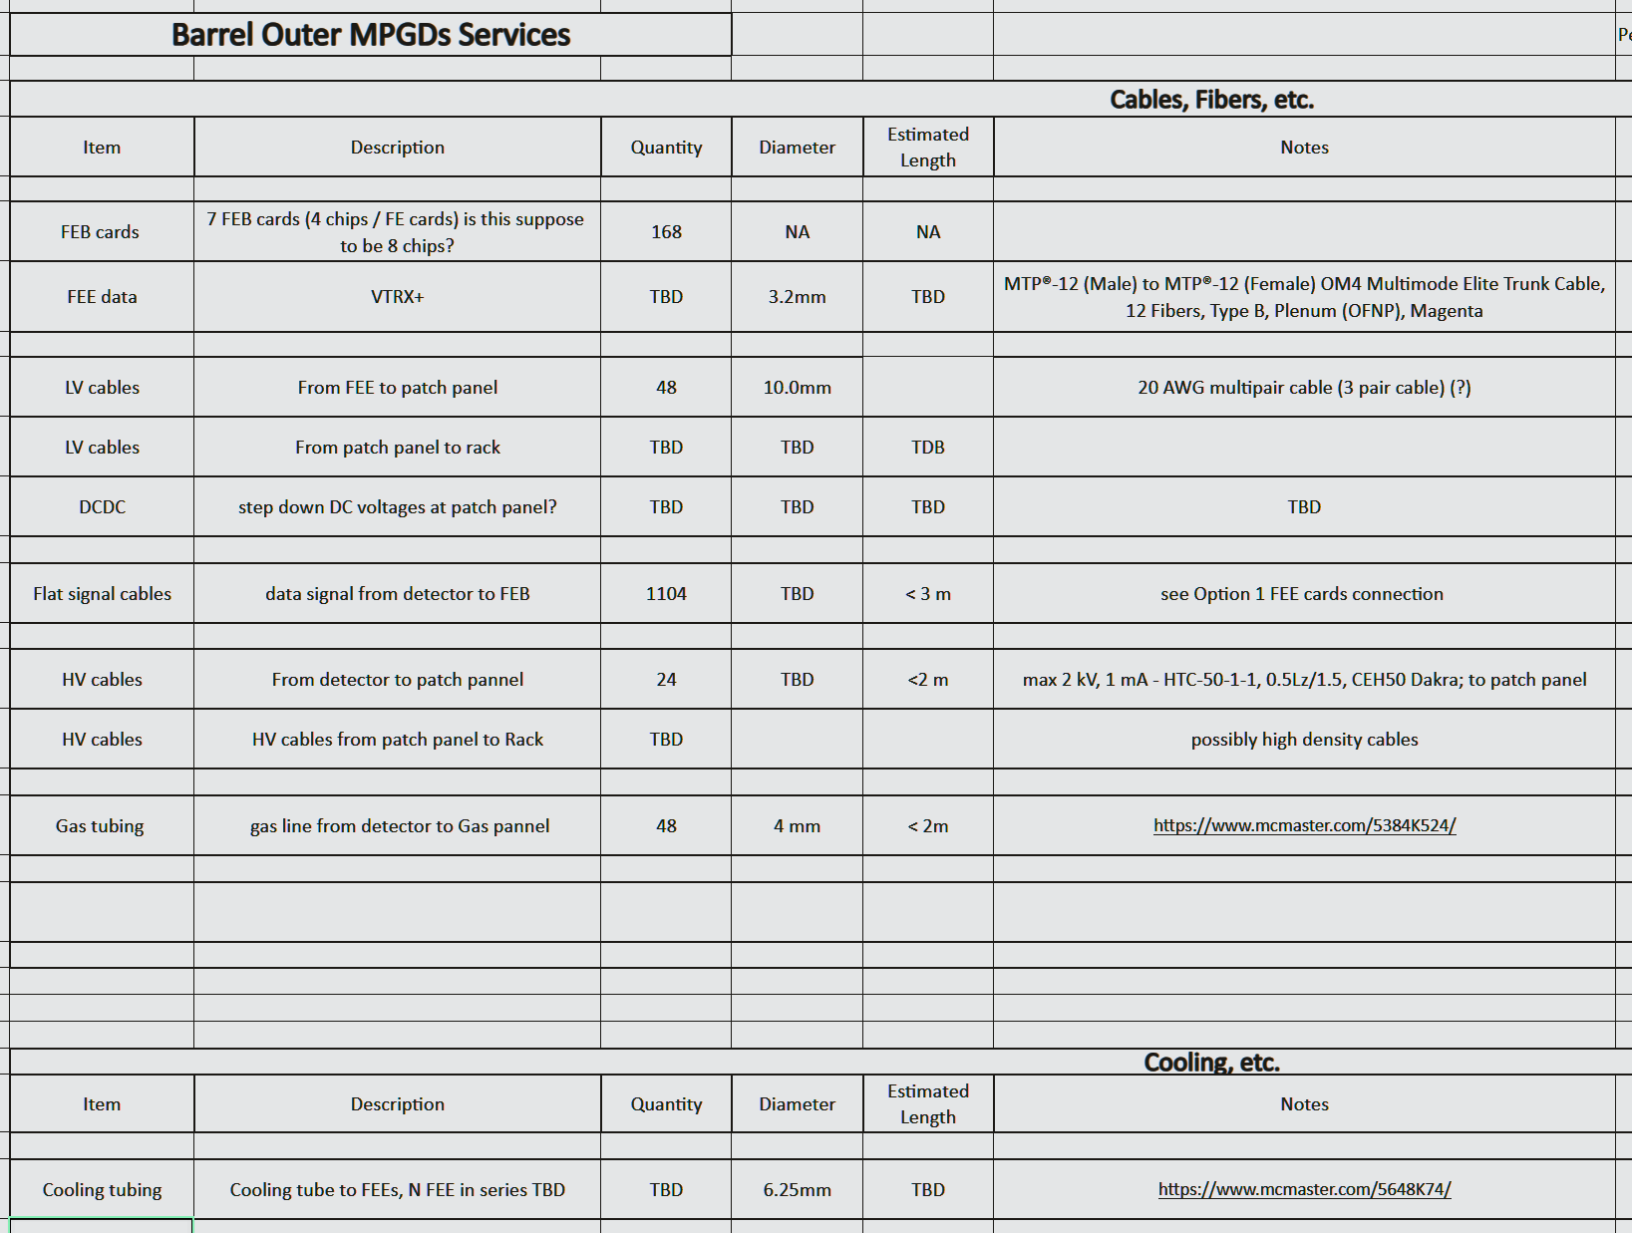
    - Inner Barrel
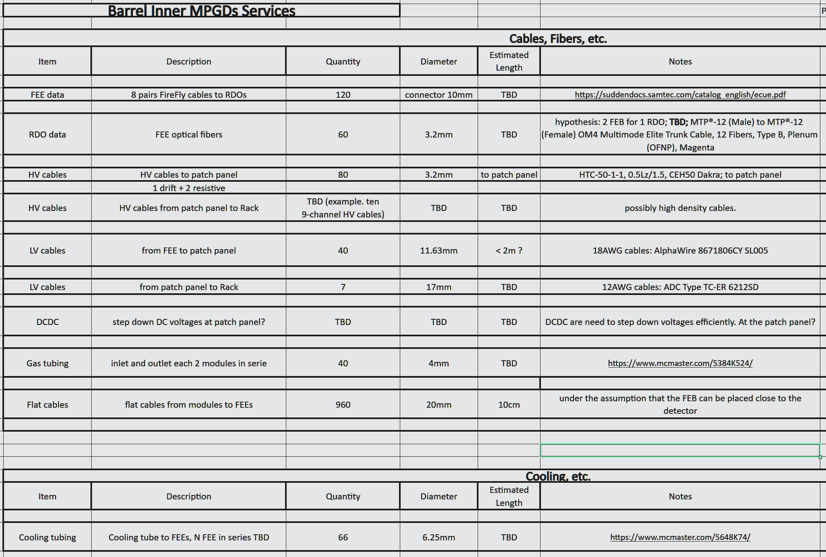
    - HE Disks
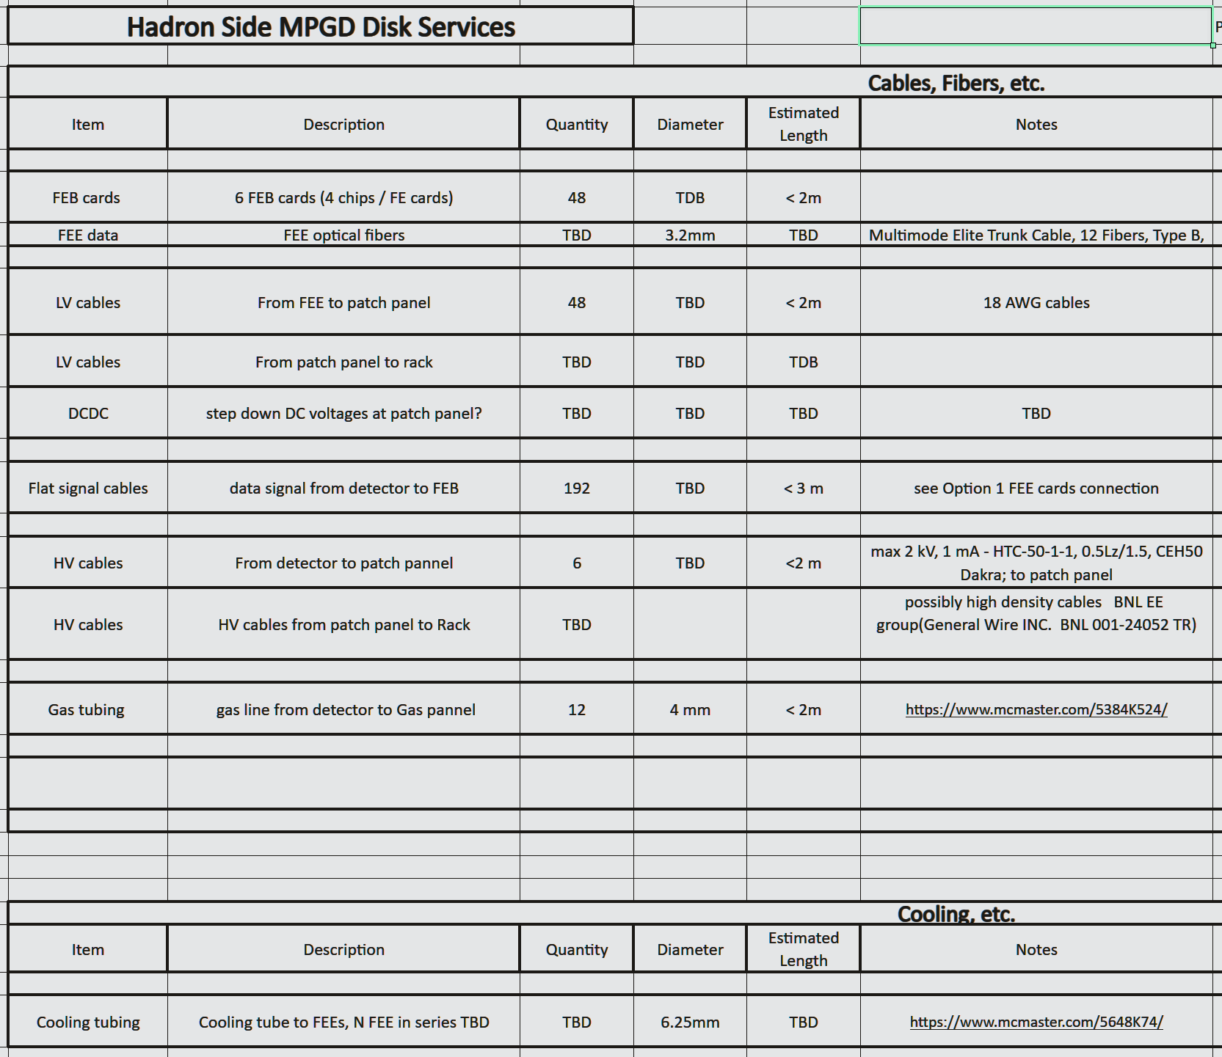
    - EE Disks
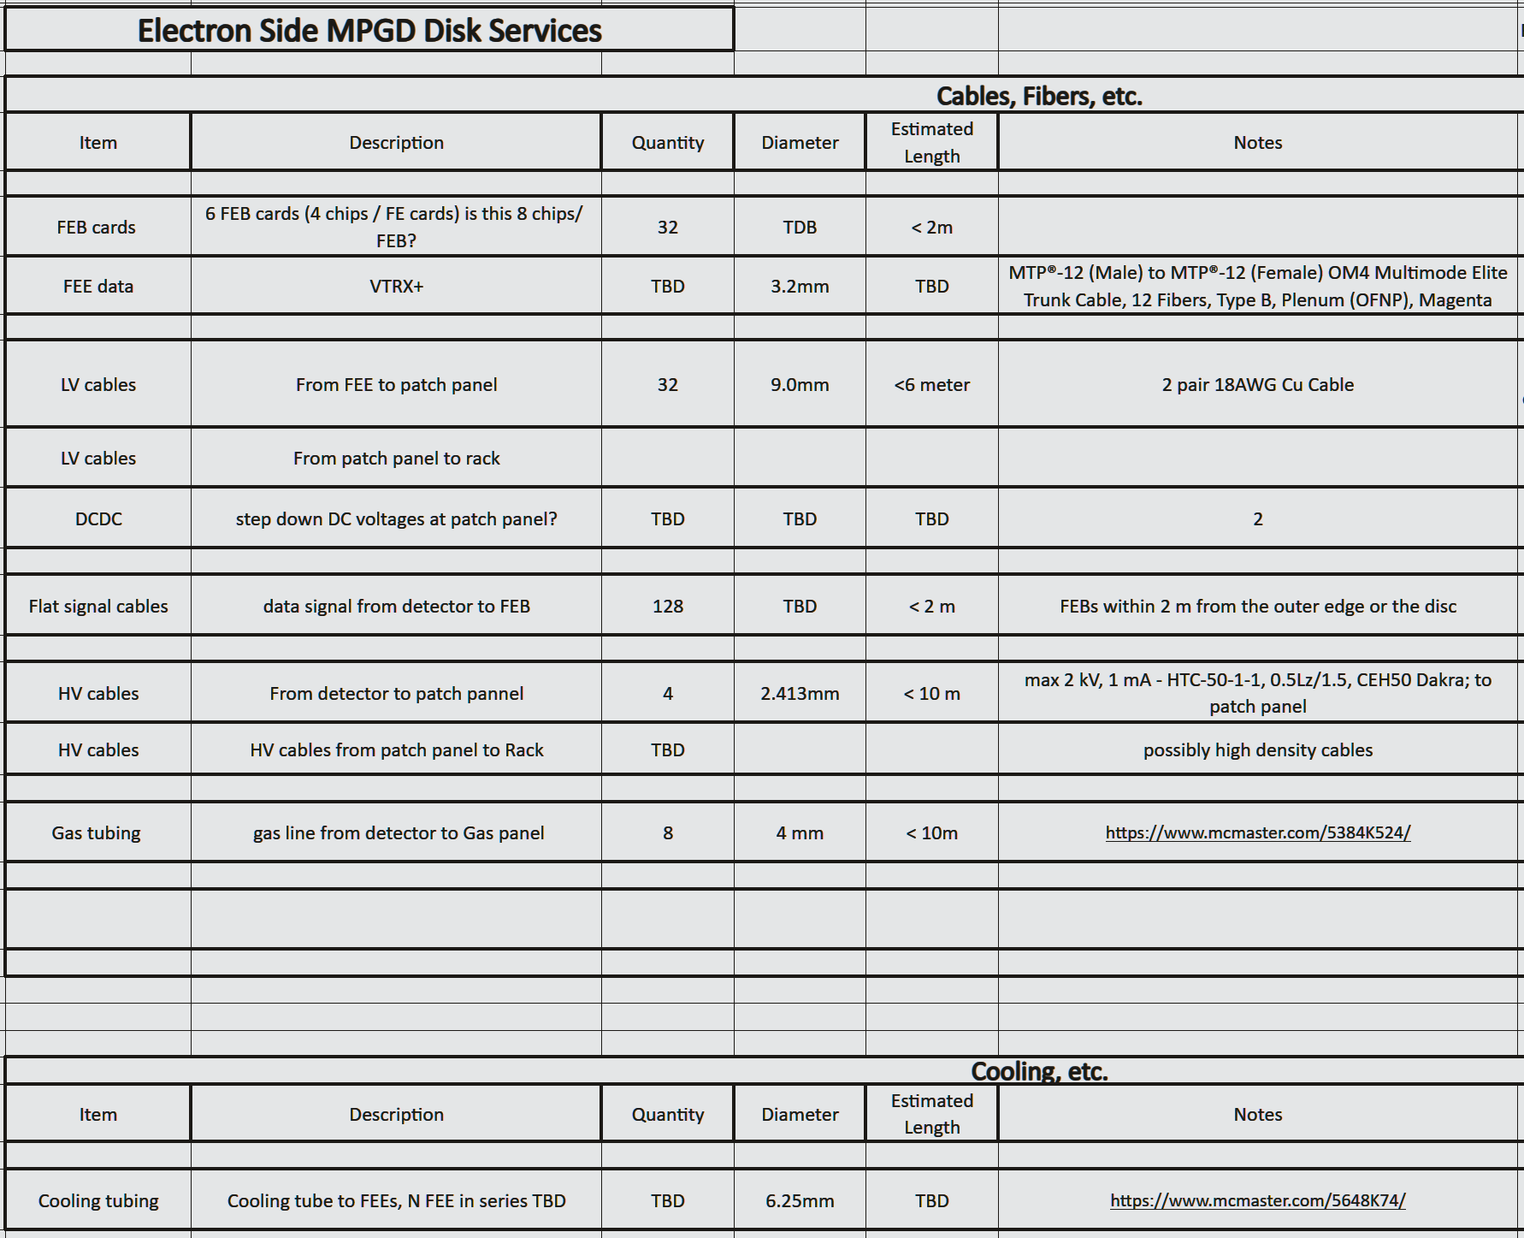
  - Cooling
    - Heat Dissipation – Total heat dissipated by the detector.
      - Sensors
      - FEBs
      - RDOs
    - Heat Stability – Changes in heat dissipation over time.
      - Activity
      - Radiation damage
      - Temperature
    - Pressure Drop – Drop in pressure across the detector
    - Temperature – Desired operating temperature.
    - Tolerance – Allowable deviation from the desired temperature.
    - Gradient – Allowable difference in temperature across the detector.
    - Stability – Allowable deviation from the desired temperature over time.
    - Segmentation – The number of detector components there are that require cooling, we can determine the number of parallel or series lines, manifolding, etc.
    - Leak mitigation – Air, negative pressure water, non-conductive fluid, etc.
    - Cooling Reference
    - Outer Barrel
    - Inner Barrel
    - HE Disks
    - EE Disks
- Support
  - Mounting locations
  - Adjustment
    - Beampipe clearance (more space needed during bakeout)
  - Detector weight
  - Serviceability
  - Beam pipe clearance? Bakeout?
- Detector
  - Envelope
    - Outer Barrel - 725mm Inner radius, 750mm Outer radius, 1675mm neg Z (Lepton side), 3440mm total length
    - Inner Barrel - 550mm Inner radius, 600mm Outer radius, 1050mm neg Z (Lepton side), 2480mm total length
    - HE Disks - 90mm Inner radius, 500mm Outer radius, 1480mm, 1610mm pos Z (Hadron side), 25mm total length
    - EE Disks - 55mm Inner radius, 500mm Outer radius, 1100mm, 1200mm neg Z (Lepton side), 25mm total length
    - Reference
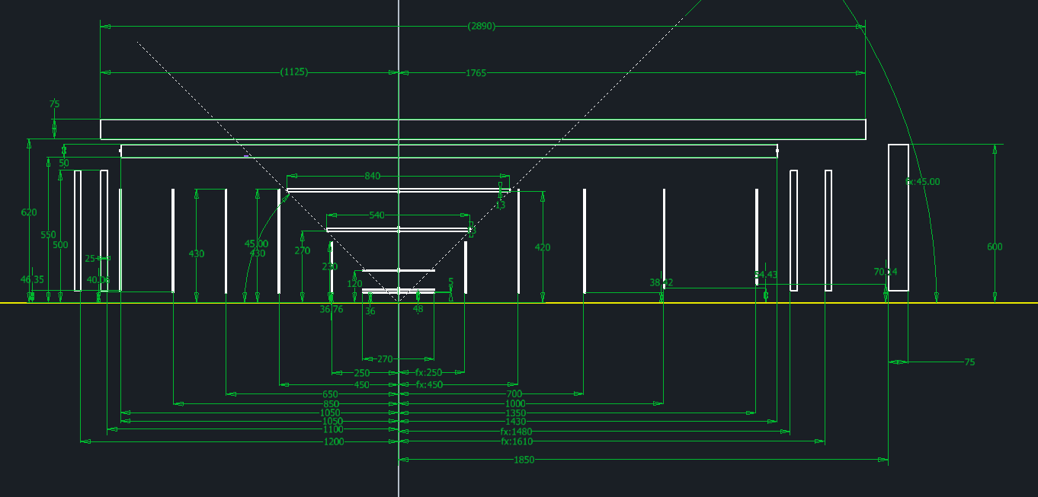
    - Reference
