DSC SVT Questions – 10/18/2024
- Services
  - Cables
    - Low Voltage - How many cables come from the SVT?
    - High Voltage - How many cables come from the SVT?
    - Sensor Bais - How many cables come from the SVT?
    - Readout / Data - How many cables come from the SVT?
    - Cooling estimate - More questions below, quick estimate on needs?
    - Gas lines (dry air/nitrogen or something else)?
    - FEBs / electronics – Do we still fit in the envelope?
    - Cable Reference
      - “Sagita” layers
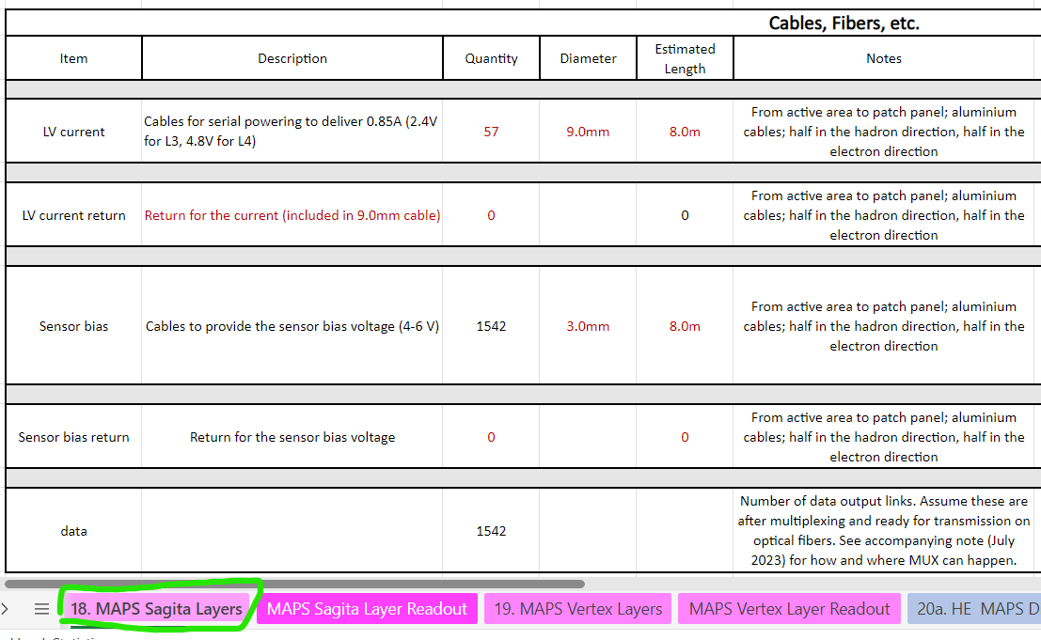
      - “Vertex” layers
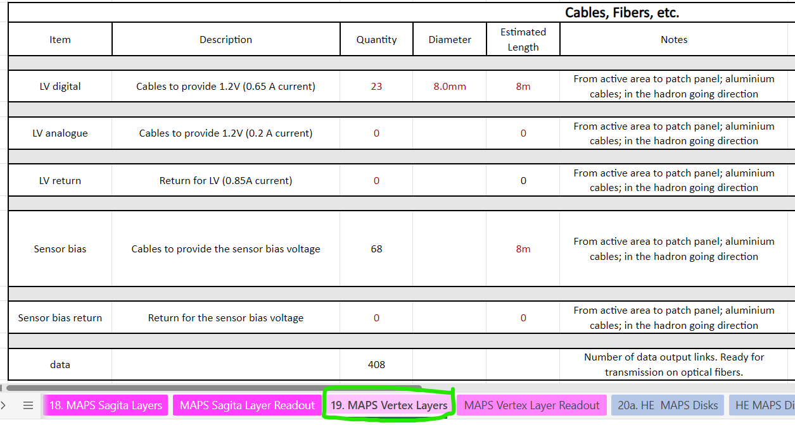
      - HE Disks
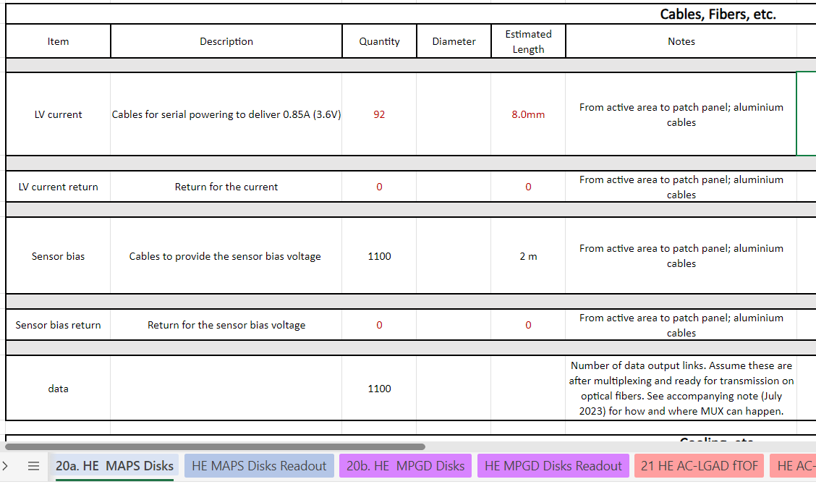
      - EE Disks
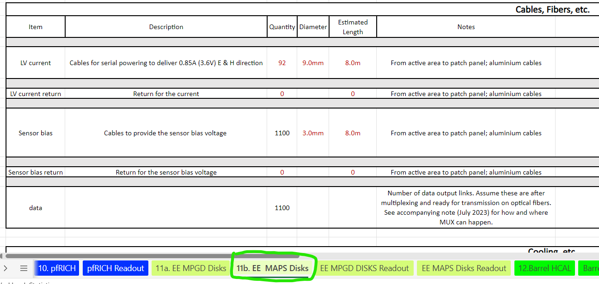

  - Cooling
    - Heat Dissipation – Total heat dissipated by the detector.
      - Sensors
      - FEBs
      - RDOs
    - Heat Stability – Changes in heat dissipation over time.
      - Activity
      - Radiation damage
      - Temperature
    - Pressure Drop – Drop in pressure across the detector
    - Temperature – Desired operating temperature.
    - Tolerance – Allowable deviation from the desired temperature.
    - Gradient – Allowable difference in temperature across the detector.
    - Stability – Allowable deviation from the desired temperature over time.
    - Segmentation – The number of detector components there are that require cooling, we can determine the number of parallel or series lines, manifolding, etc.
    - Leak mitigation – Air, negative pressure water, non-conductive fluid, etc.
    - Cooling Reference
      - “Sagita” layers
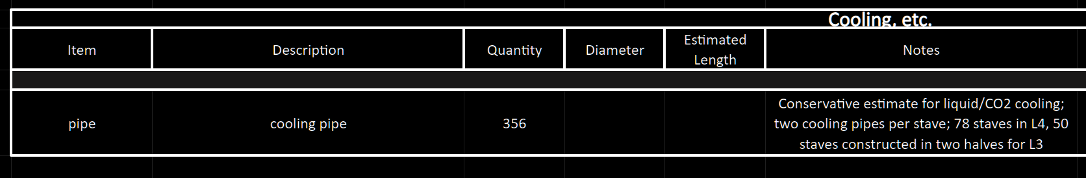
      - “Vertex” layers
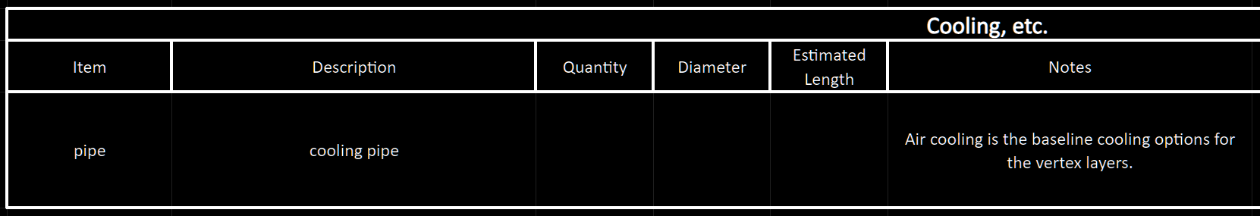
      - HE Disks
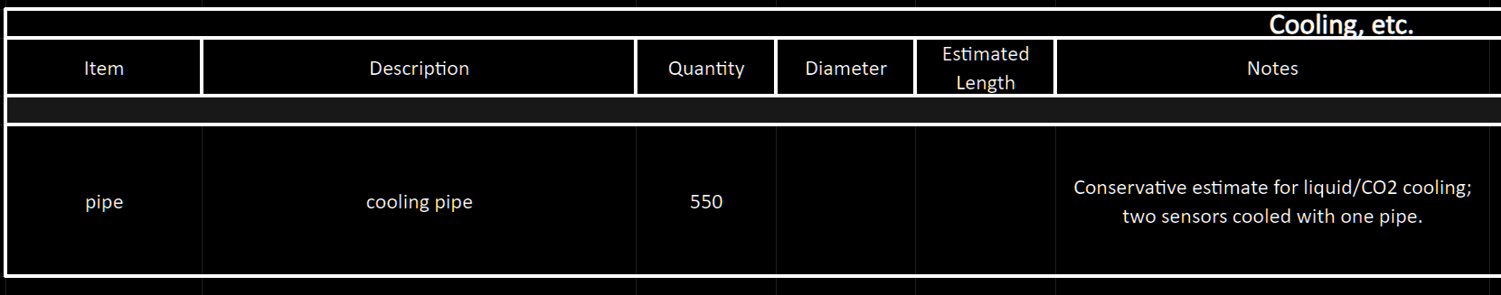
      - EE Disks
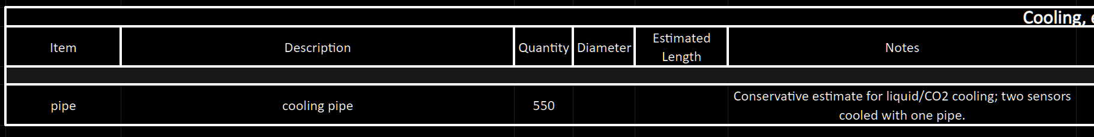
- Support
  - Mounting locations
  - Adjustment
  - Detector weight
  - Serviceability
  - Beam pipe clearance
- Detector
  - Envelope
    - Bunch of envelope interferences. Screenshots below show the models extending past the given envelopes. This doesn't matter as much as the fact that most of the models now interfere with one another and there is no space for services.
    - Reference


       