Draft 0.1 June 16, 2025

Charter of EIC International Computing Organization
A.Boehlein, A.Bressan, M.Diefenthaler, R.W.L.Jones, T.Gunji, A.Klimentov, C. Munoz Camacho, E. Yen
Brookhaven National Laboratory (BNL) and Thomas Jefferson National Accelerator Facility (JLab), as Electron Ion Collider (EIC) [1] host laboratories, created in the fall of 2023 a joint structure, the EIC Computing and Software Joint Institute (ECSJI), incorporating parts of BNL and JLab facilities to support the EIC computing and software needs and activities. ECSJI will leverage complementary expertise at the two Labs and provide needed visibility to the respective Lab management and stakeholders (Annex 1). The EIC International Computing Organization (EICO) addresses the participation of International partners in computing. This document describes the functions and responsibilities of the EICO and relationship to the ECSJI and the EIC Resources Review Board (RRB, [2])

EIC Computing Organization
EIC Computing and Software Joint Institute provides for EIC computing and software matters:
1) A single entity to interface with the EIC programme and the ePIC collaboration,
2) Maintains Service Level Agreements and statements of work outlining the host labs’ contribution to the ePIC collaboration concerning computing resources, services, and
personnel assigned to work on ePIC computing and software deliverables,
3) A coordinating body for interacting with international partners providing computing resources as in-kind contributions. This includes assessing resources, managing the agreements of cooperation with the sites delivering resources (including service levels agreements), and facilitating and assessing the delivery against the agreements,
4) Execution of host laboratories responsibilities
  - Assessing resources.
  - Managing the agreements with the sites delivering resources (including service levels).
  - Facilitating and assessing the delivery against the agreements.
The Institute management comprises two co-Directors; each is nominated by one Lab. The institute’s management reports jointly to the EIC Computing Council. EIC Computing Organization (as seen by DOE NP Office) is shown on Fig.1 (as in spring 2025);
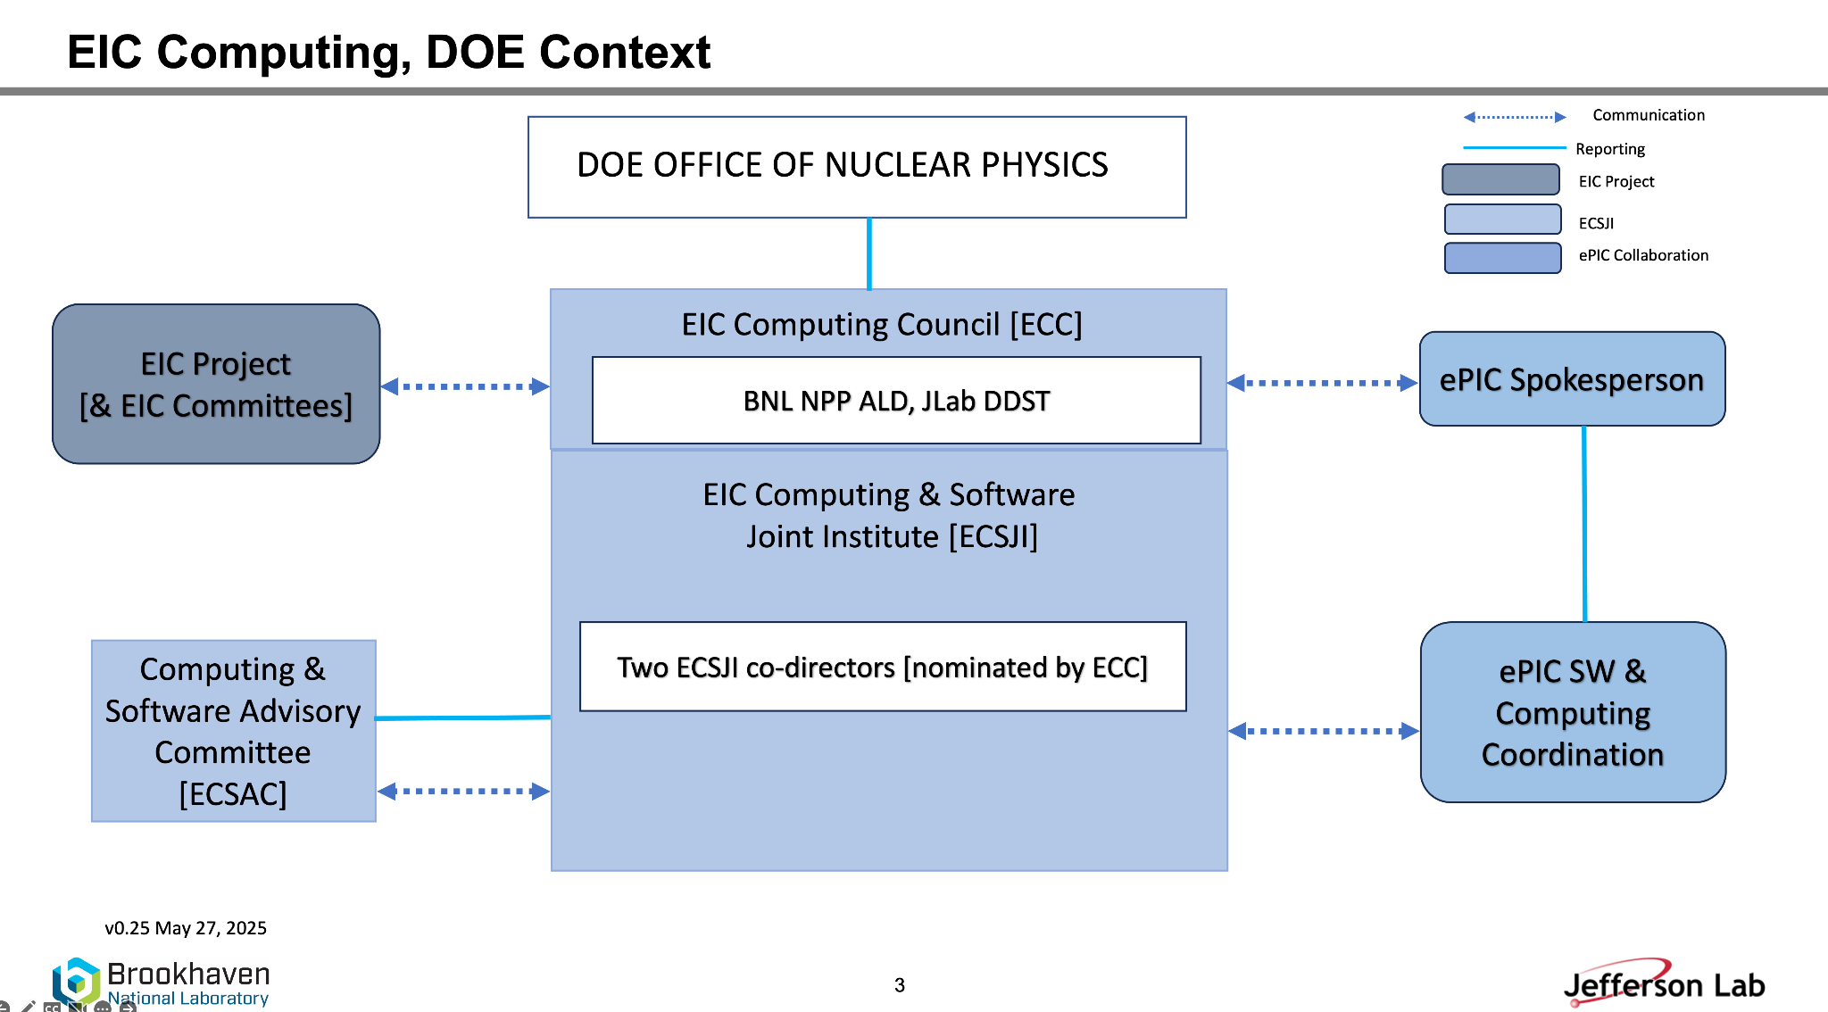
EIC Computing Council. The EIC Computing Council (ECC) reviews the ECSJI strategic direction and supports leadership in managing effective interfaces of the ECSJI to the EIC programme and ePIC collaboration. ECC approves the ECSJI strategic direction, leadership changes, annual budgets, resource allocations, and performance milestones. The ECC is chaired in alternation by the Associate Laboratory Director for Nuclear (ALD) and Particle Physics of BNL and the Deputy Director for Science (DDST) of JLab. It comprises the ALDs/ADs and deputies involved in the EIC science program and Institute management. To maintain connection with the EIC International Computing Organization, the Oversight Board (OB) Chair of the EIC International Computing Organization (EICO) is included as a member of the EIC Computing Council.

EIC Computing and Software Advisory Committee. The EIC Computing and Software Advisory Committee (ECSAC) is chartered to propose advice, guidance, and counsel on the strategy and objectives of the Institute and of the EIC International Computing Organization. The committee reports to the EIC Computing Council (who may delegate logistics to the ECSJI) The ECSAC chair and committee members include external experts in the field appointed by Institute management in consultation with host lab management. It will meet at least twice a year.
The ECSAC responsibilities include to:
- Review the strategy and objectives of the Institute to support EIC Computing and Software.
- Evaluate the adequacy of the infrastructure and resources to meet the computing requirements of the ePIC collaboration.
- Evaluate proposed technical solutions and their implementation.
- Identify opportunities to increase effectiveness and efficiency.
- Provide recommendations on technical and organizational matters.
- Provide recommendations if conflicting requirements affect operation, planning, or budget.
EIC International Computing Organization is led by the Institute's co-directors and administered by the ECSJI. This organization exists to provide computing resources, infrastructure, and services related to the EIC. The current focus is on the ePIC experiment. This will be extended to other foci as endorsed by the EIC RRB. Funding agencies will indicate the activities and services they will provide, and this will be approved by RRB. The EICO structure is formally documented in this charter.

EIC International Computing Organization
Participation in EIC Computing is initiated by subscribing to this Charter and signing a Cooperation Agreement, which defines the EIC Computing Collaboration and its objectives, and the rights and obligations of the Collaboration Members. The needs of the Experiments, on which the pledged Computing Resource Levels are based, will be reviewed annually by the EIC RRB.
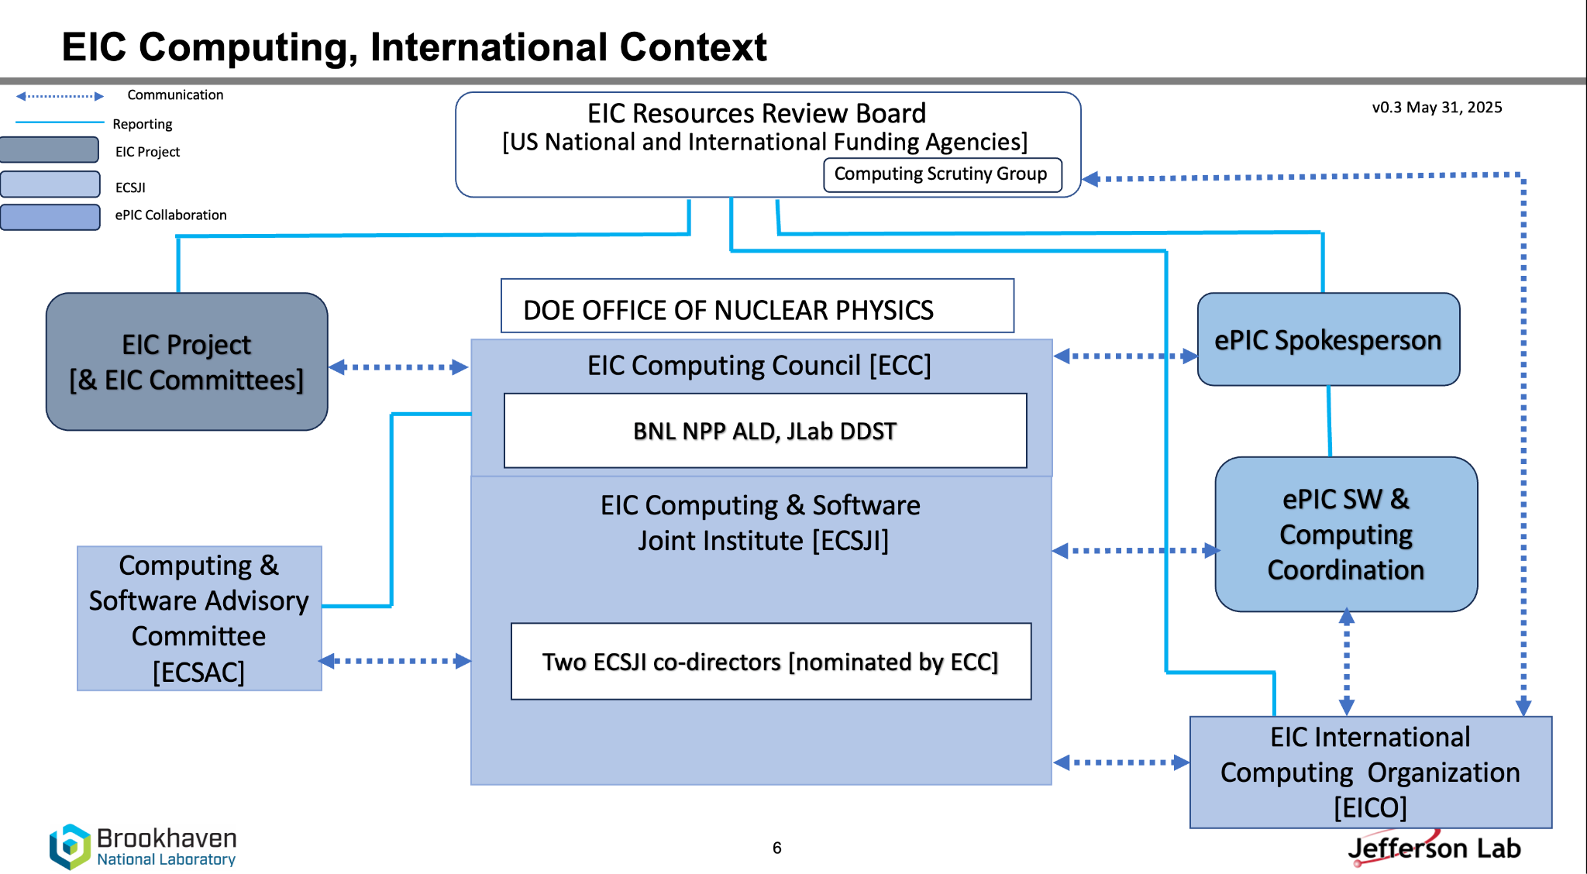

The purpose of the ECSJI and EICO is to provide the computing resources needed to process and analyse the data gathered by the EIC Program. EICO relations with ECSJI, ePIC collaboration and RRB scrutiny group is shown on Fig.2 (as in June 2025). The EIC computing project is assembling a distributed computing system. The ePIC computing model [3] classifies the computer centres functionally in Echelons.

ePIC Computing Model: The ePIC detector, together with the DAQ system, constitutes Echelon 0. Two Echelon 1 sites are located at the host laboratories, BNL and JLab, both equipped to function as fully capable peers for host-site ePIC computing, providing processing and storage resources. Echelon 2 sites contribute resources, infrastructure, and services to accelerate the science. Echelon 2 roles and use-cases are described in [3]. The EICO will follow the developments of the ePIC computing model and the refined resource estimates of the collaboration. The minimum compute capability requirements for Echelon 2 will be defined jointly by EICO and the ePIC collaboration. Echelon 3 supports the analyzers at their home institutions, primarily via services hosted at Echelon 1 and 2. Echelon 3 sites are not part of the EICO. A contributing computing center may also support other computing use cases that benefit the EIC program, such as accelerator simulations, studies of new detector concepts, or theory calculations. The ePIC Software & Computing schedule is aligned with the deliverables and milestones of the EIC Project. The deployment of compute resources, infrastructure, and services for the EIC will proceed in accordance with this schedule.

EICO Overview Board. The Overview Board (OB) oversees the functioning of the EICO. It is composed of a representative of each Institution that is a member of the EICO, the ECSJI directors and the Spokesperson(s) of each EIC Experiment with voting rights. The OB is co-chaired by EIC Computing Council Members, which include a member of the OB appointed as a co-chair.

OB meetings are held at least twice per year. The two scheduled meetings are held prior to the RRB meeting to approve the report that details the accomplishments of the EICO, and the individual site metrics outlined in the cooperation agreement. The OB has the responsibility to manage external relationships with partner organizations, such as WLCG. The OB has the responsibility to manage external relationships with partner organizations, such as WLCG, also supporting the priorities of EICO within the global ecosystem of the different computing centers. The OB also provides a resolution path for institutional issues relative to the cooperation agreement.

EICO Management Board. The Management Board (MB) organises the work of the EIC Computing as a set of formal activities. It maintains the overall programme of work and all other planning data necessary to ensure the smooth execution of the work of the EIC Computing. It provides half-year progress and status reports to the OB. The MB membership includes the ECSJI directors, the Technical Heads of the Echelon 0, Echelon 1 and Echelon 2 Centres, the leaders of the major activities and projects managed by the Board, the Computing Coordinator of each EIC experiment, the Chair of the Technical Forum, a Scientific Secretary and other members as decided from time to time by the Board. MB meetings are held on a regular basis (usually monthly). MB has several roles, including :
- to broker and manage agreements between the resource centres and the experiment(s). In practice, this will require background agreements with other organisations that run various parts of the infrastructure, such as fabrics and storage operations, certificate authorities, network providers, etc.;
- to broker and manage agreements between resource centres, and between resource centres and EIC host labs;
- to review schedules, service performance, resource utilisation, etc. and decide about tools to be used to assess centers reliability and availability;
- to oversee publications, communications, conference submissions, and speakers, where it concerns software and computing activities that are not completely within EIC experiment(s).
The MB endeavours to work by consensus but, if this is not achieved, the ECSJI Directors shall make decisions taking into account the advice of the Board. In case there is a need for voting, MB members belonging to the same funding agencies will cast one vote. For a vote during a meeting only people present may vote. Votes may be delegated from the official delegate to other people if announced to the MB chairperson(s) prior to the meeting.

EICO Technical Forum. The Technical Forum (TF) is part of the EICO and represents in particular the computing centers (including Echelon 1 centers). The TF has several roles, including:
- to exchange information;
- to act as a forum for technical discussions and planning, including schedules, resources utilization and technical solutions, challenges and requirements;
- to organize technical discussions related to production system and middleware, etc and make proposals to the MB;
- discuss technical roadmap for the evolution of EIC facilities and services;
The TF meetings are open to all interested members of the EIC computing. Other parties may be invited for topical discussions. The TF chairperson is appointed by MB for a two-year period. Extension is possible with full concurrence of OB. The TF reports to the MB. The chair of the TF is an ex officio member of the EICO Management Board. The TF may start and stop working groups when needed to address technical issues. TF shall provide regular (bi-monthly) updates on its activity to MB.

EIC International Computing Organization and the EIC RRB
An EIC Resources Review Board was established in 2023. Computing resource requests are approved by the EIC RRB after a review through an independent scrutiny process. The RRB consists of representatives from all EIC funding agencies, the management of BNL and JLab, the ePIC experiment and the EIC programme. The RRB is co-chaired by a representative of one of the international funding agencies and a rotating chair between BNL ALD and JLab DDST. The RRB meeting cadence is twice a year, in spring and autumn. The ECSJI Directors and the ePIC SW&C Coordinator report regularly to the RRB on technical, managerial, financial and administrative computing matters.

[comment to ECC and RRB : We add the section below as a reflection of our understanding, but with a clear understanding that it is for the RRB to set the terms of its remit, which we anticipate them doing in the process of reviewing, revising and endorsing this document.]

It is envisaged that the RRB has the following approval and oversight roles with respect to the EIC Computing (ECSJI, ePIC), in the exercise of which it shall operate by consensus except as it shall itself decide otherwise :
  - Approval of this charter and thereafter monitoring its execution.
  - Approval of Amendments and Addenda .
  - Resolution of disputes forwarded by OB.
  - Endorsement of new Members of the EICO on the proposal of the ECSJI.
  - Annual approval at its autumn meeting of the Computing Resource Levels pledged to the EIC Experiment(s) by the Institutions for the following year.
    - To this end, the management of the ECSJI shall report to the RRB at its spring meeting the Computing Resource Levels pledged by the Host Labs and EICO for the next year and planned to be pledged in each of the four subsequent years revising the information, if necessary, for the RRB’s autumn meeting.
  - For each Institution, the Computing Resource Levels i) actually made available by the Institution and ii) actually used by each of the EIC Experiment(s) and EIC users are monitored centrally by the management of the ECSJI, which reports the figures for the previous year to the RRB at its spring meeting, along with the equivalent cost of providing these Computing Resource Levels at host labs. The RRB shall take note of the participation of the Institutions concerned, in terms of the Computing Resource Levels that were actually made available, and shall act accordingly.

Intellectual Property

- The software contributed to the EICO must be free to use by the members of the EIC programme and members of the EIC experiments. It must also fulfill the requirements of replicability, reproducibility and reuse into the future, which implies the software must be free to use for future analysers perhaps after the EIC experiments have dissolved.
- The responsibility for ensuring that these conditions are met rests with those contributing the new or pre-existing software; the experiment computing organization will also confirm that these conditions have been met.

Annexes

ECSJI MoU

List of EICO members by country/funding agency as in June 2025
Canada
France
Japan
Italy
Taiwan
UK
USA

References
- Electron Ion Collider: The Next QCD Frontier : Understanding the glue that binds us all Eur.Phys.J.A 52 (2016) 9, 268, Sep 2016, DOI: 10.1140/epja/i2016-16268-9
- RRB charter, April 2023, https://www.bnl.gov/eic-rrbmeeting/events/2023/files/pdf/rrb-charter.pdf
- ePIC Computing Model, v2, 2024, https://zenodo.org/records/14675920

Documents to be prepared after the EICO charter will be presented and approved by the RRB
- Cooperation agreement template
- Echelon 1 and 2 requirements
- OB and MB composition and membership
- …

