Commissioning,
Maintenance and Operation of the ePIC Experiment at the EIC

Original draft prepared by:
Abhay Deshpande, Rolf Ent, John Lajoie and Rosario Nania
April 30, 2024

Updated draft prepared by:
Abhay Deshpande, Rolf Ent, Paolo Giubellino, Peter Jones and John Lajoie
November 8, 2024

Next version of updated draft prepared by:
Abhay Deshpande, Rolf Ent, Paolo Giubellino, Peter Jones and John Lajoie
May 30, 2025

Commissioning, Maintenance & Operation of the ePIC
Experiment at the EIC

- Overview

  - Purpose of this document

The EIC Resources Review Board (EIC-RRB) provides coordination among the different funding partners both during the ePIC detector development and construction phase of the project and during the operations of the experiments that follow. This will include computing needs of the ePIC detector. The RRB provides oversight of resources utilized for detector construction and planning, and computing resources. The RRB functions as the body that reaches agreement on scope entailed in common projects, as appropriate, which shall be funded by Funding Agencies of the RRB. The RRB is responsible for annually agreeing on and endorsing detector financial commitments from the members.

The EIC-RRB has the dual authority to evaluate funds to the ePIC collaboration and to monitor the use of those funds. Separate international agreements are pursued that will define costs and funding commitments for constructing the ePIC detector.

Maintenance and Operation (M&O) costs of the experiment are incurred not only when the detector is running but also during construction and commissioning. Institutes and
agencies committed to supplying ‘deliverables’ as defined in separate agreements have implicit responsibility for M&O costs associated with construction and commissioning of those items. In addition, M&O for general infrastructures and items shared among the different detector systems should be considered as common costs and should be divided among the funding agencies. The purpose of this document is to define responsibilities for M&O costs and a foreseen timetable, and to outline the responsibilities of the US as host country for the EIC.

1.2 Contents of this document
The information in this document is presented for consideration by the EIC-RRB. Further M&O agreement should then emerge from the joint deliberations of the Funding Agencies (FAs), the ePIC Collaboration and the EIC Partnership Host Labs Management.

The document contains a draft list of items that incur M&O costs to operate the ePIC experiment. Ultimately this list will define what is included and is not included in the M&O agreement(s). It will cover material costs, any personnel costs related to detector operation that are either ’billed’ (e.g., outsourced manpower) or external (e.g., the use of personnel for tasks directly and exclusively to do with ePIC detector M&O), and computing-related costs. In the updated revisions, preliminary estimates of the costs that could be considered as common funds were introduced. We included initial preliminary estimates of the common funds needed for operating the ePIC experiment. These will need refinements and a better basis of estimate in future iterations and in cost scrutiny efforts.

Possible algorithms for sharing M&O costs are outlined with some consequences of
adopting different schemes.

1.3 Timetable
The initial draft document was prepared to guide first discussions at the RRB in May 2024. The discussions, followed up by the written exchange of comments, allowed a further iteration of the document for the RRB in late 2024, and provided the seeds that can be used in further agreements between the EIC host labs and the agencies. Comments of the RRB in November 2024 were mainly aimed at the intrinsic differences between a CERN-based versus a US-based RRB. The next version of the document was prepared to fold in those comments for further discussion at the RRB in June 2025.

1.4 Period of validity
This document is aimed at preparing agreement to cover the extraordinary M&O costs incurred during ePIC detector construction, commissioning, and operations that go beyond what is normally provided at a DOE Office of Science User facility. It is assumed to start from 2029 onwards to allow time for the funding agencies to prepare. The year 2029 is correlated with when the experimental areas will be ready for new installations. Costs for the period 2025-2028 can be handled ‘informally’ as has been the case hitherto. An assumption has been made for how costs and funds will evolve in time from construction to running. It is anticipated that the actual M&O costs will be updated annually for approval by the EIC-RRB.

- DOE Office of Science User Facility

The EIC is a US-based collider. It is anticipated that EIC will be designated as an Office of Science user facility, or will resume such role from the Relativistic Heavy Ion Collider (RHIC). Such designation connotes that the facility provides state-of-the-art capabilities to a broad segment of the scientific community.

The Office of Science defines a user facility as follows:
A user facility is a federally sponsored research facility available for external use to advance scientific or technical knowledge under the following conditions:
- The facility is open to all interested potential users without regard to nationality or institutional affiliation.
- Allocation of facility resources is determined by merit review of the proposed work.
- User fees are not charged for non-proprietary work if the user intends to publish the research results in the open literature. Full cost recovery is required for proprietary work.
- The facility provides resources sufficient for users to conduct work safely and efficiently.
- The facility supports a formal user organization to represent the users and facilitate sharing of information, forming collaborations, and organizing research efforts among users.
- The facility capability does not compete with an available private sector capability.

- Governance Model

DOE and the host labs promote the EIC as a facility that is fully international in character with the EIC-RRB to provide oversight of resources utilized for detector construction, operations, and planning. To set the stage towards costs, we give here a short description of the key governance principles:
- US DOE finances EIC accelerator operations, determines number of operations weeks.
- US DOE supports the host labs’ administrative and technical staff and the detector operations and infrastructure costs for the experiments.
- US DOE supports the host labs' computing facilities, including but not limited to the data acquisition, data processing, and centralized services for the experiments.
- DOE and non-DOE participate in and finance the governance of the experimental program including construction and upgrades, maintenance and operations (M&O) of specialized equipment built by a sub-set of the collaboration, mainly sub-detectors, and computing resources and software.
- BNL and TJNAF, as the co-hosts for the EIC Experimental Program, convene nominally twice a year the EIC-RRB as international oversight body.

- Costs

The EIC-RRB must concur that all M&O costs are correctly itemized and that there is a
reasonable framework for an equitable cost distribution among the participating countries, agencies, and institutes. It will be the ongoing task of the EIC-RRB to oversee the provision and spending of M&O funds and to take action if problems arise with cash flow, contributions, crises or the evolution of responsibilities. It seems likely that in some cases the EIC-RRB will have to endorse in-kind rather than cash contributions to M&O costs.

Appendix A is a draft list of items incurring M&O costs with tentative categorization that the EIC-RRB should scrutinize for completeness and correctness. Appendix B contains preliminary projected estimates of percentages of the total M&O costs for the years 2028 to 2037. This timeline is based on a timeline of actuals of the M&O of the CERN-LHC experiments. The projected timeline assumes EIC construction and early detector arrival to start after 2025, EIC pre-operations to start in the early 2030s, and completion of the EIC Project and start of EIC science operations in 2035. Then, the translation into preliminary estimates of M&O costs is added as of November 8th, 2024.

4.1. Cost categories
There are three categories of M&O costs according to the items involved. These categories define responsibilities for covering the costs. A fourth category D recognizes that the EIC is a US-based collider which comes with some natural host responsibilities.
- Category A concerns shared equipment built and maintained using Common Funds e.g. jointly-funded sub-detectors , or extraordinary services and operations common to the whole experiment e.g. distributed computing data transfer and specialized software licenses.
- Category B concerns maintenance of equipment built by a sub-set of the collaboration, mainly sub-detectors. This often requires specialist expertise.
- Category C concerns collaboration support using Common Funds, e.g., support for travel and as-needed time for key Collaboration functions, local co-support of travel for visiting scientists, and general support for a global strategy to allow for underprivileged scientists to participate in EIC science.
- Category D concerns items for which the DOE and US host laboratories would naturally assume responsibility for, e.g. costs to run the accelerator which sets the weeks of operations and schedule, costs to maintain and operate the detector including computing costs for the experiment(s), infrastructure for the experimental areas and experiments and infrastructure operations costs, survey and alignment, and the overall Environmental, Health, and Safety aspects for detector operations.

The Funding Agencies (FAs) and Collaborating Institutes (CIs) will be apportioned a share of Category A costs, and of Category B costs for any specific projects in which they participate. The FAs and CIs will also be apportioned a share of Category C costs. DOE and the host laboratories will pay the Category D costs. Concerning Category A, B and C costs, the host laboratories will be treated as the other CIs.

4.2 Cost sharing
The goal is to reach an equitable sharing of extraordinary M&O costs and to find effective methods of managing and monitoring the funds. Several algorithms have been commonly used to cover M&O costs of experiments in high energy physics, namely sharing by number of scientists (authors), sharing by scientists in the collaboration with a PhD-equivalent level degree, and sharing by costbook (capital investment). Cost-sharing algorithms may be different for category A, B and C items.

4.2.1 Category A items
Sharing by scientists rather than by costbook is popular as it is linked directly to the exploitation of a detector (including computing) and is perceived to be a fair measure of benefit. To fold in the educational and more transient character of students, ’scientists’ are taken to be fully-qualified PhDs, or the equivalent, appearing as named authors on publications of the collaboration. This implies that a reference publication is defined annually.

4.2.2 Category B items
For Category B items a sharing with a different cost-sharing algorithm may be more appropriate. FAs and CIs can retain responsibility for their own category B costs and sharing can vary with sub-system. Because many ePIC sub-systems have multiple participants, the institutes participating to a given detector sub-system will propose a sharing of the M&O costs as agreed among themselves, and the EIC-RRB will make sure this proposal can be accepted. The ePIC collaboration will have to manage and monitor costs and funds, as the RRBs will do for category A items. It will be incumbent on the spokesperson to guarantee the integrity of all sub-systems to the Collaboration, the RRB and the host laboratories, and to demonstrate that there is sufficient provision for M&O, e.g. via a document presented annually to the RRB. In addition, a recovery plan must be agreed in case of a disaster in any one sub-system, and the threshold at which intervention will occur must be defined.

4.2.3 Category C items
Category C items can be handled in the same way as category A items, as a sharing with scientists with a PhD-equivalent level. The cost-sharing mechanism may be chosen to differ from that used for category A items to take into account the special role of the DOE host laboratories to host the ePIC collaboration and visiting scientists, and to encourage participation in ePIC detector operations of underprivileged scientists.

4.3 Fair Sharing
There are several groups of participants in the ePIC experiment and contributions may differ. Some examples are listed below.

- Participants that have contributed to building the EIC machine and those that have not so contributed.
- Participants that have contributed to the ePIC detector and/or possible upgrades by in-kind sub-system contributions or by intellectual contributions.
- Participants that have provided labor or have provided direct equipment scope.
- Participants that provide contributions to the ePIC distributed computing.
- Participants that belong to RRB member FAs or participants that belong to RRB non-member or observer status.

It is important that all participants are treated in a transparent way and that due recognition is given for their contributions. Specific situations will be evaluated by the EIC-RRB.

4.4 Rebates and Joining Fees
In the CERN-LHC model for M&O, contributions to the machine and/or to the distributed computing have been recognized via ’rebates’, whereby CERN pays part of the category A bill of contributors. In some cases, fees have been charged to new institutes joining experiments at later times. Given the EIC’s status as a DOE Office of Science User Facility, neither ‘rebates’ nor ‘joining fees’ are countenanced for the US-EIC model.

The rationale is that in-kind contributions to the construction costs are welcomed but not required by DOE for individual institutes or countries to exploit the facility. International contributions to construction by non-DOE agencies are essential to complete an experimental program that is international in character, however the share of the in-kind contribution is not designed to be equitable. Since equity is not intended, the concept of rebates is not applicable. Similarly, user fees are not charged for non-proprietary work in the experiment operations phase if the user intends to publish the research results in the open literature. A joining fee cannot be justly levied based on not contributing to construction when this is not a requirement to join in the construction phase.

4.5 Flexibilities
It is understood that the financial situation in each member and non-member (observer) country that participates in the EIC-RRB may be different. There should be some means for the EIC-RRB to apply flexibility in contributions to the M&O Common Funds. For example, the contributions of various agencies to common-funded detector construction, to planned future detector upgrades, or to the EIC computing and software may be different. The EIC-RRB can fold this into their determinations of equitable sharing of M&O costs at their bi-annual meetings.

APPENDIX A: Table outlining the items incurring M&O costs during the construction, pre-operations, and operations of the EIC experiments, with UPDATED categorization.

* The Special Services category is intended to cover specific exceptional needs that go beyond what would ordinarily be expected to be covered by the host laboratory.
.

APPENDIX B: Estimates of combined M&O costs

A timeline to achieve full M&O costs in terms of percentages of total M&O costs for Category A items. This timeline is based on a timeline of actuals of the M&O of the CERN-LHC experiments. The projected timeline assumes EIC construction and early in-kind detector arrival to start late 2020s (and after the experimental areas are ready for new installations), EIC pre-operations to start in the early 2030s, completion of the EIC Project and start of EIC science operations in 2035. (We note that the projected preliminary Category A common funds are mostly in the computing area, and that in the present planning analysis and streaming data challenges already start in 2028. Since it is not clear what of those Category A computing costs are directly correlated with the planned data challenge, we assume costs for the latter can still be handled ‘informally’ as has been the case hitherto for all ePIC-related work.)

A timeline to achieve full M&O costs in terms of percentages of total M&O costs for Category B items. The category B costs are assumed to be flat after installation. The projected timeline assumes detector installation to be completed by 2032 and EIC pre-operations to start in the early 2030s.

A timeline to achieve full M&O costs in terms of percentages of total M&O costs for Category C items. This timeline is assumed to be earlier than that for Category A items as the support of people naturally coincides with the various component arrival, early construction, installation, pre-operations and science operations activities. The ramp-up of Category C item costs is assumed to be faster than those for Categories A and B and follows the planned ramp-up of collaboration labor commitments from a recent ePIC survey. The projected timeline assumes EIC construction and steady detector component arrival to start after 2028 once the experimental areas are cleared for new installations, EIC pre-operations to start in the early 2030s, completion of the EIC Project and start of EIC science operations in 2035.

Initial estimates of M&O Category A (in FY25 k$)
Category | Description | 2025
Detector related costs  Subtotal | Gas consumption  M&O of gas systems  M&O of cooling systems (incl. consumption)  M&O of moving/hydraulic systems  Shutdown gas consumption and maintenance  Magnet power supply maintenance  UPS maintenance for common systems  Beam pipe components + dry gas  Counting & control rooms QOL  Test and Diagnostic Equipment | 0  0  0  0  0  0  0  0  100  45  145
Computing  Subtotal | Recording media  Software & computing central services  Detector controls (in counting room)  Computer/LAN maintenance/replacement  Distributed computing data transfer  Central services management  Extraordinary software license fees  Shared desktop infrastructure  Physics data preservation & accessibility | 0  1800  120  0  300  880  330  60  660  3490
Collaboration Secretariats  Subtotal | Printing Services  Printing and publication costs  Administrative assistance | 70  80  165  315
Test Beams and Calibration Facilities  Subtotal | General operation  Upgrades development  Common electronics and DAQ  Test and Diagnostic Equipment  Counting & control rooms, dedicated DAQ/monitors | 135  40  60  20  15  270
Special Services  Subtotal | Laboratory instruments  Test and Diag. Equipment  Assembly & Active Storage Areas  Machine Shop work  Cooling, ventilation & pumps  Heavy Transport & Cranes  Transportation  Passive storage space  Engineering  Collaboration ES&H Support | 45  0  0  160  0  0  90  0  0  0  295
Communications  Subtotal | Cellular phones  Videoconferencing | 6  50  56
Grand Total |  | 4571*
*The point estimate given should be considered rough and preliminary. The detailed numbers indicate a specificity that does not exist at the moment, and should be considered with caution. Given the uncertainties at this early stage, we estimate a current range of +/-30% to the total point estimate, or a best guess for a total point estimate range for M&O Category A of $3M to $6M (FY25$).

Initial estimates of M&O Category B (in FY25 k$)
Category | Description | 2025
Detector related costs  Subtotal | M&O of gas systems  M&O of cooling systems (incl. consumption)  Sub-detector mechanical maintenance  Sub-detector electronics maintenance | 25  50  200  252  527
Test Beams and Calibration Facilities  Subtotal | Upgrades development  Test and Diagnostic Equipment  Counting & control rooms, dedicated DAQ/monitors | 40  20  15  75
Special Services  Subtotal | Laboratory instruments  Test and Diag. Equipment  Machine Shop work | 45  396  160  601
Communications  Subtotal | Cellular phones  Videoconferencing | 15  0  15
Grand Total |  | 1218*
*The point estimate given should be considered rough and preliminary. The detailed numbers indicate a specificity that does not exist at the moment, and should be considered with caution. This is even more true for M&O Category B items that depend on the technology used, are modulated according to the capabilities and possibilities of the labs and can vary enormously from year to year. Fr this reason, we used a larger range of +/-50% to the total point estimate, or a best guess for a total point estimate range for M&O Category B of $0.6M to $1.8M (FY25$).

Initial estimates of M&O Category C (in FY25 k$)
Category | Description | 2025
Computing | Support for Visiting S&C Scientists | 270
Collaboration Secretariats | Support for Visiting Scientists  Support for Collab. Positions | 540  1050
Outreach | Outreach Events and Activities | 457
Grand Total |  | 2317*
*The point estimate given should be considered rough and preliminary. The detailed numbers indicate a specificity that does not exist at the moment, and should be considered with caution. For M&O Category C items we estimate a current range of +/-30% to the total point estimate, reflecting M&O category A. Hence, a best guess for a total point estimate range for M&O Category C is $1.6M to $3M (FY25$).

APPENDIX C: Common Fund Computing Categories

- Recording Media
- Central Services
  - Databases
    - DAQ, Run Control, Slow Control, H&S, QA, Monitoring, Central instances supported at Host Labs
  - Data management
    - Data Transfer and Data Streaming central services @ host labs
  - Workload and Workflow Management central services @ host labs
    - Production (MC and data processing), physics groups and individual users’ workflows orchestration and dispatching to available computing resources
    - Streaming workflow orchestration
  - Web services
    - Central web services for EIC
  - Collaborative tools
    - Membership DB, documents db, tools to manage them, APIs, etc
- Detector control in counting house
  - Monitoring, data QA, counting room / machine communication tools
- Computer/LAN maintenance – getting data to the “border”
  - 5 years warranty policy, LAN switches and infrastructure in general
  - HPSS (or whatever will be used for data archive)
    - License, maintenance
  - Disk storage (for instance, intermediate data buffering)
- Distributed Computing Data Transfer – computing to support the distributed model
  - Extra data transfer nodes and associated hardware
  - A dedicated network switch at the border
- Central Services management and administration, including users support (users = DAQ, EIC, etc., not end-users)
- Software licensees
  - Operating System, critical storage, data archiving, databases, ...
- Shared desktop infrastructure and end-users support

APPENDIX D: EIC Resources Review Board Charter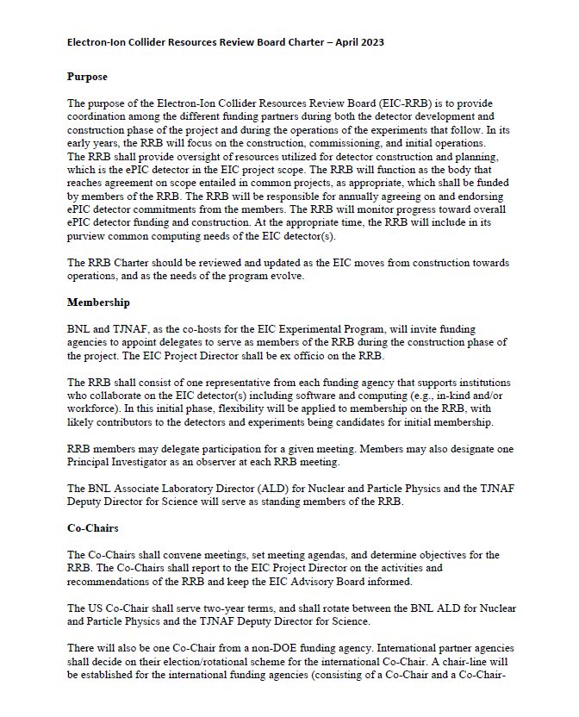
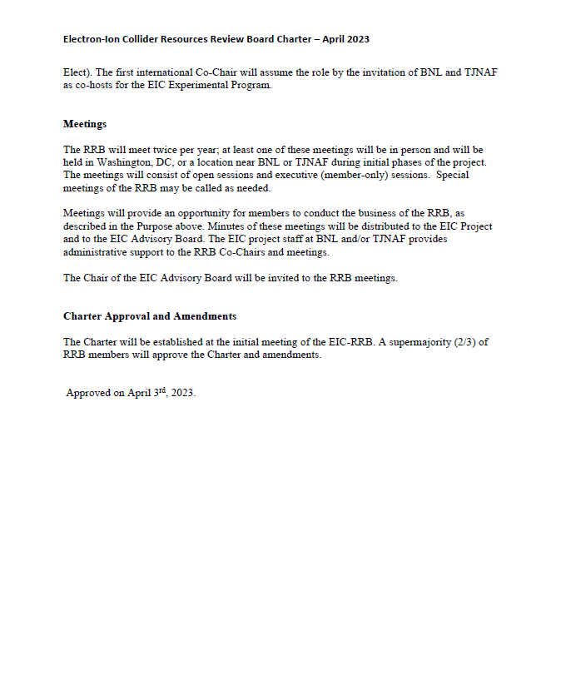

The present draft relates to the ePIC experiment but can also serve as model for a potential future second EIC detector.
https://science.osti.gov/User-Facilities/Policies-and-Processes/Definition

