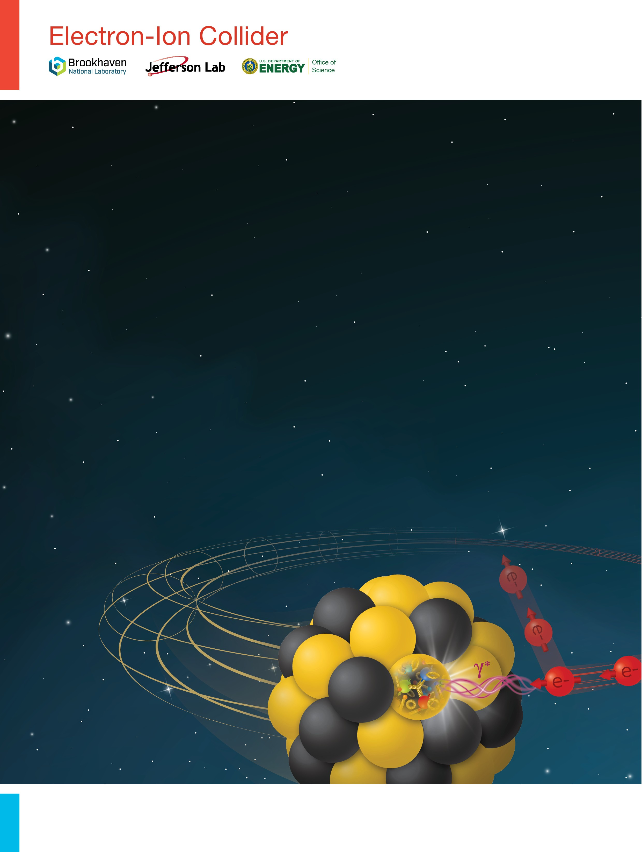

Final Report

Incremental Preliminary Design and Safety Review of the ePIC Barrel Imaging EMCal

September 19, 2024

Table of Contents
1 Executive Summary 3
2 Reponses to Charge Questions 4
3 Findings/Comments/Recommendations 6
4 Appendices 9
4.1 Appendix A: Charge to the Review Committee 9
4.2 Appendix B: Review Committee 10
4.3 Appendix E: Agenda 11

Executive Summary

The scope of this review includes all aspects of particle detection using the Barrel Imaging electromagnetic Calorimeter (BIC) of the ePIC detector at EIC, which combines two technologies, light-collecting calorimetry based on SciFi embedded in Pb and imaging calorimetry based on monolithic silicon sensors AstroPix. The review includes design and fabrication scenarios and their cost-effectiveness, optimization of physics performance, construction schedule, early considerations for safety and quality assurance, front-end electronics and interface to the data acquisition system, commissioning and calibration procedures, considerations for materials and labor, operational reliability and longevity, and any other considerations that may influence the construction and operation of the Calorimeter.

Reponses to Charge Questions

Charge Question #1
Are the technical performance requirements appropriately defined and complete for this stage of the project?

Response:

SCIFI: Project design is considered very advanced, and technical specifications have been met in several parts. There are some relevant items (e.g. noise pedestal position with respect to MIP, that is a critical scope for the calibration of the calorimeter) that have to be confirmed by a full prototype test with final electronics and cabling. The group can rely heavily on the past experience with GLUEX.

Imaging Layers: the AstroPix chip (designed for space applications) was chosen to equip these layers. The chip design is well advanced, and a production size prototype is ready for the characterization. The performance figures of the present version of the chip are already very close to the specifications for the BIC imaging layers, even though a further optimization of the timing performance is needed.

Charge Question #2
Are the plans for achieving detector performance and construction sufficiently developed and documented for the present phase of the project?

Response:

SCIFI: The review showed a quite complete level of documentation about tests and performance achieved, in small scale prototypes and in test beams, and in overall project schedule management.

Imaging Layers: The design of modules, staves and trays is ongoing. The review showed a reasonable level of development of the detection system for the present phase of the project; better understanding of the different elements is expected by the beginning of 2025, when first prototypes will be available.

Charge Question #3
Are the current designs and plans for detector and electronics readout likely to achieve the performance requirements with a low risk of cost increases, schedule delays, and technical problems?

Response:

SCIFI: Testing the final assembly layout of signal processing is considered mandatory to obtain real figures for overall performance and to reduce to a minimum the risks of problems (delays, non-conformity, etc…). This activity, if not yet present, should be adequately integrated in the current schedule, with adequate timing allocated.

Imaging Layers: similar considerations apply to Imaging layers. In addition, redundancy of readout and power interconnections should be carefully addressed.

Charge Question #4
Are the calorimeter fabrication and assembly plans consistent with the overall project and detector schedule?

Response:

SCIFI: A detailed schedule of calorimeter fabrication has been presented, and it is consistent with the rest of the project. QA/QC procedures for fiber quality and construction dimensional checks are relevant and should be reinforced to maintain excellent performance of the modules throughout the construction.

Imaging Layers: the review showed that the collaboration has a detailed plan for the construction, including person power and timeline figures. Detailed QA procedures for the selection of production grade detection elements should be envisaged and quality levels determined once prototypes of each element are available.

Charge Question #5
Are the plans for detector integration in the EIC detector appropriately developed for the present phase of the project?

Response:

SCIFI: Mechanical and electronic integration schemes have been presented. Final assembly procedures, including cabling and cooling should be tested on mockups to guarantee a reliable construction. Here again the group can profit of GLUEX and BNL expertise.

Imaging Layers: The integration at the two front faces of the calorimeter is in the phase of the conceptual design. The front face PCB of the SciFi part foresees slots for the insertion of the AstroPix trays. The conceptual design is appropriate at the current level. The realization requires close collaboration between the teams that work on the subsystems within BIC.

Charge Question #6
Have ES&H and QA considerations been adequately incorporated into the designs at their present stage?

Response:

SCIFI: ES&H and QA have been fully addressed throughout the entire review and are considered fully compliant to standards.

Imaging Layers: Plans for the QA chain have been presented. They look well-conceived and feasible. A minor risk is the (yet) uncertain participation of the Korean groups. ES&H aspects have been fully addressed and comply with standards.

Findings/Comments/Recommendations

General Questions:

- Provide a full schedule in which critical items are identified. For these items
- Set-up a risk register;
- For each sub-system, study and solve potential issues with full scale “prototype 0”.

Project Management:
- Findings
  - The project consists in reality of two subsystems (SciFi and Imaging Layers)
  - At the day of the review the project didn’t have an ePIC subsystem project manager

- Concerns
  - No clear project management may lead to divergences between the subsystems
  - Electronics integration of SciFi/Imaging Layer seems to be under the responsibility of Korean groups that are not yet approved.

- Comment
  - Clarify the situation with the Korean Groups and develop alternatives in case of the (unlikely event) of a non-approval (see also below “Collaboration”)

- Recommendation
  - Implement as quickly as possible an ePIC subsystem project manager

Collaboration
- Findings
  - AstroPix In-kind contributions from international partners (South-Korea and Canada) likely but not yet secured

- Comment
  - Define timeline to settle the agreements of in-kind contributions

SciFi/Pb:

General concept:

- Findings
  - Copy of GlueX Experiment however with integration of AstroPix layer.

- Recommendation:
  - Check integration problems in the cabling of the two front parts of each module wedge.

SciFi/Pb (low) energy response in simulation:

- Findings
  - MIP 8 p.e. away from pedestal and pedestal width ~2 p.e.
  - Photo-electron spectrum is very wide and 4 sigma noise cut would cut into the middle of the signal (at least according to the red/blue plot)
  - This is the worst case scenario but still. Testing the final assembly layout of signal processing is considered mandatory to obtain real-life figures for pedestal noise

- Concerns
  - Noise will increase by adding the electronic circuits with a number of parasitic capacitances

- Comments
  - Produce similar plots for η=0 and with all noise sources incorporated
  - Set procedures for QA/QC for fibers batch and for monitoring the effective dimensional construction of each module.

Imaging layers:

Chip performance assessment:

- Findings
  - The specifications of AstroPix almost match those required by BIC imaging layers and the better timing performance seems feasible

- Concerns
  - The change of foundry for the chip production could delay the chip development progress

- Comments
  - Put in place characterization procedure on large sample of chips already on AstroPix v4/5
  - Evaluate fluctuations on wafer (distribution of thresholds and noise)
  - Evaluate wafer to wafer fluctuations
  - Consider producing small size test structures to characterize the technology process in the new foundry (on the same wafer on which the foreseen reticle size chips production is done)

Module concept:

- Findings
  - Flex circuit design is still very preliminary
  - Only one LV pin considered
  - DAISY Chain on chips

- Concerns
  - Planning until the first Bus Tape (=flex PCB?) Test Article looks aggressive (Due in Q1 ‘25).
  - Relatively low level of redundancy in design
  - One dead chip disables the entire stave

- Comments
  - Envisage flex circuit performance simulation (power and data lines)
  - Design for two LV pins
  - Envisage design with by-passing of chips
  - Choice of connectors, evaluate insertion strength
  - Study of module heating and threshold dependence on the temperature variations: are we confident that cooling is useless in such a tight assembly?

Imaging layers:

End of tray card:

- Findings
  - No showstopper but still in early design phase

- Concerns
  - No schedule until test article given

- Recommendation
  - Define clear schedule until test article and test early with real AstroPix modules

Stave concept:

- Findings
  - Concept in very early phase

- Recommendations
  - Simulate power and data transmission along the full chain to the EOS board
  - Prepare mock ups of the full stave for data integrity studies

Tray assembly

- Comments
  - Use mechanical dummies to study insertion and removal of staves (modules) from the tray
  - Better explain the insertion of trays in the calorimeter sectors

Imaging layers:

End of Sector Board:

- Findings
  - Concept in very early phase
  - Concerns/recommendation
  - Detailed design of lines on the PCB required quickly
  - Services: carefully study on mock-ups space requirements for FPC/cables
Testing:

- Findings
  - So far, no construction of full sector (ScFi/PB+AstroPix) as technological prototype (or module-0) planned

- Concern
  - Problems due to integration aspects may appear during construction and operation

- Recommendation
  - Incorporate construction of one full sector (SciFi/PB + AstroPix) in planning

Construction:

- Findings:
  - Construction of modules involves a large amount of detectors (LHC-like experiment).

- Comment
  - Cross check that the organization has some redundancy. Some risks analysis would be helpful

Appendices

Appendix A: Charge to the Review Committee

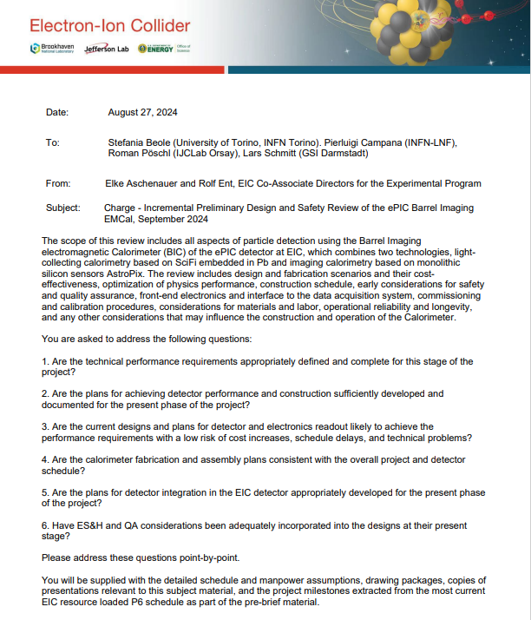

Appendix B: Review Committee

Stefania Beole (University of Torino, INFN Torino). Pierluigi Campana (INFN-LNF),
Roman Pöschl (IJCLab Orsay),

Appendix E: Agenda

