N0001421WX00568 – Plasma compression for terawatt long wavelength lasers (Daniel Francis Gordon, Naval Research Laboratory, Plasma Physics Division)
Annual Summary Report | FY24
Grant or Contract Number: | N0001421WX00568
Project Title: | Plasma compression for terawatt long wavelength lasers
Principle Investigator: | Daniel Gordon, Daniel.f.gordon2.civ@us.navy.mil, Naval Research Laboratory
Co-Principle Investigator(s):
Reporting Period: | 01/01/2024 – 12/31/2024

Submitted to:
Quentin Saulter
Program Officer
Quentin.e.saulter.civ@us.navy.mil
Office of Naval Research

Acknowledgement/Disclaimer: This work was sponsored by the Office of Naval Research (ONR), under grant/contract number N0001421WX00568. The views and conclusions contained herein are those of the authors only and should not be interpreted as representing those of ONR, the U.S. Navy or the U.S. Government.
Section I: Project Summary

Overview of Project
Lasers operating in the mid to long wavelength infrared (LWIR) typically deliver far less peak power than their near infrared counterparts. The carbon dioxide (CO₂) laser is an exception that can deliver joules of pulse energy in a few picoseconds at 9-10 micron wavelength. In order to obtain much shorter pulses, one must employ an optically pumped gas cell at extreme pressure, or utilize some form of nonlinear compression. This project pursues the latter course. The original vision was to perform key experiments at the Brookhaven National Laboratory (BNL), which offers synchronized near-infrared and long-wave-infrared beamlines that are ideal for this effort. More recently it has become possible to consider using the DOD CO² laser (housed at NRL) as well. The enabling technology is a simple arrangement of nonlinear frequency shifting in a crystal such as tellurium [C.K.N. Patel, Phys. Rev. Lett. 15, 1027 (1965), D. Matteo et al., Opt. Exp. 31, 27239 (2023)]. In this approach the synchronized seed pulse is directly derived from the pump pulse.
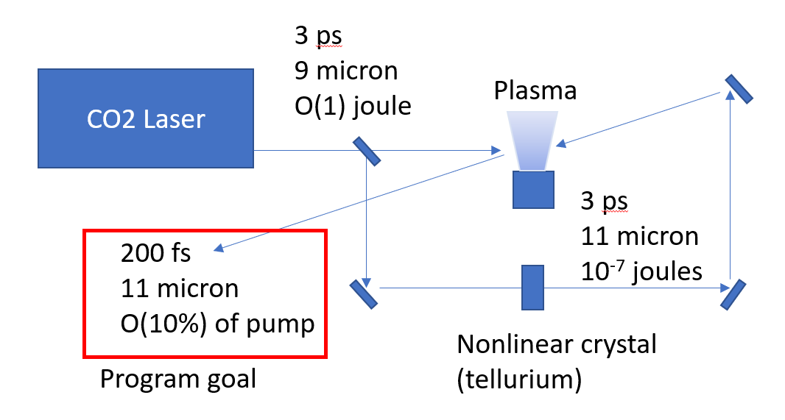
Figure 1: New scheme in which either the DOD or BNL CO² laser can be used. No externally synchronized seed laser is required, and only one plasma is needed.
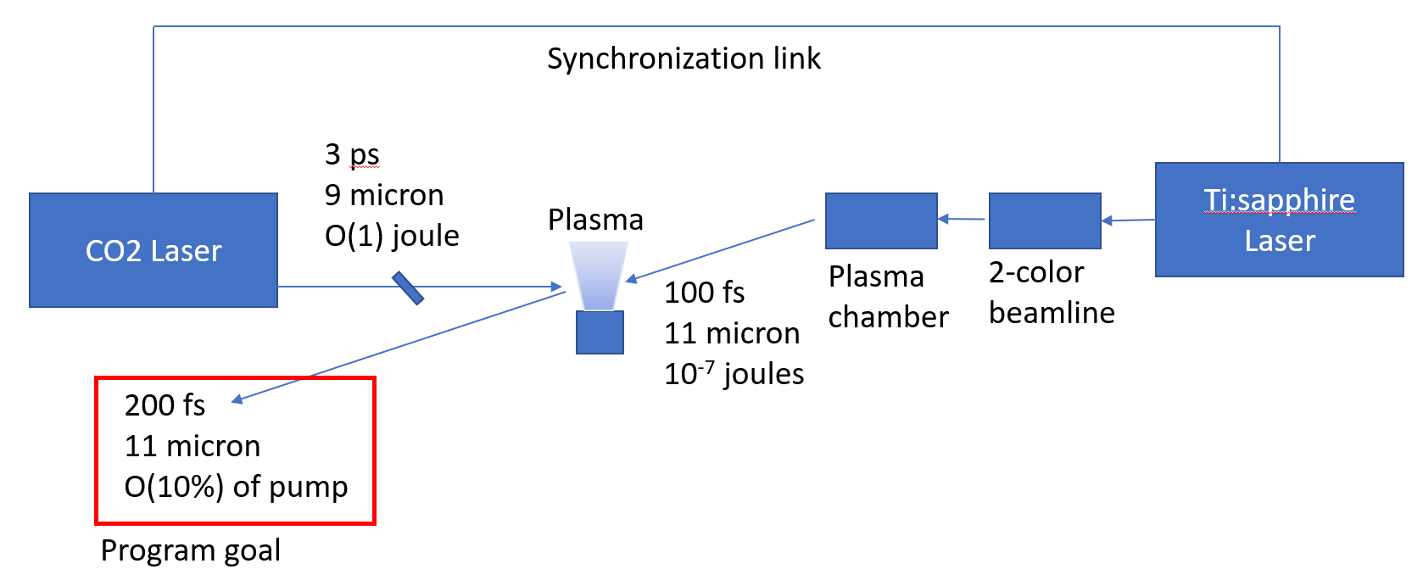
Figure 2: Original scheme which requires a secondary plasma interaction and externally synchronized seed laser.
The originally proposed scheme utilizes 2-color “THz” generation in a plasma to produce the LWIR. Tremendous progress has been made in this setup, and the LWIR radiation can be generated quite reliably with it. However, it has two major drawbacks. The first is that it requires an externally synchronized near-infrared (NIR) laser to drive the plasma. Secondly the optical components in the “plasma chamber” tend to get damaged even during normal operations. Part of the program is to develop solutions to the second issue, as detailed below.
Payoff: Lighter more robust long wavelength, high peak power laser technology, operating in the atmospheric window.
Executive Summary:
The project effort has shifted in the direction of an experiment that could be carried out at NRL. The key element in this new direction is utilizing the very large nonlinearity in a tellurium crystal to produce strongly red-shifted radiation in a relatively simple, easy to synchronize way.
Nevertheless, improvements on the original concept are considered, which rely on flying-focus optical elements to control the angular spread of the pump and signal in advantageous ways. There is also a new physics result on plasma generation.
Improvements to the SeaRay code are discussed.
The DOD CO² laser development is discussed, since this is now an element of the project.
Objective:
The program aims to produce extraordinary long wavelength infrared pulses with sub-picosecond pulse duration, joule class energy, and terawatt class power. Primary objectives are demonstration of the compressed pulse characteristics, and developing the science of plasma compression in a new wavelength regime.
Naval Relevance:
Our measurements indicate that esoteric effects of short pulses are more dramatic when driven by long wavelengths [submitted to JDE]. Currently, joule class LWIR pulses are produced using cumbersome and unreliable high pressure discharge technology. Nonlinear compression allows this technology to be replaced by lower pressure discharges which can support high repetition rates far more reliably. This solution may turn out to be more cost effective and more realizable in the near-term than optical pumping.
Introduction/Background:
Pulsed laser radiation may have applications in directed energy, particularly if one is interested in affecting a target with minimal beam energy. Almost all of the research to date concerns near-infrared wavelengths, yet longer wavelengths have advantages in terms of propagation lengths and materials interaction. Most solid-state, broadband, laser materials produce wavelengths in the range of 0.7-1.1 microns. Using photonic downconversion schemes, the range of wavelengths can be extended into the mid-IR, but with poor efficiency (e.g., 0.1% at 10 microns). In contrast, carbon dioxide (CO₂) lasers produce radiation at a fundamental wavelength of 10 microns, and can easily deliver many Joules per pulse. The difficulty is that the CO₂ gain medium has insufficient bandwidth for high peak power operation, unless extraordinary measures are taken, such as operating at extreme pressure, using mixed isotopes of CO₂, or relying on nonlinear effects such as power broadening. This tends to lead to a system design with bulky components, low efficiency, high operating cost (isotopes), and low repetition rate. The motivation for the proposed program is to completely bypass all of the issues arising from the bandwidth limitations of CO₂ by compressing a relatively long CO₂ laser pulse in plasma.
The plasma compression scheme is based on backward Raman amplification (BRA) [1-11]. BRA uses a low energy, short, seed pulse, counter-propagating in a plasma with a high energy, long, pump pulse. The seed pulse reflects the pump pulse by means of the backward Raman instability. In this process, the seed pulse beats with the pump pulse to drive plasma waves, which reflect and shift the pump radiation such that the seed is coherently reinforced. The amplified signal can become even shorter in duration than the initial seed pulse, but with much greater energy. There is a critical advantage in using plasma compression by means of BRA compared to conventional grating or prism compressors: in the case of plasma compression, the bandwidth of the incoming radiation is dramatically increased, whereas grating/prism compressors work by manipulating frequency components that are already present.

Activities and Accomplishments
Simulation and Design
We refactored the SeaRay code, and benchmarked the rotational model against J. Wahlstrand et al., Phys. Rev. A, 043820 (2012). As a reminder, this is an advanced quantum model that accounts for a large number of rotational states (typically about 30 are involved at room temperature), embedded in a full propagation code. We obtain agreement either with the paraxial or UPPE models.
We began to consider using a flying focus optic in the 2-color LWIR generation process. This could be a breakthrough in terms of controlling damage issues. To see why consider Fig. 3. On the left, the NIR driver is dumped through a hole and the LWIR is collected by reflection. In the flying focus configuration, the NIR driver is dumped by any surface (reflection, absorption, specular or diffuse) and the LWIR is collected through a hole. The latter configuration is more flexible and importantly, the fluence on the beam dump is more readily controllable.
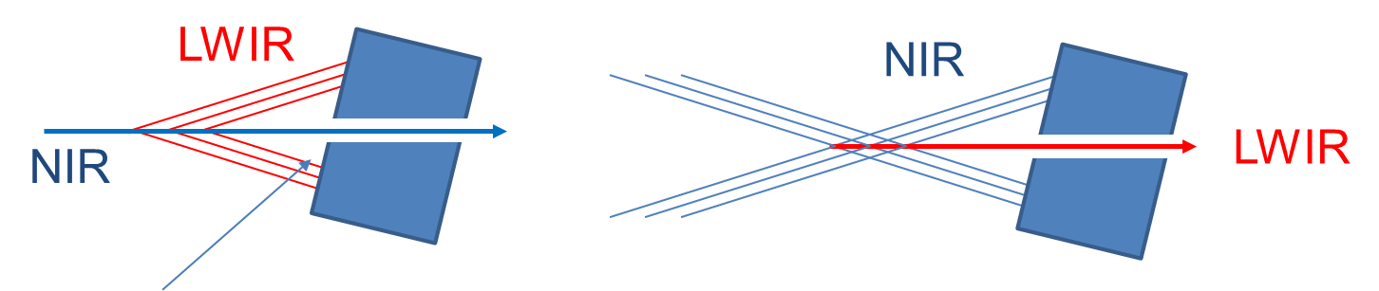
Figure 3: comparison of filament (left) and flying focus (right) configurations
In regards to flying focus, we developed an automated design process where a desired ionization front is specified, and an echelon and Fresnel lens are worked out that gives the specified ionization front. In carrying out flying focus simulations, the difficulty that emerges is that boundary conditions have to be handled much more carefully. This is because in these configurations, larger amplitudes tend to reach the radial boundaries. A generalized flying focus generator was added into SeaRay. Fig. 4 shows a SeaRay simulation of the flying focus optics. The special lens causes rays to form an on-axis caustic region that emits LWIR. The time delay of each ray is controlled such that a superluminal ionization front results, which is favorable for the mode and amplitude of the signal. The figure on the right is the wave amplitude (derived from ray/eikonal data) in the plane of radius and time. The peculiar “forward leaning” wavefront is a characteristic of the flying focus mode.
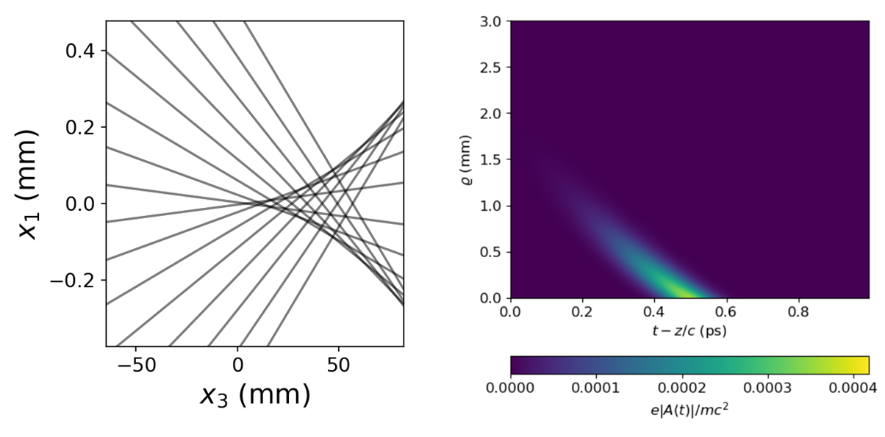
Figure 4: SeaRay simulation of flying focus in vacuo
Fig. 5 shows the form of the Fresnel lens that leads to flying focus with 10 cm length and velocity of 0.999c. Please note that the vertical and horizontal scales are very different (the grooves are in fact much more shallow than they appear). The groove depth has mostly to do with how far from the lens the flying focus is projected. The last figure shows the form of the echelon that also plays a role in determining the flying focus parameters (especially the velocity).
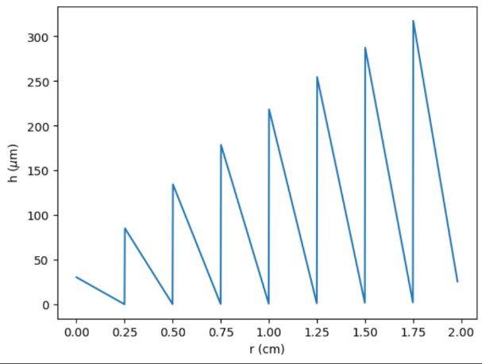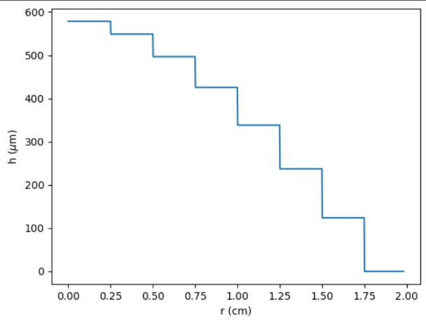
Figure 5: Form factor of the Fresnel lens with velocity 0.999c

Experiments on LWIR Transport
In order to test the transportability of the LWIR pulses produced by our combination LWIR source & spectrometer (see prior year’s report), we set up a rail system with Fourier plane imaging. Fig. 6 shows the transverse k-spectrum of the LWIR pulses as a function of rail position:

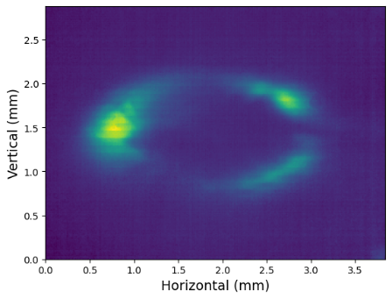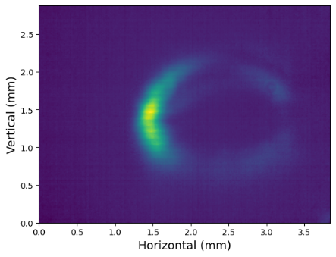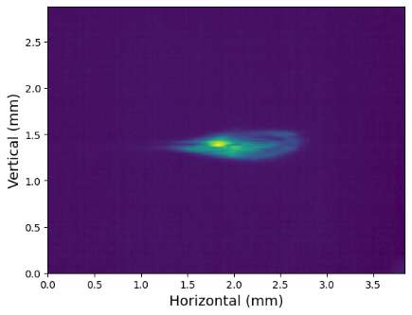
Figure 6: k-space shown at rail position 0 (left) and rail position 30 cm (center), and real space showing astigmatic focus (right)
These exhibit the expected “ring” pattern. The differing ellipticity suggests the vertical is well collimated, while the horizontal is slightly focusing, as expected. If the sensor position is adjusted to look at the image of the source, we get an astigmatic focus. This was also scanned over 30 cm (holding lens to sensor separation fixed) with the result that the picture changes very little. We took a preliminary step to compensate the astigmatism, with some success, but fully compensating requires installation of a new optic.
In summary, the LWIR pulses can be propagated far enough to couple into the plasma compression stage. We will next verify that the transverse mode can be refined.
Experiments with Reflective Axicon
As a simple test on the way to a true flying focus, we utilized a reflective axicon. According to theory, the velocity of the flying focus produced by the axicon is approximately 1 + β², where β is the approach angle of the Bessel beam rays. For our axicon this corresponds to β = 5 degrees, source velocity of 1.0076c, and LWIR emission angle of 7 degrees. We concluded that the axicon generated plasma generates no measurable RF or LWIR. Attempts were made using a horn collection method and a D-dot probe, and various laser parameters were scanned to optimize plasma brightness, but in no case could the RF be detected. The LWIR was similarly below threshold. We conclude that the axicon generated plasma, for this particular axicon, is not suitable for RF or LWIR generation. Theoretical analysis of this fact will come later.
As a result, in order to continue this line of attack it will be necessary to replace the axicon with a more highly engineered flying focus lens (as was always the plan).

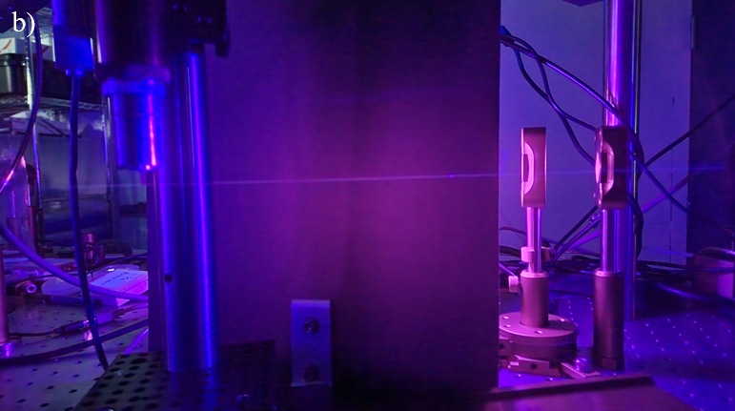
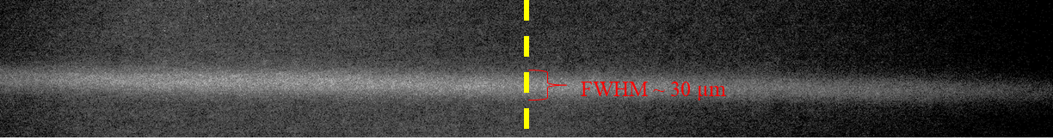
Figure 7. Photo of the long axicon-produced plasma (upper) and measurement of the plasma diameter (lower). Measurements were taken with both single and two-color ionization. The diameter was not affected, but the brightness was much higher with two colors.
Plasma Formation Physics
Although the axicon plasma did not produce measureable LWIR or RF radiation, there is a physics issue with the dependence of plasma brightness on the 2-color laser parameters. In particular, the presence of 2-colors together makes an unexpected change (increase) in plasma brightness. This is in despite of the fact that the ratio of blue to red energy is only a few percent, typically. The effect is illustrated in the series of traces in Fig. 8, showing the brightness (overall level of curve is what matters) vs. angle of the calcite delay compensator. Please note the vertical scale is in dB (log scale). When the calcite is moved of the optimal position, where both colors are synchronized, a dramatic reduction in brightness is observed.
One theory about why this happens has to do with the polarization state produced by the axicon, particularly with respect to how it transforms the two color pulse. In order to examine this physics theoretically we propose to use the strong field physics modules in turboWAVE.

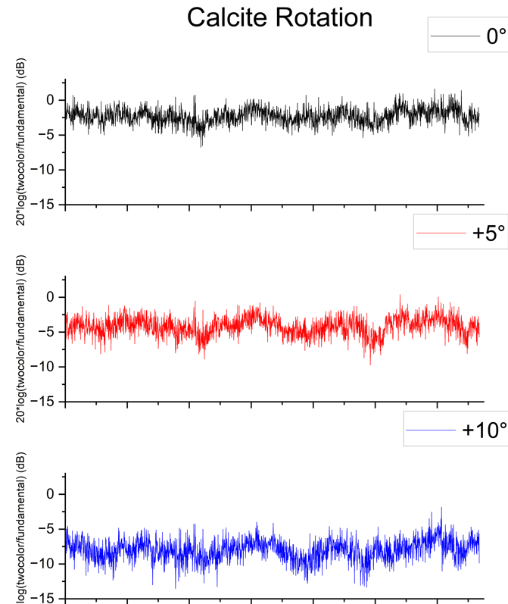
Figure 8: Plasma brightness vs. calcite angle. The effect of the calcite angle is to change the delay between the two colors. Synchronization makes much brighter plasmas. It is the degree of this effect that is surprising.
LWIR Generation in Tellurium
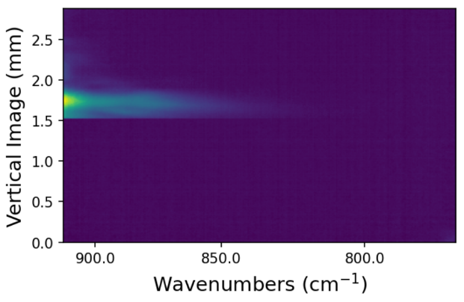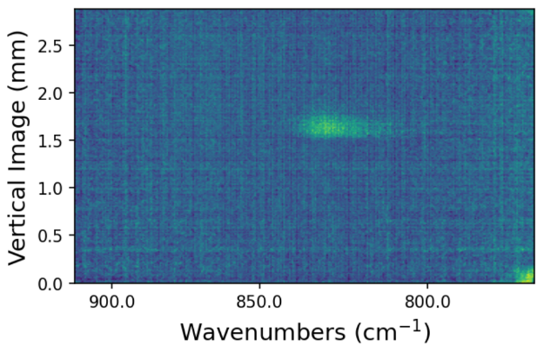
Figure 9: Spectra produced by the tellurium crystal
We carried out experiments using the DOD CO² laser as a driver of a tellurium crystal. The objective is to produce a LWIR seed without the need of a plasma or a synchronized NIR laser. For most of these experiments it was sufficient to use the front end (actually no CO² gas involved). We show here calibrated spectrometer images with and without a bandpass filter, in the LWIR region of the spectrum. The spectrometer was re-calibrated for the different camera by using the known wavelength fiducial at the “zero degree” prism setting, and then translating to obtain the calibrated axis at the LWIR setting (-0.4 degrees). The “hard” edges that sometimes appear as horizontal cutoffs are artifacts of the rolling shutter. They do not affect confidence in the spectral axis. Fig. 9 (left) shows the spectrum without any filtering. The pump wavelength is at about 970 cm⁻¹, which is off-screen. What is seen is a long red tail. This is likely due to strong self-phase modulation. The next figure shows the same screen, but with the bandpass filter in place. There is enough dynamic range to detect this far part of the tail, which is of direct interest for the Raman amplification process, i.e., this is the portion of the spectrum that can seed plasma compression.

Findings and Conclusions
The most important finding is that a relatively simple nonlinear frequency conversion arrangement appears to be suitable for seeding the backward Raman amplification. This goes a long way toward making the scheme viable for real applications. This finding also affects the program, because it makes it possible to carry out a demonstration at either NRL or BNL.

Plans and Upcoming Events
The tellurium experiments will continue with measurement of the pulse energy in the LWIR band of interest (from 11-13 microns). These measurements will be used as inputs into the particle-in-cell model of the BRA process.
We will develop a simulation capability for nonlinear frequency conversion in tellurium. We will adapt existing Navy codes turboWAVE and SeaRay with the specific crystal parameters.
We will setup up the DOD CO² laser in two stages. The first stage will be a simple 1-pass in the power stage. This should produce 50 mJ, and provide a reliable basis of operation for many experiments.
The second stage is to utilize the 3-pass off-axis unstable resonator configuration. All components for this stage are in place. Practical issues of alignment and control of parasitic lasing are the primary tasks to be carried out. This should produce O(1) joule of pulse energy.

Transitions and Impacts
As far as we know the BRA scheme for LWIR compression has not been adopted by other groups. One measure of software impact is the count of the forks of publicly released software. TurboWAVE has been forked 7 times. SeaRay has been forked 5 times. Both, but especially the latter, have been developed under this program.

Recommendations for Future Work:
The most important future work would be scaling up the compression ratio using a long pulse laser, ideally about 100 ps. This is non-trivial, and also requires longer plasma sources.

Personnel
Principal Investigator
Full Name | Approximate Level of Effort – LOE - (Hours This FY) | Country of Residence | National Academy Member? (Y/N)
Daniel Gordon | 600 | USA | N
Co-Investigator(s) or Co-PI(s)
Full Name | Approximate Level of Effort – LOE - (Hours This FY) | Country of Residence | National Academy Member? (Y/N)
Yu-hsin Chen | 400 | USA | N
Patrick Grugan | 400 | USA | N
Alexander Englesbe | 200 | USA | N
Performer Business Contact(s)
Full Name | Role | Country of Residence
Additional (Non-Student) Team Members
Full Name | Approximate Level of Effort – LOE - (Hours This FY) | Country of Residence | National Academy Member? (Y/N)
Melody DeGuzman | 160 | USA | N
Subcontractors
Full Name and Organization | Approximate Level of Effort – LOE - (Hours This FY) | Country of Residence | National Academy Member? (Y/N)
Susan Dewaters, HII/CTI | 80 | USA | N

Collaborations
Full Name | Organization | Collaboration Summary
Sergei Tochitsky | UCLA | Consultation on tellurium interactions

Students
Doctoral Student(s)
Full Name | University | Graduated? | Graduation Year
Masters Student(s)
Full Name | University | Graduated? | Graduation Year
Undergraduate Student(s)
Full Name | University | Graduated? | Graduation Year
Angel Alberto Hernandez | Virginia Tech | N | TBD

Technology Transfer
N/A

Products, Publications, Patents, License Agreements, etc.
Publications resulting from this project for the reporting period:
Archival Publications
No information to report
Conference Papers
No information to report
Books
No information to report
Book Chapter
No information to report
Theses
No information to report
Websites
No information to report
Patents
No information to report
Other Products:
# | Product Description | Acknowledged ONR Support Received?  (Y/N) | Peer Reviewed?  (Y/N)
1 | SeaRay | Y | Y

Point of Contact in U.S. Navy / Marine Corps
N/A

Appendix A. Section II: Project Metrics

Grant or Contract Number: | N0001421WX00568
Project Title: | Plasma compression for terawatt long wavelength lasers
Principle Investigator: | Daniel Gordon
Co-Principle Investigator(s):
Date Prepared: | 03/03/2025
Annual Summary Report: | FY24

Metrics

Number of faculty supported under this project during this reporting period: | N/A
Number of post-doctoral researchers supported under this project during this period: | N/A
Number of graduate students supported under this project during this reporting period: | N/A
Number of undergraduate students supported under this project during this period: | 1
Number of scientists / engineers / technicians supported under this project during this reporting period: | 4
Number of refereed publications during this reporting period for which at least 1/3 of the work was done under this effort: | 0
Number of publications (all) during this reporting period | 0
Number of patents during this reporting period: | 0
Number of M.S. students graduated during this reporting period: | 0
Number of Ph.D. students graduated during this reporting period: | 0
Awards received during this reporting period: | 0
N/A
Invited talks given:
N/A
Conferences at which presentations were given (not including invited talks above):
N/A

Financial information

FY 2024 | Total Budget | Obligated This Period | Obligated Cumulative | Expended This Period | Expended Cumulative | Grant/ Contract Period of Performance
6.1  (Basic Research Funding) | 500K | 500K | 500K | 500K | 500K | 12/31/2024
6.2
(Applied Research Funding)
Total
(if both 6.1 and 6.2 funding was used)

Administrative notes and other items of interest
N/A

