CERN test beam list of items

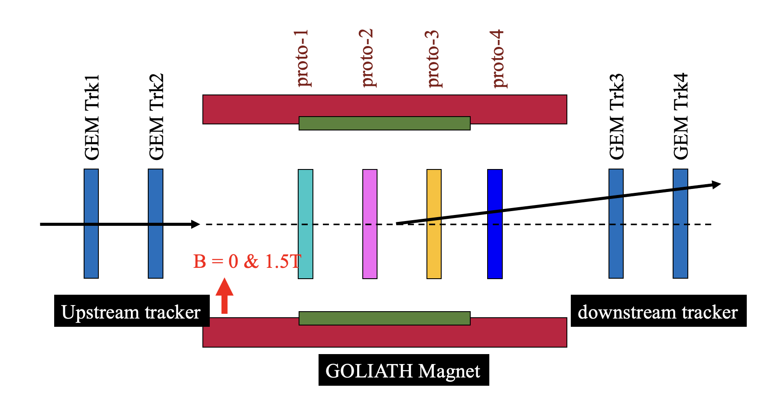
- 4 trackers + 4 DUTs
- HV channels:
  - 4 Trackers: 4
  - DUTs: 16
  - Ideally two double sided with one reading out one detector at a time.
    - 2 set up with one small detector with pad readout (8 APVS) and other will be large chamber + 2 small single thin gap chamber
    - JLAB provide 12 channels.

- HV cables:
  - 4 trackers: 4
  - 2 DUTs: 16

- APVs:
  - 4 Trackers: 8 (4 pairs Master -Slave)
  - DUTs
    - Small thin gap pad readout – 8 APVs
    - Large double side - 8 APVs
    - Probably can get 5 Masters + 5 slaves from Vanderbilt APVs

- HDMI cables (longest one available) for
    - 8 NEEDED and all of the HDMI cables can be taken from Hall D TRD project and some spare.

- Flat ribbon cables for APV Master slave (longest available)
  - Based on configuration of Master slave from previous bullets 8 ribbons
- Scintillator+ PMT for trigger : 2
- SRS system : 1 (One from Hall D) + may be 1 from UVA additional
- DAQ computer : 1
- Ethernet cable : 2-3
- DUT support structure using 80/20 frame: 1 (40 cm x 40 cm x 40 cm)
- Tracker support structure using 80/20 frame : 2 (40 cm x 40 cm x 20 cm)
- Gas tubing (?)
- Some hardware like screw driver etc
- Network switch
- External hard disc ( 2-4 TB)
- Lemo cables
- Twisted cables (Xinzhan)

- Ask CERN to provide 2 NIM bin slots .

