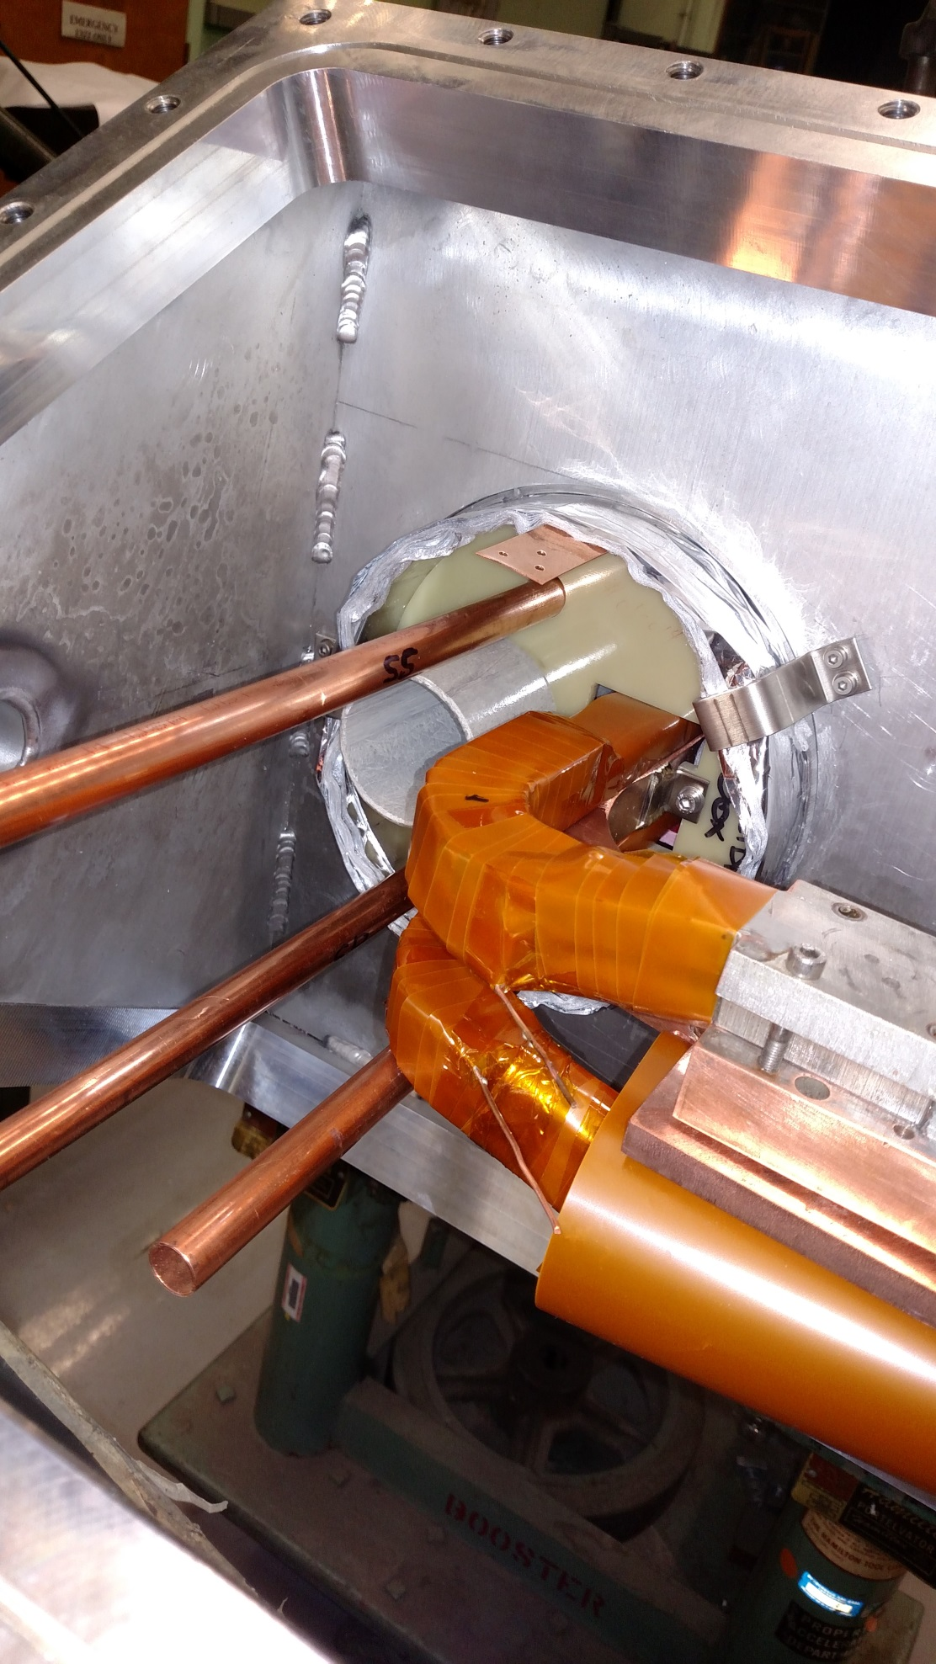
2 similar sensors on other side of extension
Sensor 2
Sensor 1
This one has a different range.
