The EIC Computing and Software Joint Institute (ECSJI)

Brookhaven National Laboratory (BNL) and Thomas Jefferson National Accelerator Facility (JLab), as Electron Ion Collider (EIC) host laboratories, established in the fall of 2023 a joint structure, the EIC Computing and Software Joint Institute (ECSJI), to support the EIC computing and software needs and activities. ECSJI will leverage complementary expertise at the two Labs and provide needed visibility to the respective Lab management and stakeholders. The advantages of such a structure also include increased reliability and availability of resources for the ePIC collaboration.

The success of the EIC, an international scientific endeavor, will benefit from contributions from international partners towards its computing effort. To facilitate efficient coordination, the institute will administer the EIC International Computing Organization (EICO), the EICO addresses the participation of International partners in computing. This document describes the functions and responsibilities of the ECSJI.

Scope of the EIC Computing and Software Joint Institute
This institute will provide for EIC computing and software matters:

- A single entity to interface with the EIC project and the ePIC collaboration,

- Maintains Service Level Agreements and statements of work outlining the host labs’ contribution to the ePIC collaboration concerning computing resources, services, and personnel assigned to work on ePIC computing and software deliverables,

- A coordinating body for interacting with international partners providing computing resources as in-kind contributions. This includes assessing resources, managing the agreements of cooperation with the sites delivering resources (including service levels agreements), and facilitating and assessing the delivery against the agreements,

- Execution of host Lab responsibilities as detailed below
  - Assessing resources.
  - Managing the agreements with the sites delivering resources (including service levels).
  - Facilitating and assessing the delivery against the agreements.

Organization & Governance
The institute aims at providing efficient support to the EIC while acknowledging the differences in the organization at the two Labs. The proposed governance model ensures that the EIC experiment(s) are well supported in matters of computing and software, the institutes’ performance is monitored, and reporting is clearly defined.

The Institute Management
- Composition: the management will comprise two co-Directors; each is nominated by one Lab (see Appendix I)
- Reporting: the institute’s management will report jointly to the two host Lab management.
- Duties and accountability:
  - The management will be responsible for organizing the institute to deliver on the responsibilities defined above.
  - The management will maintain a multi-year operation plan for the host Labs, providing matrixed staff members to support the activities.
  - The management will provide a yearly report to the host Lab’s management.
The proposed governance structure is composed of two central bodies and is designed to facilitate communication, coordination, escalation of issues, and conflict resolution. EIC Computing Organization (as seen by DOE NP Office) is shown on Fig.1 (as in spring 2026).

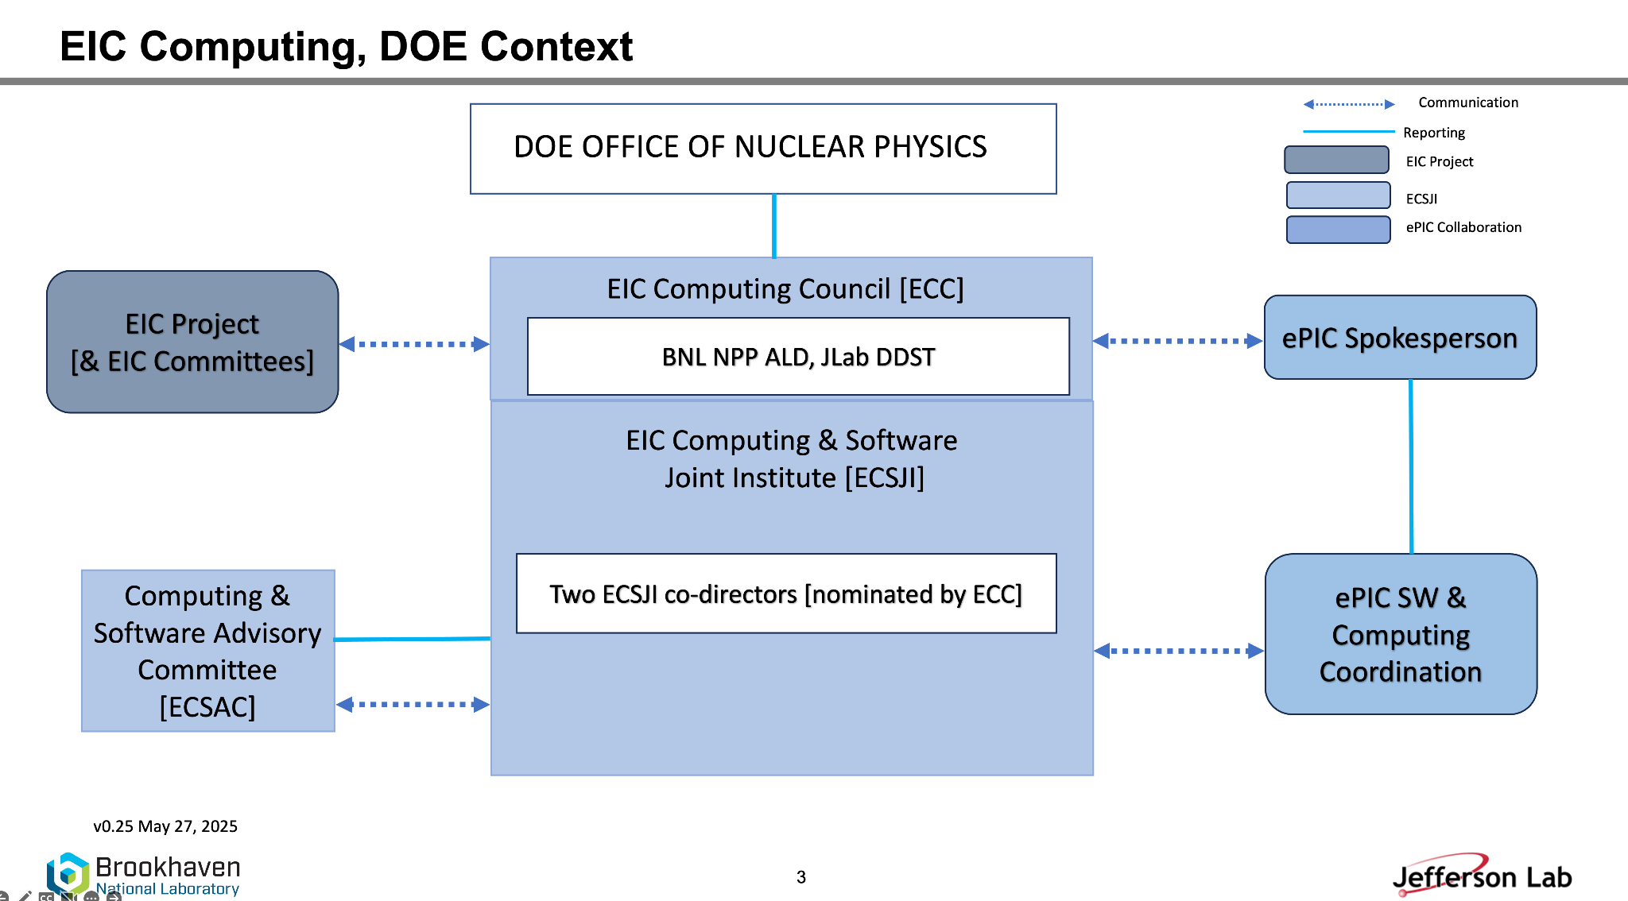

.

The EIC Computing Council
The EIC Computing Council (ECC) reviews the ECSJI strategic direction and supports leadership in managing effective interfaces of the ECSJI to the EIC program and ePIC collaboration. ECC approves the ECSJI strategic direction, leadership changes, annual budgets, resource allocations, and performance milestones. The ECC is chaired in alternation by the Associate Laboratory Director for Nuclear and Particle Physics (ALD) of BNL and the Deputy Director for Science (DDST) of JLab. It comprises the ALDs/ADs and deputies involved in the EIC science program and Institute management. To maintain connection with the EIC International Computing Organization, the Oversight Board (OB) Chair of the EIC International Computing Organization (EICO) is included as a member of the EIC Computing Council.

- Responsibility: Review the ECSJI strategic direction and support leadership in managing effective interfaces of the ECSJI to the EIC project and ePIC collaboration.
- Authority: Approve the ECSJI strategic direction, leadership changes, annual budgets, resource allocations, and performance milestones.

- Oversee the development and implementation of EIC Computing and Software and review future computing needs,
- Oversee synergies between the host Labs in EIC scientific computing area and provide institutional strategic direction,
- Resolve high-level issues between different stakeholders.

The ECC will initially meet at least twice a year or as requested by the management of the Institute and hear reports from the Institute management.

The EIC Computing and Software Advisory Committee
The EIC Computing and Software Advisory Committee (ECSAC) is chartered to propose advice, guidance, and counsel on the strategy and objectives of the Institute and of the EIC International Computing Organization. The ECSAC reports to the ECSJI management. The ECSAC chair and committee members include external managers and experts in the field appointed by the Institute management in consultation with the host Lab’s management. It will initially meet at least twice a year or as requested by the Institute management. The ECSAC serves as the Institute management’s external advisory committee; it will submit a report to the Institute management after each meeting.

The ECSAC responsibilities include to:
- Review the strategy and objectives of the Institute to support EIC Computing and Software,
- Evaluate the adequacy of the infrastructure and resources to meet the computing requirements of the ePIC collaboration,
- Evaluate proposed technical solutions and their implementation,
- Identify opportunities to increase effectiveness and efficiency.

If conflicting requirements affect the operation, planning, or budget, the ECSAC will be asked to provide recommendations to the Institute management, who will escalate them to the EIC Computing Council.

The EIC International Computing Organization
The EIC International Computing Organization (EICO) is led by the Institute's co-directors and administered by the ECSJI. This organization exists to provide computing resources, infrastructure, and services related to the EIC. The current focus is on the ePIC experiment. This will be extended to other foci as endorsed by the EIC RRB. Funding agencies will indicate the activities and services they will provide, and this will be approved by RRB. The EICO structure is formally documented in the EICO charter.
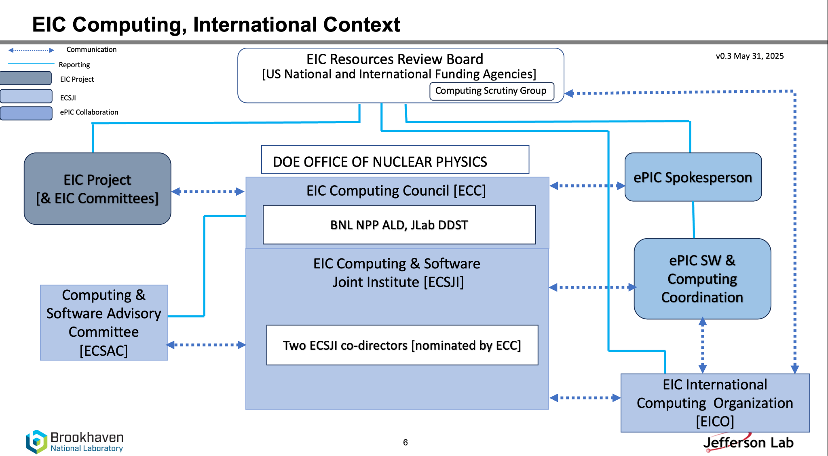

The purpose of the ECSJI and EICO is to provide the computing resources needed to process and analyse the data gathered by the EIC Program. EICO relations with ECSJI, ePIC collaboration and RRB scrutiny group is shown on Fig.2 (as in February 2026). The EIC computing project is assembling a distributed computing system. The ePIC computing model classifies the computer centres functionally in Echelons. The EICO is managed by the Overview Board (OB). The Overview Board oversees the functioning of the EICO. It is composed of a representative of each Institution that is a member of the EICO, the ECSJI directors and the Spokesperson(s) of each EIC Experiment with voting rights. The OB is co-chaired by EIC Computing Council Members, which include a member of the OB appointed as a co-chair.

Responsibilities

The Host Labs’ Responsibilities
The primary technical responsibilities of host Labs include and are not limited to the following:
- Oversight for EIC experiment(s) software and computing designs and execution to provide assurance functions for the host Labs and DOE,
- Provisioning and operating standard infrastructure solutions consistent with supported Lab infrastructures and with community best practices,
- Support for the EICO,
- Interface for local resources and policies at the respective Labs,
- On-going computing operations in support of the accelerator and detectors design and construction,
- Operational Support Functions for:
  - Experimental data curation,
  - First-pass processing,
  - Data analysis,
  - Support of collaboration(s) and users,
  - Accelerator and detector simulations to support EIC program

  - .

ePIC Collaboration Responsibilities
The ePIC collaboration responsibilities include and are not limited to the following:
- Developing and documenting a cost-effective computing model tailored to the experiment's needs, with the concurrence of the host Labs,
- Developing and maintaining multi-year resource plans,
- Report ePIC status in computing and software to the EIC-RRB,
- Identifying with input from the host Labs, a Computing and Software coordinator who serves as Point of Contact to ECSJI,
- Developments of Software Algorithms,
- Production operations.

Abhay Deshpande David J. Dean
Associate Laboratory Director for Nuclear Deputy Director for Science
and Particle Physics Jefferson Laboratory
Brookhaven National Laboratory

Date Date

VERSION HISTORY
Revision | Effective Date | Summary of Change
00 | 11/01/2024 | Original version
01 | 02/06/2026 | Revise the charter to comply with the EICO charter.
0.1.1 | 03/09/2026 | Updated version (ECSJI Co-Directors)

Appendix I EIC Computing Council and ECSJI Management composition (Spring 2026)

- EIC Computing Council
  - David Dean JLab DDST
  - Abhay Deshpande BNL NPP ALD
- ECSJI Co-Directors
  - Amber Boehnlein, JLab ALD for Computing and CIO
  - Alexei Klimentov, BNL Scientific Computing and Data Facilities Division Director

Appendix II EIC Computing and Software Advisory Committee (Spring 2026)

- Simone Campana, CERN (Chair)
- Ilya Baldin (JLab)
- Mario Cromaz (LBNL)
- Verena Martinez-Outschoorn, University of Massachusetts Amherst
- Pere Mato, PIC
- Wei Yang, SLAC

