BTOF Stavelet Inspection and Test Plan

Simone Mazza¹, ...
1 - University of California - Santa Cruz, ...

Abstract
Stavelets for the time-of-flight barrel detectors are assembled as modules in multiple sites. The QA/QC will be done first on components (electrical, visual), then after assembly (metrology) and finally on the completed stavelet (ASIC charge collection). Stavelet are shipped to stave assembly site where they are loaded on the half stave, then QA/QC is performed. Finally, two half staves are joined on the backside to fabricate the final double sided stave.

Contents
1. Stavelet Properties 1
2. Processes and Procedures 1
2.1. [Property 1] 1
2.1.1. In-Process Testing 2
2.1.2. Incoming Inspections or Acceptance Testing 2
2.1.3. Verification Testing 2
2.1.4. Failures and Non-Conformances 2
2.2. [Property 2] 2
2.2.1. In-Process Testing 2
2.2.2. Incoming Inspections or Acceptance Testing 2
2.2.3. Verification Testing 2
2.2.4. Failures and Non-Conformances 2
3. Experimental/Test Setups 2
3.1. Your Experimental Method 1 2
3.1.1. Resource Requirements 2
3.1.2. Test Conditions 3
3.1.3. Equipment 3
3.2. Your Experimental Method 2 3
3.2.1. Resource Requirements 3
3.2.2. Test Conditions 3
3.2.3. Equipment 3
4. Environment, Safety & Health Considerations 3
5. Records and Documentation 4
5.1. Manufacturer/Producer Records 4
5.2. Deliverable Documentation and Records 4
6. References 4

Stavelet Properties

The module of the BTOF is referred to as ‘stavelet’, it is made from an interposer board loaded by sensor, ASIC (FCFD) and minimal electronic components. The assembled stavelets will be loaded on a stave on both sides of the stave, each side will have 7 stavelets and a Service Hybrid loaded. The cooling is provided by a pipe running inside the stave. Figure 1 shows the exploded view of a stave. The fully loaded stave total thickness will be around 7-8mm with a material budget of 5-6% X, Figure 3.
The stavelet interposer is a thin FPC of Kapton and copper (1-layer but might need 2-layers) to support the sensors and ASIC assembly. As seen in Figure 2 (left), sensors are placed on a large metal pad that provides bias voltage. The ASICs are placed around each sensor they are interconnected via traces going around the sensor on the interposer board, only one of each set of four has external communication with the FPC bus. Sensors and ASICs are glued on the interposer and connected via wirebonds. The interposer board will also host bias capacitor and temperature sensors. Other materials for the stavelet will be explored as well, e.g. thin ceramic (rigid, but higher material budget). Another option is adding stiffeners to the design. The loading tolerance for the sensor is 150um or better to ensure double-sided overlap. A stavelet prototype is shown in Figure 2 (right).
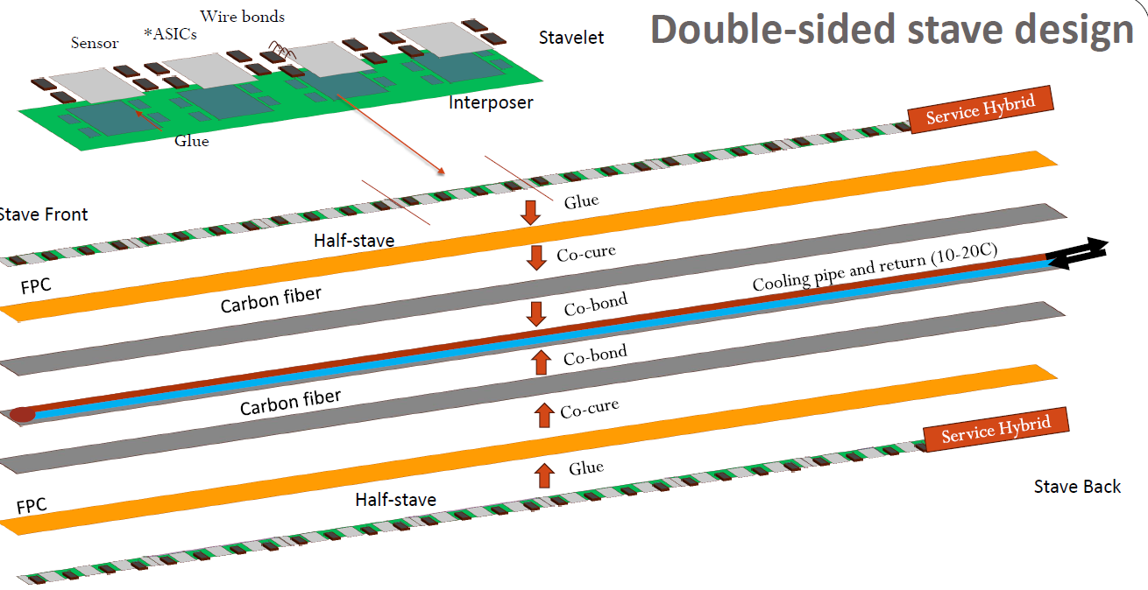
Figure 1. Exploded view of a double-sided stave.
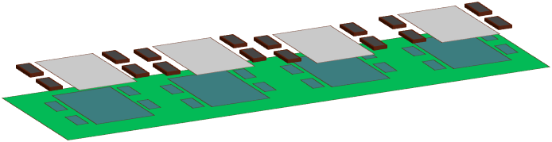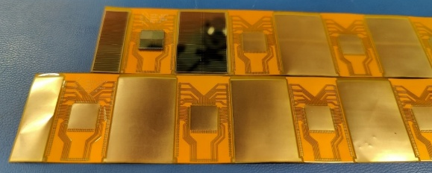
Figure 2. Left: Stavelet components, black: FCFD ASIC, grey: AC-LGAD sensor, green: interposer board. Right: first stavelet prototype fabricated (old design) with some components loaded.
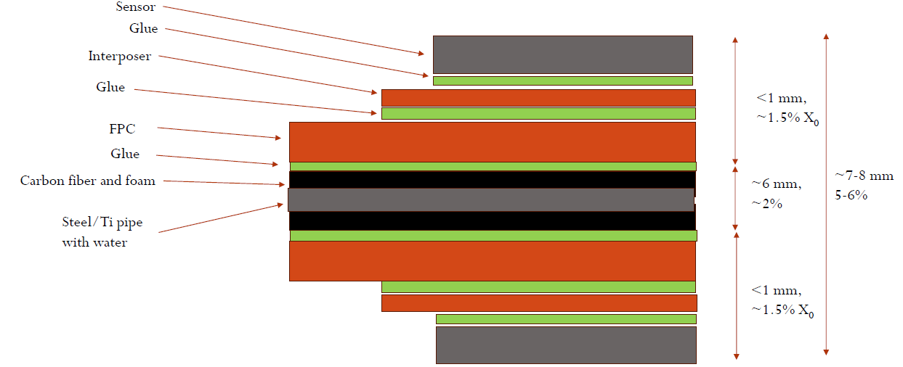
Figure 3: cross section of a stave stack with thickness and material budget

Pre-assembly requirements
 | Workspace, equipment and storage
 |  | Parameter | Value
 |  | Cleanliness of the assembly area | ≥ISO6
 |  | Components and stavelet storage requirements | Dry cabinets
 |  | Equipment status | Regularly serviced and calibrated
 |  | Components | Qualified and certified working
 |  | Glue storage | Temperature controlled dry environment
Post-assembly requirements
 | Mechanical
 |  | Parameter | Value
 |  | Mechanical alignment of components | <150um
 |  | Measured relative position of components | <5um
 |  | Glue thickness | 50-100um?
 |  | Glue homogeneity | 10%?
 |  | Glue coverage | >80%?
 |  | Connection integrity | Wire bonds pull force >10gF
 | Electrical
 |  | Parameter | Value
 |  | FCFD powering test | Lack of short and open circuits
 |  | FCFD digital communication tests | No errors in digital communication
 |  | FCFD channel operation | <X%? of bad channels
 |  | FCFD power lines voltage variation | <5%
 |  | Sensor operation | Breakdown voltage between [180, 190] V
 | Full System
 |  | Parameter | Value
 |  | Charge response of each FCFD channel | Homogeneity within X%

Processes and Procedures
2.1. Pre-assembly: Workspace, equipment and storage
The workspace, equipment and storage of detector modules is standardized and monitored.
Cleanliness of the assembly workspace: to check that the cleanliness of the workspace is sufficient to handle and interconnect 50 µm thin sensors with interconnection pads of ~100 µm size. Failure to do so would impact on the module production yield.
Servicing of equipment for electrical interconnection (e.g. wirebonding machines): to check that the equipment used to electrically interconnect the detector modules is reliable and does not develop faults that could lead to major downtime and delays in the production of modules.
Calibration of power supplies and oscilloscopes: to check that the equipment is reliable to supply and measure electrical currents and electrical potentials.
Environmentally controlled storage of sensors and FCFD: to prevent deterioration of components after acceptance testing.
Environmentally controlled storage of glue: to prevent deterioration of glue, it will be dry stored at cool temperature.
Verification Testing
- Cleanliness of the assembly workspace: periodic certification of the workspace to meet ISO6 or higher, following the ISO 14644-1 standard.
- Servicing of equipment for electrical interconnection (e.g. wirebonding machines): periodic servicing and maintenance of the equipment for electrical interconnection (i.e. wirebonding machines).
- Calibration of power supplies and oscilloscopes: periodic calibration of the equipment.
- Environmentally controlled storage of sensors and FCFD: to be store in dry storage units.
- Environmentally controlled storage of glue: to prevent deterioration of glue, it will be dry stored at cool (10-15 C) temperature.
2.2. Pre-assembly: Components acceptance testing
The components and tools required to assemble stavelets require acceptance testing in order to verify their compliance with their individual specifications. This process checks that components are suitable for the production of detector grade modules.
Incoming Inspections or Acceptance Testing
- FCFD acceptance testing: to check that the chips are compliant with detector grade requirements. To be assessed via visual inspection and access to a shared database containing results of verification tests (e.g. visual inspections and metrology (potentially) and electrical tests) performed at the FCFD QC sites.
- Sensor acceptance testing: to check that the sensors are compliant with detector grade requirements. To be assessed via visual inspection and access to a shared database containing results of verification tests (e.g. visual inspections and metrology (potentially) and electrical tests) performed at the sensors QC sites.
- Interposer acceptance testing: to check that the interposer is compliant with detector grade requirements. To be assessed via visual inspection and access to a shared database containing results of verification tests (e.g. visual inspections and electrical tests) performed at the FPC QC sites.
- Epoxy glue acceptance testing: to check that the glue is in date and stored according to the manufacturer’s requirements.
- Jigs and tools to be metrology tested via coordinate measurement machines at metrology workshops before deployment. This guarantees compliance with the mechanical tolerancing specified in their related mechanical drawings. To inspect the position of alignment pins, flatness, perpendicularity.

2.3. Post-assembly: Mechanical test: glue coverage and homogeneity
The glue coverage and homogeneity are measured to ensure good thermal connection and wire bonding support
Verification Testing
- Automatic inspection by SmartScope; laser measurement of components planarity
- Sample inspection; separate components and verify glue coverage

2.4. Post-assembly: Mechanical test: Welding integrity of microelectronics interconnects
The welded joints that are required by the electrical interconnects (wirebonds) are responsible for the robustness of the module electrical interconnection.
Verification testing
- Visual inspection by microscope; Impedance tests; Pull/shear tests on interconnects.
- Visual inspection before after (potential) potting

2.5. Post-assembly: Mechanical test: Mechanical integrity and alignment of module components
The welded joints that are required by the electrical interconnects (wirebonds) are responsible for the robustness of the module electrical interconnection.
Verification testing
- Visual inspection by microscope; Impedance tests; Pull/shear tests on interconnects.
- Visual inspection before after (potential) potting

2.6. Post-assembly: Electrical test: sensor electrical test
Verify sensor is working after assembly
Verification testing
- Run a current over voltage test on all sensors on the stavelet (probably sharing one bias voltage line) in a dark enclosure. Compare with sum of current over voltage measurements of all sensors mounted from pre-assembly stage.

2.8. Post-assembly: Electrical test: FCFD powering tests
Impedance measurements: to check for short circuit and open circuit defects.
Power consumption measurements: to check that the device operates within the functional limits of its power domains.
Verification Testing
- Impedance measurements: To measure the impedance of the power rail without applying any supply voltage. Measurement performed by probe testing on dedicated interposer pads.
- Power consumption measurements: To set the supply current(s) and voltages(s) to the nominal value(s) and to measure the associated current(s); To repeat the measurement with the supply voltage(s) over-biased and under-biased (e.g. min, max) with respect to the nominal value(s).

2.9. Post-assembly: Electrical test: FCFD digital communication tests
Configuration and register read-back measurements: To check that the device can be configured and it communicates with the other chips
Verification Testing
- Configuration and register read-back measurements: To configure the device and to measure the power consumption of the device after configuration. To write and read back a known value on a selected register multiple times without errors. To check communication with all FCFD daisy-chained together.
2.10. Post-assembly: Full system test: Charge response of each FCFD channel
Digital scan: to check the response of the in-channel digital circuity and the readout path through the highspeed data links.
Analogue scan: to check the response of the in-channel circuity (analogue and digital) and the readout path through the high-speed data links.
Threshold scan: to check the threshold value of the in-channel comparator and the noise of each pixel in units of electrons.
Threshold tuning: to adjust the in-channel comparator to a certain threshold value with a narrow spread across all pixels.
Verification Testing
- Digital scan: To inject a known number of digital pulses in the in-channel digital circuitry of each pixel. To count the number of recorded hits detected in each pixel.
- Analogue scan: To inject a known number of analogue pulses with fixed amplitude in the in-channel analogue circuitry of each channel. To count the number of recorded hits detected in each channel.
- Threshold scan: To scan the amplitude of analogue pulse from low to high. For each amplitude, to inject a fixed number of pulses in each channel and record the number of detected hits. Perform the first derivative of the obtained S-curve to extract the associated Gaussian. To extract the mean value for threshold measurement, and the standard deviation for the noise measurement.
- Threshold tuning: To scan iteratively the in-channel settings/registers to set the voltage as close as possible to the target value.
- Charge collection: Bias the sensors and inject a known charge in each channel using an X-ray source. Verify homogeneity of channel response.

Experimental/test setups
3.1 Post-assembly: Mechanical tests
Visual inspections: to be performed via microscopes and/or optical metrology equipment, with possible automation. Position of components on the board in respect of alignment markings measured with <5um precision. Leveling of components to evaluate glue planarity measured with <Xum precision.
Pull/shear tests on interconnects: to be performed with dedicated commercial off the shelf pull/shear test equipment.
Resource Requirements
- Visual inspections: This is a one-person task using a microscope and and/or optical metrology equipment.
- Pull/shear tests on interconnects: This is a one-person task using the pull/shear test equipment.
Resource Test conditions
- Visual inspections: Good lighting conditions, in clean room.
- Pull/shear tests on interconnects: Good lighting conditions, in clean room
Equipment
- Visual inspections: Microscopes and/or optical metrology equipment. Example equipment shown in Figure 4.
- Pull/shear tests on interconnects: pull/shear test equipment.
Figure 4. Metrology station (SmartScope) inspecting a mockup stavelet

3.2 Post-assembly: Electrical tests
The assembled stavelets will be tested with a test board (Figure 5) that comprehends a temporary FPC (or PCB), clamped/connected to the interposer board, and a service hybrid. The SH will communicate with a test FPGA that is connected to a DAQ PC for the testing. The DAQ PC will ave automated scripts to run the testing. The schematics of the setup are shown in Figure 6. The FCFD chips will be tested using both internal charge injection from the FPGA and using an external source to inject a known signal inside the sensors, the source, possibly mounted on a sliding motor, can scan across all four sensors positions on the stavelet.
Resource Requirements
The test system will consist of a custom-made printed circuit board (PCB) for data acquisition (DAQ). This DAQ card will perform readout and control operations on the stavelet. Tests will be automated via scripts running on a PC. The PC will control the peripheral DAQ card and the power supplies. The software of the system will combine a series of scripted scans that will be executed sequentially as part of the qualification tests on the module. Quality factors will be extracted from the tests using fiducial cuts. They will be used to accept or reject modules.
Test conditions
Electrical tests on stavelets will be performed at room temperature and in a dark environment to avoid the undesired noise produced by photo-generated currents. It is under consideration the adoption of a metal cooling plate to support the module during the post assembly qualification tests. The plate will be connected to a chiller with water as coolant.
Equipment
Tests will be automated via scripts running on a PC. The PC will control the FPGA that will control the SH. Schematics are shown in Figure 5 and 6.
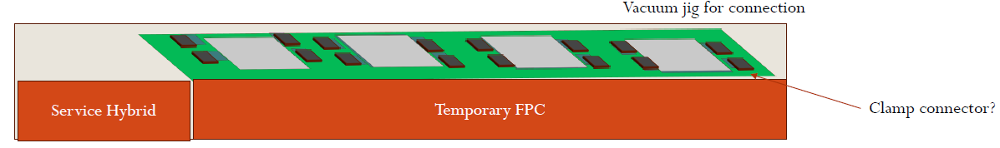
Figure 5. Mechanical schematics of the test board, the setup will be in a dark box

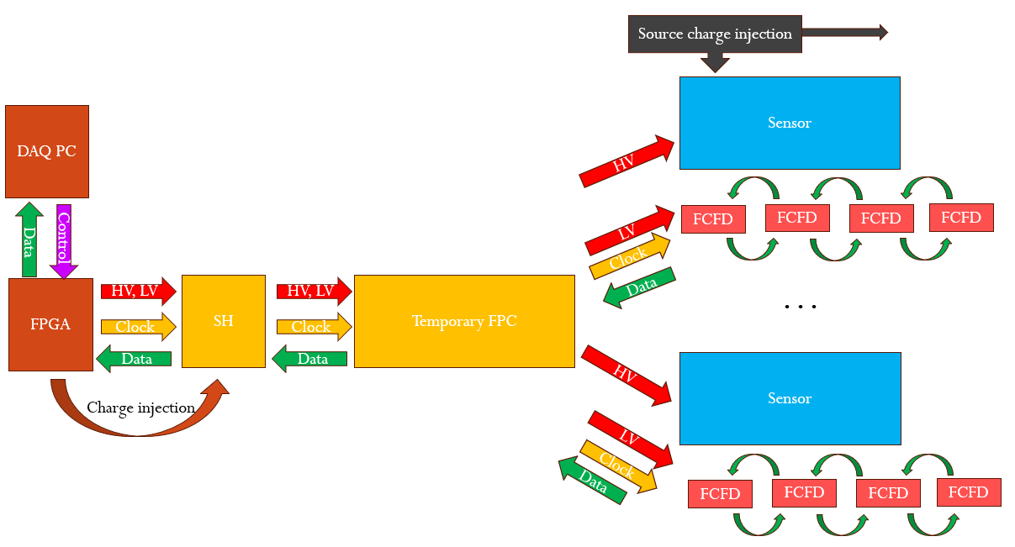
Figure 6. Schematics of the test board, the chips will be tested both with internal charge injection and with charge injection via a source on the sensor.

ENVIRONMENT, SAFETY & HEALTH CONSIDERATIONS
All procedures described in this document are carried out in accordance with the Environment, Safety, and Health (ES&H) policies of the relevant laboratories and work areas. Activities are implemented following the established Work Planning and Control frameworks of the participating institutions:
- At University of California, Santa Cruz (UCSC): Activities comply with the university’s Environmental Health and Safety (EHS) regulations, ensuring adherence to national regulations for laboratory safety and radiation protection.
- At …: Activities are conducted under the Japan Health and Safety (H&S) policy?
- At Purdue University: Activities comply with the university’s Environmental Health and Safety (EHS) regulations, ensuring adherence to national regulations for laboratory safety and radiation protection.
- At Brookhaven National Laboratory (BNL): Work is carried out according to the Integrated Safety Management (ISM), ensuring compliance with U.S. Department of Energy (DOE) regulations and the safe execution of experimental activities.

Records and Documentation
Sensors: reports with acceptance tests performed by the responsible sensors QC sites within the BTOF collaboration.
FCFD: reports with acceptance tests performed by the responsible FCFD QC sites within the BTOF collaboration.
Interposer: reports with acceptance tests performed by the responsible interposer QC sites within the BTOF collaboration, and external manufacturers.
Technical datasheets of glues for Control of Substances Hazardous to Health (COSHH). Health (ES&H) policies of the relevant laboratories and work areas. Activities are implemented following the established Work Planning and Control frameworks of the participating institutions:
Documentation: The assembly procedure will be documented in a series of documents, slides or twiki pages as the process gets developed.
Database: A database entry of components (sensor, stavelet, FCFD) proprieties (pictures, current over voltage, digital communication tests, position from Metrology etc.) will be added in the ePIC common database in the BTOF section. This will allow to keep track of all components and assemblies during the installation and run.

