Accelerator Operations Training and Development Program -An Update
Isadoro Terry Carlino
Abstract: At the Workshop on Accelerator Operations 2004, Michael Epps, then the Accelerator Operations Deputy Group Leader at Jefferson Lab gave a talk called Accelerator Operations Training and Development Program which described a proposed training program which JLab was just beginning to develop at that time. 14 years down the road how has it worked out? This talk is a retrospective of what was done, what worked and what did not. What has been done and what still needs to be done to finish implementing JLab's plan to have a fully functioning sustainable training program.

Authored by Jefferson Science Associates, LLC under U.S. DOE Contract No. DE-AC05-06OR23177. The U.S. Government retains a non-exclusive, paid-up, irrevocable, world-wide license to publish or reproduce this manuscript for U.S. Government purposes.

1. Introduction
Over ten years ago Jefferson Lab presented a talk at WAO on the Accelerator Operations Training and Development Program which was under development. At that time, Operations had been developing a program for at least a year, yet only small parts of the program were actually in place. Moodle, the open source course management system, had not yet been deployed at JLab. Several pieces of training software were under development. An already existing library of video lectures were in place, but often contained obsolete information that was not obvious to the student.
Up until this time operator training was conducted entirely through On the Job training. Technical materials, primarily Tech Notes and powerpoint presentations as well as the aforementioned videos were the only instructional materials available. USPAS was always a method by which new operators were introduced to the fundamentals of Accelerator Physics.
Operations was determined to move to a better paradigm that would produce operators with a more consistent level of knowledge. The Operations group leader put development of the program in the hands of the deputy group leader, who along with a committee of qualified crew chiefs developed a plan to implement a new training program.
So the question is, over fourteen years in, how did it work? This report will outline the program that was developed and explained what worked and what did not. The figures in this paper are actual slides from the previous WAO talk given, with some update from the present. In each section, the talk slides will be presented and then a short discussion presented on the outcome of the planned training program.

2. Timeline
Initially a Training Time Line was developed to standardize operator training. As can be seen operator development was divided into Phases. A time for completion was assigned to each Phase. Each Phase was to have a Focus.
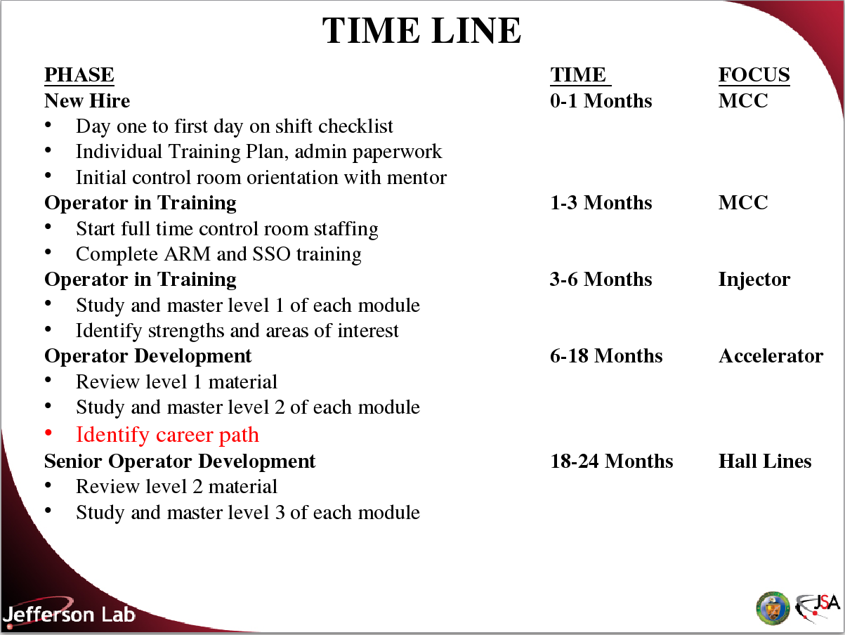Illustration 1: Time Line

As a starting point the Time Line provided a framework from which to start our efforts. In order to successfully implement a program we would have to determine the methods we would use to train our operators. Then we would have to determine what resources were available to us and develop the additional resources we would need.
The prior training program consisted of assigning unqualified new operators to shifts and leaving their qualification up to their crew mates. A number of technical notes and videos were available, but no organized training program was in effect. Spot training on specific procedures was conducted on a shift-by-shift basis with little consistency in the training each individual operator received.
New operators quickly received channel access to machine controls. [CEBAF EPICS controls used the Channel Access protocol to control each individual’s ability to change the values of system Process Variables.] The new program would require certain training be completed before the trainee was given channel access. All trainees would receive the same training.

3. Training Issues
The original list of training issues is still relevant. Expectations must be well defined. The purpose of the training program is to maintain a knowledge level among the operations staff that is consistent and above a minimum proficiency. It must meet DOE training standards. Any training must address the 24/7 work schedule of operations.
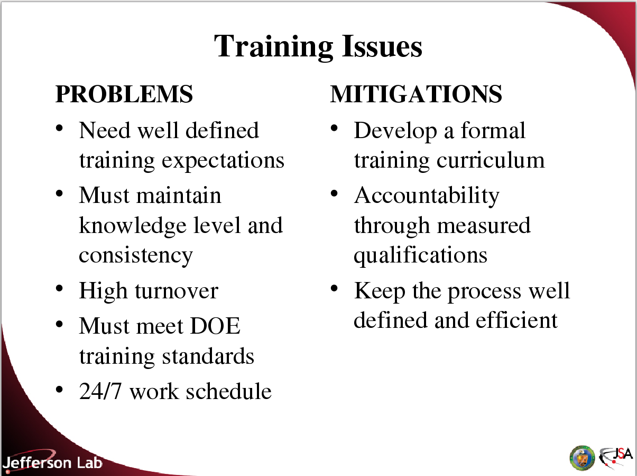Illustration 2: Training Issues
High turnover was mitigated by changing from rotating shift work to a long rotating fixed shift a subject that was covered in detail in a talk at WAO 2012 (Operator Development: Nature & Nurture.)
Mitigations would help us address the problems. Through a formal training program a baseline of minimum qualifications would be established. Accountability would be ensured because every trainee would have to pass the same tests and show proficiency in completing the same tasks.

4. Methods
To some extent all four methods were already being used. Lectures were often presented by Subject Matter Experts (SME) to describe the operation of new hardware, software and explain new procedures. These lectures were usually recorded and made available in an on-line video repository.
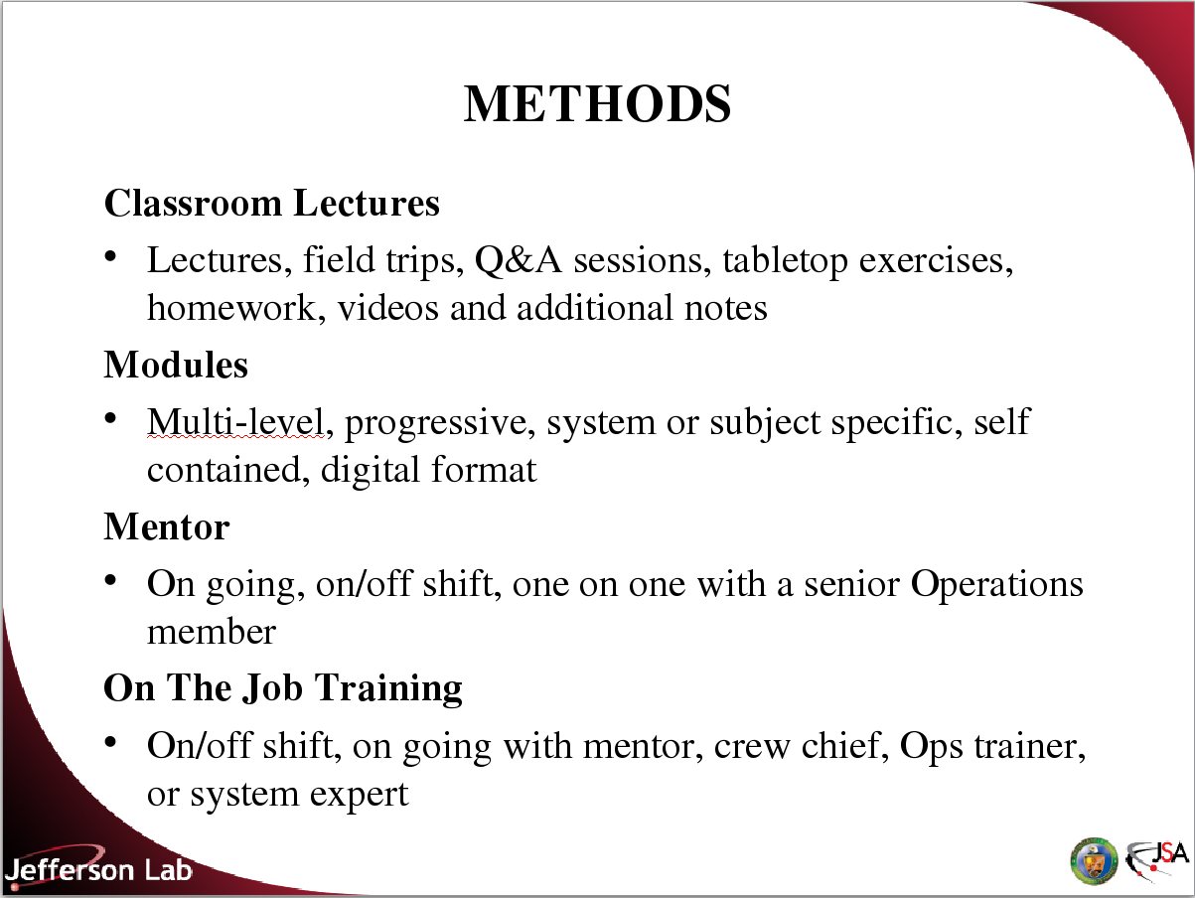Illustration 3: Methods
Many lab wide training requirements were satisfied by on-line training. The on-shift Crew Chief and more senior operators often acted as mentors to the new trainee, though the relationship was not formal and did not follow the trainee from shift-to-shift. Prior to the implementation of the new program almost all training was conducted as OJT.
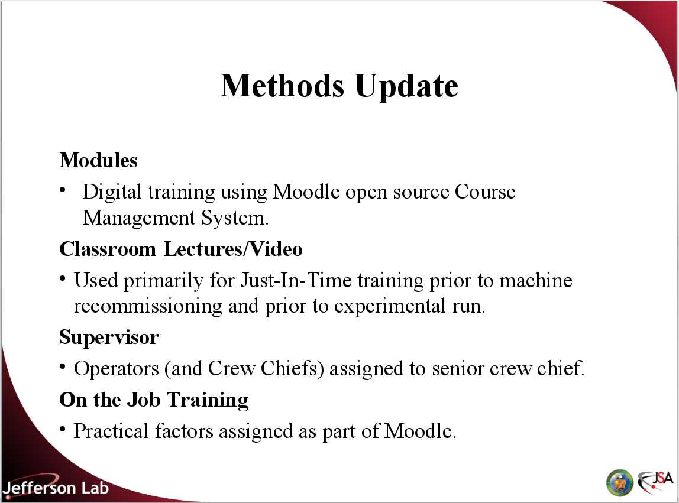Illustration 4: Methods Update
In implementation it was determined that Training Modules, using the Moodle Course Management System, were the best vehicle for the majority of our training. Using online training allowed us to leverage System Experts in the most efficient way, since the author of the module could interface with Subject Matter Experts(SME) when necessary, but SMEs were not required to be available in an ongoing manner as they would if they were required to teach classes. Also SMEs are not required to learn to use the Moodle authoring software. Instead a subset of Operations Staff prepare modules based on lesson plans and SME input.
Classroom Lectures are used primarily for training related to new systems, procedures and software. Classroom training is recorded and incorporated into Just-In-time Training for those who miss the lectures. Periodic review of existing modules incorporates new information from lectures into the training modules.
The Operations division was restructured to assign Operators and junior Crew Chiefs to Senior Crew Chiefs as direct reports. These Senior Crew Chiefs act as mentors, particularly for new operators and Crew Chiefs-In-Training.
Tasks and procedures to be completed as part of the training program are specified as Practical Factors as part of each training module. Practical Factors are completed under the supervision of a qualified Operator or Crew Chief and primarily occur while the student is on shift with a crew.

5. Resources

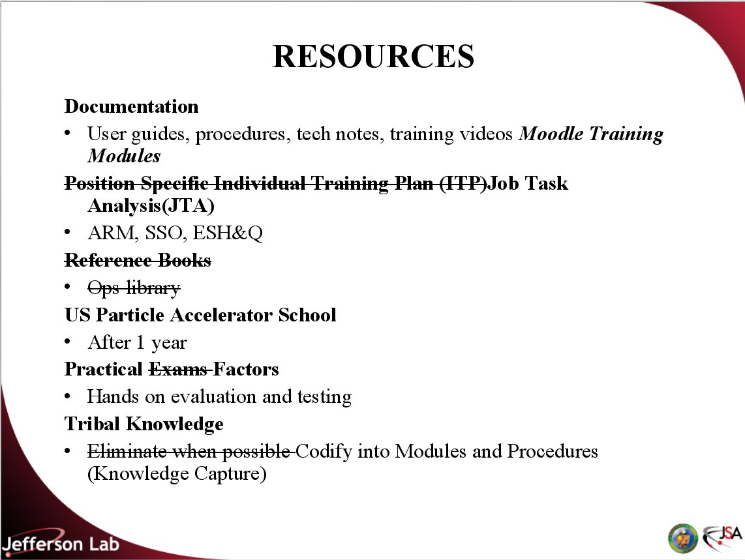Illustration 5: Resources
The Resources needed to create lesson content and provide training were well understood from the beginning. Individual Training Plans were replaced with Job Task Analysis(JTA), a skills based competency tracking system, used by JLab for employee training. Assigned Radiation Monitor(ARM), Safety System Operator(SSO) and general safety training are tracked and training is provided through a set of on-line and classroom training and exams by Jlab’s training office in collaboration with the Environmental, Safety, Health and Quality office (ESH&Q).
Reference works are primarily on line and an Ops Library has never materialized. Jefferson Lab continues to assign operators to take an Accelerators Fundamentals course through the US Particle Accelerator School after they have been at the Lab for a year.
As already stated Practical Factors have been incorporated into the Moodle training system. Elimination of the use of Tribal Knowledge has been redirected into the practice of attempting to codify into modules and procedures what was previously Tribal Knowledge held in the heads of specific individuals. This practice of knowledge capture is particularly important in an environment where the average age of laboratory staff is increasing and a large number of individuals can be expected to leave the Lab workforce in the next decade.

6. Training Modules
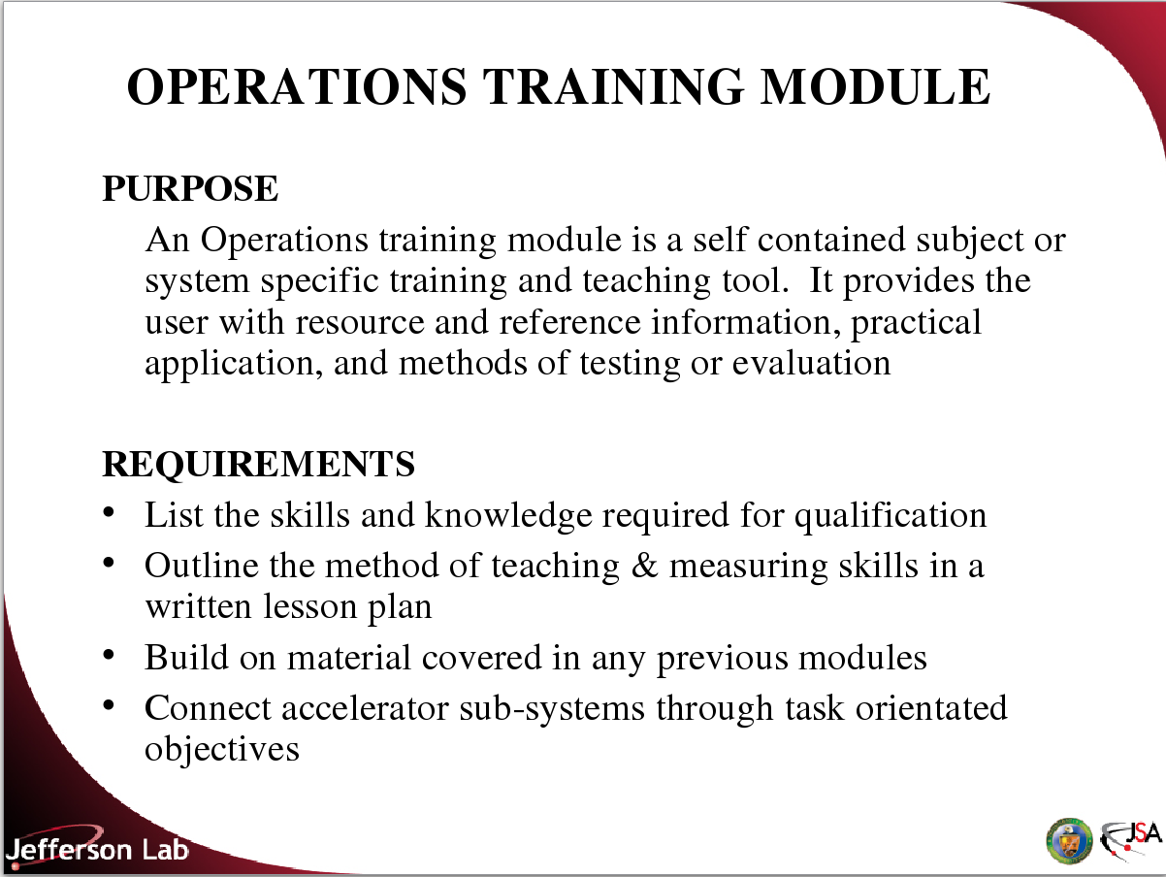Illustration 6: Training Modules
The specific software to be used for On-Line Training was not yet determined when the Training Program development started. Toolbook was originally considered as an option. Jefferson Lab’s Training Office uses a combination of Acrobat and Adobe Flash in it’s on-line training and those application were also considered. Eventually Moodle, an open source course management system was selected as the learning platform for Operations training.

In many ways the Learning Platform is independent of the process used to create modules. Which is outlined below:
- First determine the skills necessary for qualification at each level of the program.
- Outline the methods required to teach the skills, including practical factors and use this to create a lesson plan.
- Test based on the lesson plan.
  - Content is created based on the lesson plan.
  - Tests are created from the lesson plan, not the content.

7. Training Development Process
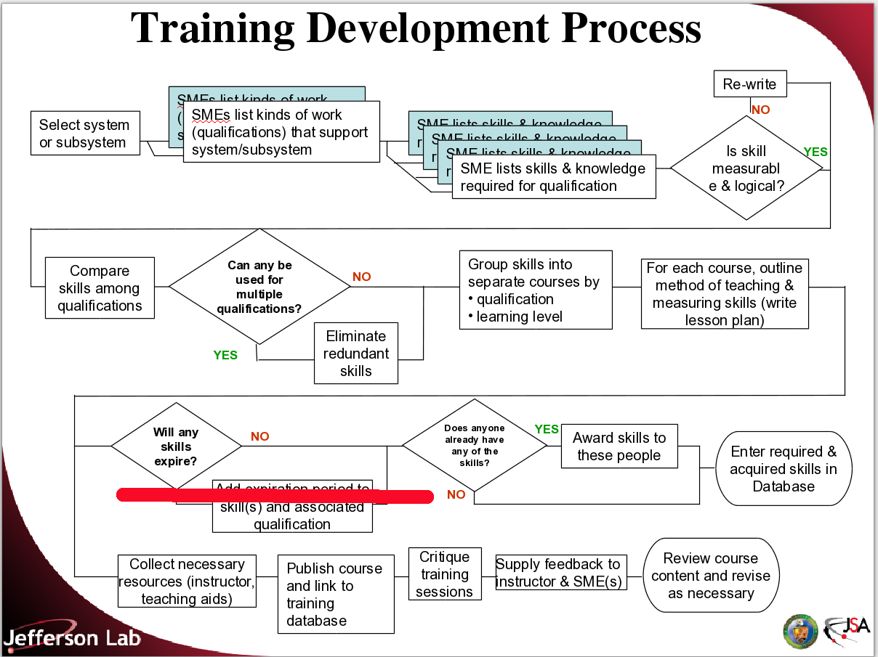
The Training Development Process was followed almost exactly as envisioned. The decisions was made not to expire skills nor require requalification. The exception to this was that all Operations staff were required to attend a set of training lessons prior to commissioning of the 12 GeV upgrade CEBAF machine.
The actual development of the program was completed as described below.
Modules were divided into five categories based upon qualification goals and required skill sets.
- MCC-100 Operator in Training
- MCC-200 Qualified Operators
- MCC-300 Crew Chief in Training
- MCC-600 First Action Response
- MCC-700 Just-In-Time Training
MCC-500 was reserved for the now unused JLab FEL machine and MCC-400 for Qualified Crew Chief training, still undeveloped at this time.
MCC-100 training was structure into four phases. Once the new Operator completes their safety and RadCon training (necessary for access to the accelerator tunnel) they begin Phase I.
- Phase I: Preshift courses. Completed before starting shift work.
- Phase II: Complete in the first two shift cycles. Completing this phase of qualification is used to grant the Operator-In-Training limited access to the machine controls through a restricted form of Channel Access.
- Phase III: System courses and Practical Factors on accelerator systems.
- Phase IV: Integrated Systems Introduction
The purpose of the MCC-100 set is to produce a qualified Operator who knows enough to perform routine tasks under the supervision of a Crew Chief and a more experienced qualified Operator.
MCC-100 modules were written by a combination of highly qualified Operators and Crew Chiefs with input from SMEs in the individual areas. The first iteration of these ~50 modules was completed in about a year and a half. Modules are written by the author and reviewed by the MCC Operations Training Committee (MOTC) under the leadership of the Deputy Group Leader. Quiz development was turned over to a single individual to provide consistency in quiz structure and then reviewed separately from the individual modules.
Students follow a syllabus which indicates the order in which they must complete the MCC-100 level modules. Before being qualified the student must complete a comprehensive test.
Next to be developed were the MCC-300 level modules for qualification of Crew Chiefs. The ~25 modules are primarily concerned with Administrative tasks, such as Beam Operations Time Accounting, Safety documents and Control Room management and supervision. Modules were authored by a handful of senior Crew Chiefs. Development ran parallel to development of the MCC-100 level modules. MCC-300 modules are supplemented by Crew Chief in Training (CCiT) students standing shifts under instruction. After each shift the CCiT is evaluated by the Crew Chief on a Performance Evaluation form.
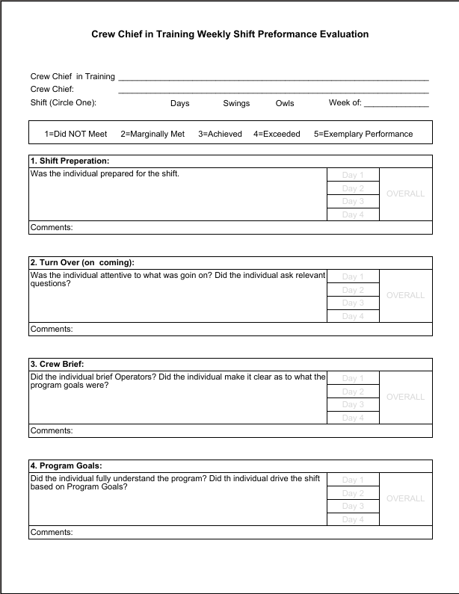
As for the MCC-100 level the CCiT must complete a comprehensive test to qualify.
MCC-600 level modules are for First Level Response. They were developed to increase up time by training operators to perform simple resets and minor maintenance actions, like replacing magnet trim cards. This reduces downtime by eliminating the need to call in maintenance personnel, primarily on weekends and after regular working hours. Several MCC-600 level modules qualify Operators to act as safety persons for the Lock Tag and Try (LT&T) of equipment. This prevents having to call in two system experts after hours when one would only be present for safety reasons.
Operators complete the MCC-600 level modules as soon as they become qualified Operators. Unlike MCC-100, 200 and 300 level modules the MCC-600 level modules were not developed from Lesson Plans and generally do not include Quizzes. Modules are typically completed by performing the task under supervision of an SME or Operator qualified to perform the task. The modules often contain supporting documentation so that the student understands what they are doing rather than just repeating tasks learned by rote.
The MCC-700 level modules were initially envisioned to contain training presented on new systems, software and procedure. However during the 12 GeV upgrade the focus of the module set was shifted. Machine operations were halted for over a year and a half and was slated to include at least another year or two of commissioning tasks. It was clear that an Operator requalification program would have to be put in place, to retrain operations prior to commissioning the newly rebuilt machine. To meet DOE expectations and to ensure operations staff, most who had been loaned out to other groups during the down period, were still competent to operate old and newly upgraded systems.
A process was developed to requalify Operators. A series of lessons were scheduled. The lessons were given by Subject Matter Experts(SME). At the completion of the lesson a quiz would be given to verify mastery of the subject. Lessons were recorded and made available in MCC-700 modules for individuals who were not able to attend. Observation of the video and completion of the quiz would be sufficient for completion of the lesson.
MCC-700 level modules continue to be used for system upgrades, new experiments and other training. Video recording the classroom lessons and making them available through the Moodle system ensures everyone in Operations can receive the training.
During the recommissioning period it was also decided to restrict the access to the machine Process Variables during machine operation to a greater level that had been the case during 6GeV operation. A Machine Access Control (MAC) Training program was developed using a subset of the MCC-100 level modules for SME and members of the Accelerator Physics staff. In order to directly control accelerator components during beam operation the expert must have completed the MAC program. The Crew Chief has individual access controls for MAC qualified individuals who get open channel access for a specific amount of time, and must work from the control room. A MAC syllabus identifies which courses they must take and their order. MAC access is also used for Operators in training for the time between when they complete Phase II of the Operator-In-Training program and when they become a fully qualified Operator.
The MCC-200 Level modules contain advanced system centered courses, as well as integrated systems courses, advanced fundamental training in computer systems, field response and troubleshooting. Since most of these courses are in depth they often require multiple sessions, over a longer period to complete, rather than the 1 or 2 hours per lesson required for the MCC-100 & 600 Level lessons. Because they are more complicated and require a hihger level of in depth knowledge to compose many are still in development.
Once the 12GeV upgrade was authorized, most work on the MCC-200 modules was suspended. Much of the information was impacted by changes made to the Accelerator, hardware and also to much of the existing software infrastructure. In the 6 GeV period accelerator tune-up was performed empirically, with setups either scaled from existing canned setups or downloaded from painstakingly tuned canned setups. 12 GeV setups were to be model driven and much new software and supporting systems were created to make this work. For much of the time before 12 GeV commissioning and even during it, these processes were in development. Creating Lesson Plans and content containing modules was not possible at this time because processes and systems were in flux.
Once the commissioning period was completed the entire training program was re-factored to ensure that obsolete Lesson Plan Objectives and even complete modules were removed. New Lesson Plans, particularly in the MCC-200 Level were created, reviewed and sent to authors for completion. At this time approximately half of the 36 MCC-200 level modules are completed and released for qualified Operators to complete.

8. Simulators
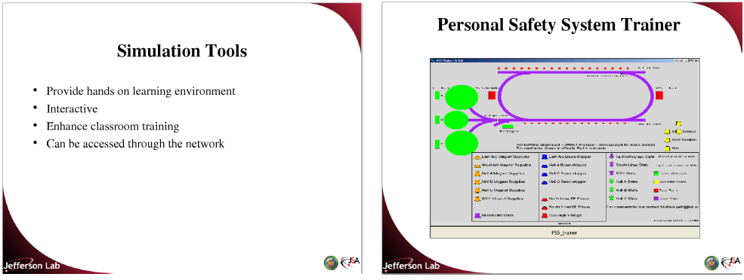
Simulators have turned out to be a less useful aid in training than hoped. The PSS trainer was made obsolete by the 12GeV upgrade and it was determined that the effort to keep it synchronized with a PSS system that is still being upgraded and improved was not a good use of resources considering the small number of users who could benefit from its use. Instead better PSS training and procedures was seen as the better alternative.

9. Professional Development
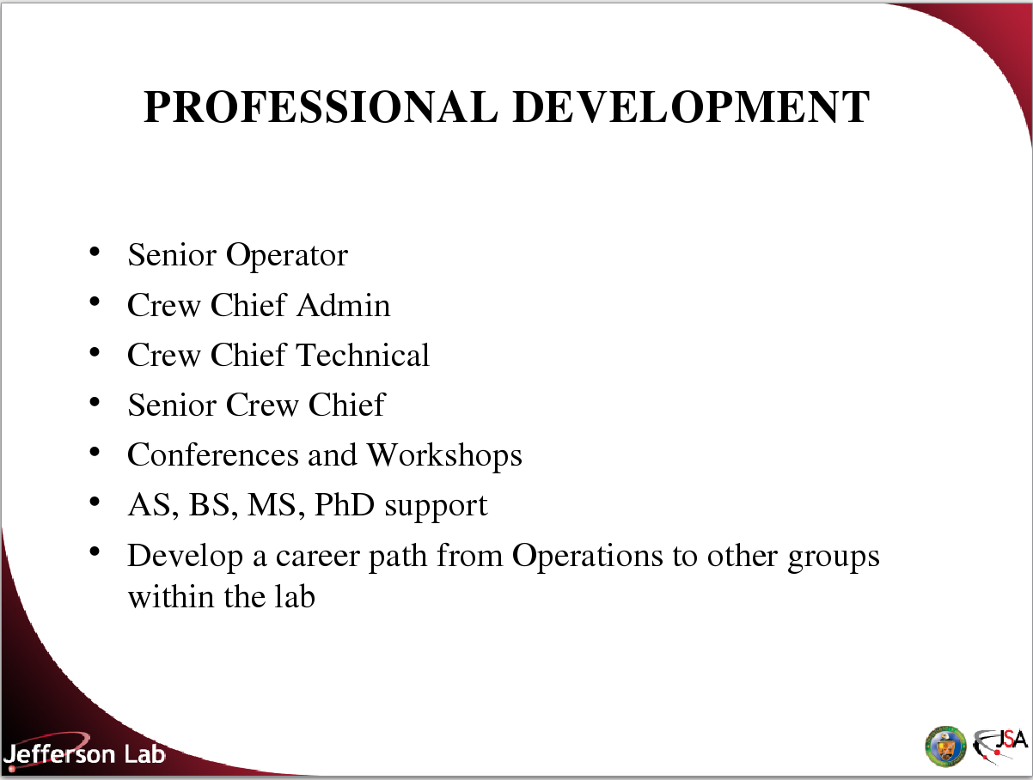
Professional Development efforts continue. Originally Operators were divided into Operator I and Operator II pay grades. At some time in the past the Operator II level was deprecated. This has resulted in a situation where an Operator unsuited or uninterested in becoming a Crew Chief has no path forward, except to leave Operations. Operations management has recognized this deficiency and is working to reestablish the Operator II position.
The establishment of the Senior Crew Chief position has allowed the Operations to move to a more traditional 5-6 subordinate to supervisor ratio, rather than the previous 20+ to 1 ratio. This has also allowed these individuals a path for development beyond Crew Chief. Senior Crew Chiefs exercise more responsibility outside control room operations and fulfill assignment requirements in other areas of the lab, particularly when the machine is not running.
Jefferson Lab continues to support attendance at US Particle Accelerator School. Very few candidates for positions in Operations have any background in accelerator physics. The Accelerator Fundamentals course at USPAS continues to be the best way to introduce Operators to these concepts.
As always JLab remains committed to support of WAO and other related workshops and conferences. These continue to have a place in Operator professional development.
Jefferson Lab continues to support ongoing education of its staff through the Tuition Assistance and other program, including Masters and PhD programs, with research funded through Lab resources.
Most recently Operations has also shared some hires with other groups, with Operators hired with specific skills to allow them to be permanently assigned out to other groups during off shift time and accelerator downs. At least one of these individuals has transferred to the other group when a position became available.

9: Summary
The creation of a Training and Development Program is an endeavor that requires years to implement. Planning is only the initial stage and, absent a large staff of specialists, the execution of even a well developed plan will take time and dedication. Often when Operator turnover is low the time and effort to develop a comprehensive training program may seem wasted. However investment in knowledge capture can benefit even experienced operators by increasing the transfer of knowledge from Subject Matter Experts to Operations. A well documented training program also insures that regulator concerns in the competency of Operations staff can be addressed in an efficient manner.

Acknowledgements

This material is based upon work supported by the U.S. Department of Energy, Office of Science, Office of Nuclear Physics under contract DE-AC05-06OR23177.

