**Mill Pond Golf and Country Club**

**Dinner Banquet**

**October 9, 2017, 6:45pm**

[](http://www.anthonymatthewcaterers.com/)   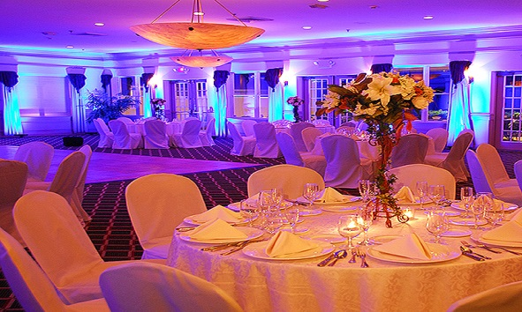

[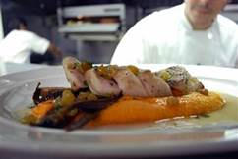](http://www.restaurantorto.com/images/items/IMAGE8.JPG)

300 Mill Road, Medford, New York 11763| 631-320-0061| www.anthonymatthewcaterers.com

Directions: Go towards the main gate (cross over William Floyd Parkway) and stay straight on Longwood Road.  When you get to the end, make a left onto Yaphank-Middle Island Road (CR-21).  At the second light, make a right.  Go straight and veer right onto Mill Road at the next light.  The golf course is about a mile down on the right.