
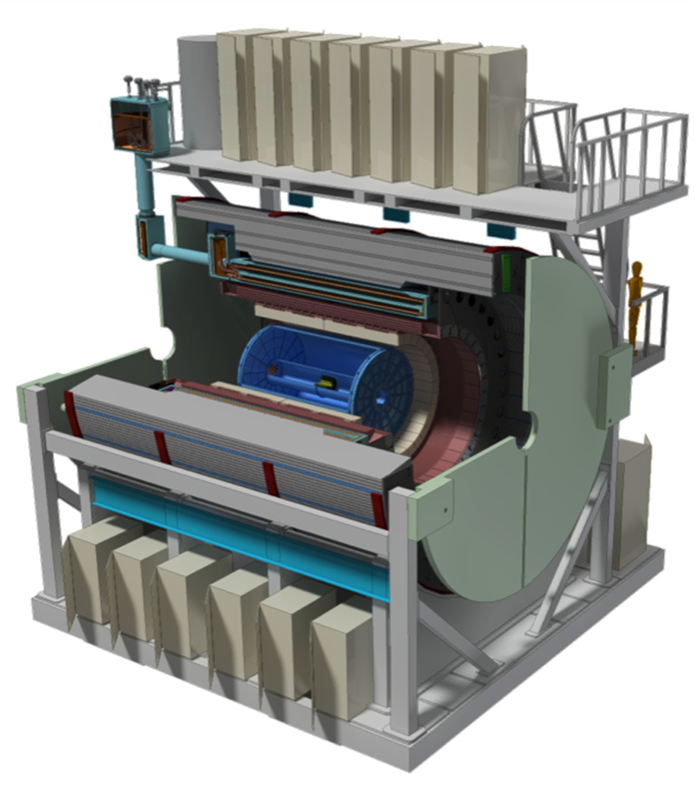

sPHENIX Preliminary Project Management Plan
Project # 17-N1
At Brookhaven National Laboratory
Office of Nuclear Physics
Office of Science
U.S. Department of Energy
October 2018

Submitted by:

Edward O’Brien Date
sPHENIX Project Director

Glenn Young Date
sPHENIX Project Manager

Maria Chamizo-Llatas Date
Director, Detector Projects

Berndt Mueller Date
Associate Laboratory Director Nuclear and Particle Physics

Concurrence:

Robert Gordon, Manager Date
Brookhaven Site Office, DOE

Elizabeth Bartosz Date
Program Manager for Nuclear Physics Instrumentation
Office of Nuclear Physics, DOE

James Hawkins Date
Program Manager for Major Initiatives
Office of Nuclear Physics, DOE

Jehanne Gillo,
Director of Facilities and Project Management Division Date
Office of Nuclear Physics, DOE

Timothy Hallman Date
Associate Director of the Office of Nuclear Physics
Office of Science, DOE

Approval:

Doon Gibbs, Laboratory Director Date
Brookhaven National Laboratory

Preliminary Project Management Plan
for the
Super Pioneering High Energy Nuclear Ion eXperiment
(sPHENIX)
Change Log

Revision History
Rev. | Date | Reason
Initial Release | October 2018

List of Acronyms
ALD Associate Laboratory Director
AS Acquisition Strategy
ASE Accelerator Safety Envelope
AY Actual Year Dollars
BHSO Brookhaven Site Office
BNL Brookhaven National Laboratory
BSA Brookhaven Science Associates
C-AD Collider-Accelerator Division
CAM Control Account Manger
CCB Change Control Board
CD Critical Decision
CDR Conceptual Design Report
CERN European Council for Nuclear Research
CR Continuing Resolution
CY Calendar Year
DAM Data Aggregation Module
DAQ Data Acquisition
DOE U.S. Department of Energy
EIA Electronic Industries Alliance
EMCal Electromagnetic Calorimeter
ES&H Environment, Safety and Health
EVMS Earned Value Management System
FPM Federal Program Managers
FY Fiscal Year
Gbps Gigabits-per-second
GEM Gas-Electron Multiplier
HCal Hadronic Calorimeter
HQ DOE Headquarters
IHCal Inner Hadron Calorimeter
INTT Intermediate Silicon Strip Tracker
IPR Independent Project Review
ISM Integrated Safety Management
ISMS Integrated Safety Management System
KPP Key Performance Parameter
kHz kilohertz
L2 Level 2
L3 Level 3
LCC Life Cycle Costs
LHC Large Hadron Collider
LRP Long Range Plan
MBD Minimum Bias Trigger Detector
MIE Major Item of Equipment
MOA Memorandum of Agreement
NEPA National Environmental Policy Act
NP Nuclear Physics
NPP Nuclear and Particle Physics
NSAC Nuclear Science Advisory Committee
OHCal Outer Hadron Calorimeter
ONP DOE’s Office of Nuclear Physics
OPC Other Project Costs
OPPO Office of Project Planning and Oversight
OPS Operations Program
OSH Occupational Safety and Health
PB Performance Baseline
PC Project Controls
PCR Project Change Request
PD Project Decision
PKPP Preliminary Key Performance Parameters
PPMP Preliminary Project Management Plan
PMP Project Management Plan
PHAR Preliminary Hazard Analysis Report
PHENIX Pioneering High Energy Nuclear Interaction experiment
PMG Project Management Group
PMT Project Management Team
POB Project Oversight Board
QA Quality Assurance
QAP Quality Assurance Plan
QPD Quantum Chromodynamics
QGP Quark Gluon Plasma
R&D Research & Development
RHIC Relativistic Heavy Ion Collider
RLS Resource Loaded Schedule
RM Risk Management
RMP Risk Management Plan
SAD Safety Assessment Document
SBMS Standards Based Management System
SC Office of Science
SC Magnet Superconducting Magnet
SiPM Silicon Photomultipliers
SOW Statement of Work
sPHENIX Super Pioneering High Energy Nuclear Interaction experiment
STAR Solenoidal Tracker at RHIC
SVAR Security Vulnerability Assessment Report
TEC Total Estimated Cost
TPC Time Projection Chamber
UPP Ultimate Performance Parameters
USI Unreviewed Safety Issue
WBS Work Breakdown Structure
WP Work Packages

sPHENIX Project Management Plan

1.0 INTRODUCTION 3
1.1 Project Background 3
1.2 Justification of Mission Need 3
2.0 PRELIMINARY PROJECT BASELINE 4
2.1 Preliminary Scope Baseline 4
2.2 Preliminary Cost Baseline 6
2.3 Preliminary Schedule Baseline 7
2.5 Preliminary Funding Profile 13
3.0 LIFE CYCLE COST 14
4.0 ACQUISTION APPROACH 14
5.0 Tailoring Strategy 15
6.0 MANAGEMENT ORGANIZATION AND STRUCTURE 16
6.1 Department of Energy 17
6.2 Federal Program Manager 17
6.3 Brookhaven Site Office Manager 17
6.4 BNL Laboratory Director 17
6.5 BNL Associate Laboratory Director 18
6.6 BNL Co-Director of the Office of Project Planning and Oversight (OPPO) 18
6.7 sPHENIX Project Director 19
6.8 sPHENIX Project Manager 20
6.9 sPHENIX Project Scientist 21
6.10 sPHENIX Resource Coordinator 21
6.11 sPHENIX Project Engineer 22
6.12 sPHENIX Chief Mechanical Engineer 22
6.13 sPHENIX Project Controls Manager 22
6.14 Project System/Integration Office 23
6.15 sPHENIX Level 2 Managers 23
6.16 Project Management and Project Support Offices 24
8.0 PROJECT MANAGEMENT OVERSIGHT 26
8.1 Risk Management including the Risk Management Plan 26
8.2 Project Reporting 26
8.3 Earned Value Management System 27
8.4 Project Reviews 28
8.5 Engineering and Technical Readiness 28
8.6 Analysis of Alternatives and Conceptual Design Report 28
9.0 ENVIRONMENT, SAFETY, SECURITY, HEALTH AND QUALITY 28
9.1 Institutional Requirements 28
9.2 Organizational Requirements 29
9.4 Safeguards and Security 29
9.5 System Engineering 30
9.6 Value Management 30
9.7 Value Engineering 30
9.8 Configuration Management 30
9.9 Quality Assurance 31
10.0 TRANSITION TO OPERATIONS 32
11.0 PROJECT CLOSE OUT 32
List of Figures: 33

1.0 INTRODUCTION

The Preliminary Project Management Plan (PPMP) describes the management and project execution processes that will be used to ensure that the sPHENIX MIE will be completed on time and within budget, meeting all of its Threshold Key Performance Parameters (KPPs). The PPMP defines the preliminary project scope, describes the organizational framework and overall management system for the project. It identifies roles and responsibilities for project participants. It also describes the formal change control process by which the project scope, schedule and budget can be revised. The PPMP will be reviewed, revised and updated as appropriate with the final PMP completed at BNL Project Decision-2/Project Decision-3 (BNL PD-2/3) Review.

1.1 Project Background

The sPHENIX MIE will be a major upgrade to the PHENIX experiment that will enable the precision characterization of jets produced in nucleus+nucleus (AA), proton+nucleus (pA) and proton+proton (pp) collisions at the Relativistic Heavy Ion Collider (RHIC) located at Brookhaven National Laboratory (BNL). The experiment will also collect a large sample of upsilons with a mass resolution that allows for their separation into three mass states, and the study of their behavior on different distance scales. sPHENIX provides excellent opportunities complimentary to measurements being made at the Large Hadron Collider (LHC) at CERN and extends the RHIC physics program in ways that fully exploits RHIC’s unique performance capabilities.

1.2 Justification of Mission Need

The mission of the Office of Science (SC) is to deliver the scientific discoveries and major scientific tools that transform our understanding of nature and advance the energy, economic, and national security of the United States. SC accomplishes this mission through the direct support of research, construction, and operation of national scientific user facilities, and the stewardship of ten world-class national laboratories. The SC national laboratories collectively comprise a preeminent federal research system that develops unique, often multidisciplinary, scientific capabilities beyond the scope of academic and industrial institutions, to benefit the nation’s researchers and national strategic priorities.

The Nuclear Physics (NP) program plans, constructs, and operates major scientific user facilities and fabricates experimental equipment to serve researchers at universities, national laboratories, and industrial laboratories as part of its strategic mission. The program provides world-class, peer- reviewed research results in the scientific disciplines encompassed by the NP mission areas under the mandate provided in Public Law 95-91 that established the Department of Energy (DOE).

The DOE NP program addresses three broad, interrelated scientific thrusts in pursuit of its mission: Quantum Chromodynamics (QPD), Nuclei and Nuclear Structure and Astrophysics, and investigations of Fundamental Symmetries using neutrons and nuclei. sPHENIX addresses goals within the “QPD investigations” within the NP program. Over the last two decades, the heavy ion nuclear physics component of the QPD scientific thrust has focused on the discovery and characterization of the Quark Gluon Plasma (QGP): a form of matter believed to have last naturally existed in the universe approximately one microsecond after the Big Bang. Since the discovery of the QGP at the BNL RHIC over ten years ago, and subsequent confirmation by experiments at CERN’s LHC, a number of important characteristics of the QGP have been measured. Though great progress has been made over the last twenty years, the 2015 Nuclear Science Advisory Committee (NSAC) Long Range Plan (LRP) identified a vital QGP-related research question that remains unaddressed. The field must “probe the inner workings of the quark gluon plasma by resolving the properties at shorter and shorter length scales.” A virtually identical goal was recommended in the 2010 National Academy Study,” Nuclear Physics, Exploring the Heart of Matter.” The sPHENIX MIE enables the pursuit of this directive at RHIC. The LRP states: “This program requires large samples of jets in different energy regimes, with tagging of particular initial states, for example, in events with a jet back-to-back with a photon. The full power of this new form of microscopy will only be realized when it is deployed at both RHIC and the LHC, as jets in the two regimes have complementary resolving power and probe QGP at different temperatures, with different values of the length scale at which bare quarks and gluons dissolve into a near perfect liquid”. sPHENIX is needed to make these measurements feasible. Neither the existing STAR nor PHENIX experiments can make the required measurements with the necessary sensitivity.

Obtaining the scientific goals of sPHENIX has been identified by both the recent NSAC LRP and the National Academy study as needed to carryout NP’s scientific mission. There is currently a gap in capabilities that needs to be addressed in order to reach those goals.

2.0 PRELIMINARY PROJECT BASELINE

This section documents the project’s preliminary Performance Baseline (PB) that consists of the scope, cost, schedule (time line to the Project Closeout date), funding profile, and other related information. Lower tier documents will capture the details and plans for resource cost/schedule/scope and project life cycle from the project initiation through the start of operations to the project closeout.

2.1 Preliminary Scope Baseline

The preliminary scope baseline for the sPHENIX Project is:

- A Time Projection Chamber (TPC), Electromagnetic Calorimeter (EMCal), and a Hadronic Calorimeter (HCal) all covering 2π in azimuth. The TPC and HCal have pseudorapidity coverage of -1.1 ≤ η ≤ 1.1. The EMCal has pseudorapidity coverage of -0.85 ≤ η ≤ 0.85.
- A Minimum Bias Trigger detector (MBD).
- Readout electronics to fully instrument the TPC, EMCal, HCal and MBD.
- A data acquisition (DAQ) system with the capability to readout the TPC, EMCal, HCal and MBD with an event rate and data-logging rate commensurate with the sPHENIX physics goals.
- A DAQ/Trigger system that can provide minimum bias and energy cluster triggers at a rate necessary to carry out the sPHENIX physics program in AA, pA and pp collisions at RHIC.
- Project Management to carry the project scope through to a successful on time and on budget completion.

This project will be declared complete when the defined scope is delivered to BNL and the Threshold KPPs are satisfied through bench tests. Installation and integration of these delivered components and parallel activities associated with this sPHENIX MIE are not part of this project’s scope to be delivered at CD-4.
The preliminary KPPs are shown in Table 1. The Threshold KPPs are the minimum parameters against which the project performance is measured at the Project Closeout Review. The Objective KPPs are the stretch performance parameters that will be achievable within the Performance Baseline project scope, cost and schedule performance baseline when established. The KPPs are chosen because they comprise a set of minimum test results that once demonstrated, will allow one to conclude with confidence that sPHENIX will be able to meet its mission need after a period of commissioning, calibration and data-taking. The KPPs define tests for each of the sPHENIX Level 2 deliverables. The tests will establish that the subsystems are working at a performance level that is consistent with their design. The difference between the Threshold and Objective KPPs is essentially the difference between the expected Level 2 subsystem performance soon after initial power-up and the performance after a period of debugging and maintenance.
System | Demonstration or Measurement | Threshold KPP’s | Objective KPP’s
Time Projection Chamber | Preinstall,  Bench Test | ≥ 90% live channels based on  laser, pulser, cosmics | ≥ 95% live channels based on  laser, pulser, cosmics
Time Projection Chamber | Preinstall,  Bench Test | Ion Back Flow ≤ 2% per  Quad GEM Module | Same
Time Projection Chamber | Preinstall,  Bench Test w/cosmics | ≥ 90% single hit  efficiency / mip track | ≥ 95% single hit  efficiency / mip track
Time Projection Chamber  Front End Electronics | Preinstall,  Bench Test | Cross talk ≤ 2% each channels | Same
EM Calorimeter | Preinstall,  Bench Test | ≥ 90% live channels based  on LED, cosmics | ≥ 95% live channels based  on LED, cosmics
Hadronic Calorimeter | Preinstall,  Bench Test | ≥ 90% live channels based on  LED, cosmics | ≥ 95% live channels based on  LED, cosmics
EM Calorimeter | Preinstall,  Bench Test | Each sector with an absolute  energy pre-calibration to a precision of ≤ 35% RMS | Same
Hadronic Calorimeter | Preinstall,  Bench Test | Each sector with an absolute  energy pre-calibration to a precision of ≤ 20% RMS | Same
Min Bias Trigger Detector | Preinstall,  Bench Test | ≥ 90% live channels based  on laser.  120 ps/channels timing resolution w/ Bench Test | ≥ 95% live channels based  on laser.  100 ps/channels timing resolution w/ Bench Test
DAQ/Trigger | Event rate | 10 kHz with random  pulser | 15 kHz with random  pulser
DAQ/Trigger | Data Logging  Rate | 10 GBit/s with pulser | Same
Table 1: Table of Preliminary Key Performance Parameters
In addition to these KPPs, preliminary Ultimate Performance Parameters (UPPs) have been defined. The UPPs are listed in Table 1a and describe the performance needed after project completion to realize the scientific goals of the project. These parameters are outside the project’s scope.
Preliminary Ultimate Performance Parameters
Upsilon (1S) mass resolution ≤ 125 MeV
≥ 90% Tracking Efficiency
≤ 10% momentum resolution at 40 GeV /c
≤ 150% / √E_{jet} jet-energy resolution for R=0.2 jets
≤ 8% single photon energy resolution at 15 GeV
Table 1a: Preliminary Ultimate Performance Parameters. UPPs for measurements made at 10% central Au+Au RHIC events at the average RHIC store luminosity

2.2 Preliminary Cost Baseline

The preliminary Total Project Cost range of the sPHENIX MIE is $24.2-$34.5 million AY dollars ($). The lower end of the cost range assumes approximately 20% of contingency in lieu of the current estimate of 30%, while the upper range addresses possible additional scope. The breakdown by WBS Level 2 can be seen in Table 2. The preliminary cost baseline includes the contingency estimate of an overall average cost contingency of 30%. The contingency was based on a graded contingency rating given to each WBS element where the grade applied was determined from the confidence in the choice of a specific item, source of pricing information, maturity of the design, and other similar factors.
Table 2: sPHENIX MIE Total Project Cost in AYk$.

2.3 Preliminary Schedule Baseline

The Level 1 Project milestones of the Major Item of Equipment (MIE) are seen in Table 3. The MIE, Closeout Review date is Q1 FY2023, which includes 14 months of schedule contingency. The sPHENIX Project Summary Schedule is shown in Figure 1. The Project early completion date is October 2021. The major milestones of the Level 2 subsystem that are the MIE deliverables can be seen in Table 4. The integrated Resource-Loaded Schedule (RLS) has a Critical Path (CP) that goes through the procurement, fabrication and assembly of the EMCal prototype. It proceeds through Calorimeter Electronics procurement, fabrication and assembly of the Silicon Photomultipliers (SiPM). Finally, the CP runs through EMCal Module/Sector (production) fabrication and assembly, followed by EMCal sector testing. The RLS CP is shown in Figure 1.
The project requested and received for CD-3A approval on specific long lead-time items at the CD-1/3A review conducted in May 2018, prior to the release of the memo from S. Binkley on August 2 that exempted projects from the requirements of DOE Order 413.3B. The scope of the long lead procurements is: Scintillating Tiles for the HCal, SiPMs for the EMCal and HCal readout, Scintillating Fibers Production order for the EMCal, Tungsten Powder Production Order for the EMCal and the cost is $5.850 million including 30% contingency. These are long lead procurements because they are on or near the critical path or are part of components/systems on or near the critical path or are a risky procurement from a foreign vendor.
The long lead-time items include Silicon Photomultipliers for the calorimeters, scintillating tiles for the HCal, tungsten powder and scintillating fibers for the EMCal with a cost of $5.850.
A Project Production authorization (BNL PD-3) will be requested from BNL with concurrence of DOE-NP at the same time as the Project Performance Baseline authorization (BNL-PD-2). The plan is based on the assessment by the project team that the technical design and R&D of all Level 2 systems will be 90% complete in the aggregate at the time of the BNL PD-2/3 Review.

Milestone | Schedule Date
CD-0, Approve | 9/16/2016 (A)
CD-1/3A, Approve Alternative Selection and Cost Range, Long Lead Procurements | 8/16/2018 (A)
Approve PD-2/3 Approve Performance Baseline/Approve Project Production | Q4 FY 2019
Approve Project Completion | Q1 FY 2023
Table 3: Table of sPHENIX MIE Project Decision Milestones

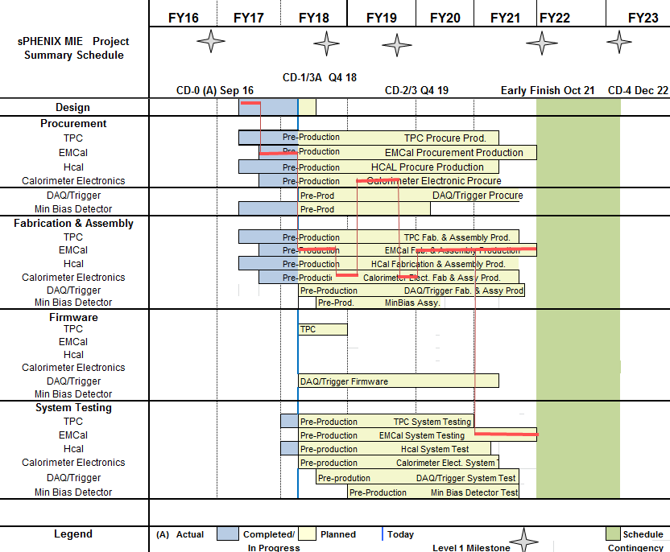
Figure 1: sPHENIX MIE Summary Schedule. The red line shows the project critical path.

WBS | Level 2 Project Milestones | Scheduled Dates
1.02.06 | TPC DAM Preproduction Readiness Review | Q4FY18
1.03.02 | EMCal Preproduction Sector 0 Assembled | Q1FY19
1.05.02 | HCal Preproduction Electronics Complete | Q2FY19
1.02.02 | TPC Module Production Readiness Review | Q2FY19
1.02.05 | TPC FEE Production Readiness Review | Q3FY19
1.05.02 | HCal Preproduction FEE Complete | Q3FY19
1.04.02 | Outer HCal Lifting Fixture and Support Design Complete | Q4FY19
1.05.02 | EMCal Electronics Preproduction Complete | Q4FY19
1.03.01 | EMCal W Powder Acquisition Complete | Q1FY20
1.05.03 | CalDigitizer Production Readiness Review | Q1FY20
1.02.05 | SAMPA ASIC Performance Accepted | Q1FY20
1.02.06 | TPC DAM Felix 2.0 Production Complete | Q2FY20
1.03.01 | EMCal Scintillating Fiber Acquisition Complete | Q2FY20
1.02.03 | EMCal Production Readiness Rev Blocks/Modules/Sectors | Q2FY20
1.05.01 | EMCal/HCal SiPM Sensor Production Complete | Q2FY20
1.05.02 | HCal SiPM Boards Assembly Complete | Q2FY20
1.02.01 | GEM Production Complete | Q3FY20
1.04.02 | First Outer HCal Sector Ready to Install | Q3FY20
1.05.02 | HCal Electronics Complete: Production | Q4FY20
1.02.02 | TPC R1 GEM Modules Production Ends | Q4FY20
1.02.03 | TPC R2 GEM Modules Production Ends | Q4FY20
1.02.04 | TPC R3 GEM Modules Production Ends | Q4FY20
1.02.05 | TPC FEE Production Complete | Q4FY20
1.06.03 | GL1 Ready to Operate | Q4FY20
1.05.02 | EMCal SiPM Boards Production Complete | Q1FY21
1.06.02 | Trigger LL1 Preproduction Complete | Q1FY21
1.04.02 | Last Outer HCal Sector Ready to Install | Q1FY21
1.02.07 | TPC Cooling System Complete | Q1FY21
1.07.03 | MBD Production Complete | Q1FY21
1.02.07 | TPC Gas System Complete | Q2FY21
1.02.01 | TPC Ready to Install | Q2FY21
1.05.02 | EMCal Electronics Complete | Q3FY21
1.05.03 | CalDigitizer Production Complete | Q3FY21
1.05.03 | Calorimeter Electronics Complete | Q3FY21
1.06.02 | LL1 Trigger Production Complete | Q3FY21
1.02.06 | TPC DAM Production Complete | Q4FY21
1.03.01 | EMCal Final Blocks Arrive at BNL | Q4FY21
1.03.02 | EMCal Modules Complete | Q4FY21
1.07.04 | Min Bias Detector Ready to Install | Q4FY21
1.06.01 | DAQ Production: DAQ Ready to Operate | Q4FY21
1.06.02 | LL1 Ready to Operate | Q4FY21
1.03.02 | EMCal Sectors Complete | Q1FY22
1.03.02 | EMCal Ready to Install | Q1FY22
1.01.01 | Early Project Completion | Q1FY22
Table 4: Level 2 Subsystem Milestones of the sPHENIX MIE
2.4 Work Breakdown Structure

The sPHENIX MIE has been organized into a WBS that is documented in the WBS dictionary.
The Level 2 WBS is the Control Account level for the project and can be seen in Figure 2.

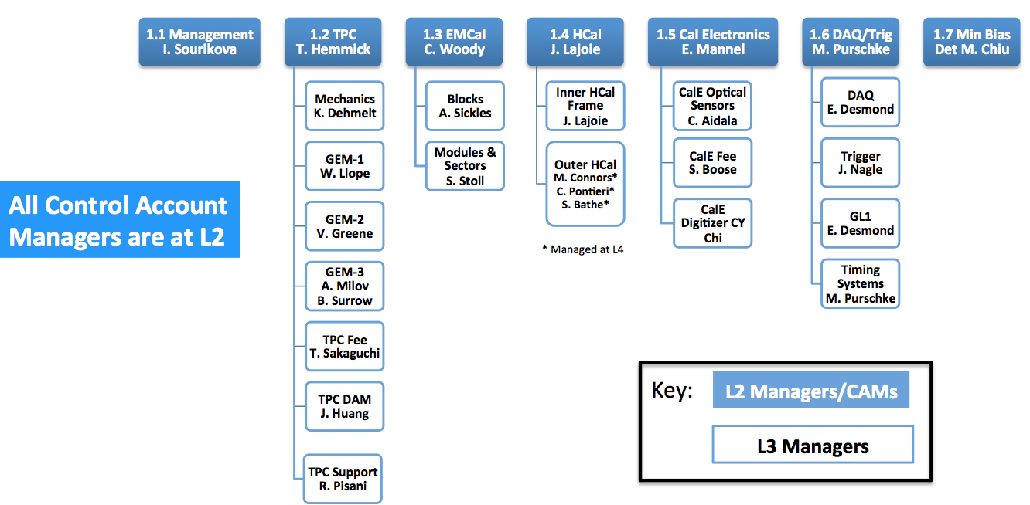
Figure 2: The Level 2 and Level 3 Work Breakdown Structure for sPHENIX MIE

  - 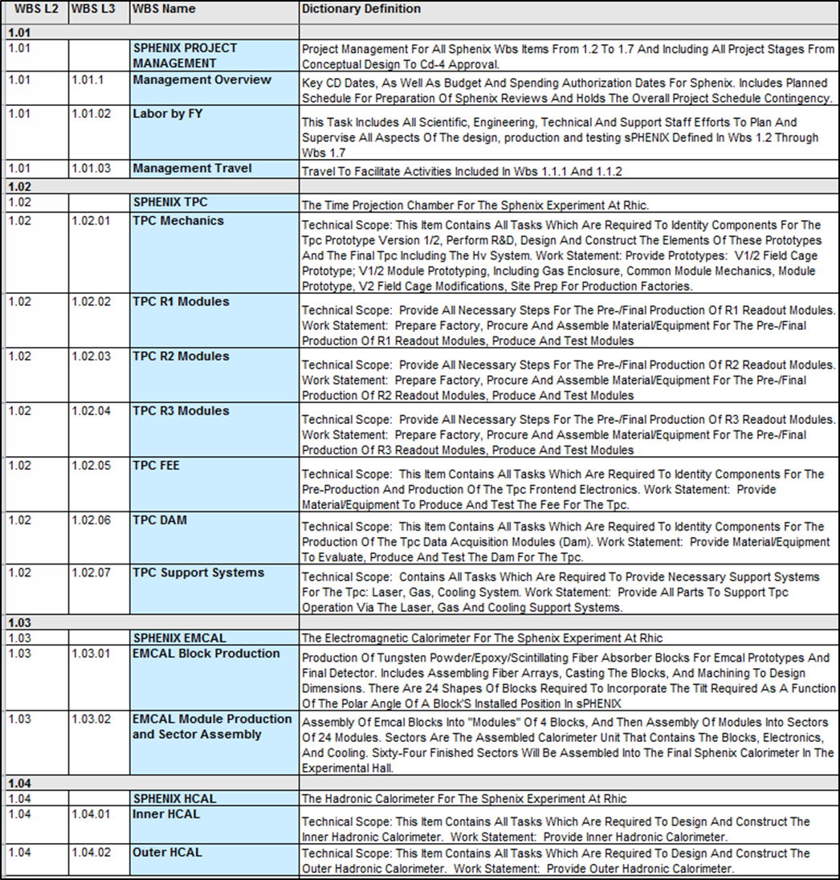
Table 5a: WBS Dictionary at the Level 2 and Level 3 Work Breakdown Structure for the sPHENIX MIE.
The WBS Dictionary describes the project scope to Level 3 of the WBS 1.1 – 1.4.
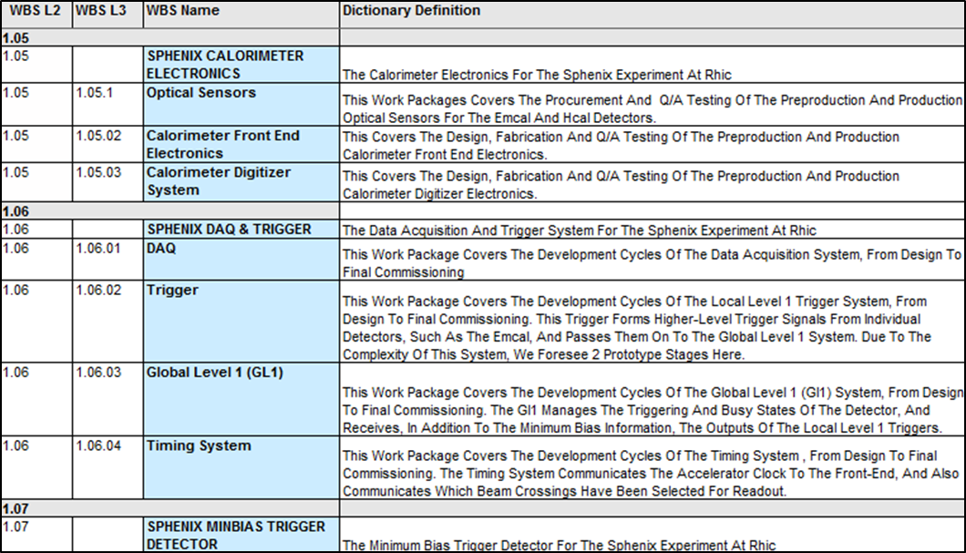
Table 5b: WBS Dictionary at the Level 2 and Level 3 Work Breakdown Structure for the sPHENIX MIE.
The WBS Dictionary describes the project scope to Level 3 of the WBS 1.5 – 1.7.

2.5 Preliminary Funding Profile
The Total Project Cost for sPHENIX is estimated to be in a range $24.2-34.5M AY. The funding profile is shown in Table 6. This project is implemented with existing funding from within the RHIC facility operations budget provided by NP within the SC.
Funding Profile in AY k$
 | Prior  Yrs | FY17 | FY18 | FY19 | FY20 | FY21 | FY22 | Total
Pre-R&D
R&D |  | 1,513 | 4,260 | 350 |  |  |  | 6,123
PDR |  | 100 | 200 |  |  |  |  | 300
Construction |  |  |  | 5,310 | 9,524 | 5,080 | 213 | 20,127
Pre-Ops
TEC |  |  |  | 5,310 | 9,524 | 5,080 | 213 | 20,127
OPC |  | 1,613 | 4,460 | 350 |  |  |  | 6,423
Total Project Cost |  | 1,613 | 4,460 | 5,660 | 9,524 | 5,080 | 213 | 26,550
Table 6: Preliminary Funding Profile

3.0 LIFE CYCLE COST

The costs are discussed for the three phases of the sPHENIX life cycle:
- Conceptual Design and R&D
- Fabrication
- Operations
The project life-cycle cost of sPHENIX is estimated to be approximately $86.5–94.5 million AY. This includes the cost of sPHENIX fabrication and five years of sPHENIX Operations. There is confidence in the estimate for sPHENIX operating costs because the scale and complexity of sPHENIX is known to be very similar to the PHENIX experiment as determined by staff members of the sPHENIX Management team who were involved in PHENIX Operations throughout the experiment’s 16 year operating period. The size of the sPHENIX operating support team, as well as annual consumable and maintenance costs, is estimated to be very similar to that of the PHENIX experiment. The operating costs of $10 million in FY2016 escalated to the sPHENIX operating period of FY2023-FY2027 at 2% escalation per annum results in a five year sPHENIX operating cost of $60 million AY. The estimate presumes that after five years of operations, the sPHENIX Detector is re-purposed for other research activities.
The capital value of sPHENIX will be added to the capital value of the RHIC facility at the completion of the sPHENIX project. It is expected that sPHENIX will operate until the end of the operations of the RHIC facility. At the end of RHIC operations, sPHENIX will either be re-purposed for an application that is commensurate with the future science mission of facilities currently in use by RHIC, such as an Electron Ion Collider, or it will be decommissioned. The cost of re-purposing is not included in the Lifetime Costs due to the negligible costs estimated for repurposing sPHENIX equipment for future use.

4.0 ACQUISTION APPROACH

Acquisition of sPHENIX will be conducted by BNL. BNL will direct the sPHENIX project management team in the execution of the project and delegate to the team its authority for project execution. The BNL sPHENIX Project Office will manage the distribution-to and expenditure-of DOE funds including collaborating sPHENIX institutions. The project scope to be accomplished at collaborating institutions will be documented in Memoranda of Agreements between BNL and collaborating institutions. Statements of work between BNL and the collaborating institutions, including frequent milestones, will be used to track progress of their contributions to the project. The acquisition approach for the project is described in detail in the sPHENIX Acquisition Strategy (AS).

BNL will collaborate and work with many institutions, including other DOE National Labs and Universities (i.e. Stony Brook University). BNL will be responsible for overall project management but collaborators have will hold key roles as the WBS Level 2 Managers, Level 3 Managers and Control Account Managers.

5.0 Tailoring Strategy

Management of the sPHENIX Project will follow the following project management principles:
- Line management accountability.
- Sound disciplined up-front planning.
- Well-defined and documented project requirements.
- Corporate effective risk handling mechanisms.
- Well-defined and managed project scope and risk-based performance baselines and stable funding profile that support original baseline execution.
- Development of reliable and accurate cost estimates using appropriate cost methodologies and databases.
- Properly resourced and appropriately skilled project staffs.
- Effective implementation of management systems supporting the project (e.g., quality assurance, integrated safety management, risk management, change control, performance management and contract management systems).
- Early integration of safety into the design process.
- Effective communication among all project stakeholders.
- Utilization of peer reviews throughout the life of a project to appropriately assess and make course corrections.
BNL Project Management procedures allows for the development of a Tailoring Strategy for each project, based on the risk, complexity, visibility, cost, safety, security, and schedule. The requirements of BNL are to be applied on a tailored basis as appropriate to the project. Tailoring is subject to the Laboratory Director’s approval and DOE NP’s concurrence and is identified prior to the impacted significant project decisions/approvals (e.g. Approve Project Performance Baseline, Approve Project Production and Approve Project Completion). These reviews will be conducted as independent reviews with invitations to DOE NP and the BHSO Manager to observe.
The sPHENIX MIE strategy has been tailored to allow for the early procurement of long lead-time items starting in FY19. The project requested and received for CD-3A approval on specific long lead-time items at the CD-1/3A review conducted in May 2018, prior to the release of the memo from S. Binkley on August 2 that exempted projects from the requirements of DOE Order 413.3B The long lead-time items include Silicon Photomultipliers for the calorimeters, scintillating tiles for the HCal, tungsten powder and scintillating fibers for the EMCal. Aspects of the sPHENIX design associated with the long lead-time items have been quickly brought to a mature state. In addition, due to the advanced nature of both the R&D and detector design, the sPHENIX MIE is proposing a combined Project Performance Baseline/Project Production Review to obtain Project baseline approval and begin procurement and production. The project will have a single Project Closeout (Approve Project Completion) milestone.

6.0 MANAGEMENT ORGANIZATION AND STRUCTURE
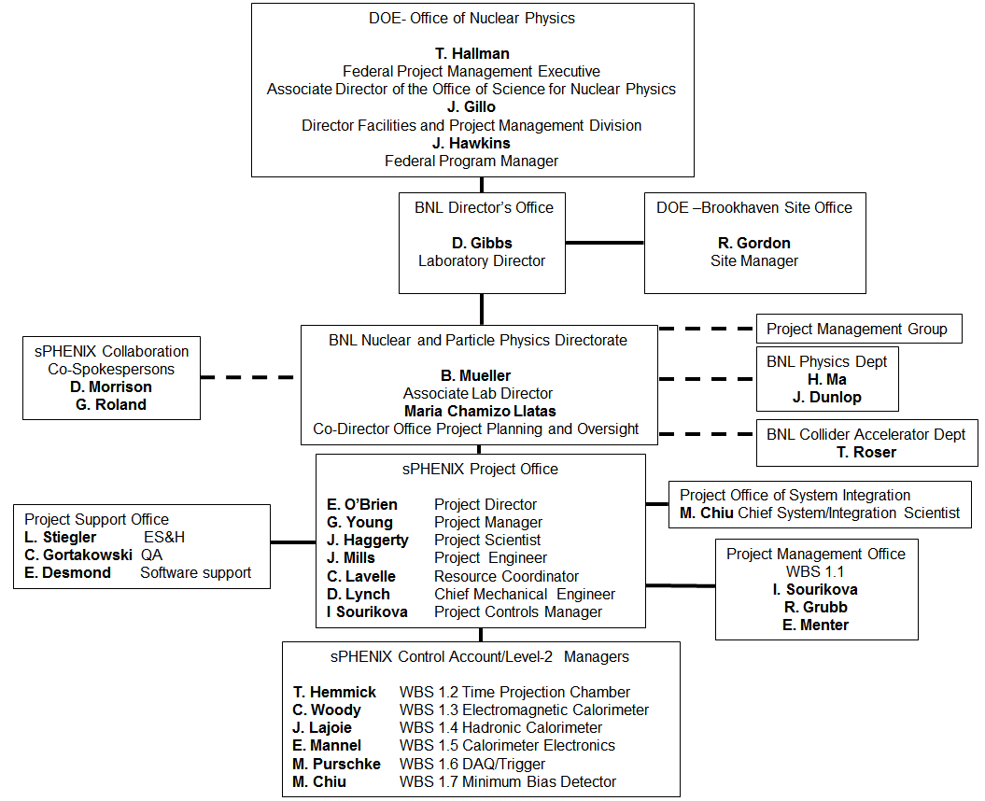
Figure 3: The sPHENIX Organization Chart
The sPHENIX MIE is managed by Brookhaven National Laboratory, Director of Nuclear and Particle Physics, delegated by the BNL Laboratory Director. The sPHENIX effort divides into the seven WBS elements shown in Table 2 that are known as the Level 2 deliverables. The organization of Level 2 Managers, Level 3 Managers and Control Accounts can be seen in Figure 2. Level 2 managers are each responsible for one of the seven items. They report directly to the sPHENIX Project Management team. The Project Management team reports directly to the BNL office of the Associate Lab Director who reports to the BNL Laboratory Director.

The responsibilities of the members and organizations managing the sPHENIX MIE are as follows:

6.1 Department of Energy

Funding for the sPHENIX MIE is redirected funds from the RHIC Facility Operations provided by NP with the DOE SC. The Associate Director for the Office of Nuclear Physics in DOE SC approves Level 1 baseline changes.

6.2 Federal Program Manager

The Federal Program Manager (FPM) serves as the primary DOE NP point of contact for the sPHENIX MIE and is charged to fulfill NP responsibilities for project funding, coordination, oversight, and communication with other HQ offices. The DOE FPM responsibilities include:

- Functions as DOE HQ point-of-contact for project matters.
- Serves as the representative in communicating the interests of the SC program.
- Coordinates with Lab Director, Site Office Manager, SC Staff offices, and DOE HQ program offices, as needed to execute the project.
- Assists with budget formulation.
- Reviews and concurs with Level 1 baseline changes.
- Attends monthly meetings.
- Reviews and concurs with the PMP.
- Reviews project progress reports and deliverables.
- Is consulted in the charge, agenda and schedule of formal periodic reviews of the project, including BNL Independent Project Reviews (IPR)s

6.3 Brookhaven Site Office Manager

The Brookhaven Site Office (BHSO) supports the Program Office in their oversight of the sPHENIX Project Management Team for success of the sPHENIX MIE. The BHSO Site Managers responsibilities include:

- Appointed as the Contracting Officers Representative, as determined by the Contracting Officer.
- Reviews development and implementation of key project documentation.
- Reviews project cost, schedule, performance, and scope progress to baseline plans.
- Ensures design, construction, environmental, safety, security, health, and quality efforts performed comply with the contract, public law, regulations, and Executive Orders.
- Reviews reported progress.
- Concurs with changes in compliance with the approved change control process documented or referenced in the PMP.

6.4 BNL Laboratory Director

The BNL Laboratory Director has full responsibility for project planning and execution, and for establishing broad policies and requirements for achieving project goals. The Director of the Facilities and Project Management Division in NP concurs on project documentation submitted to the Lab Director for approval and provides general guidance to the Project and Program Directors. The Laboratory Director’s responsibilities include:
- Approves Project Decisions
- Ensures that the Project Director appointed to the project is qualified and has appropriate communication and leadership skills prior to designation
- Approves the Project Management Plan.
- Initiates objectives of the project.
- Approves Level 2 baseline changes.
- Initiates IPRs including: Approve Project Performance Baseline, Approve Project Production, Approve Project Completion. Initiates Annual Project Status Reviews after approval of the Project Performance Baseline (PD-2).
- Provides HQ technical guidance and resources to the Federal Program Manager.
- Supports and recommends funding for the construction of this project.

6.5 BNL Associate Laboratory Director

The BNL Associate Laboratory Director (ALD) for Nuclear and Particle Physics (NPP) responsibilities include:

- Represents BNL in its capacity as Lead Laboratory and ensures BNL Lead Laboratory responsibilities are met in executing the project within scope, cost, and schedule in a safe and responsible manner.
- Closely monitors the progress of the sPHENIX MIE.
- Initiates IPRs as appropriate to be carried out by committees under his charge.
- Appoints the sPHENIX Project Director
- Ensures access to laboratory/contractor resources, systems, and capabilities required to execute the project.
- Approves major subcontracts
- Identifies the redirection of funding that supports the funding profile of the project and allows the continuation of support for other operational priorities.

6.6 BNL Co-Director of the Office of Project Planning and Oversight (OPPO)

The Co-Director of the Office of Project Planning and Oversight for the Nuclear and Particle Physics Directorate of BNL:

- Oversees the sPHENIX MIE for the BNL Nuclear and Particle Physics Directorate.
- Chairs the Project Management Group (PMG) whose function is to provide expert project management and technical advice to both the ALD for Nuclear and Particle Physics and the sPHENIX Project Management team.
- Facilitates the coordination of different aspects of the sPHENIX upgrade program
- Organizes IPRs on cost, schedule, technical reviews as appropriate for the monitoring of the progress of the project, cost and schedule performance and major project risks.

6.7 sPHENIX Project Director

The sPHENIX Project Director leads the sPHENIX Project Management team. The Project Director is appointed by and reports directly to the BNL ALD for Nuclear and Particle Physics. The sPHENIX Project Director is responsible for ensuring that the delivered sPHENIX MIE meets the CD-0 mission need. The Project Director is responsible for ensuring that adequate direct, indirect, and support resources are available for the successful execution of the sPHENIX MIE. The Project Director provides senior management oversight, provides direct access to the BNL Nuclear and Particle Physics ALD and BNL Laboratory Director. The Project Director reviews and approves all PCRs before submission to BNL Management for approval and to DOE-NP for concurrence/approval. The responsibilities of the Project Director include, but are not limited to, the following:

- Approves the project organization in consultation with the ALD and the OPPO for Detector Projects
- Oversees the sPHENIX Project Manager.
- Represents the project in interactions with the DOE.
- Collaborates with the Project Manager and the Project Scientist to provide overall direction to the project.
- Establishes clear and achievable project objectives (KPPs) in consultation with the FPM.
- Successfully executes the sPHENIX MIE scope.
- Assembles the staff and resources necessary to complete the sPHENIX MIE.
- Collaborates with the Project Manager in appointing Level 2 Managers, Level 3 Managers and Control Account Managers (CAMs) for the project whom will be responsible for managing bid package(s), overseeing daily technical and managerial oversight of specific assigned WBS tasks from design through construction, and for preparing change requests in conformance with Baseline Change control.
- Manages the completion of Project deliverables as defined in the PMP.
- Ensures that the project deliverables meet sPHENIX functional requirements.
- Ensures timely resolution of critical issues within Project Director’s control
- Identifies risks to scientific and technical performance; works with the Project Manager to control project risks.
- Defines areas of collaboration and relationship between sPHENIX other BNL departments and divisions, and other institutions participating in sPHENIX. Develops appropriate Memoranda of Agreement (MoA) and collaborative agreements.
- Works with Project Manager, Resource Coordinator and Project Engineer to define the WBS structure and to establish intermediate milestones
- In consultation with the Project Manager and Resource Coordinator, allocates contingency funds according to the procedure defined in the Baseline Change Controls Procedure.
- Provides monthly financial reports to DOE-ONP and the BNL Director of OPPO for Detector Projects.
- Approves major subcontracts.
- Implements a tailored earned value management system.
- Assures that work is performed in compliance with the BNL Environmental, Safety and Health requirements.

6.8 sPHENIX Project Manager

The sPHENIX Project Manager reports to the sPHENIX Project Director and is responsible for the successful execution and closeout of the sPHENIX MIE. Authority flows from the sPHENIX Project Director to Project Manager by delegation of all day-to-day decision-making. The Project Manager manages design, development and delivery of all sPHENIX deliverables, and ensures compliance to cost, schedule, and technical performance. The responsibilities of the Project Manager include, but are not limited to, the following.

- Oversees the sPHENIX design, construction and acceptance.
- Establishes technical and administrative controls and monitoring to ensure the project is executed within the approved cost, schedule, and technical scope
- Identifies and manages project risks.
- Leads project meetings, participates in management meetings, and communicates project status and issues.
- Implements a tailored approach to Earned Value Management System (EVMS) to track performance against the approved project baseline.
- Submits Project Change Requests (PCRs) to the Project Director for review and approval prior to Project Director’s submission of the PCR to BNL for approval, and to DOE for concurrence/approval.
- Balances the demand for project quality, scope, time, and cost.
- Collaborates with the Project Director and Project Scientist in setting the direction of the sPHENIX MIE.
- Collaborates with the Project Director to assemble the staff and resources necessary to complete the sPHENIX MIE.
- Collaborates with the Project Director in appointing Level 2 Managers, CAMs and Level 3 Managers for the project whom will be responsible for managing bid package(s), overseeing daily technical and managerial oversight of specific assigned WBS tasks from design through construction, and for preparing change requests in conformance with Baseline Change Control.
- Communicates the functional requirements to the Level 2 managers, Level 3 managers and CAMs
- Ensures that all sPHENIX MIE deliverables meet the technical and performance requirements
- Executes the project in compliance with the National Environmental Policy Act (NEPA) and other applicable ES&H rules and regulations.
- Ensures that safety, environmental, quality assurance safeguards and security responsibilities and requirements are integrated into all phases of the project, and that project activities are conducted in a safe and environmentally-sound manner.
- Directs the work of the Project Systems Scientist and Systems Integration Office
- Develops and maintains project documentation.
- Prepares and submits monthly and quarterly progress reports to DOE.

6.9 sPHENIX Project Scientist

The sPHENIX Project Scientist is responsible for ensuring that the project meets the sPHENIX
Experiment objectives as described in the approved Mission Need Statement (CD-0). The Project Scientist reports to the Project Manager. The responsibilities of the Project Scientist include, but are not limited to the following:

- Provides the project with oversight regarding the technical specifications to ensure that the project will meet the sPHENIX scientific goals.
- Communicates with the sPHENIX project team and the Co-Spokespersons to negotiate any revisions or clarifications to sPHENIX scientific and technical requirements.
- Works with the sPHENIX engineering team to ensure that the science requirements flow to the sPHENIX MIE components, and that the performance requirements are being adequately verified.
- Works with the Project Director, Project Manager and Project Engineer to evaluate the impact of design or performance revisions to scientific requirements.
- Collaborates with the Project Director and Project Manager in setting the technical direction and defining the technical requirements of the sPHENIX MIE.
- Communicates the functional requirements to the Level 2 managers, Level 3 managers and CAMs.
- Ensures that all sPHENIX MIE deliverables meet the technical and performance requirements necessary to meet Mission Need.

6.10 sPHENIX Resource Coordinator

The sPHENIX Resource Coordinator is responsible for managing all activities of the sPHENIX Project Office. The Resource Coordinator is appointed by and reports directly to the sPHENIX Project Director. The responsibilities of the Resource Coordinator include, but are not limited to, the following list. The responsibilities of the Project Engineer include, but are not limited to, the following:

- Oversees the management of the sPHENIX budget, sPHENIX labor (reporting), Resource Loaded Schedule, Risk Registry and the Earned Value Management system.
- Supervises the sPHENIX Project Management Office
- Provides regular budget and labor data reports to the Project Director. Prepares reports for BNL and DOE as required.
- Develops and Implements the sPHENIX Procurement Plan.
- Develops and maintains project documentation on sPHENIX fiscal, project and labor matters.
- Advises the Project Director on all matters relating to project resources including, budgets, labor, property, space and facilities.
- Serves as sPHENIX liaison with BNL Procurement and Property Management for contract administration, procurements and property issues.

6.11 sPHENIX Project Engineer

The sPHENIX Project Engineer is responsible for managing all engineering activities within the sPHENIX Project. The Project Engineer is appointed by and reports directly to the sPHENIX Project Director. The responsibilities of the Project Engineer include, but are not limited to, the following list. The responsibilities of the Project Engineer include, but are not limited to, the following:

- Supervises all engineering associated with the sPHENIX MIE including all day-to-day engineering activities. Assigns engineering responsibilities as appropriate.
- Supervises the sPHENIX Project Support Office.
- Collaborates with the Project Director to assemble the staff and resources necessary to complete the sPHENIX MIE.
- Is responsible for the Scheduling and Management of Design, Safety and Readiness reviews. Coordinates the reviews together with the assistance of the Project Manager, Chief Mechanical engineer and the ESH Coordinator.
- Under the direction of and by delegation from the Project Director, the Project Engineer executes project scope and supplies the engineering deliverables associated with the MIE and other sPHENIX parallel efforts under the direction of and as designated by the Project Director.

6.12 sPHENIX Chief Mechanical Engineer

The sPHENIX Chief Mechanical Engineer oversees the mechanical engineering content of all tasks within the sPHENIX Project scope. He is appointed by and works directly for the sPHENIX Project Director. The responsibilities of the Chief Mechanical Engineer include, but are not limited to, the following:

- Serves as the Integration Engineer in the Office of System Integration
- Supervises all technicians working on sPHENIX MIE activities at BNL. Monitors all technical activities at sPHENIX MIE remote sites and provides regular reports on those activities to the Project Director, Project Manager and Project Engineer.
- Assists the Project Engineer in the scheduling, planning and oversight of Design, Safety and Readiness reviews
- Communicates all the mechanical engineering requirements to the Level 2 managers and the Control Account Managers.

6.13 sPHENIX Project Controls Manager

The sPHENIX Project Controls (PC) Manager is the Level 2 Manager for sPHENIX MIE WBS 1.1 Project Management. The PC is responsible for monitoring and reporting the EVMS of the Project. The PC is appointed by and works directly for the sPHENIX Project Director. The responsibilities of the Project Controls Manager include, but are not limited to, the following:
- Monitors and report the EVMS of the Project including uploading monthly financial information to BNL and DOE.
- Manages the Risk Registry and Risk Mitigation Plan.
- Updates the Resource-Loaded Schedule under direction of the Project Director, Project Manager or Resource Coordinator.
- Advises the Project Director in all matters of Project Controls including Cost, Schedule, Earned Value, Contingency, Management Reserve, Risk and Risk Mitigation
- Develops and provides sPHENIX MIE documentation and reports as requested by the Project Director, Project Manager or Resource Coordinator for all reviews, including sPHENIX Project reviews, BNL Director’s reviews.
- Provides Project Controls data to the sPHENIX MIE team and participates in monthly reporting.

6.14 Project System/Integration Office

The sPHENIX Project System/Integration Office is responsible for managing the sPHENIX team responsible for assuring that all sPHENIX Level 2 components are fully integrated into the global sPHENIX design, have well-defined interface points with other subsystems and closely associated parallel projects such as the components of the Infrastructure and Facility upgrade or the Intermediate Tracker. The Project System/Integration Office:

- Leads a system integration team containing the sPHENIX Integration Engineer, technical and engineering representatives from each of the Level 2 subsystems and representatives from each component of parallel projects closely associated with sPHENIX such as the Infrastructure and Facility upgrade.
- Holds regular meetings of the system integration team.
- Mediates integration disputes between subsystems and identifies and resolves all system interface issues.
- Reports to the Project Manager

6.15 sPHENIX Level 2 Managers

The sPHENIX Level 2 Managers are also the Control Account Managers. Each sPHENIX Level 2 Manager is responsible for one of the seven sPHENIX MIE components: Project Management, TPC, EM Cal, HCal, Calorimeter Electronics, DAQ/Trigger, and Minimum Bias Trigger Detector. They report directly to the sPHENIX Project Manager and working together with the Project Management team are responsible for the design, construction, installation, and testing of their subsystem, in accordance with the performance requirements, schedule, and budget. The responsibilities of the Level 2 Managers include, but are not limited to, the following:
- Execute the activities within their Control Accounts within the time and budget constraints stated in the (RLS).
- Collaborate with the sPHENIX Project Management team to assemble the staff, resources, and schedule needed to complete the subsystem;
- Collaborate with the Project Director, Project Manager and Project Scientist to define, manage, and coordinate scientific requirements; communicate the subsystem design requirements to the staff;
- Ensure that subsystems meet sPHENIX system design requirements, including interfaces.
- Carry out the design, construction and assembly of the subsystem in accordance with the scope, schedule, and budget, assuming funding and resources as described in the PEP;
- Control project risks within the WBS Level 2 and update the Risk Registry and Risk Management Plan as appropriate together with the Project Director and Project Manager.
- Submit Baseline Change Proposals when changes affect technical, cost or schedule deliverables
- Generate and archive the WBS Level 2 project documentation;
- Provide regular reports on the status of the subsystem to the Project Manager;
- Provide oversight of sPHENIX quality assurance program and implement QA within their relevant sPHENIX MIE subsystem.
- Provide monthly EVMS reports of the subsystem to Project Controls.
- Ensure the work is performed safely and in compliance with the Integrated Safety Management System (ISMS) rules.

6.16 Project Management and Project Support Offices

The Project Management Office is overseen by the Resource Coordinator. The Project Management Office includes the Project Controls Manager and the Resource Coordinator. The Project Support Office is overseen by the Project Engineer. The Project Support Office contains the Environment Safety and Health Manager, the Quality Assurance Manager and the Software Support Manager. The Project Management Office and Project Support Office each have specific responsibilities for project documentation preparation, administration and archiving their respective documents.

7.0 Baseline Change Control

Changes to the technical, cost, and schedule baselines established at the Approve Baseline/Procurement/Production Review will be controlled using the thresholds described in Table 7. PCRs will be approved as necessary to modify the project baseline. To initiate a baseline change, the Project Director, the Project Manager, Project Engineer, or a Level 2 Manager submits a PCR form to the sPHENIX Change Control Board (CCB). The CCB advises the Project Director on actions to be taken on PCRs. All PCRs become part of the permanent project documentation maintained by the Project Manager. All Level 3 PCRs will be approved by the Project Director. All PCRs above Level 3 thresholds will be either endorsed or rejected by the Project Director. If endorsed, the PCR will be submitted by the Project Director to the Lab Director, or his designee. All PCRs surpassing the Level 3 thresholds will be reviewed by the Change Control Board and acted on by the Lab Director as recommended. For PCRs exceeding the thresholds for Level 2, the Lab Director, or his designee, will forward the PCR to DOE Headquarters with the CCB recommendation. The CCB consists of the Lab Director (chair) or his designee, the sPHENIX Project Director, the sPHENIX Project Manager, the sPHENIX Project Engineer and the sPHENIX Resource Manager. Technical experts will be included in the CCB as appropriate.

If a PCR is approved, a copy of the approved PCR, together with any qualifications or further analysis or documentation generated in considering the request, is returned to the requester and copies are sent to the official at the next higher control level and to the Project Director for filing. If approval is denied, a copy of the PCR, together with the reasons for denial, is returned to the requester, and a copy is filed. The official at the next higher control level may review the granted change to ensure proper application of the procedure and consistency of the change with the goals and boundary conditions of the project. Any contingency or management reserve usage will require the approval of the Project Director as defined through the change control process.

After the cumulative threshold has been reached and the next higher authority has been notified and has approved the changes, the cumulative cost thresholds will reset.

 | Associate Director of Science for Nuclear Physics:  Change Control Level 1 | Lab Director, or his designee:  Change Control Level 2 | sPHENIX Upgrade Project Director*  Change Control Level 3
Scope | Any changes in scope and/or performance that affects the ability to satisfy the mission need or is not in conformance with the current approved Threshold KPPs. | Any addition to scope as described in the PEP, Section 2.1. | Changes in scope affecting the technical performance WBS Level 2 components that do not affect the KPP’s or major changes in the technology or approach to Level 2 WBS components.
Cost | Any increase in the  Total Project Cost of the Project as stated in the PMP Table 2. | Cumulative allocation of $3.5M of Contingency or Management Reserve** Or any change to TEC or OPC that does not increase the Total Project Cost. | Any Contingency or Management Reserve usage*.
Schedule | Any delay in Project Closeout, Approve Project Completion. | Any delay to a Project Decision Level 1 milestone as shown in Figure 2 (with the exception of Approve Project Completion) | Any delay greater than or equal to three months to a schedule milestone shown in Table 3.
Table 7: Baseline Change Control Thresholds and Authorities
*Any Contingency or Management Reserve usage will require the approval of the Project Director or his designee. **After the cumulative threshold has been reached and the associated change approved, the cumulative cost thresholds will be reset.

8.0 PROJECT MANAGEMENT OVERSIGHT

8.1 Risk Management including the Risk Management Plan

The management and mitigation of the risks to the project cost, schedule, and technical performance are described in the sPHENIX Risk Management Plan (RMP) and are managed in accordance with BNL Standards Based Management System (SBMS) requirements. The sPHENIX RMP provides a structured and integrated approach for identifying, evaluating, mitigating, and tracking project risks to increase the probability of project and activity success by bringing attention to problem areas early and reducing the amount of costly rework in the future. The management of ES&H risks is handled separately through the BNL ISMS. These ES&H risks are considered negligible at this time. Anticipated project risks will be managed at every stage of the project life cycle in order to minimize chances of risks becoming real problems. Abatement strategies iteratively developed and refined during regular sPHENIX meetings will be based upon risk category as well as lessons learned from projects of similar scope and complexity. A risk registry will be used as a project-wide risk-monitoring tool, while the accountability will be achieved by assigning risk ownership based on the identified risk level. The sPHENIX project team together with the Level 2 Managers and CAMs has developed a preliminary risk registry.

Contingency is one of the major resources available to deal with unexpected problems during project execution. The management of cost, schedule and performance risks is closely linked to the use of contingency proactive risk identification and mitigation can therefore reduce pressure on contingency, by reducing the probability of events that could require the use of contingency.

A detailed RMP that describes the project’s risk identification and management approach and an associated risk registry has been developed. The major risks are currently identified and the risk management approaches are identified in the Risk Registry. Risk Management meetings will be held with the Level 2 Managers on a monthly basis after CD-1.

8.2 Project Reporting

The sPHENIX MIE will provide the Lab Director, the BHSO Manager and the FPM a monthly project progress report, and consistent with tailored requirements to the EVMS description document as defined in the PMP. After BNL PD-2/3 approval, the report will include the latest earned value data together with a variance analysis provided in the monthly report. The Lab Director, or his designee, will organize regular project performance meetings, nominally annually, with the project personnel, Lab Director, and the FPM. The project will also schedule regular monthly calls to report on project status. Other organizations or personnel who may also participate in these calls include the Lab Director, or his designee, BHSO Site Office Manager, or his designee, the FPM, and others as necessary. The purpose of these calls is to provide updates on project progress and to anticipate, discuss, and resolve issues.

8.3 Earned Value Management System

BNL uses a tailored EVMS to integrate the project management elements required to effectively plan, organize, and control complex projects. The BNL-EVMS is designed to provide project managers with a system that develops and maintains the baseline; tracks project cost, schedule, and scope; and allows for the generation of timely performance measurement data and reports. Performance measurement reports provide management with objective project information critical to monitoring progress, identifying significant issues, and implementing corrective actions as needed.

Technical performance will be monitored throughout the execution of the project to insure conformance to technical performance requirements. Design reviews prior to fabrication, and performance testing of the completed system components will be used to ensure that the equipment meets the functional requirements.

The sPHENIX project will implement a tailored approach to the BNL EVMS. BNL has a DOE certified EVM System that will be implemented on the sPHENIX project using a tailored approach. The sPHENIX project will follow the principles of EVMS:

- Objectively assess accomplishments at the work performance level
- Plan all work scope for the program from inception to completion
- Break down the program work scope into finite pieces that can be assigned to a responsible person or organization for control of technical, schedule, and cost objectives
- Integrate program work scope, schedule, and cost objectives into a performance measurement baseline plan against which accomplishments may be measured
- Use actual costs incurred and recorded in accomplishing the work performed
- Analyze significant variances from the plan, forecast impacts, and prepare an estimate at completion based on performance to date and work to be performed
- Control changes to the baseline and maintain the baseline throughout contract execution
- Use EVMS information in the organization’s management processes

Tailoring the implementation of EVMS will include:

- Eliminating the use of Control Account Work Authorization documents
- Generating Cumulative to date Variance Analysis if the cost and schedule variances exceed the thresholds.
- Reporting a WBS only Cost Performance Report on a monthly basis

The EVMS for sPHENIX will use the standard project controls tools that are used on most BNL projects including: Primavera for scheduling, Cobra for Earned Value Reporting, PeopleSoft for Actual Costs and Procurement and Integrated Project Database for reporting.

After PD-2/3 approval, the sPHENIX Project will generate a monthly Cost Performance Report (CPR) each month by WBS that provides BCWS (planned value), BCWP (earned value) and ACWP (actual costs) for current month and cumulative to date. The cost and schedule variances and SPI and CPI indices will be calculated and reported each month. Variance analysis will be written for each Control Account when the cumulative cost and schedule variances exceed the following thresholds:

  - Cumulative variations of +$100K
  - SPI and CPI variations of +/- 10%

8.4 Project Reviews

BNL will conduct IPRs of the project status and management prior to each Project Review and typically annually after PD-2/3 approval. The FPF will review the Review Team charge and the team members. The Project Director/Project Manager will organize Final Design reviews by teams external to the project. Additional external and independent technical reviews, as applicable, may be performed including Conceptual, Preliminary and Final Design reviews. The Project team will also perform internal production readiness reviews as part of the production process. The Co-Director of the OPPO will organize reviews as appropriate to monitor sPHENIX technical issues, cost and schedule performance and critical issues. The reviews will be carried out by externals teams that will have membership taken from the PMG, BNL Project Oversight Board subcommittee (POB) and additional outside experts.

8.5 Engineering and Technical Readiness

Project management will assess engineering and technology readiness through design reviews, IPRs, and other independent technical reviews.

8.6 Analysis of Alternatives and Conceptual Design Report

The Alternative Analysis is documented in the sPHENIX Analysis of Alternatives document. The proposed conceptual design for sPHENIX is described in the Conceptual Design Report prepared for the sPHENIX MIE for CD-1.

9.0 ENVIRONMENT, SAFETY, SECURITY, HEALTH AND QUALITY

9.1 Institutional Requirements

The ES&H requirements for the proposed sPHENIX Experiment begin with BNL’s Institutional Assessment Process as related to Accelerator Safety. These requirements are delineated by DOE Order 420.2C “Safety of Accelerator Facilities”. Oversight is conducted by the Operations Management Division of the DOE Site Office (BHSO). This is not limited to just ionizing radiation hazards from beams or sources. It is for analysis of the other two non-standard industrial safety hazards, namely, large volumes of flammable gas and the potential for oxygen deficiency from helium, nitrogen, or other inert gases.

9.2 Organizational Requirements

The BNL organizational requirements for compliance with ES&H are implemented by the Collider Accelerator Department (C-AD), Occupational Safety and Health (OSH), and Environmental programs. They are employed at the job level, are described in detail on the C-AD ES&H webpage and are compared to the ISMS for DOE. Additionally, guidance is also provided by the BNL SBMS in the Accelerator Safety subject area. The DOE O 420.2C Accelerator Safety Program must include a Safety Assessment Document (SAD), Accelerator Safety Envelope (ASE) and Unreviewed Safety Issue (USI) process. The sPHENIX Experiment is planned to be constructed in the existing RHIC 1008 Facility following PHENIX removal and repurposing. The conceptual designs, thus far, reveal that sPHENIX will be a similar experiment to PHENIX, from an ES&H perspective, of lesser scope with the added feature of a superconducting main magnet. Therefore, the hazards and controls for sPHENIX are expected to be similar to those previously included in the C-AD 2011 SAD (up for 2016 revision). Nevertheless, mainly due to the addition of helium cooling, sPHENIX shall undergo a USI screening, evaluation and disposition workflow. By definition, a USI is a significant increase in the probability of, or consequences from: 1) A planned modification that creates a previously unanalyzed postulated accident or condition that could result in a significant adverse impact; or 2) A previously analyzed postulated accident or condition. The USI process starts by using a C-AD USI Checklist that asks a set of questions. Once answered, the checklist returns an evaluation with either a positive or negative result. A negative result requires no further action in regards to the SAD or ASE. If positive, a Preliminary Hazard Analysis Report (PHAR) is then sent to the Accelerator Safety Committee, the Experimental Safety Committee, and eventually DOE for approval. After BHSO approval, any resulting affects to the SAD and ASE are first added as appendices to the SAD prior to its five-year revision cycle.

9.3 National Environmental Protection Act

In accordance with NEPA (required by DOE Order 451.1B), an Environmental Evaluation Notification Form has been completed for the sPHENIX MIE by the BNL Environmental Protection Division. This document was submitted to DOE- BHSO on April 16, 2016 for review and NEPA determination as required by 10 CFR 1021 which are DOE’s Rules for Implementing NEPA. The Categorical Exclusion was approved. A preliminary Hazard Analysis Report has also been developed. The report concludes that all hazards identified are similar in nature and magnitude to those already found in other types of nuclear or particle physics projects. The impact of any hazard will be minor off-site and negligible on-site. The Hazard Analysis Report will be updated as required.

9.4 Safeguards and Security

The plan for equipment safeguards and cyber-security at the 1008 facility during the construction and operation of the sPHENIX MIE has been evaluated by the BNL Protection Division and Information Technology Department. The assessment of both groups is that our equipment safeguards and cyber-security plans are valid, and will meet the BNL criteria established for both areas. The safeguards and security issues for this project are considered small and manageable with standard BNL practices currently in place. The project does not require a Security Vulnerability Assessment Report (SVAR) or additional security requirements that are not already addressed by current Brookhaven policies and procedures. The project will use the existing program and policy that is already approved by DOE.

9.5 System Engineering

The project will use a tailored systems engineering approach to execute and manage the project including performing value management analysis and value engineering studies; specification and design development; verification, and reviews; risk analysis and management; coordination of fabrication of equipment and systems; and other interface management activities. The Systems Engineering function within the sPHENIX MIE will be led by the Project Engineer, with responsibilities that include quality assurance oversight, and management. The Project Engineer will work with the Chief Mechanical Engineer, and the sPHENIX Detector Integration Task Force to manage the interfaces between the subsystems. The Project Engineer will lead, and organize technical subsystems reviews, and assessments as appropriate.

9.6 Value Management

The project will use a tailored system engineering approach to execute and manage the project including performing value management analysis and value engineering studies; specification and design development, verification, and reviews; risk analysis and management; and coordination of fabrication of equipment and systems, and other interface management activities. The Systems Engineer will provide high-level systems engineering and value management oversight of all aspects of the project. The System Engineer will participate in, and frequently lead, technical alternatives studies to determine the best, most cost effective, design solutions. Value management and optimization, by seeking the lowest cost and risk solution to each design problem, will be a continuous process throughout the sPHENIX MIE.

9.7 Value Engineering

The project will perform Value Engineering assessment as part of the conceptual, preliminary and final design process to define the scope of work that would be affordable given the prescribed budget, the expertise of the participating sPHENIX institutions, funding sources and agreements with the various institutions. The review teams will evaluate alternative design approaches and evaluate the flexibility of the design for present and future research as appropriate. The Value Engineering approach will determine the impacts on cost (both project and life-cycle) of any suggested changes to the design. Additionally, the project team will perform informal Value Engineering evaluations throughout the duration of this MIE.

9.8 Configuration Management

The sPHENIX MIE will adhere to the configuration management requirements described in the BNL SBMS. Configuration management is used to identify and document the configuration of the end products and control changes to the configuration during the life cycle. The Project Manager together with the Project Engineer and Chief Mechanical Engineer has initiated a configuration management system on sPHENIX, which will ensure the delivery of complete as-built documents at the close of the project. Documents defining the configuration of the project baseline will be maintained through the formal baseline change control process, as described in Section 7 of this PMP. Configuration definition documents consist of the following:
- Critical Decision Record Documents
- Acquisition Strategy
- Project Management Plan
- Safety and Hazard Analysis Report
- Quality Assurance Plan
- Risk Management Plan
- Design Documents
- WBS Dictionary
- Procurement specification documents for technical equipment
- Approved Baseline Change Proposals

9.9 Quality Assurance

The sPHENIX MIE will be conducted in accordance with the BNL Quality Assurance (QA) Program that applies to all work conducted at BNL. The program conforms to the requirements of DOE Order 414.1D, Quality Assurance. These requirements include:

- Program
- Personnel training and qualifications
- Quality improvement
- Documents and records
- Work processes
- Design
- Procurement
- Inspection and acceptance testing
- Management assessment
- Independent assessment
A QA Plan has been developed to integrate the program requirements that apply to all sPHENIX work. The primary objective of this plan is to implement quality assurance criteria in a way that achieves the project’s performance goals, taking into account the work to be performed and the associated environmental, safety and health hazards. Effective implementation of the QA Plan will enable the project to:

- Design in quality and reliability
- Promote early detection of problems to minimize failure costs and impact on schedule
- Develop appropriate documentation to support upgrade and operational requirements
- Define general requirements for design and readiness reviews for all aspects of the project.
- Assure that personnel are trained before performing critical activities, especially those that have environmental, safety, health and quality consequences.

The sPHENIX Project Director is responsible for achieving performance goals. The sPHENIX Level 2 Managers are responsible for implementing the QA Plan within their subsystem. The sPHENIX QA Coordinator is responsible for ensuring that a quality system is established, implemented, and maintained in accordance with requirements, and for providing oversight and support to the project participants to ensure a consistent quality program.

10.0 TRANSITION TO OPERATIONS

The sPHENIX MIE deliverables shall include all scope delineated in section 2, including all deliverable listed items and tasks mentioned in the WBS with performance satisfying the Threshold KPPs. The management and organization of operations including installation and commissioning is outside the scope of the sPHENIX MIE project, and will be summarized in the sPHENIX Transition to Operations Plan to be developed in support of the Project Closeout Review. The Transition to Operations plan will include a schedule for accomplishing the UPPs and will be tracked to completion.

11.0 PROJECT CLOSE OUT

When the project nears completion, a project closeout plan will be developed and implemented.
The following activities will be discussed in the closeout plan:
- Project lessons learned.
- How all contract obligations, products, services, and deliverables have been completed and accepted by the client.
- How project team members will be informed that the work is complete and that they are no longer authorized to charge to project charge codes.
- How subcontractors/vendors are notified of the closeout, and how a formal request is submitted to BNL to de-obligate balances and/or accrue outstanding costs and resolve/de-obligate outstanding balances. De-obligation and contract close out requires formal concurrence of vendors.
- How costs associated with closed charge codes must be cleared.
A Draft Project Closeout Report will be developed prior to Project Completion approval and the Initial Project Closeout Report will be developed after the project is complete. The completion report will contain the final cost of the project, project lessons learned, and performance achieved at project completion. The initial Project Closeout Report will be submitted to the BHSO Manager and the FPM within 90 days after the Project Closeout is approved.

List of Tables:
Table 1: Table of Preliminary Key Performance Parameters ………………………..............5, 6
Table 1a: Table of Ultimate Performance Parameters…………………………………………...6
Table 2: sPHENIX MIE Total Project Cost in AYk$..................................................................6
Table 3: Table of sPHENIX Milestones…………………………………………………....……8
Table 4: Level 2 Subsystem Milestones of the sPHENIX MIE…………………………......9, 10
Table 5: WBS Dictionary at the Level 2 and Level 3 Work Breakdown Structure…….….12, 13
Table 6: Preliminary Funding Profile…………………………………………………………...13
Table 7: Baseline Change Control Thresholds and Authorities…………………………….......25

List of Figures:
Figure 1: sPHENIX MIE Summary Schedule……………………………….……………..........9
Figure 2: The Level 2 and Level 3 Work Breakdown Structure for sPHENIX………………...11
Figure 3: The sPHENIX Organization Chart…………………………………………….…......16

