Ranking Criteria, LHC Crab Cavities
R. Calaga, O. Capatina , E. Jensen (Updated May 6th, 2014)
1 Executive Summary 2
2 Introduction 2
3 Technical Ranking Criteria, Cavities 3
3.1 RF Cavity Design & Fabrication 3
3.1.1 Kick Voltage & Surface Fields 3
3.1.2 Aperture 3
3.1.3 Operating Mode Impedance 4
3.1.4 Lorentz Force Detuning & Mechanical Stability 5
3.1.5 Multipacting & Field Emission 5
3.1.6 Cavity Fabrication, Materials & Vacuum 5
3.2 Surface Treatment Aspects 6
3.3 Input Coupler & Amplifier 6
3.4 Impedance & Higher Mode Damping 7
3.5 RF Multipoles & Fabrication Errors 8
4 Technical Ranking Criteria, Cryomodule 9
4.1 Safety & Standards 9
4.2 Frequency Tuning System & mechanical stability 10
4.3 Static Magnetic Shielding 11
4.4 Heat Loads 11
4.5 Cryomodule Envelope & Interfaces 12
4.6 LHC Implementation Aspects 13
4.6.1 Fabrication errors and alignment 13
4.6.2 Alternating Crossing Planes 13
4.6.3 Modularity 13
5 Cost & Schedule Criteria 13
5.1 Assumptions 13
5.2 Material Choice and Cost 14
5.3 Cost of Fabrication & Processing 14
5.4 Assembly & Tooling 15
5.5 Readiness & Risk: SM18 Testing & SPS Installation 15
6 Machine Protection 16
7 References 16

Executive Summary
This document summarizes the general criteria to be used for the ranking of the three potential cavities for the LHC crab crossing. The primary aim of this document is to provide the requirements and constraints in the LHC and the SPS machines as a basis for the ranking of the cavities. These criteria are not comprehensive.

Introduction
In order to sustain the surface fields at the required kick gradient of 3.4 MV/cavity for LHC crab crossing, superconducting technology is essential; space restrictions, voltage requirements and impedance considerations strongly rule out a normal conducting option. “Conventional” superconducting elliptical cavities as already used at KEK pose significant integration problems at the operating frequency of 400 MHz in the LHC.
This led to the concept of “compact” cavities. These cavities have unconventional geometries not widely used in superconducting technology. A few concepts with complex shapes exist primarily in the field of heavy ion acceleration. Such structures fit within the LHC constraints in the existing tunnel and reveal significantly better surface fields′ characteristics than the conventional cavities for beam deflection. As a result of an intense R&D program within the EuCARD and LARP programs and other external collaborators during the past 4 years, three compact designs at 400 MHz have emerged as potential candidates. Their topologies are shown in Figure 1. The three proposed designs are at least 4 times smaller in the plane of crossing compared to an elliptical cavity with a ratio of the kick gradient to the peak surface fields lower by a factor of 2.
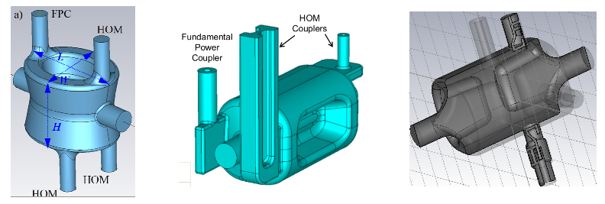
Figure 1 Compact cavities: a): Double quarter wave cavity b): RF dipole cavity c): 4-Rod Cavity (Courtesy Brookhaven National Lab, Old Dominion University, Lancaster University).
As a part of the R&D phase, it was determined to prototype the three designs for demonstration of reaching the nominal kick voltage. Furthermore, it was recommended by the Crab Cavity Advisory Panel at least one prototype cavity is tested with beam. A two-cavity configuration in the SPS machine with LHC type beams should validate the performance and investigate effects on protons and relevant machine protection aspects. Excellent progress was made in 2012-13 to fabricate prototypes of the three cavities and validate their performance at 2 K and 4.5 K. Simultaneously, the development of a two cavity cryomodule is in an advanced design stage in preparation for the SPS tests in 2017. Major milestones of an overall planning until the full installation in the LHC (during LS3) are shown in Table 1.
Table 1 Overview of Crab Cavity Planning from R&D to installation in the LHC.
2013-2014 | 2015-2016 | 2017 | 2018-2021 | 2022
Cavity Testing & Prototype Cryomodule | SPS Cryomodule Fabrication | SPS Beam Tests | LHC Cryomodule Construction | LHC Installation

For the May 2014 crab cavity review, a technical panel is put in place to evaluate the present status of the three design concepts and the preparation of the SPS tests, identify merits and risks in view of HL-LHC. This evaluation leading to a ranking based on RF and mechanical design, fabrication aspects, operational reliability and margin, cost and complexity should aid in making the best choice of the cavities for the LHC interaction regions 1 (vertical crossing) and 5 (horizontal crossing).

Technical Ranking Criteria, Cavities
The following sections will elaborate on the aspects relevant for the LHC crab cavities and the SPS prototype which can serve as guidelines towards ranking the different designs. An effort was made to the ranking criteria topics comprehensive. However, the ranking may depend on other criteria not (yet) on the list.

RF Cavity Design & Fabrication

Kick Voltage & Surface Fields
A nominal voltage of 3.4 MV per cavity is specified in the functional specifications [1]. The operational margin considered at this nominal voltage specification is only about 5-10%. An operational margin of 50% leading to kick voltage of the cavity to 5 MV without significant degradation of the cavity quality factor is highly desired. This allows for compensation of imbalances among the 4 cavities or in the worst case due to one non-operational cavity.
The minimization of the surface field to kick voltage ratio allowing the cavity to reach the pushed kick voltage of 5MV with moderate surface fields is important.
$$R=\left\{\begin{matrix}0 & \text{if } V<3.4 \text{MV} \\ V/{\left(3.4 \text{MV}\right)} & \text{if } V<5.1 \text{MV} \\ 1.5 & \text{if } V≥5.1 \text{MV}\end{matrix}\right.$$

Aperture
Measuring from the electric centre of the cavity (where the integral $\int_{-∞}^{∞}{E_{z}e^{j\frac{ω}{c}z}dz}$ of the operating mode vanishes), a circular aperture of 42 mm radius must be kept clear (cf. Fig. 2, hashed circle). This will allow the transverse alignment of the cavity without reducing the aperture for the beam. For the 2nd beam pipe it is required that the transverse space >145 mm is also kept clear (the maximum extent of the cavity outer wall at 300 K). Since the 2nd beam pipe (dotted circles) is at a distance of 194 mm horizontally for both cases, horizontal and vertical dipole kick, cavities have to be designed that the passage for the 2nd beam pipe is assured for either polarization of the dipole kick.
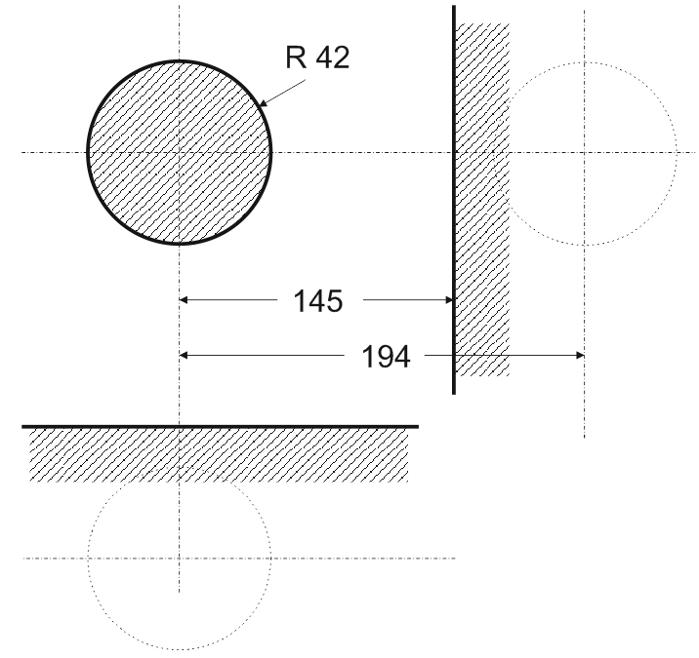
Figure 2: Beam pipe separation and the maximum allowed cavity envelope in the LHC for crab cavities.
An operational reproducibility of the closed orbit of approximately 0.5 mm should be expected. This margin is already accounted in the 84 mm cavity aperture specified.
Under the assumption that closed orbit reproducibility is $<0.5 \text{mm}$ and sum of mechanical errors in radius $<0.5 \text{mm}$:
$$R=\left\{\begin{aligned}0&\text{ if }d<84 \text{mm} \\ 1&\text{ if }d≥ 84 \text{mm}\end{aligned}\right.$$

Operating Mode Impedance
The minimum effective impedance seen by the beam in the presence of a strong feedback loop can be written as
$$R_{min}≈\frac{R}{Q}ω_{0}T$$
where $ω_{0}$ is the RF frequency in rad/s, $R/Q$the classic cavity parameter and $T$ the loop delay. Due to limitations primarily in integration of the RF equipment in the LHC interaction regions, the loop delay may not be reduced.
For centered beams, the beam loading through deflecting cavities is zero or negligible. With an offset (of the orbit w.r.t the electric center) non-zero longitudinal field will be present at the operating frequency. This on-axis field can have direct impact both on the required input power and stable operation of main RF system. This resulting longitudinal impedance is a strong criterion. In particular, the high beam currents (1.1 A) in the HL-LHC and the inevitable orbit transients at injection and during energy ramp can induce beam loading where the beam induced voltage is
$$V_{b}≈Q_{L}\frac{R_{t}}{Q}\frac{ωΔx}{c}I_{b}$$
where $Q_{L}$ is the loaded quality factor, $I_{b}$ is the DC beam current, $\frac{R_{t}}{Q}$ is the transverse shunt impedance (in Ohms) and $∆x$ is the beam offset. Although the $Q_{L}$ can be increased for higher$\frac{R_{t}}{Q}$, this results in reduced cavity bandwidth thus driving the tuning requirements to be tighter. Alternatively, the input power would have to be increased, which is also unfavourable. From beam loading considerations, a smaller $\frac{R_{t}}{Q}$ is desirable.

Lorentz Force Detuning & Mechanical Stability
Although the cavities are operated in CW mode, a large detuning during cavity filling and/or discharge can disrupt the beam and potentially become a machine protection issue. The Lorentz force detuning (LFD) should be below a reasonable level $Δf_{LFD}=O\left(±3 \text{kHz}\right)$ by design and be reproducible. In this case, the tuning system is specified to compensate for it (see below).

Multipacting & Field Emission
Novel shapes with loading elements have the potential to strongly multipact. It should numerically and experimentally be demonstrated that multipacting in the range of interest is suppressed and/or easily processed. This includes not only the cavity but all coupling elements which can potentially multipact. Multipactor suppression by geometrical means has to be within the mechanical tolerances $O(500 \text{μm})$.
The cavity design including couplers should allow fabrication and surface treatments to minimize field emission.

Cavity Fabrication, Materials & Vacuum
Since the fabrication techniques for each of the designs may be different, a ranking on this aspect is only subjective. The number of independent parts, associated welds, complexity of the welds and welds at high field regions could influence the cavity performance and reliability. Therefore, the manufacturability with the minimum number of welds at low field regions is an important criterion. The material choice for the cavity with a high RRR Niobium (>300) should not be compromised due to manufacturability.
Ranking: This is not very clear yet: we might with to get a ranking that roughly penalizes a cavity with say 100 “welds” with a factor 0.9 wrt. a cavity with 10 welds and a factor 1.
Ultra high vacuum (better than 10⁻¹⁰ mbar) in the cavity is essential to guarantee cavity performance and reliability with beam both in the SPS and the LHC. Geometrical issues or complex welding procedure compromising the vacuum integrity of the cavity can negatively impact the ranking criteria.
The cavity should be leak tight ($P_{m}={10}^{-10} \text{mbar}\text{∙}l/s$ He leakage rate at $2 K$).
Ranking: $R=\left\{\begin{aligned}1 &\text{if } P≤0.1P_{m} \\ -\log\left(\frac{P}{P_{m}}\right) &\text{if } 0.1P_{m}<P<P_{m} \\ 0 &\text{if } P≥P_{m}\end{aligned}\right.$

Surface Treatment Aspects
A standard recipe established in the SRF community (bulk BCP of ~150 μm, UHV heat treatment at $600 ℃$, followed by a light BCP and high pressure water rinsing) is a minimum requirement. No special development for surface treatment is anticipated for the crab cavities in the SPS and electro-polishing is not considered as a viable option at present. The complexity of the geometry leading to inefficient surface chemistry and/or cleaning of the surface thereby limiting the maximum achievable kick voltage is an important ranking factor.
Ranking: Subjective penalty function based on the ease of evacuation of chemical agents and uniformity of surface layer removal.
No good idea how to quantify the “ease of evacuation”.
For the uniformity of the surface thickness removed by BCP, with the ratio of maximum to minimum removed material thickness$a$,
$$R=\left\{\begin{aligned}1-\frac{\log{a}}{\log{2}}& \text{if } a<2 \\ 0 &\text{ otherwise}\end{aligned}\right.$$

Input Coupler & Amplifier
A sufficient bandwidth and the corresponding power are required to compensate for the unavoidable orbit offsets. Figure shows the required forward power as a function of the$Q_{L}$ for a beam that is centred (red) and off-centred by 1 mm (green) and 2 mm (blue). It is expected that the orbit will be kept within 0.5 mm for the entire energy cycle of the LHC; another 0.5 mm should be added for mechanical tolerances. It should be noted that the maximum beam current in the SPS is about $0.3 A$ or below.
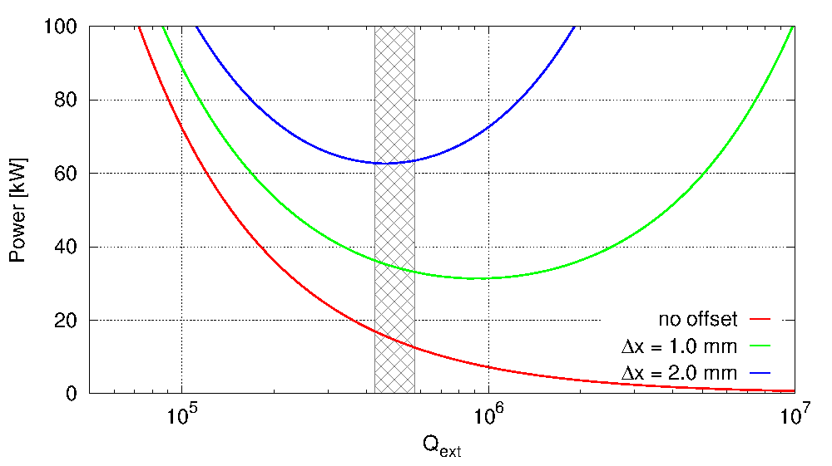
Figure 3: Forward power vs. cavity $Q_{L}$ for centered (red) and $1 \text{mm}$ offset (green) and $2 \text{mm}$ offset (blue) beams. Assumed $R/Q=400 \text{Ω}$, $3.4 \text{MV}$ RF, $1.1 \text{A}$ DC.
The power has a broad minimum of approximately 40 kW from a $Q_{L}$ of about $3∙{10}^{5}$ to $1.5∙{10}^{6}$. Selection of an optimal $Q_{L}$ value in the broad minimum is a compromise between the feasible tuning precision and the minimization of the field fluctuations from the amplifier electronics [1]. For larger bandwidth (leading to more stability), lower $Q_{L}$ values are favored – the hashed area in Fig. 3 was chosen a compromise. The optimum values for the formula below are: $Q_{opt}=5∙{10}^{5}$, $Q_{min}=3.4∙{10}^{5}$.
Ranking: $R=\left\{\begin{aligned}1-\left|\frac{Q_{L}-Q_{opt}}{Q_{opt}-Q_{min}}\right| &\text{ if } \left|Q_{L}-Q_{opt}\right|<Q_{opt}-Q_{min} \\ 0 & otherwise\end{aligned}\right.$

Impedance & Higher Mode Damping
On resonance, the large impedance of the fundamental deflecting (dipole) mode is cancelled between the positive and negative sideband frequencies, which are symmetric around $ω_{RF}$. The active feedback will reduce the growth rates by a large factor. When the beams are not in collision, the same concept is used while cancelling the effect on beam with counter-phasing the four cavities. It is also possible to detune the cavity where the growth rates of the instabilities are sufficiently small. Therefore, only beam loading aspects are considered as ranking criterion for the fundamental, which was covered above under 3.1.3.
For higher order modes (HOMs), both narrow band and broadband impedance should be minimized during the entire machine cycle as LHC will accelerate and store beams of currents exceeding 1.1 A (DC). Tolerances are set from impedance thresholds estimated from Ref. [2]. Therefore, the impedance of the HOMs below the specifications given below and additional margin is a strong ranking factor.
The longitudinal impedance has approximately a quadratic behaviour in the region of interest with the minimum threshold value at ($300÷600) \text{MHz}$. The total maximum allowed impedance from each HOM for all cavities, assuming that the HOM falls exactly on a beam harmonic is set at < 200 kΩ. If all 16 cavities have identical HOM frequencies, the longitudinal impedance cannot exceed 12.5 kΩ per cavity. For frequencies higher than 600 MHz, the threshold is higher, but we will impose the same threshold. Modes with frequencies above 2 GHz are expected to be Landau damped due to natural frequency spread and synchrotron oscillations.
With $df=|mod\left(f-10 \text{MHz},20 \text{MHz}\right)+10 \text{MHz| }$, $Z_{min}=200 \text{kΩ}$, $ζ=5$, $Z_{max}=2 \text{MΩ}$:
$$z_{lower}\left(f\right)=\log{Z_{min}+\frac{df}{10 \text{MHz}}}\left(\log{Z_{max}}-\log{Z_{min}}\right)$$
$$z_{upper}\left(f\right)=z_{lower}\left(f\right)+\log{ζ}$$
$$R_{HOM}=\left\{\begin{aligned}&0 &\text{if } \log{Z_{HOM}}>z_{upper} \left(f_{HOM}\right) \\ \left.\frac{\log{Z_{HOM}}-z_{lower}\left(f_{HOM}\right)}{\log{ζ}}\right.&&\text{if }z_{lower} \left(f_{HOM}\right)≤\log{Z_{HOM}}≤ \\ &1&\text{if } \log{Z_{HOM}}<z_{lower} \left(f_{HOM}\right)\end{aligned} z_{upper} \left(f_{HOM}\right)\right.$$
Ranking: $R=\prod_{f_{HOM}<2 \text{GHz}}{R_{HOM}}$
In the transverse plane, the impedance threshold is set by the bunch-by-bunch feedback system with a damping time of $τ_{D}=5 \text{ms}$ [5]. Assuming the pessimistic case that the HOM frequency coincides with the beam harmonic, the maximum impedance is set to be < 4.8 MΩ/m. Again, assuming 16 cavities per beam, the maximum allowed impedance per cavity is 0.3 MΩ/m. Analogous to the longitudinal modes, frequencies above 2 GHz are expected to be Landau damped due to natural frequency spread, chromaticity and Landau octupoles. It should be noted that there are nominally only 8 cavities per each transverse plane, so the threshold per cavity is higher, but the 0.3 MΩ/m is given assuming that the crossing plane between the experiments could become the same as a worst case scenario.
Ranking: same principle as above with $Z_{min}=4.8{\text{MΩ}}/{\text{m}}$ and $Z_{max}=50{\text{MΩ}}/{\text{m}}$
Due to the very tight impedance thresholds, one important factor is the distribution of the HOM frequencies due to manufacturing errors or other factors; a spread of the HOM frequencies has been included in the ranking formula above.

RF Multipoles & Fabrication Errors
The crab cavity designs presently considered are such that they lack axial symmetry. Therefore, they can potentially exhibit all higher order components of the main deflecting field. Due to the placement of the cavities at high beta-function locations, the higher order components of the main deflecting mode can affect long term particle stability.
The quadrupolar component $b_{2}$ is zero in case of perfect symmetry; due to fabrication errors and ancillary components it is non-zero – it must be smaller than 10 units leading to a tune shift in the order of ${ΔQ≈10}^{-4}$. The first systematic multipole is the sextupolar component, $b_{3}$. Long term simulations with the optical functions of the HL-LHC indicate that the $b_{3}$ component should be limited to approximately 1000 ± 10% units which results in an acceptable degradation of the dynamic aperture below $1σ$ for orbit offsets of 1.5 mm [3]. No specifications are provided for higher order terms yet, but it is expected that they be controlled to smaller values than the neighboring D2 dipole magnet.
Sensitivity to fabrication errors of the order of 0.5 mm should be minimized to less than 10% change in the multipoles thus ensuring negligible or no degradation of beam quality. The multipoles are defined to be
$$b_{n}[{\text{Tm m}}^{2-n}]=\int_{0}^{L}{B_{⊥}^{n}[{\text{Tm m}}^{1-n}]∙dz}; B_{⊥}^{n}=\frac{1}{qc}F_{⊥}^{n}$$
Ranking (with $b_{3}^{th}=1000$, $b_{3}^{max}=3000$): $R=\left\{\begin{aligned}1 &\text{if }b_{3}<b_{3}^{th} \\ 1-\frac{\left|b_{3}-b_{3}^{th}\right|}{\left|b_{3}^{max}-b_{3}^{th}\right|} &\text{if } b_{3}^{th}≤ b_{3}≤b_{3}^{max} \\ 0 &\text{if } b_{3}>b_{3}^{max}\end{aligned}\right.$
For $n≥4$, assuming a very approximate scaling of the additional kick from an orbit offset via $b_{n}$, the $b_{n}$ must be kept ${<O(10}^{n})$. Better estimates are pending; results from long-term tracking are needed.

Technical Ranking Criteria, Cryomodule

Safety & Standards
The Crab Cavities Cryomodule is a Special Equipment, according to CERN Safety Rules SR-M and GSI-M3 [1]. For this type of equipment, HSE unit identifies a set of specific safety requirements and performs a verification of the equipment Safety File to provide a Safety Clearance before the start of manufacturing, before the start of operation and dismantling.
The pressure conditions for SM18 and SPS test environment are summarised in Table 2:
Test environment | Maximum allowable pressure (absolute)
SM18 Test cryostat | 1.5 bar
SPS | 1.8 bar
Table 2 Pressure conditions for the SM18 and SPS test environment.
The total amount of helium available for the SPS tests is limited. The helium vessel fluid volume should be minimized as much as possible, ideally below 40 liters per vessel.
The pressure conditions in combination with the helium vessel fluid volume determine the risk category of the equipment. Risk category I applies between $\left(50÷200\right)\text{ bar}∙\text{litre}$.
The use of standards EN 13458 and EN 13445 gives a presumption of conformity with the Essential Safety Requirements of the Pressure Equipment Directive 97/23/EC and provides, therefore, an additional level of confidence on the safety of the equipment.
Whenever the use of these standards is not possible, ASME Code Section VIII, Division 1 and, in particular, Division 2 can be used as alternative. Any other selected construction code shall be submitted to CERN-HSE unit for approval.
For the sake of consistency and safety risk mitigation, only one single code shall be used for the design, manufacture and inspection of the different parts of the cryomodule even if performed by different suppliers.
$$R=\left\{\begin{aligned}0 &&if 1.8\frac{v}{litre}>200 \\ 1-\frac{\frac{v}{litre}1.8 \text{-50}}{150} &&if 50<1.8\frac{v}{litre}<200 \\ 1 &&if 1.8\frac{v}{litre}<50\end{aligned}\right.$$

Frequency Tuning System & mechanical stability
A number of procedures from the fabrication steps will determine the final frequency of the cavity. During the cavity filling with RF, the Lorentz forces on the cavity will further perturb the frequency. A “slow” mechanical tuning system is a requirement to alter the cavity shape and compensate the frequency change to ensure proper tune of the cavity, i.e. at $2 \text{K}$, it must be possible to tune the cavity to an operating frequency in the range $f=400.79 {\text{MHz}}_{-60 \text{kHz}}^{+0}±Δf_{LFD}$. Due to the large cold-to-warm resonance frequency change (hundreds of kHz), a significantly larger tuning range should be envisaged. The resolution of the tuner should allow at least 4 steps inside the cavity bandwidth (~800 Hz); backlash and hysteresis must be small.
Low frequency mechanical resonances (up to few 100 Hz) should be eliminated to minimize the cavity perturbation due to both helium pressure fluctuations $O\left(1 mbar\right)$ and external noise sources. No resonance should exist below 50 Hz, resonances above 150 Hz are considered benign. Fast acting piezo-tuners are foreseen to compensate small frequency changes (deformations $≤\left(10÷20\right)\text{ μm}$) due to external forces to reduce the RF power overhead (see Figure 3); no piezo-tuner for larger deformations is foreseen.
$$R=\left\{\begin{aligned}0 &if f_{res}≤50 \text{Hz} \\ f/{(100}Hz)-0.5 &if 50 \text{Hz} <f_{res}≤150 \text{Hz} \\ 1 &if f_{res}>150 \text{Hz} \end{aligned}\right.$$
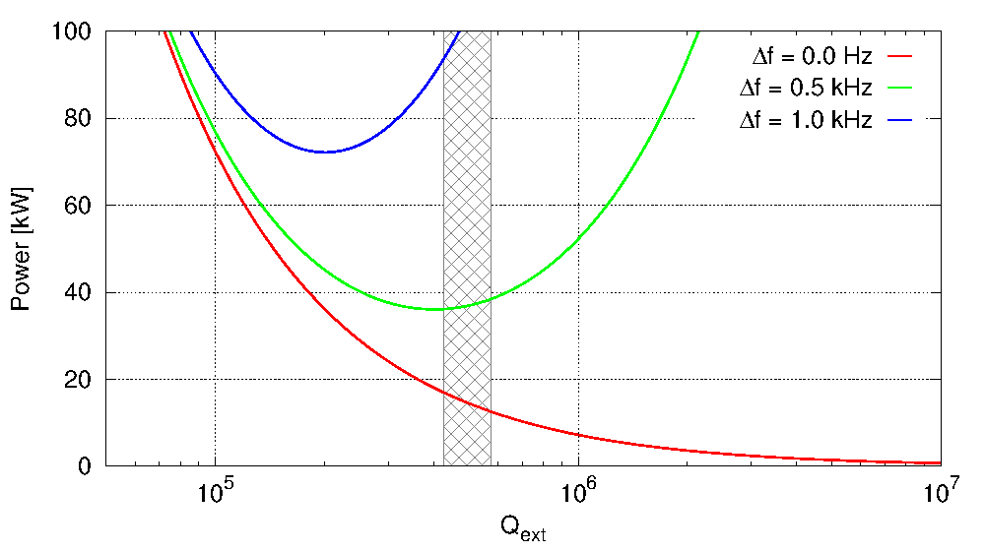
Figure 4: Forward power required a function of $Q_{ext}$ for different detuning of the cavity.

Static Magnetic Shielding
Assuming a cavity geometric factor of $G≈100 \text{Ω}$, the additional surface resistance due to trapped flux $R_{mag}$ is required to be below $(1÷2) nΩ$ to stay in the shadow of the total surface resistance specification of $10 nΩ$. To achieve this, magnetic shielding in the cryostat should reduce the external magnetic field on the outer surface of the cavity by at least a factor 100 (reaching $<1 \text{μT}$ assuming the earth magnetic field).
$$R=\left\{\begin{aligned}0 if reduction factor<100 \\ 1 & if reduction factor≥100\end{aligned}\right.$$

Heat Loads
Due to the very limited capacity available in the SPS TCF20 refrigerator, the total losses (static and dynamic) have to be limited to $25 \text{W}$ (at $2 \text{K}$) assuming the existing cryo system. This heat load, however conservative, is already at the limit of the present TCF20 system and a buffer tank is required to provide additional margin during the operation. A study to increase the heat load capacity to $40 \text{W}$ (at $2 \text{K}$) is under investigation. It is likely that a cryomodule exceeding the $40 \text{W}$ limit cannot be tested in the SPS. This heat load concerns the total power (static + dynamic) at 2 K for a complete 2-cavity cryomodule.
$$R=\left\{\begin{aligned}0 &if P_{th}≥40 \text{W} \\ 1-\frac{P_{th}-25 \text{W}}{15 \text{W}} &if 25 W≤P_{th}<40 W \\ 1 &if P_{th}<25 \text{W} \end{aligned}\right.$$
The cryogenic limits in the LHC are not known at this time. However, the $12.5 \text{W}$ per cavity heat load at $2 \text{K}$ is rather constrained and it is expected that the LHC heat load capacity is at least a factor of 2 larger. However, it should be reminded that the system in the LHC is x16 larger than the SPS. All cavity elements and cryomodule interfaces leading to a minimized heat load are an essential criterion to ensure a successful beam test in the SPS prior to any installation in the SPS.

Cryomodule Envelope & Interfaces
The relevant cryomodule envelope and for the SPS tests is given in Table 3. A sketch of the cross section is shown in Figure 4. In general, the SPS constraints largely fulfil the LHC requirements with some exceptions discussed in section 4.5.
Table 3: Cryomodule envelope dimensions
Description | Distance [mm]
Cryomodule z-length (gate-valve to gate-valve) | 3000
Cavity axis to inner edge of cryomodule volume | 420
Cavity axis to top of ceiling (cryomodule+couplers+waveguides) | 1200
Cavity axis to SPS floor | 1200
Diameter of cavity aperture | 84

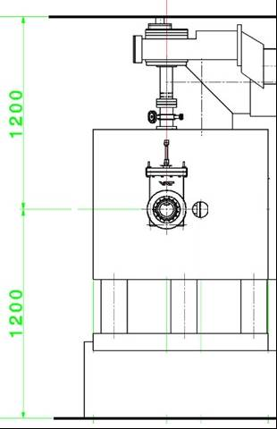
Figure 5: Cross section of the SPS-BA4 region at the location of crab cavities
Switching of cavities into or out of the beam line is to be achieved using a bypass that is mechanically moved in and out of beam positions. This bypass line is implemented by means of a Y-chamber vacuum chamber as shown in Error! Reference source not found.. The spacing between the bypass beam pipe and the crab cavity axes is 510 mm.

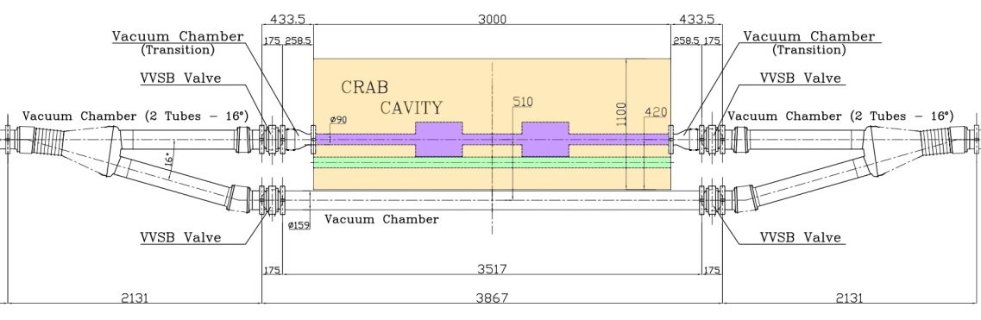
LHC Implementation Aspects
Figure 6: The crab cavity cryomodule envelope, showing the envelope (yellow), the cavities (purple), and the dummy beam pipe (green).
Aspects required in the LHC and not imposed for the SPS tests are discussed in this.

Fabrication errors and alignment
The various transverse and longitudinal alignment aspects for the LHC are discussed in Ref. [4]. The most severe are in the transverse plane with a maximum allowed offsets of 0.5 mm w.r.t to the neighbouring cavities. The roll (tilt around the beam axis) w.r.t to the neighbouring cavities should be controlled within$0.3 °$. At cryogenic temperature, the specified tolerances should be reached with passive alignment only; active alignment is considered only as a backup option.

Alternating Crossing Planes
In the LHC, the two high luminosity experiments require crab crossing in different planes. Other proposals exist with crab crossing in both transverse planes for luminosity density levelling. Therefore, all design aspects of the cavity-cryomodule should allow for crabbing in either plane. In the SPS, the plane of crossing is not imposed.

Modularity
A total of 16 cavities for each IP are required to provide the $\left(12÷13\right)\text{ MV}$/beam. The modularity of the cavity elements and the interfaces to the cryomodule will be a key factor to determine the spare policy and replacement of malfunctioning cavities. However, the total length and the rapid change of the optics functions near the interaction region require that the 8-cavity ensemble be accommodated within a maximum of 13.3 m.

Cost & Schedule Criteria
Due to the 32 cavities + 4 spares needed for the LHC, the cost of the total crab cavity system for the LHC is substantial.

Assumptions
- An approximate cryomodule cost scaling (Cavities–25%, He-Tank & Tuner–15%, Couplers–25%, Cryostat–35%) is assumed.
- A functional two-cavity cryomodule (SPS-like) is used as a fundamental unit.
- Given the schedule constraints from LS2 (2018), the SPS prototype module has be installed latest by 2016-17 winter shutdown and tested during the run 2017.

Material Choice and Cost
One of the main cost contributions towards material could be Niobium. The choice of the cavity material is required to be bulk Niobium with a RRR>300. Due to existence of several couplers near high field region, the extent of the Niobium surface beyond the bare cavity is not small. The 32 cavities for the LHC with a minimum of 4 spare cavities will amount to significant amount of high RRR Niobium. Design criteria to optimize the overall Niobium surface will impact the overall cost. Any degradation of the material due to fabrication or cost aspects on the high field surfaces has a negative impact factor.
Table 4: Total amount of expensive raw material to be purchased, in kg
Raw Materials | RF Dipole | Double Quarter Wave | 4-Rod
Bare Cavity (Nb)
Coupler Ports (Nb)
HOM Couplers (Nb)
Flanges (NbTi)
He vessel (Ti)
Tuners (Ti)

Material choices for the rest of the cavity elements and cryomodule should be optimized for mechanical, thermal, and cost criteria. For these materials, Harmonised European Standards Ref. [3] should be adopted wherever possible. If this is not possible, European Approval of Material (EAM) or Particular Material Appraisal (PMA) standards should be considered. If this is not available either (as for Nb or NbTi), dedicated qualification process approved by CERN has to be applied.
Materials shall always be purchased according to a reference document, which can be either a standard or a dedicated specification.

Cost of Fabrication & Processing
In view of the 32 cavities to provide a minimum kick voltage of 3.4 MV, the primary criteria for the fabrication should be the cavity performance, reliability and reproducibility. For example, the number of welds and their complexity at high field regions can arguably have an impact on the performance, the welds’ smoothness and uniformity being essential.
In general, all process fusion-welding governing joints shall have a quality level of imperfections corresponding to level B of ISO 5817.
The percentage of non-destructive tests of welds performed on CERN site, within the framework of installation in situ and integration with interface equipment shall be of 100% (visual and radiographic examination, this last, whenever applicable).
Remark to the committee: we are aware that the complexity of the fabrication steps is important (and should be included by a “complexity factor”), but we haven’t found a simple method of objectively quantifying it.
Table 5: Number of steps in fabrication
 | RF Dipole | Double Quarter Wave | 4-Rod
Cavity Forming
Cavity e-beam welding
Ports
Brazing/welding flanges
HOM couplers
He-vessel shaping & welding
Tuners
Total

Assembly & Tooling
Optimization of parts assembly, manufacturing processes and the required tooling for handling the cavity/cryomodule has to be made cost effective. The minimum number of functional assembly parts and the minimum number of interfaces leading could be used as approximate criteria.
Table 6: Number of parts
 | RF Dipole | Double Quarter Wave | 4-Rod
Cavity parts
Ports
HOM coupler parts
Flanges
He-vessel parts
Tuner parts
Total

Table 7: Cost of tooling for manufacturing, RF measurement, adjustment and assembly
 | RF Dipole | Double Quarter Wave | 4-Rod
Total [k$]

A design leading to a modular assembly thus reducing the handling time and limits the number of assembly errors is important. The complexity in assembly including aspects such as size, clearance, mass, fragility and related items should be considered.

Readiness & Risk: SM18 Testing & SPS Installation
In order to validate the crab cavities and the RF system for the LHC, beam tests with protons in the SPS are a prerequisite. Due to the constraints given from LS2, the installation of the cavity in the SPS should be performed no later than 2016/2017 winter shutdown. Tracing back from this deadline, a coarse schedule is shown in Table 8 by some major milestones.
Table 8: Likelihood to meet milestones, to be quantified in 0% (impossible) to 100% (certain)
MS | Milestone description | RF Dipole | Double 1/4-wave | 4-Rod
12/2014 | 2 bare cavities fabricated & tested
12/2015 | 2 dressed cavities fabricated & tested
6/2016 | 2-cavity CM ready for test in SM18
2/2017 | CM installed in SPS, ready for beam

Machine Protection
A rapid change of the field in one cavity (for example a fast quench or a power supply trip), the LHC Beam Dump System (LBDS) will act to extract the beam in a minimum time of three turns ($270 μs$). Two kinds of interlocks are foreseen: slow (on BPMs) and fast (on RF). The RF controls should minimize the effect on the beam within the 3 turns to avoid abrupt displacements which can potentially damage the machine elements.
Therefore, independent power system of each cavity with a short delay cavity controller is proposed. Operationally, it is preferred to have a low $Q_{ext}$ to reduce the sensitivity to external perturbations. However, it is assumed that machine protection may benefit from a high $Q_{ext}$ to help avoid fast dissipation of the stored energy or fast changes in the cavity phase.
To be consistent with the requirements of the machine protection, the cavities must be made “invisible” to the beam if non-functional or not in use. The following three states should be considered:
- Cavity is superconducting: one can detune and park to make it transparent
- Cavity is not cold: beam veto!
- Cavity is superconducting and amplifier/feedback is working: one can counter-phase to zero set-voltage; this is preferred for control/operational aspects.

References
[4] P. Baudrenghein et al., Functional Specifications of the LHC Prototype Crab Cavity System, CERN-ACC-NOTE-2013-003, CERN, 2013.
[2] B. Salvant et al., Presented at the HiLumi Meeting, Frascati, 2012.
[3] J. Barranco et al., Presented at the HiLumi Meeting, Frascati, 2012.
[3] European directive on pressure equipment and gas appliances 97/23/EC, http://ec.europa.eu/enterprise/sectors/pressure-and-gas/documents/ped/, 2013.

Check with Ofelia!

